ASSIGNMENT # 1

(FA21-BCS-107) (SECTION-B)

NAME : UMAR SHAHID

1. **Write a C program to print your name, date of birth. and mobile number.**

**#include<stdio.h>**

**int main()**

**{**

**printf("NAME : Umar Shahid\n");**

**printf("DATE OF BIRTH : July 24,2003\n");**

**printf("PHONE NUMBER : 0336-7100312\n");**

**}**

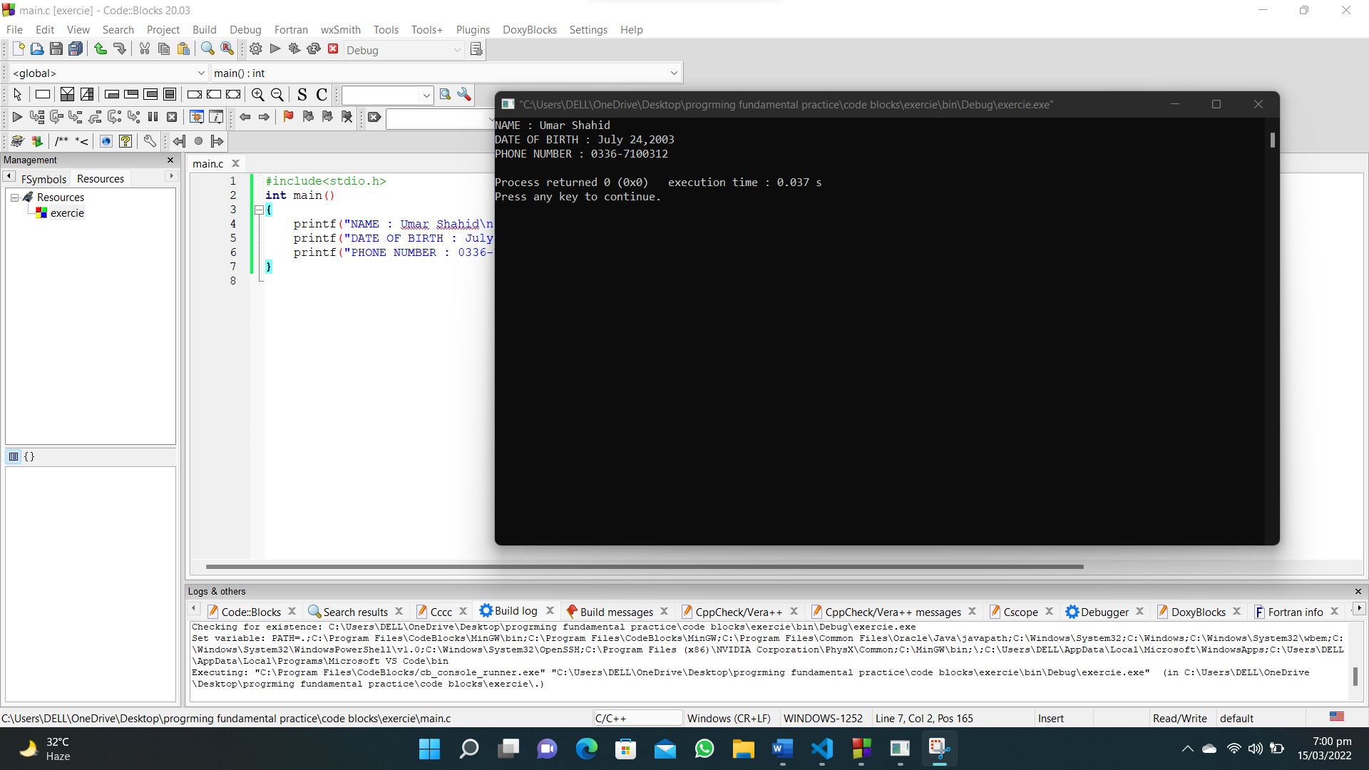

1. **Write a C program to print a block F using hash (#), where the F has a height of six characters and width of five and four characters. And also to print a big 'C'.**

**#include <stdio.h>**

**int main()**

**{**

**printf("######\n#\n#\n#####\n#\n#\n#\n\n");**

**printf(" ######\n ##\t##\n#\n#\n#\n#\n#\n ##\t##\n ######");**

**}**

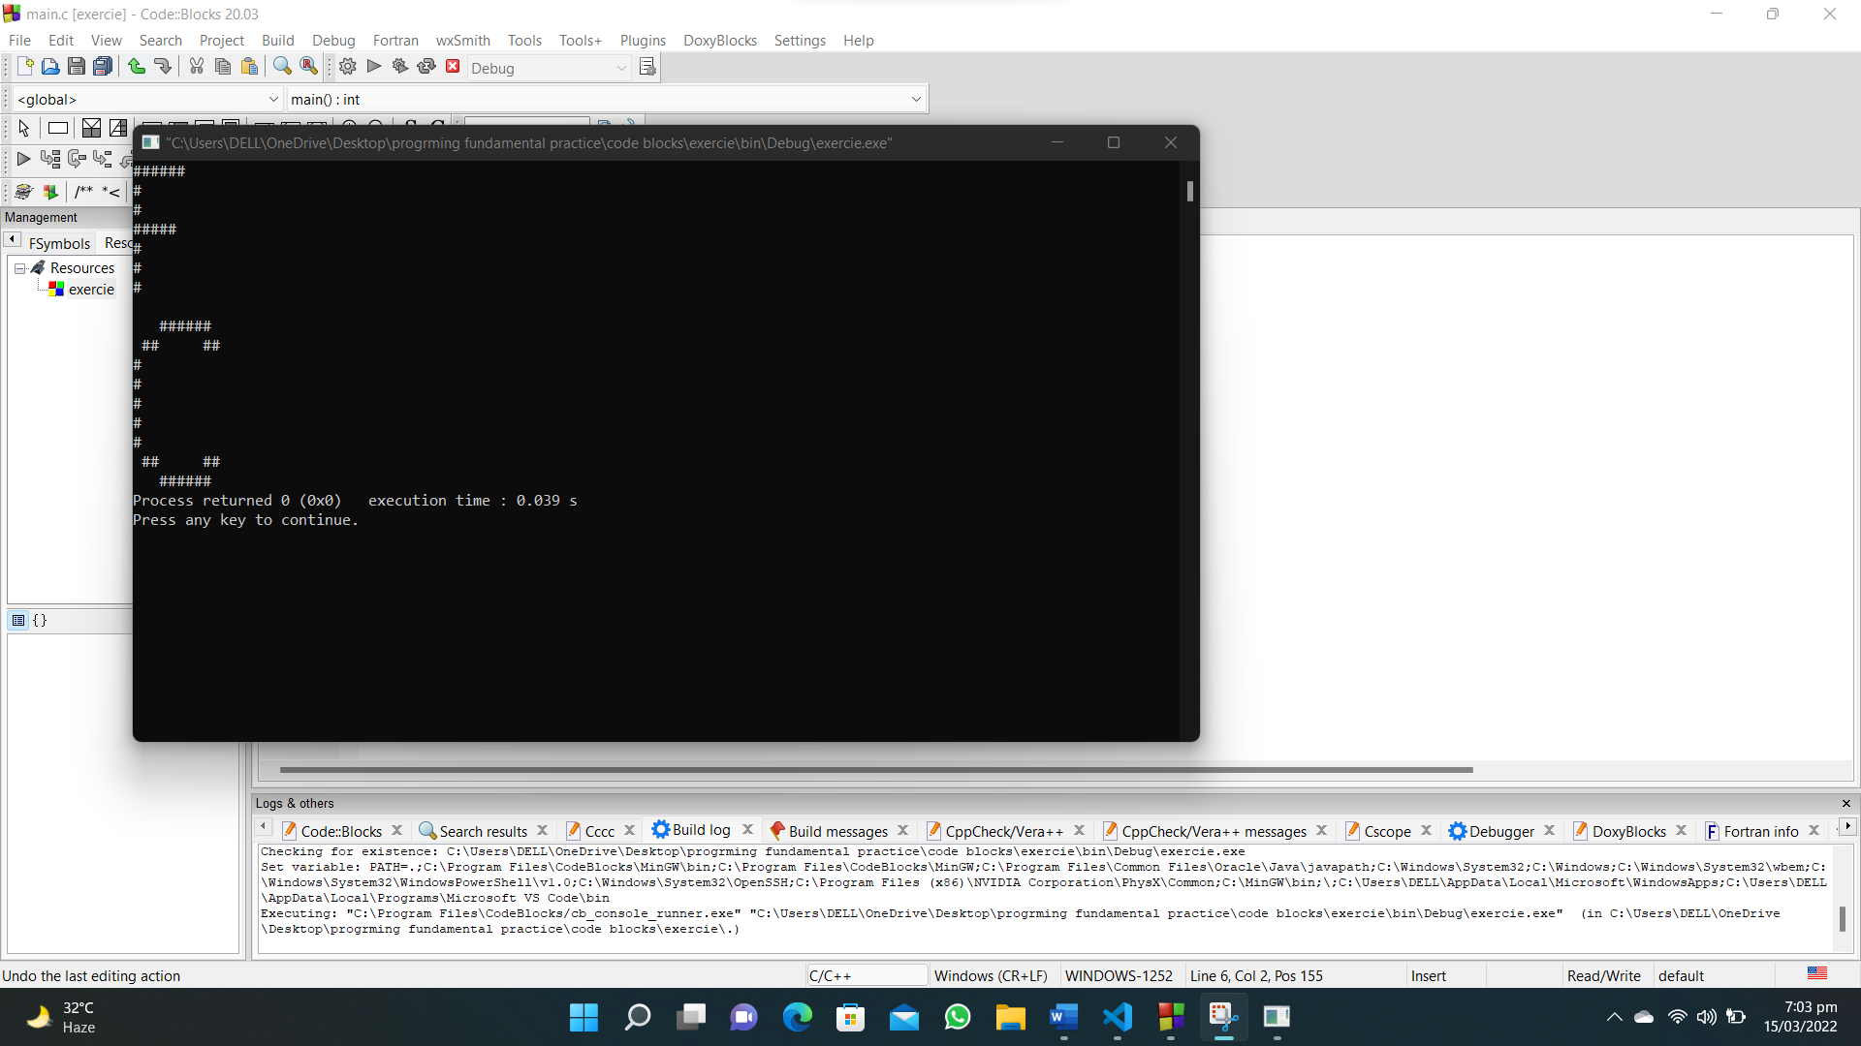

1. **Write a C program to print the following characters in a reverse way.**

**#include<stdio.h>**

**int main()**

**{**

**char x='X',m='M',l='L';**

**printf("The reverse of character %c%c%c is %c%c%c",x,m,l,l,m,x);**

**}**

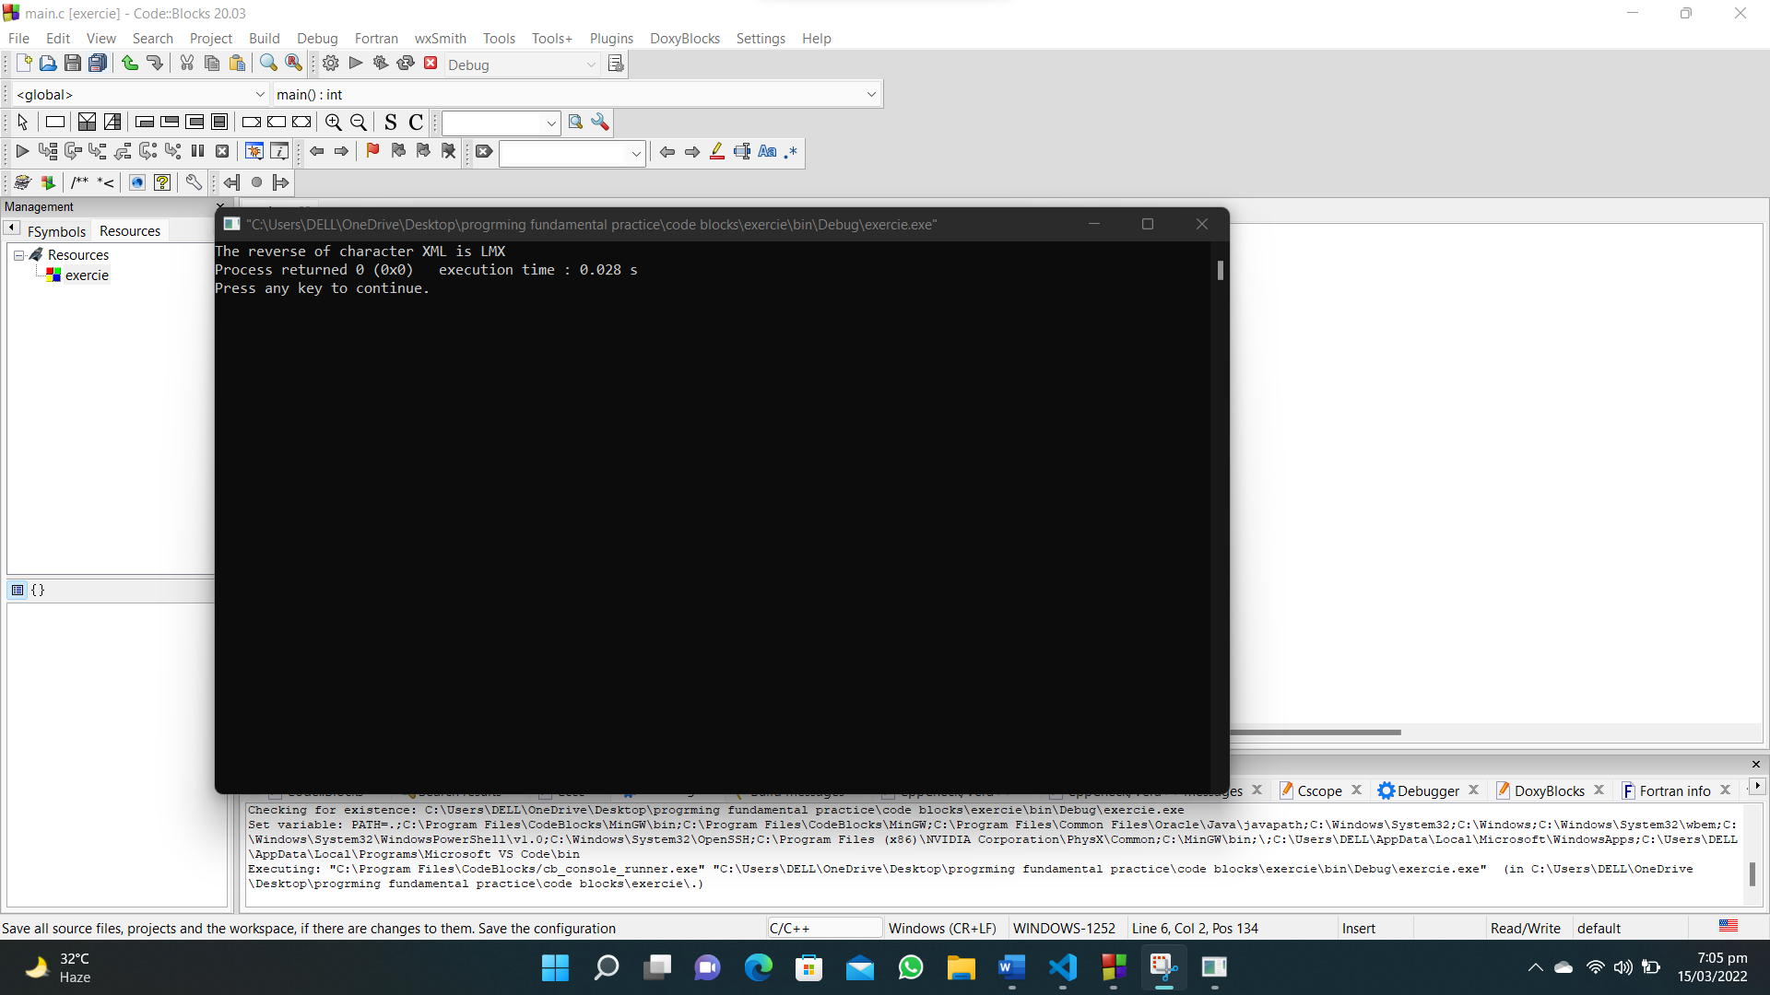

1. **Write a C program to compute the perimeter and area of a rectangle with a height of 7 inches. and width of 5 inches.**

**#include <stdio.h>**

**int main()**

**{**

**int area, perimeter, height = 7, width = 5;**

**area = height * width;**

**perimeter = 2 * (height + width);**

**printf("The area of rectangle is : %d\n", area);**

**printf("The perimeter of rectangle is : %d", perimeter);**

**}**

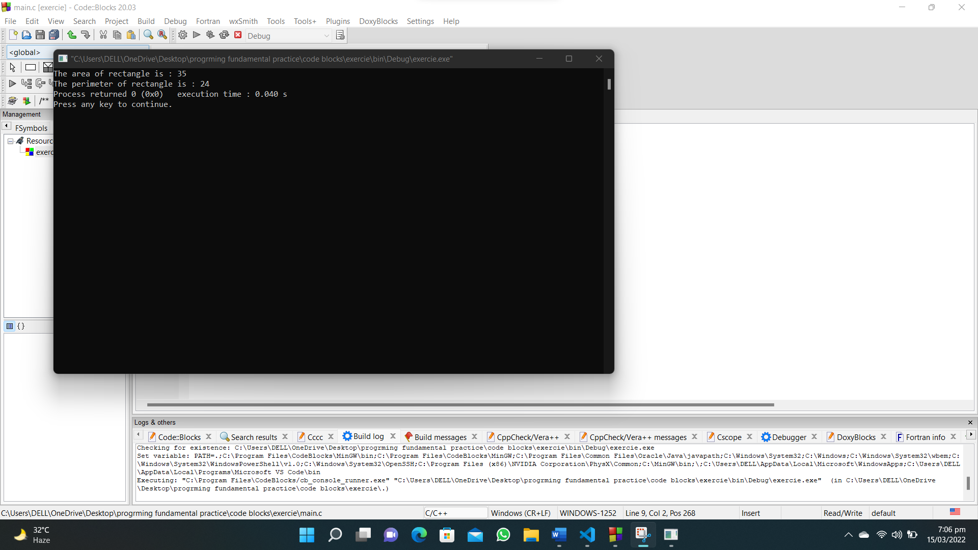

1. **Write a C program to compute the perimeter and area of a circle with a given radius.**

**#include<stdio.h>**

**int main()**

**{**

**int radius;**

**float area,perimeter;**

**printf("Enter radius of the circle : ");**

**scanf("%d",&radius);**

**area=3.14*radius*radius;**

**perimeter=2*3.14*radius;**

**printf("The area of circle is : %.2f\n",area);**

**printf("The perimeter of circle is : %.2f",perimeter);**

**}**

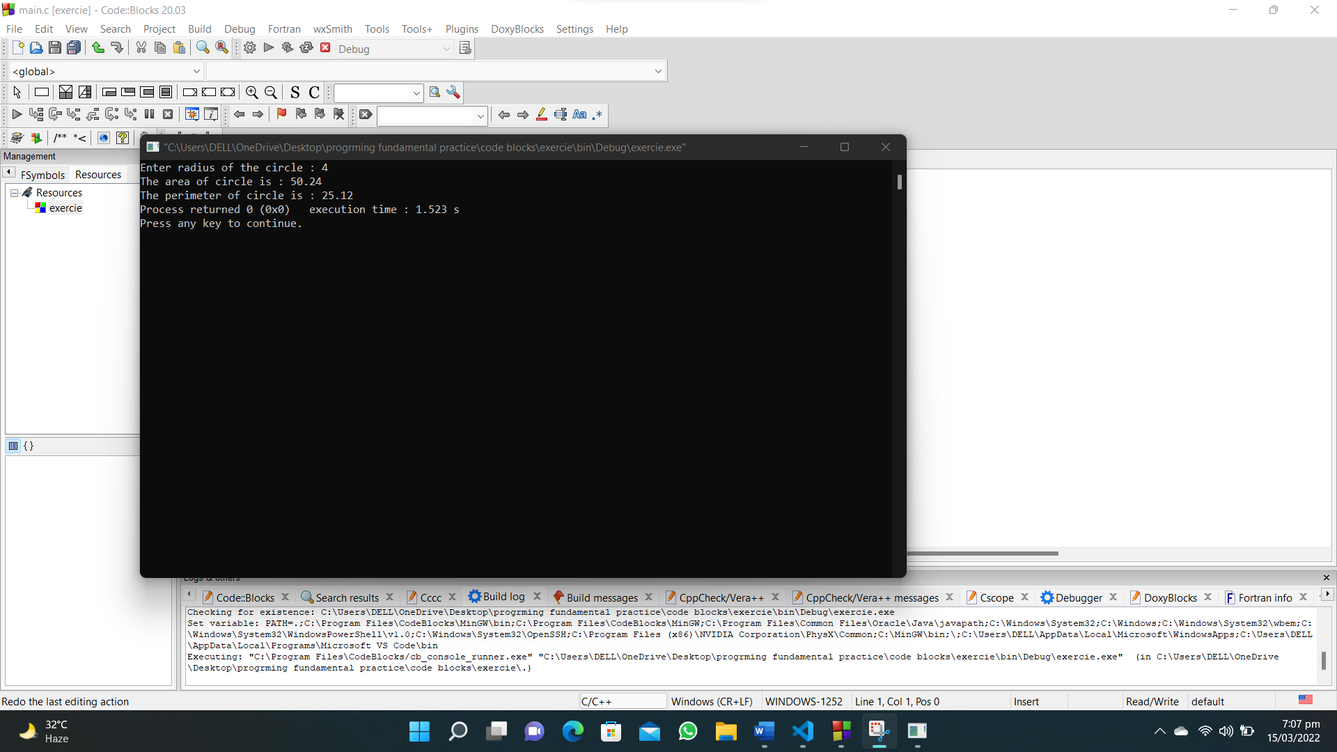

1. **Write a C program to display multiple variables.**

**#include <stdio.h>**

**int main()**

**{**

**int a = 125, b = 12345;**

**long ax = 1234567890;**

**short s = 4043;**

**float x = 2.13459;**

**double dx = 1.1415927;**

**char c = 'W';**

**unsigned long ux = 2541567890;**

**printf("a+c=%d\n", a + c);**

**printf("x+c=%f\n", x + c);**

**printf("dx+x=%lf\n", dx + x);**

**printf("((int)dx)+ax=%ld\n", ((int)dx) + ax);**

**printf("a+x=%f\n", a + x);**

**printf("s+b=%hi\n", s + b);**

**printf("ax + b = %ld\n", ax + b);**

**printf("s + c = %hd\n", s + c);**

**printf("ax + c = %ld\n", ax + c);**

**printf("ax + ux = %lu\n", ax + ux);**

**}**

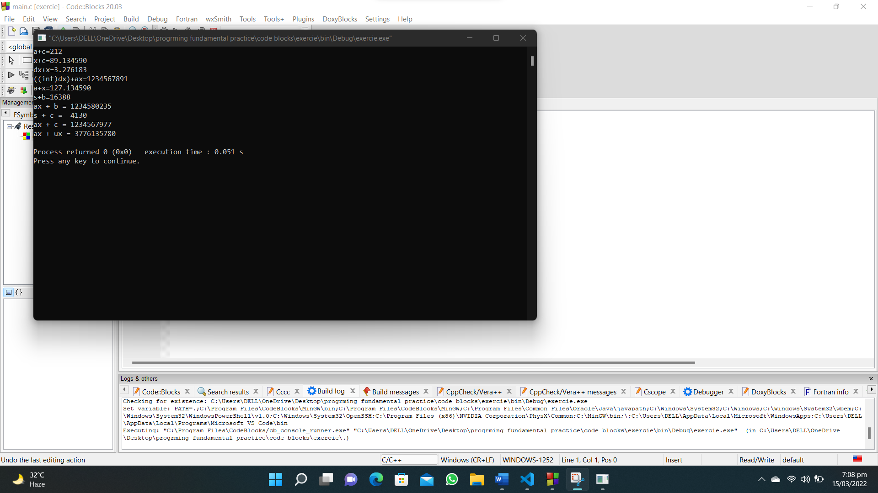

1. **Write a C program to convert specified days into years, weeks and days.**

**#include <stdio.h>**

**int main()**

**{**

**int input_days, years, weeks, days, rem;**

**printf("Enter number of days : ");**

**scanf("%d", &input_days);**

**years = input_days / 365;**

**rem = input_days % 365;**

**printf("YEARS : %d\n", years);**

**weeks = rem / 7;**

**printf("WEEKS : %d\n", weeks);**

**rem = rem % 7;**

**days = rem;**

**printf("DAYS : %d\n", days);**

**}**

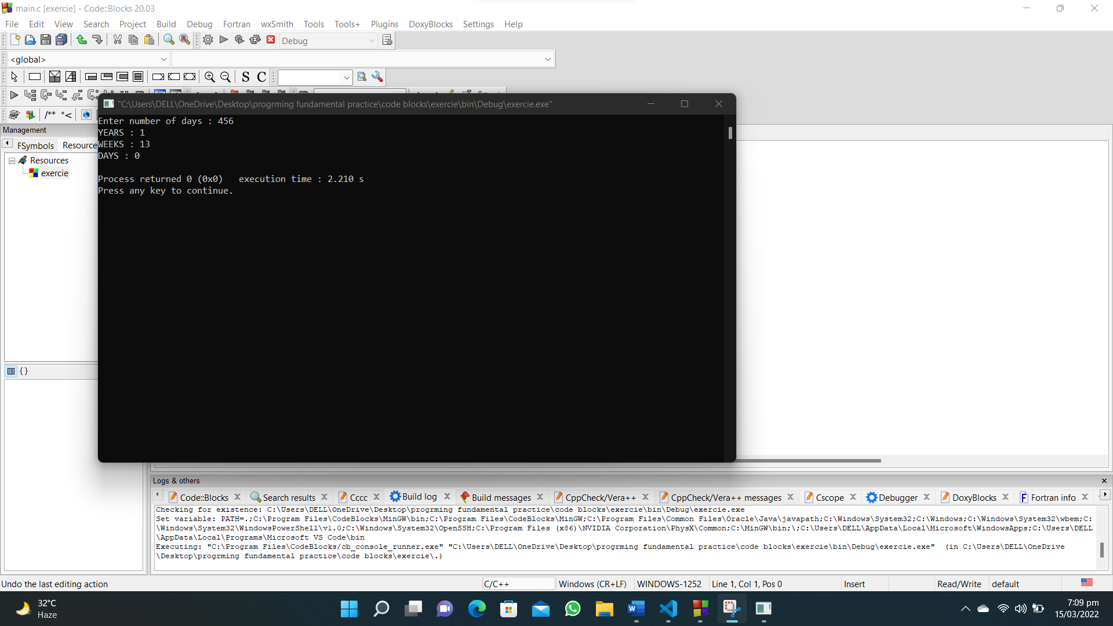

1. **Write a C program that accepts two integers from the user and calculate the sum of the two integers.**

**#include<stdio.h>**

**int main()**

**{**

**int num1,num2;**

**printf("Enter first number : ");**

**scanf("%d",&num1);**

**printf("Enter second number : ");**

**scanf("%d",&num2);**

**printf("The sum of %d and %d is : %d",num1,num2,num1+num2);**

**}**

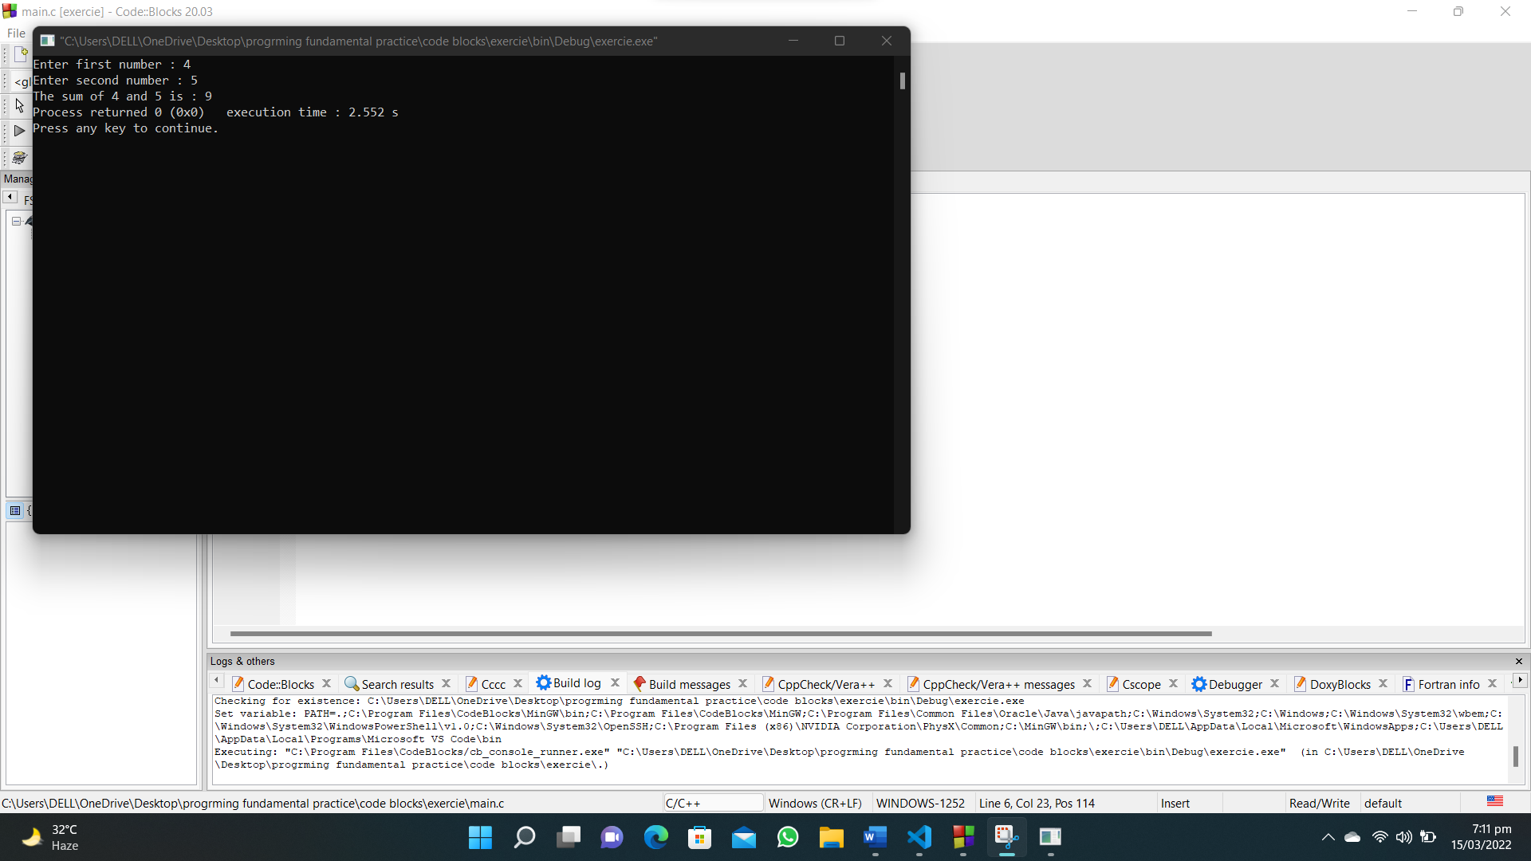

1. **Write a C program that accepts two integers from the user and calculate the product of the two integers.**

**#include<stdio.h>**

**int main()**

**{**

**int num1,num2;**

**printf("Enter first number : ");**

**scanf("%d",&num1);**

**printf("Enter second number : ");**

**scanf("%d",&num2);**

**printf("The product of %d and %d is : %d",num1,num2,num1*num2);**

**}**

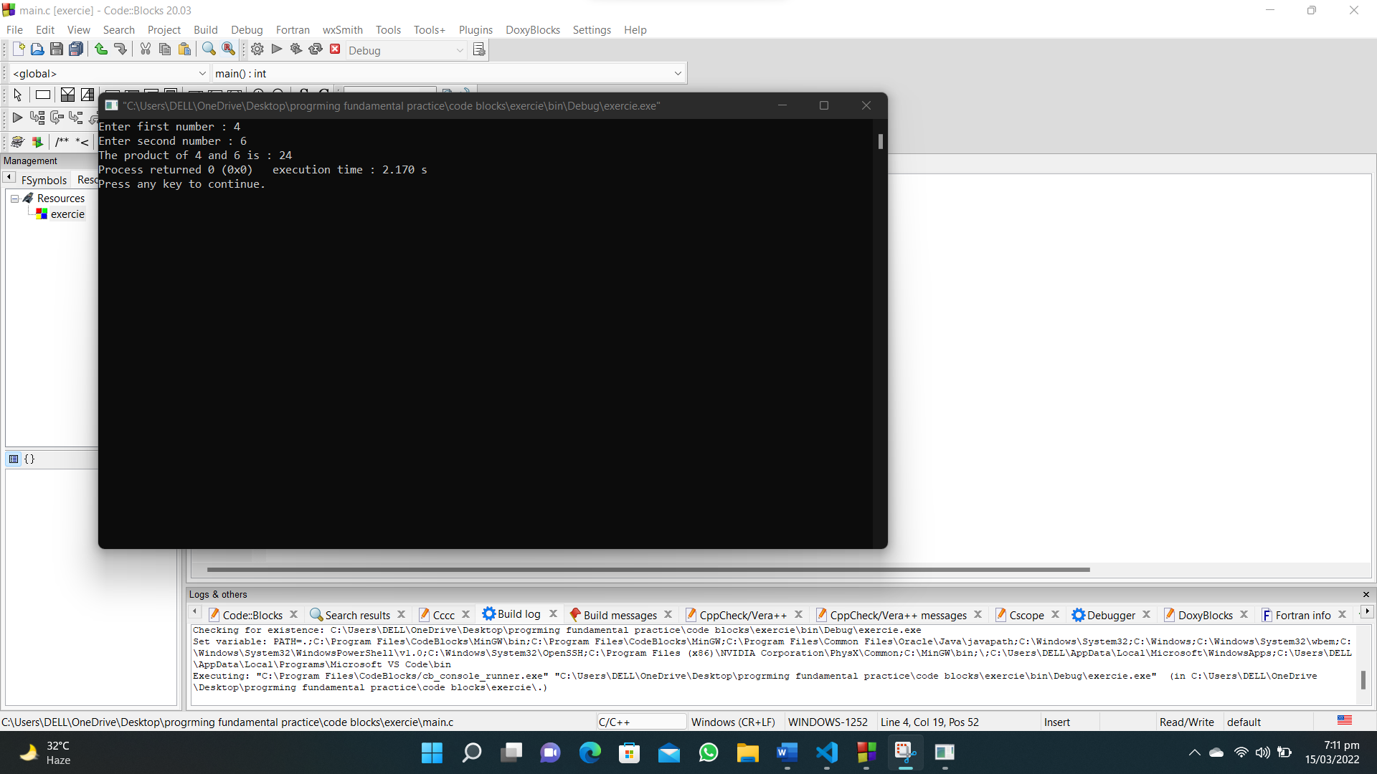

1. **Write a C program that accepts two item’s weight (floating points' values ) and number of purchase (floating points' values) and calculate the average value of the items.**

**#include<stdio.h>**

**int main()**

**{**

**float price_item1,price_item2,quantity_item1,quantity_item2,average_value;**

**printf("Weight Item-1 : ");**

**scanf("%f",&price_item1);**

**printf("Quantity Item-1 : ");**

**scanf("%f",&quantity_item1);**

**printf("Weight Item-2 : ");**

**scanf("%f",&price_item2);**

**printf("Quantity Item-2 : ");**

**scanf("%f",&quantity_item2);**

**average_value=((price_item1*quantity_item1) +(price_item2*quantity_item2)) /(quantity_item1+quantity_item2);**

**printf("The average value is : %f",average_value);**

**}**

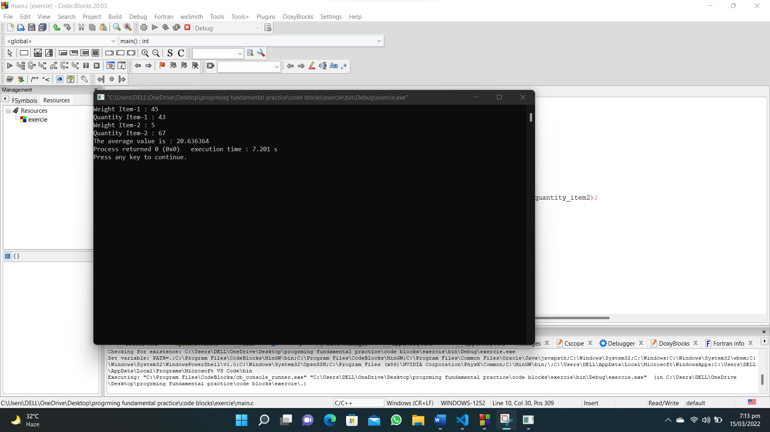

1. **Write a C program that accepts an employee's ID, total worked hours of a month and the amount he received per hour. Print the employee's ID and salary (with two decimal places) of a particular month.**

**#include<stdio.h>**

**int main()**

**{**

**unsigned long long employee_id;**

**int hours;**

**float salary;**

**printf("Enter Employee ID : ");**

**scanf("%llu",&employee_id);**

**printf("Input the working hours : ");**

**scanf("%d",&hours);**

**printf("Enter your salary amount per hour : ");**

**scanf("%f",&salary);**

**printf("Employee ID : %llu\n",employee_id);**

**printf("Salary : %.2f\n",salary*hours);**

**}**

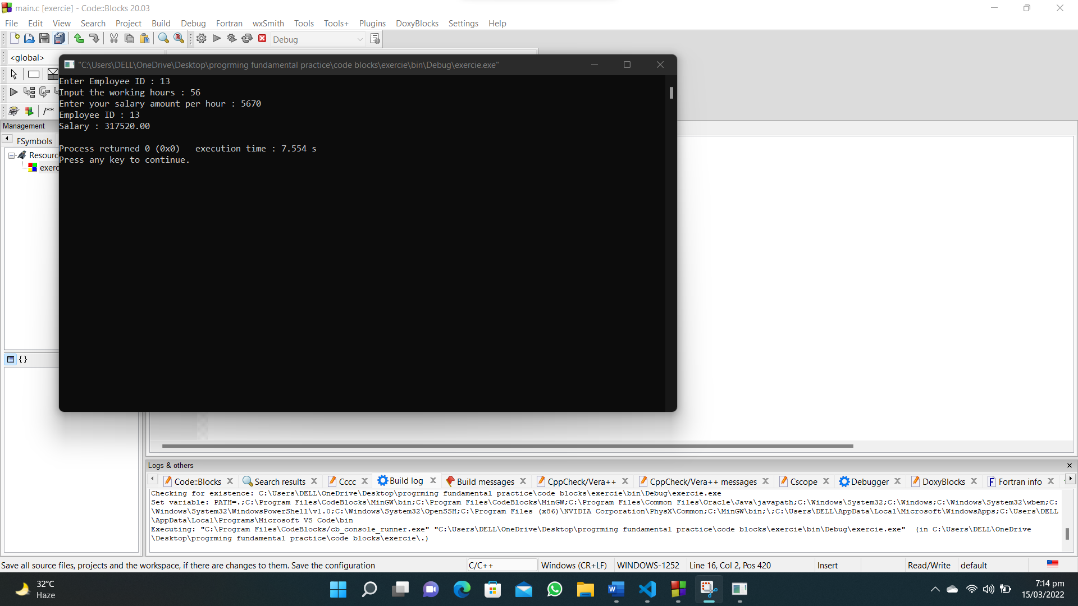

1. **Write a C program that accepts three integers and find the maximum of three.**

**#include <stdio.h>**

**int main()**

**{**

**int a, b, c, max;**

**printf("Enter first number : ");**

**scanf("%d", &a);**

**max = a;**

**printf("Enter second number : ");**

**scanf("%d", &b);**

**if (b > max)**

**{**

**max = b;**

**}**

**printf("Enter third number : ");**

**scanf("%d", &c);**

**if (c > max)**

**{**

**max = c;**

**}**

**printf("The maximum number is : %d", max);**

**}**

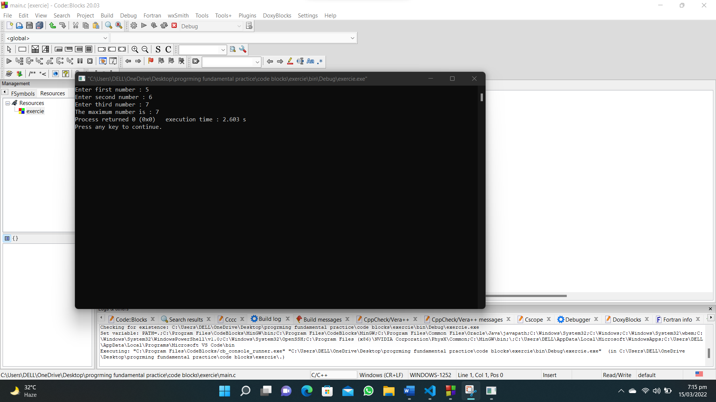

1. **Write a C program to calculate a bike’s average consumption from the given total distance (integer value) traveled (in km) and spent fuel (in liters, float number – 2 decimal point).**

**#include <stdio.h>**

**int main()**

**{**

**int distance;**

**float liters;**

**printf("Enter total distance traveled in KM: ");**

**scanf("%d", &distance);**

**printf("Enter fuel in liters : ");**

**scanf("%f", &liters);**

**printf("Average consumption of bike is : %.2f", distance / liters);**

**}**

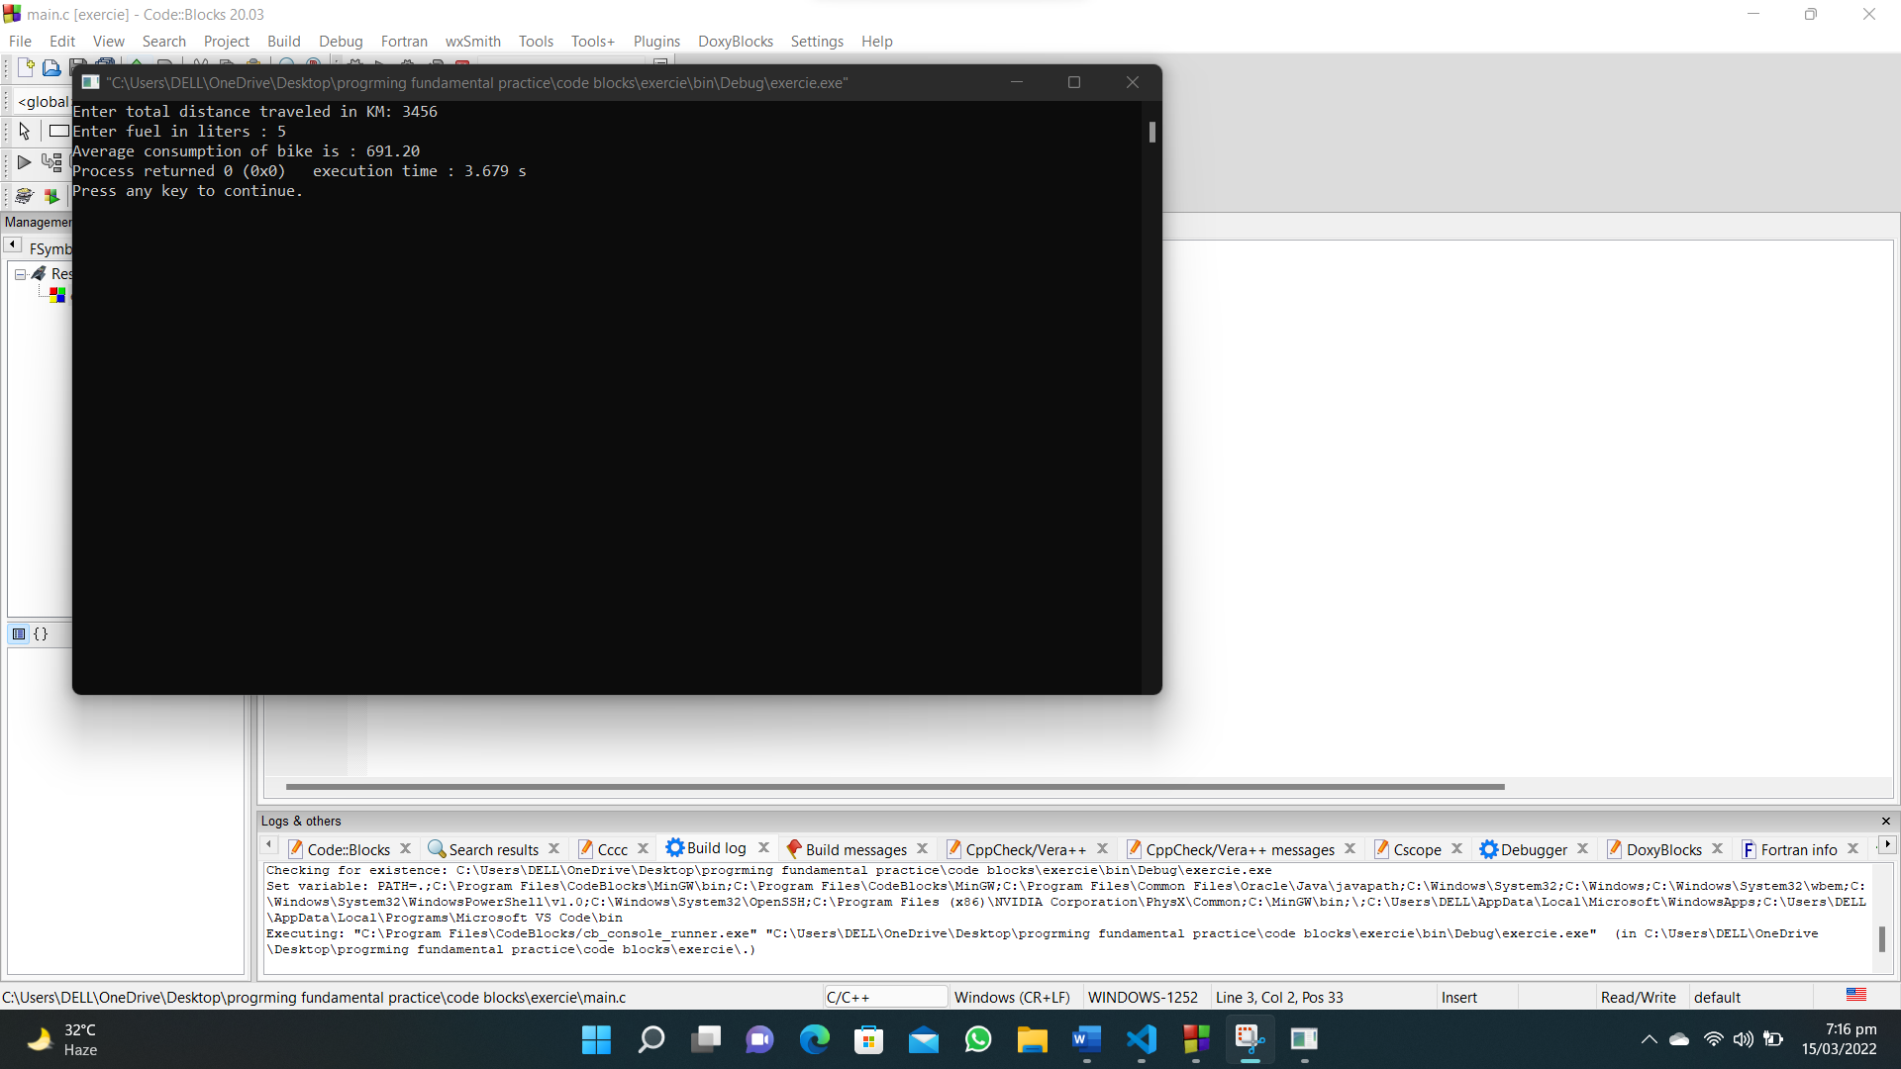

1. **Write a C program to calculate the distance between the two points.**

**#include <stdio.h>**

**#include <math.h>**

**int main()**

**{**

**int x1, x2, y1, y2;**

**float distance;**

**printf("Enter value of x1 : ");**

**scanf("%d", &x1);**

**printf("Enter value of y1 : ");**

**scanf("%d", &y1);**

**printf("Enter value of x2 : ");**

**scanf("%d", &x2);**

**printf("Enter value of y2 : ");**

**scanf("%d", &y2);**

**printf("The distance between the two points is : %f", pow(((x2 - x1) * (x2 - x1)) + ((y2 - y1) * (y2 - y1)), 0.5));**

**}**

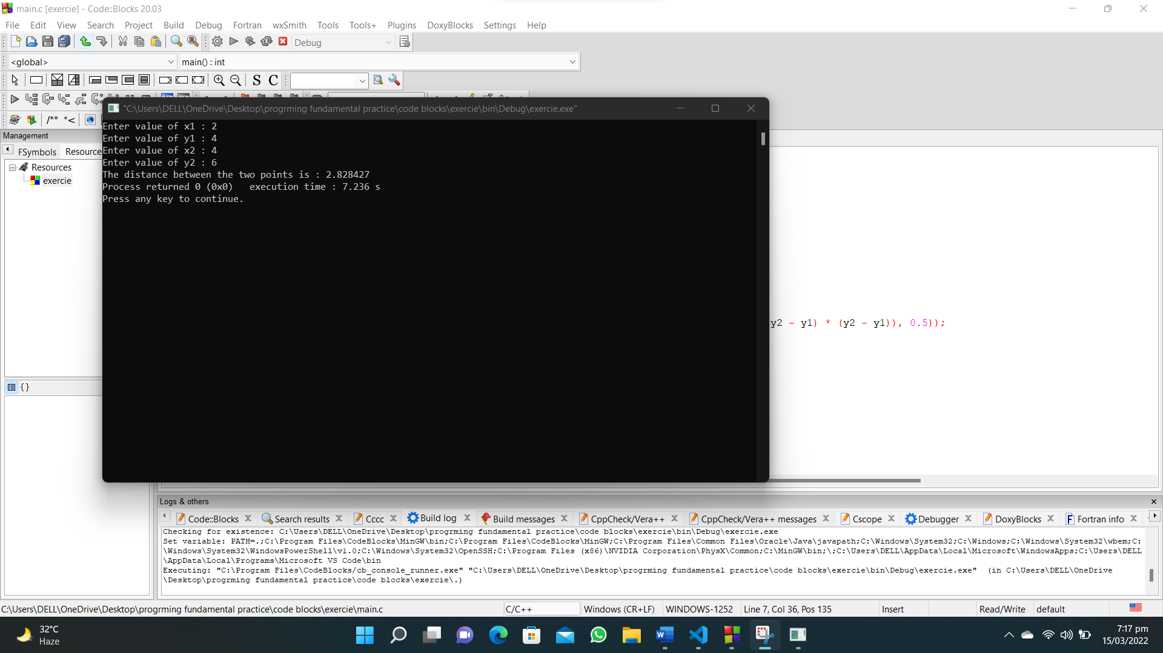

1. **Write a C program to read an amount (integer value) and break the amount into smallest possible number of bank notes.**

**#include <stdio.h>**

**int main()**

**{**

**int amount, five_thousandRs, rem, one_thousandRs, five_hundredRs, one_hundredRs, fifty_Rs, twenty_Rs, ten_Rs, five_Rs, one_Rs;**

**printf("Enter the amount : ");**

**scanf("%d", &amount);**

**five_thousandRs = amount / 5000;**

**rem = amount % 5000;**

**printf("\n%d notes of 5000\n", five_thousandRs);**

**one_thousandRs = rem / 1000;**

**rem = rem % 1000;**

**printf("\n%d notes of 1000\n", one_thousandRs);**

**five_hundredRs = rem / 500;**

**rem = rem % 500;**

**printf("\n%d notes of 500\n", five_hundredRs);**

**one_hundredRs = rem / 100;**

**rem = rem % 100;**

**printf("\n%d notes of 100\n", one_hundredRs);**

**fifty_Rs = rem / 50;**

**rem = rem % 50;**

**printf("\n%d notes of 50\n", fifty_Rs);**

**twenty_Rs = rem / 20;**

**rem = rem % 20;**

**printf("\n%d notes of 20\n", twenty_Rs);**

**ten_Rs = rem / 10;**

**rem = rem % 10;**

**printf("\n%d notes of 10\n", ten_Rs);**

**five_Rs = rem / 5;**

**rem = rem % 5;**

**printf("\n%d notes of 5\n", five_Rs);**

**one_Rs = rem / 1;**

**rem = rem % 1;**

**printf("\n%d notes of 1\n", one_Rs);**

**}**

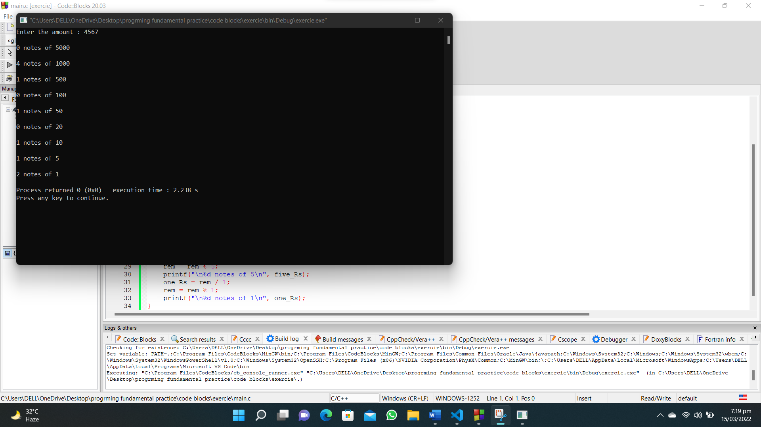

1. **Write a C program to convert a given integer (in seconds) to hours, minutes and seconds.**

**#include<stdio.h>**

**int main()**

**{**

**int input_seconds,hours,minutes,seconds;**

**printf("Enter number of seconds : ");**

**scanf("%d",&input_seconds);**

**hours=input_seconds/(60*60);**

**minutes=(input_seconds/60) % 60;**

**seconds=input_seconds%60;**

**printf("The time is = %d : %d : %d",hours,minutes,seconds);**

**}**

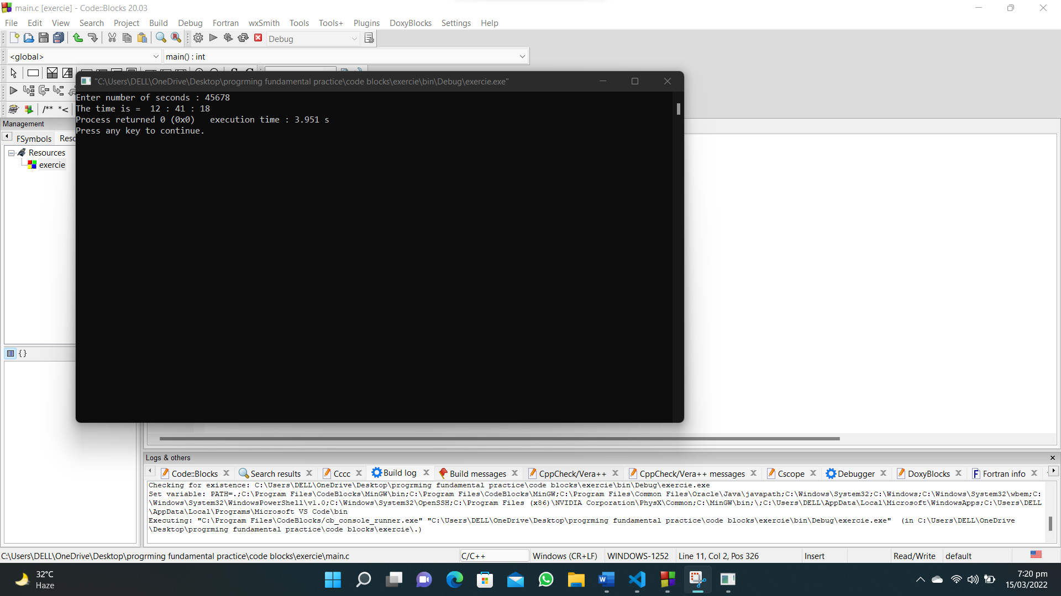

1. **Write a C program to convert a given integer (in days) to years, months and days, assumes that all months have 30 days and all years have 365 days.**

**#include<stdio.h>**

**int main()**

**{**

**int input_days,years,months,days;**

**printf("Enter total number of days : ");**

**scanf("%d",&input_days);**

**years=input_days/365;**

**months=(input_days%365) /30;**

**days=(input_days%365) %30;**

**printf("Years : %d\nMonths : %d\nDays : %d",years,months,days);**

**}**

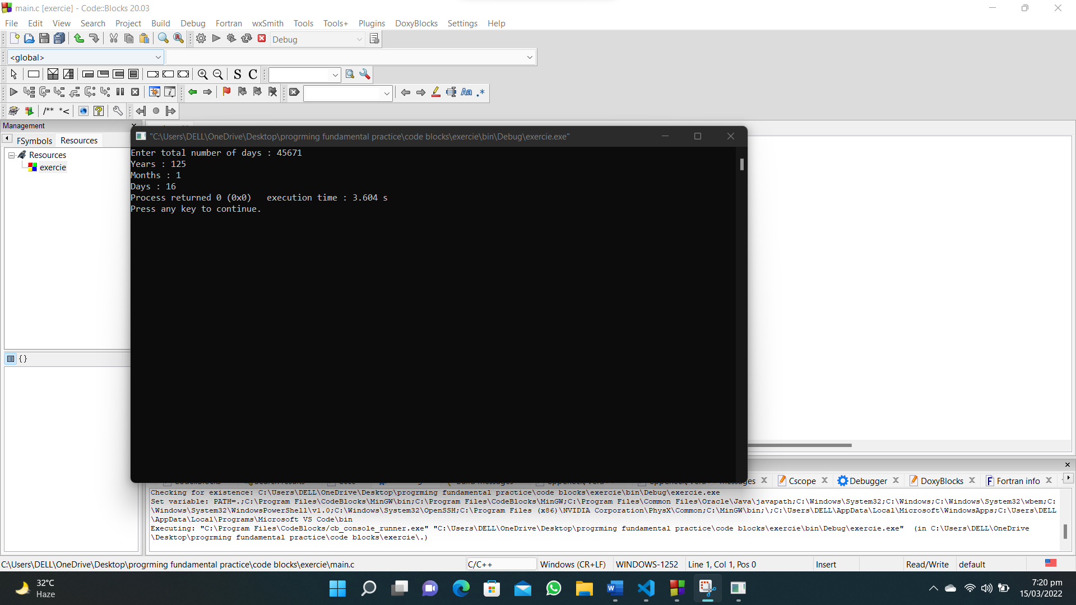

1. **Write a C program that accepts 4 integers p, q, r, s from the user where q, r and s are positive and p is even. If q is greater than r and s is greater than p and if the sum of r and s is greater than the sum of p and q print "Correct values", otherwise print "Wrong values".**

**#include <stdio.h>**

**int main()**

**{**

**int p, q, r, s;**

**printf("Enter the even value of p: ");**

**scanf("%d", &p);**

**printf("Enter the positive value of q: ");**

**scanf("%d", &q);**

**printf("Enter the positive value of r: ");**

**scanf("%d", &r);**

**printf("Enter the positive value of s: ");**

**scanf("%d", &s);**

**if (q > r && s > p && (r + s) > (p + q))**

**{**

**printf("Correct values");**

**}**

**else**

**{**

**printf("Wrong values");**

**}**

**}**

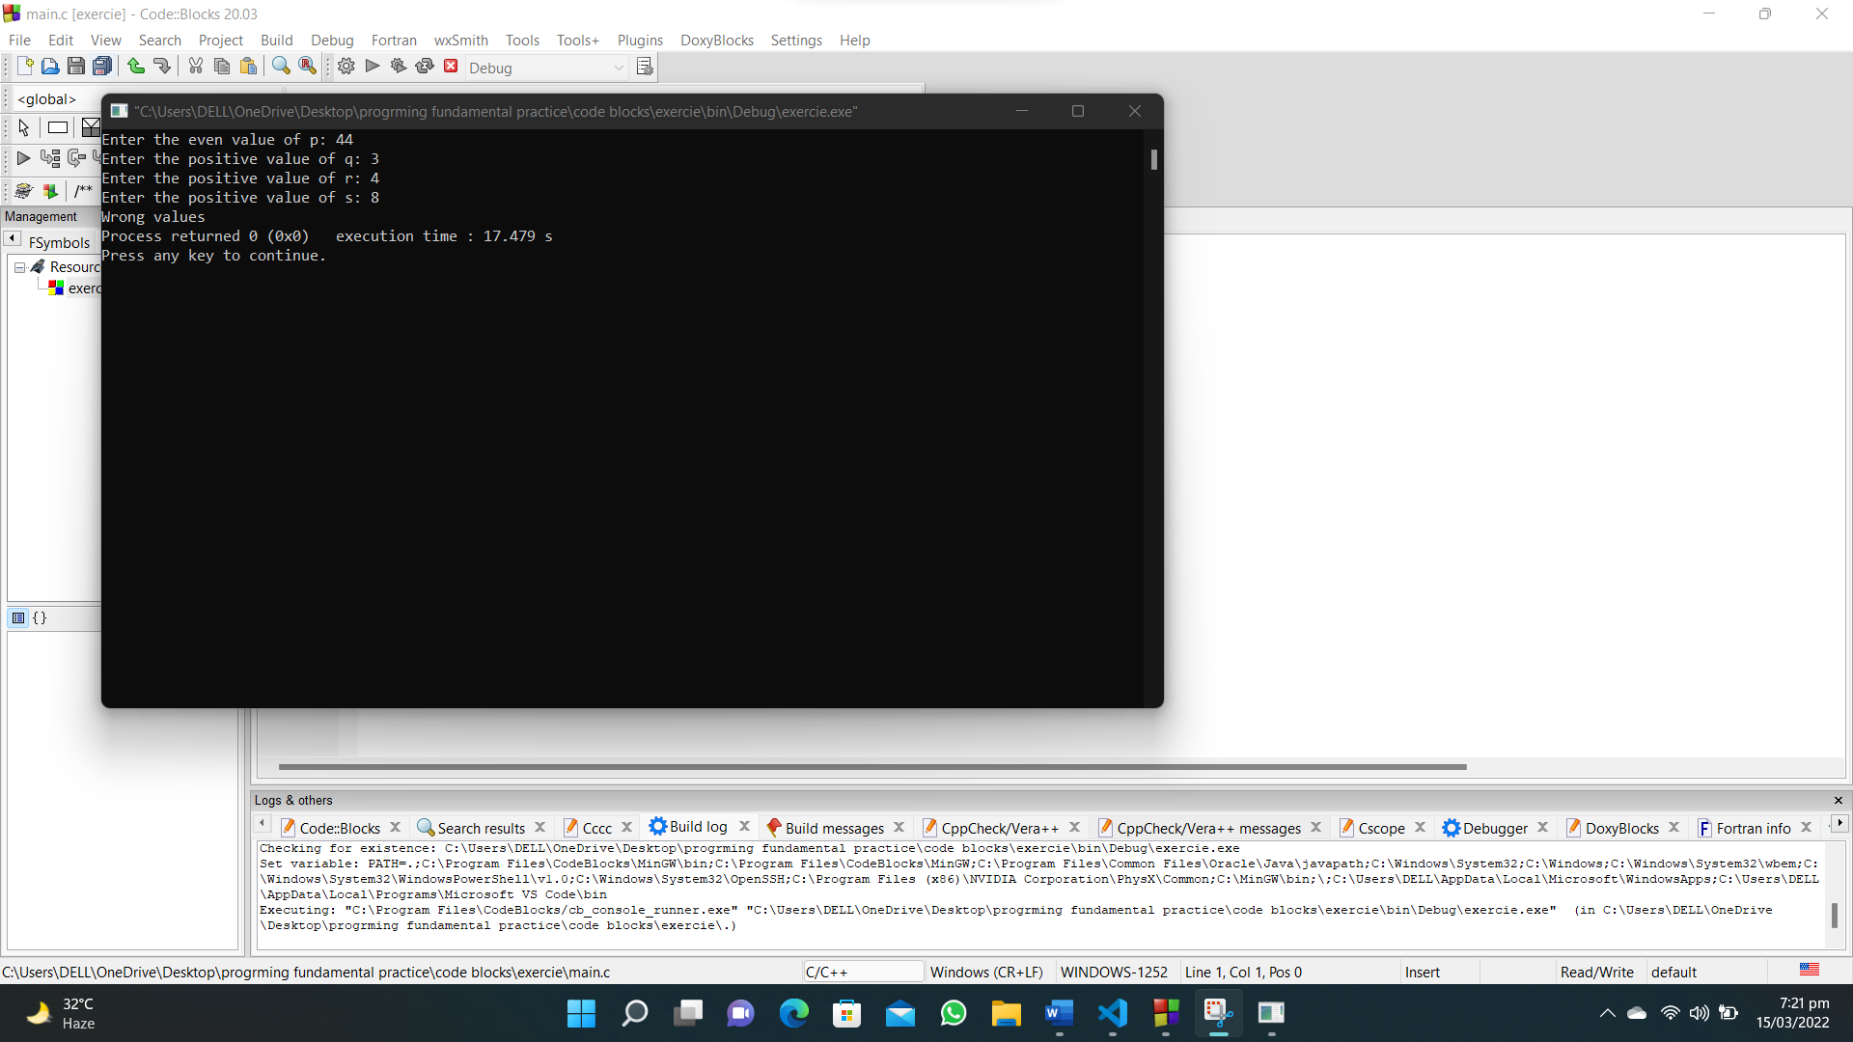

1. **Write a C program to print the roots of Bhaskara’s formula from the given three floating numbers. Display a message if it is not possible to find the roots.**

**#include <stdio.h>**

**#include<math.h>**

**int main()**

**{**

**float a, b, c;**

**printf("Input the first number(a): ");**

**scanf("%f",&a);**

**printf("Input the second number(b): ");**

**scanf("%f",&b);**

**printf("Input the third number(c) : ");**

**scanf("%f",&c);**

**printf("Root 1 : %f\nRoot 2 : %f\n",(-b + pow((b*b) - (4*a*c),0.5))/(2*a),(-b - pow((b*b) - (4*a*c),0.5))/(2*a));**

**}**

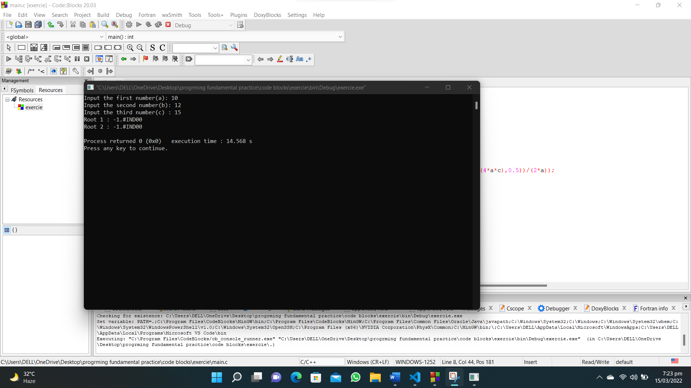

1. **Write a C program that reads an integer and check the specified range where it belongs. Print an error message if the number is negative and greater than 80.**

**#include<stdio.h>**

**int main()**

**{**

**int num;**

**printf("Enter a number : ");**

**scanf("%d",&num);**

**if (num >=0 && num <=20)**

**{**

**printf("Range [0,20]");**

**}**

**else if (num >=21 && num <=40)**

**{**

**printf("Range [21,40]");**

**}**

**else if (num >=41 && num <=60)**

**{**

**printf("Range [41,60]");**

**}**

**else if (num >=61 && num <=80)**

**{**

**printf("Range [61,80]");**

**}**

**else{**

**printf("ERROR");**

**}**

**}**

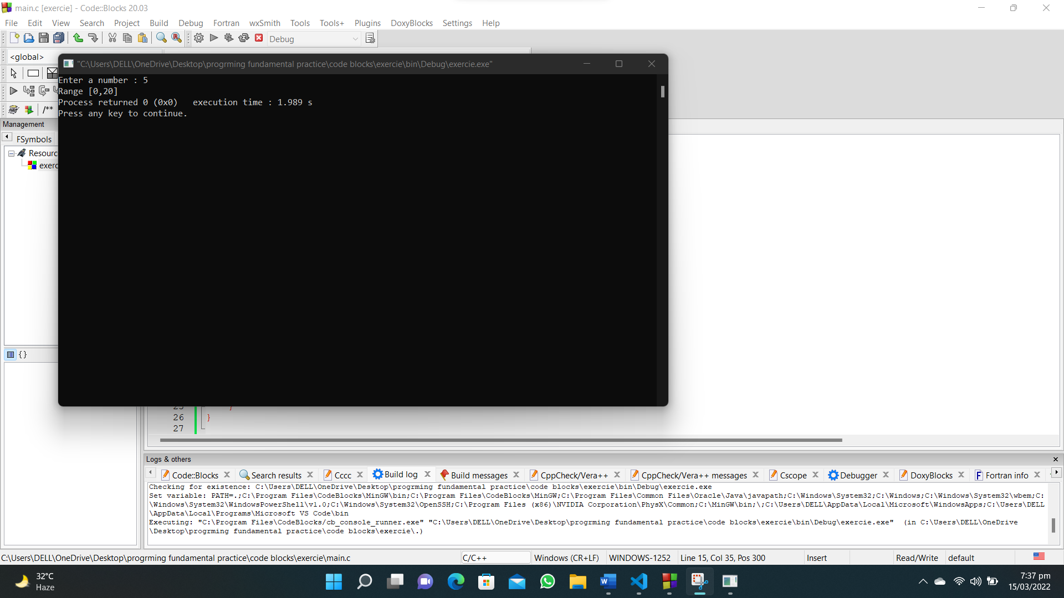

1. **Write a C program that reads three floating values and check if it is possible to make a triangle with them. Also calculate the perimeter of the triangle if the said values are valid.**

**#include <stdio.h>**

**int main()**

**{**

**float a, b, c,perimeter;**

**printf("Enter value of side a of triangle : ");**

**scanf("%f", &a);**

**printf("Enter value of side b of triangle : ");**

**scanf("%f", &b);**

**printf("Enter value of side c of triangle : ");**

**scanf("%f", &c);**

**if ((a+b) >= c && (a+c) >= b && (c+b) >= a)**

**{**

**printf("The triangle is possible\n");**

**perimeter=a+b+c;**

**printf("The perimeter of triangle is : %.2f",perimeter);**

**}**

**else**

**{**

**printf("It is not a triangle");**

**}**

**}**

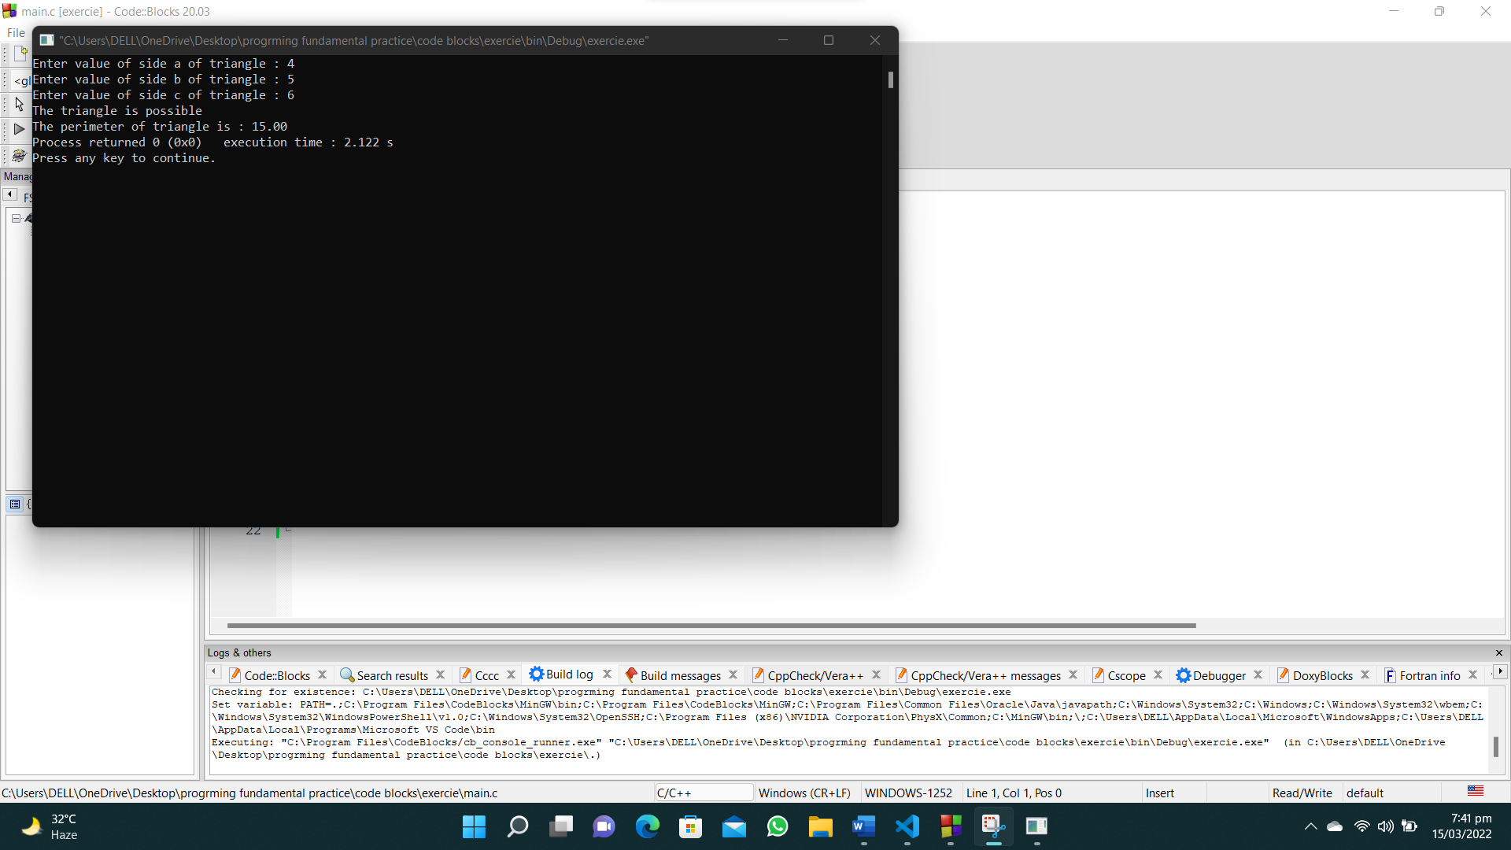

1. **Write a C program that reads two integers and checks whether they are multiplied or not.**

**#include<stdio.h>**

**int main()**

**{**

**int num1,num2;**

**printf("Enter first number : ");**

**scanf("%d",&num1);**

**printf("Enter second number : ");**

**scanf("%d",&num2);**

**if(num1%num2 ==0 || num2%num1==0)**

**{**

**printf("MULTIPLIED");**

**}**

**else**

**{**

**printf("NOT MULTIPLIED");**

**}**

**}**

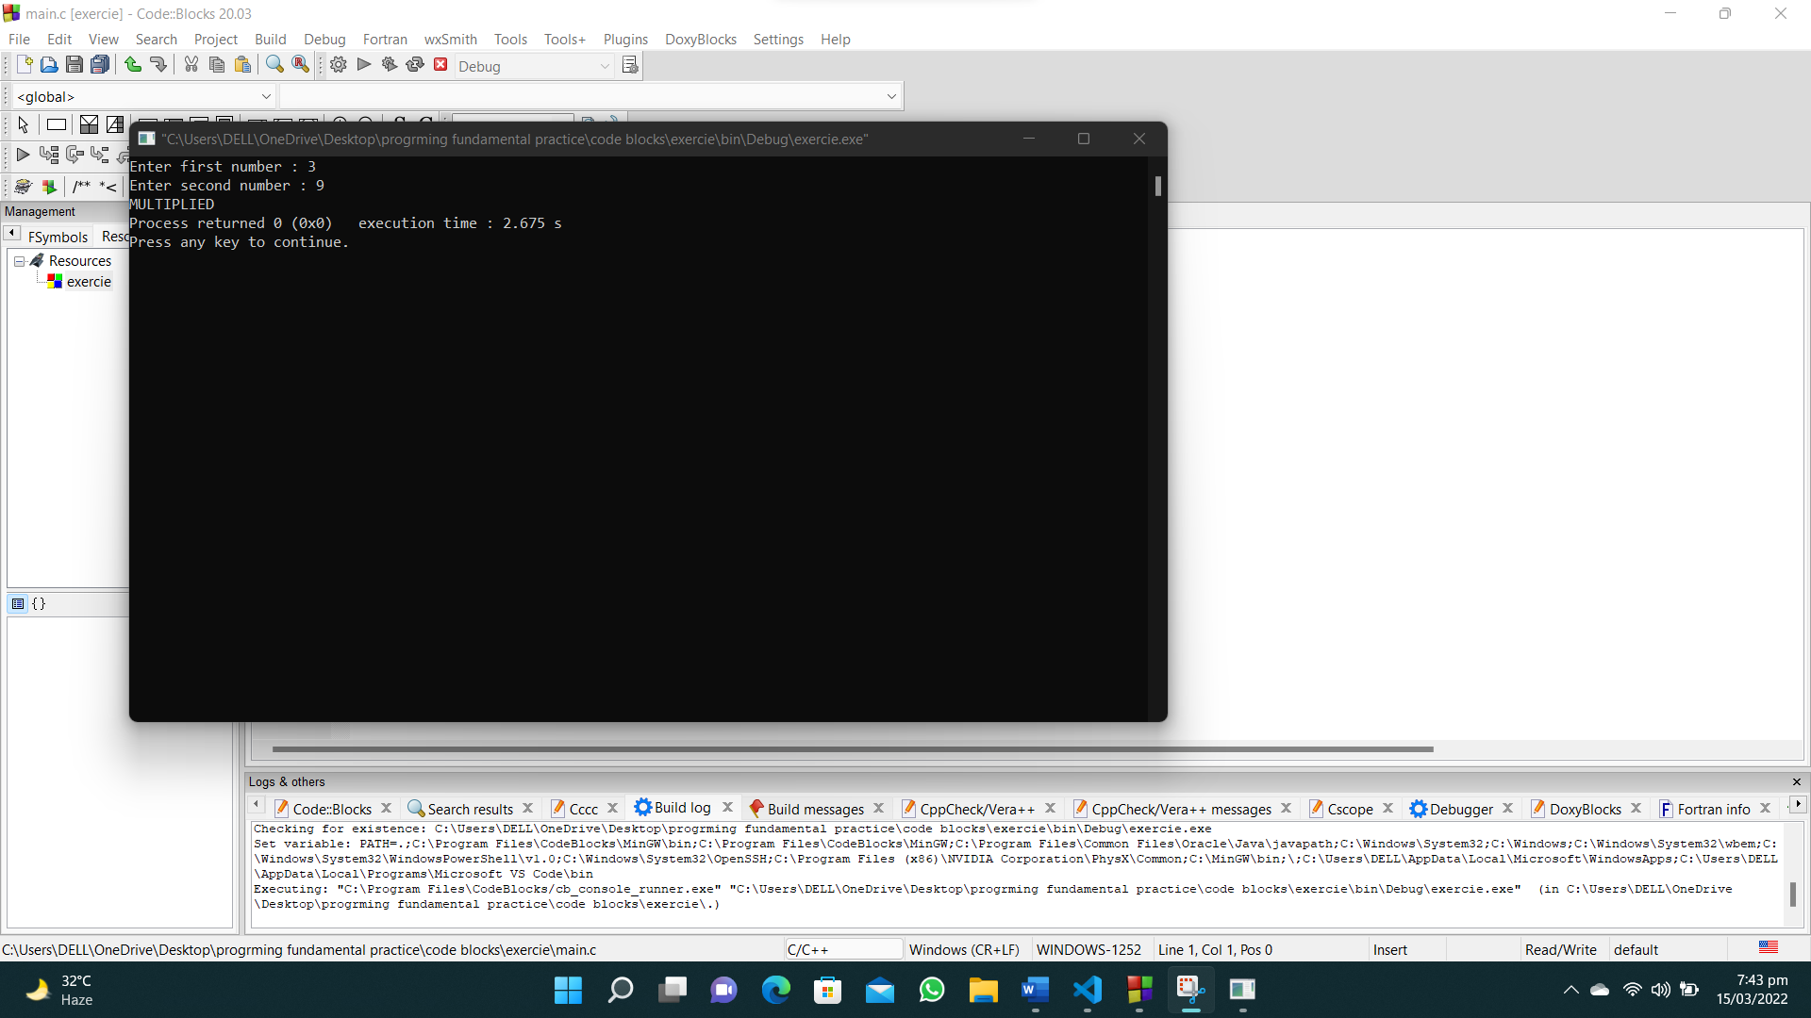

1. **Write a C program that reads an integer between 1 and 12 and print the month of the year in English.**

**#include <stdio.h>**

**int main()**

**{**

**int num;**

**printf("Enter number of the month : ");**

**scanf("%d", &num);**

**switch (num)**

**{**

**case 1:**

**{**

**printf("January");**

**break;**

**}**

**case 2:**

**{**

**printf("February");**

**break;**

**}**

**case 3:**

**{**

**printf("March");**

**break;**

**}**

**case 4:**

**{**

**printf("April");**

**break;**

**}**

**case 5:**

**{**

**printf("May");**

**break;**

**}**

**case 6:**

**{**

**printf("June");**

**break;**

**}**

**case 7:**

**{**

**printf("July");**

**break;**

**}**

**case 8:**

**{**

**printf("August");**

**break;**

**}**

**case 9:**

**{**

**printf("September");**

**break;**

**}**

**case 10:**

**{**

**printf("October");**

**break;**

**}**

**case 11:**

**{**

**printf("November");**

**break;**

**}**

**case 12:**

**{**

**printf("December");**

**break;**

**}**

**}**

**}**

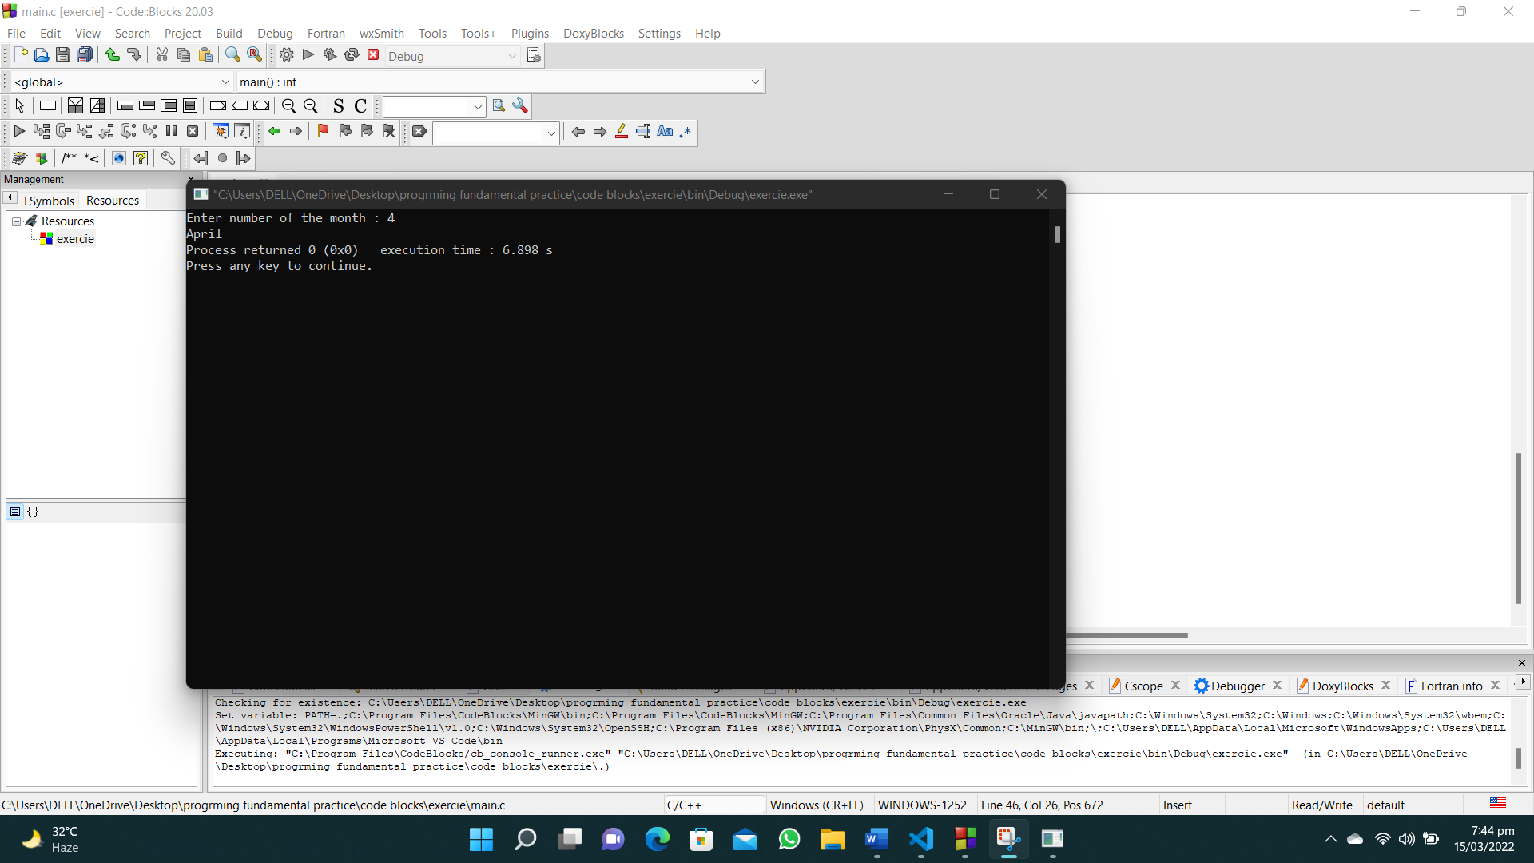

1. **Write a C program that prints all even numbers between 1 and 50 (inclusive).**

**#include <stdio.h>**

**int main()**

**{**

**int i;**

**for (i = 2; i < 51; i = i + 2)**

**{**

**printf(" %d", i);**

**}**

**}**

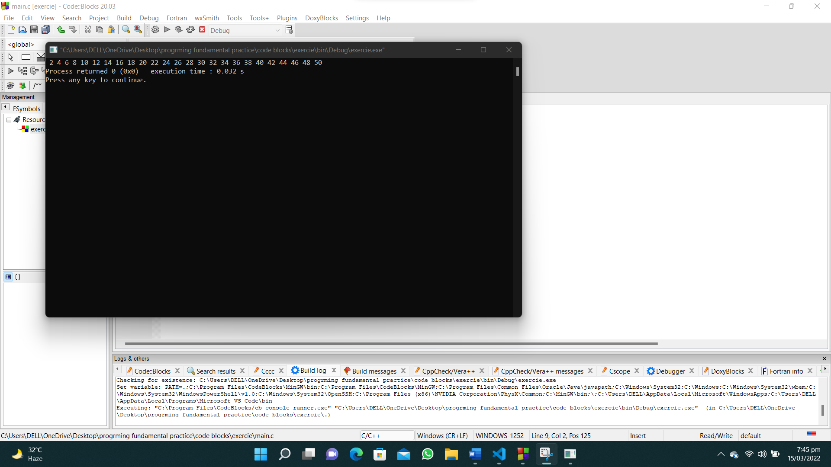

1. **Write a C program that read 5 numbers and counts the number of positive numbers and negative numbers.**

**#include<stdio.h>**

**int main()**

**{**

**int num1,num2,num3,num4,num5,pos=0,neg=0;**

**printf("Enter first number : ");**

**scanf("%d",&num1);**

**printf("Enter second number : ");**

**scanf("%d",&num2);**

**printf("Enter third number : ");**

**scanf("%d",&num3);**

**printf("Enter fourth number : ");**

**scanf("%d",&num4);**

**printf("Enter fifth number : ");**

**scanf("%d",&num5);**

**if(num1>0)**

**{**

**pos=pos+1;**

**}**

**if(num2>0)**

**{**

**pos=pos+1;**

**}**

**if(num3>0)**

**{**

**pos=pos+1;**

**}**

**if(num4>0)**

**{**

**pos=pos+1;**

**}**

**if(num5>0)**

**{**

**pos=pos+1;**

**}**

**neg=5-pos;**

**printf("The number of positive integars are : %d\n",pos);**

**printf("The number of negative integars are : %d\n",neg);**

**}**

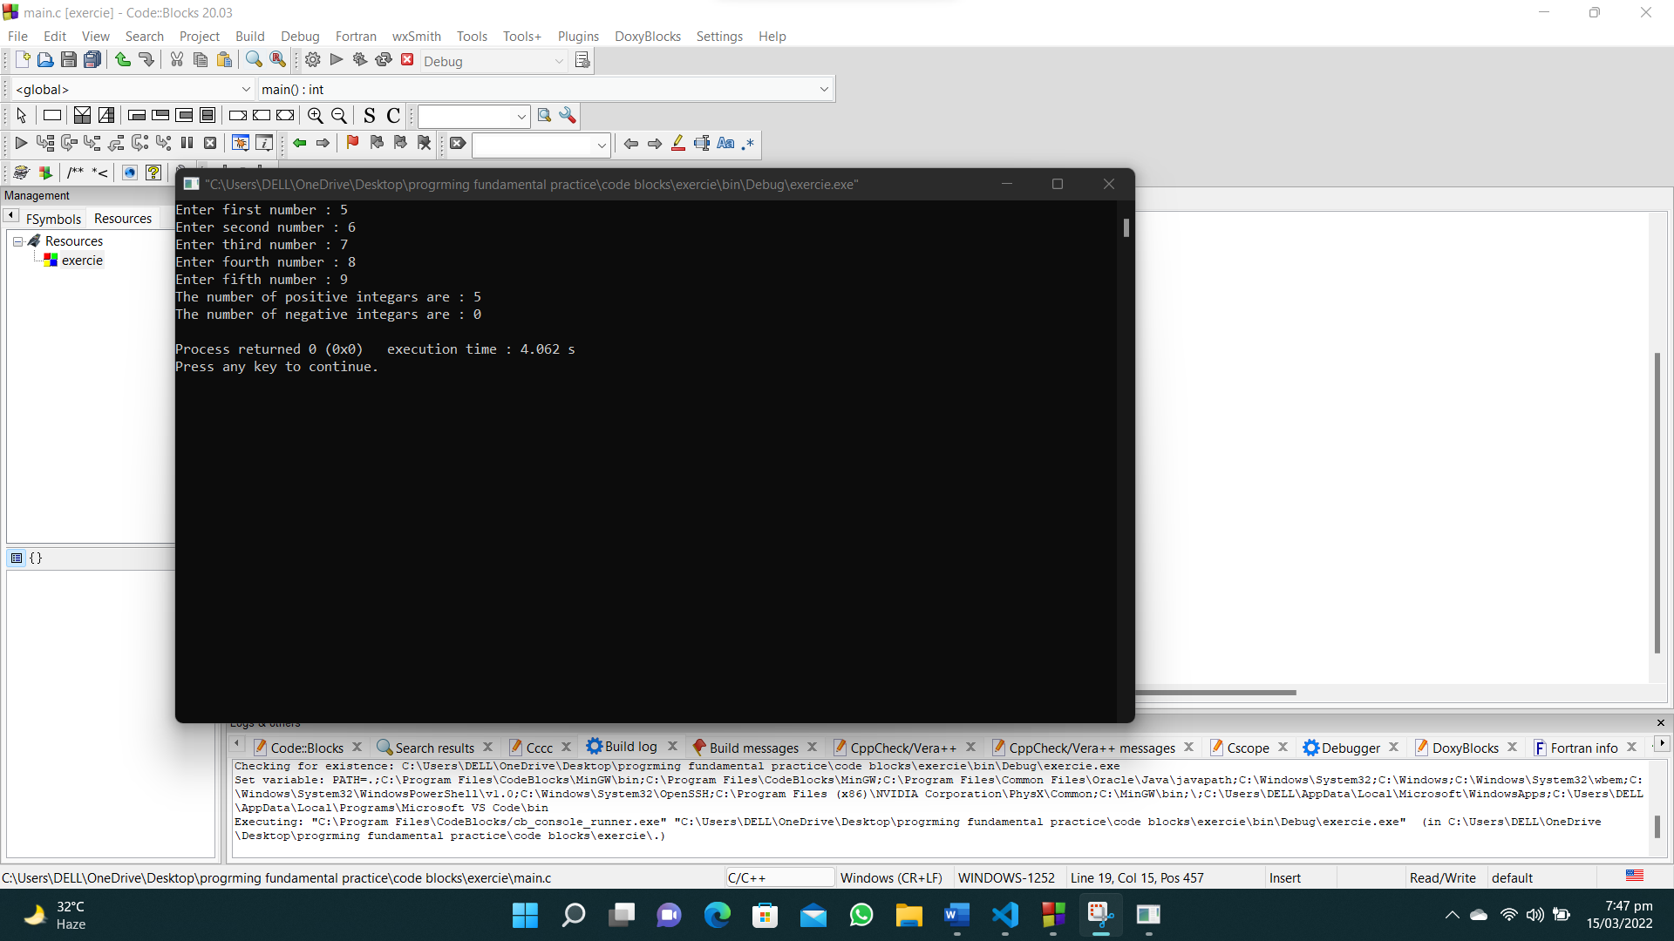

1. **Write a C program that read 5 numbers and counts the number of positive numbers and print the average of all positive values.**

**#include<stdio.h>**

**int main()**

**{**

**int num1,num2,num3,num4,num5,pos=0,total=0;**

**float average;**

**printf("Enter first number : ");**

**scanf("%d",&num1);**

**printf("Enter second number : ");**

**scanf("%d",&num2);**

**printf("Enter third number : ");**

**scanf("%d",&num3);**

**printf("Enter fourth number : ");**

**scanf("%d",&num4);**

**printf("Enter fifth number : ");**

**scanf("%d",&num5);**

**if(num1>0)**

**{**

**pos=pos+1;**

**total=total+num1;**

**}**

**if(num2>0)**

**{**

**pos=pos+1;**

**total=total+num2;**

**}**

**if(num3>0)**

**{**

**pos=pos+1;**

**total=total+num3;**

**}**

**if(num4>0)**

**{**

**pos=pos+1;**

**total=total+num4;**

**}**

**if(num5>0)**

**{**

**pos=pos+1;**

**total=total+num5;**

**}**

**printf("The number of positive integers are : %d\n",pos);**

**average=total/pos;**

**printf("The average of all positive integers is %.2f",average);**

**}**

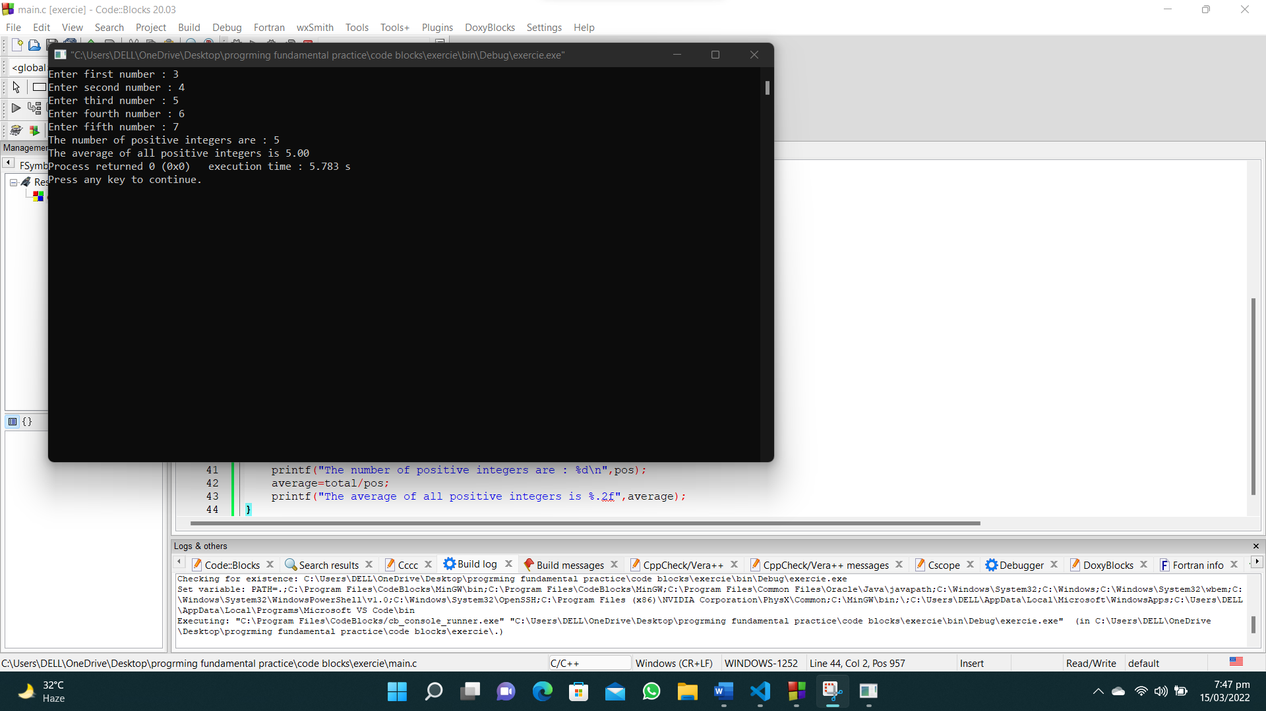

**30. Write a C program to find and print the square of each one of the even values from 1 to a specified value.**

**#include<stdio.h>**

**#include<math.h>**

**int main()**

**{**

**int num,square;**

**printf("Enter a number to which you want to find the range of squares : ");**

**scanf("%d",&num);**

**for (int i=2;i<=num;i=i+2)**

**{**

**square=pow(i,2);**

**printf("%d ^ 2 = %d\n",i,square);**

**}**

**}**

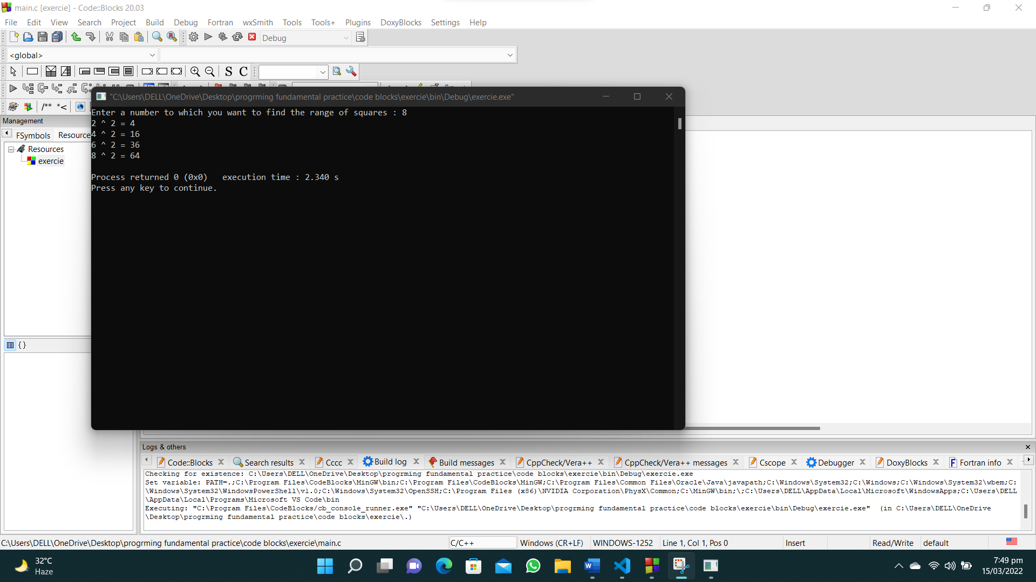

**31. Write a C program to check whether a given integer is positive even, negative even, positive odd or negative odd. Print even if the number is 0.**

**#include <stdio.h>**

**int main()**

**{**

**int num, odd = 0, even = 0, pos = 0, neg = 0;**

**for (int i = 0; i < 7; i++)**

**{**

**printf("Enter a integer : ");**

**scanf("%d", &num);**

**if (num % 2 == 0)**

**{**

**even++;**

**}**

**if (num < 0)**

**{**

**neg++;**

**}**

**if (num % 2 != 0)**

**{**

**odd++;**

**}**

**if (num > 0)**

**{**

**pos++;**

**}**

**}**

**printf("Number of even values: %d\nNumber of odd values: %d\nNumber of positive values: %d\nNumber of negative values: %d\n",even,odd,pos,neg);**

**}**

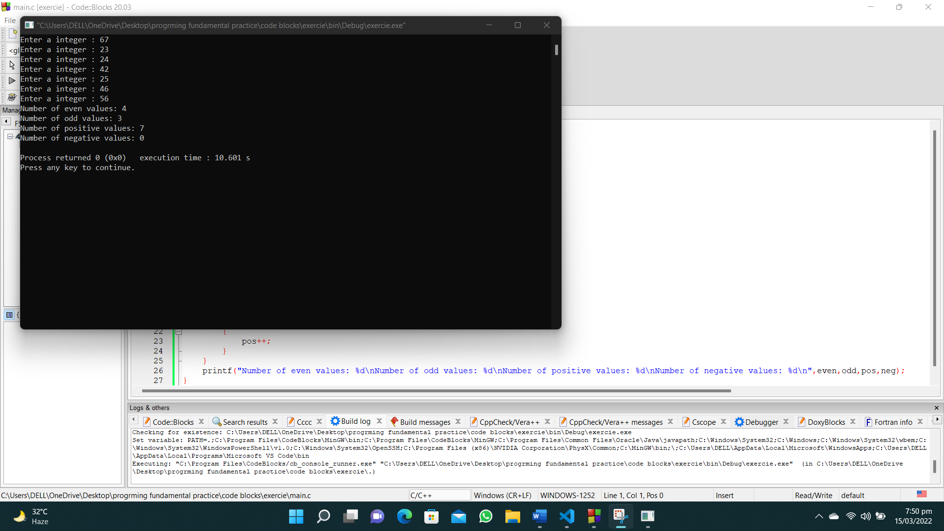

**32. Write a C program to print all numbers between 1 to 100 which divided by a specified number and the remainder will be 3.**

**#include<stdio.h>**

**int main()**

**{**

**int num;**

**printf("Enter a integer : ");**

**scanf("%d",&num);**

**for ( int i = 0; i < 100; i++)**

**{**

**if(i%num ==3)**

**{**

**printf("%d\n",i);**

**}**

**}**

**}**

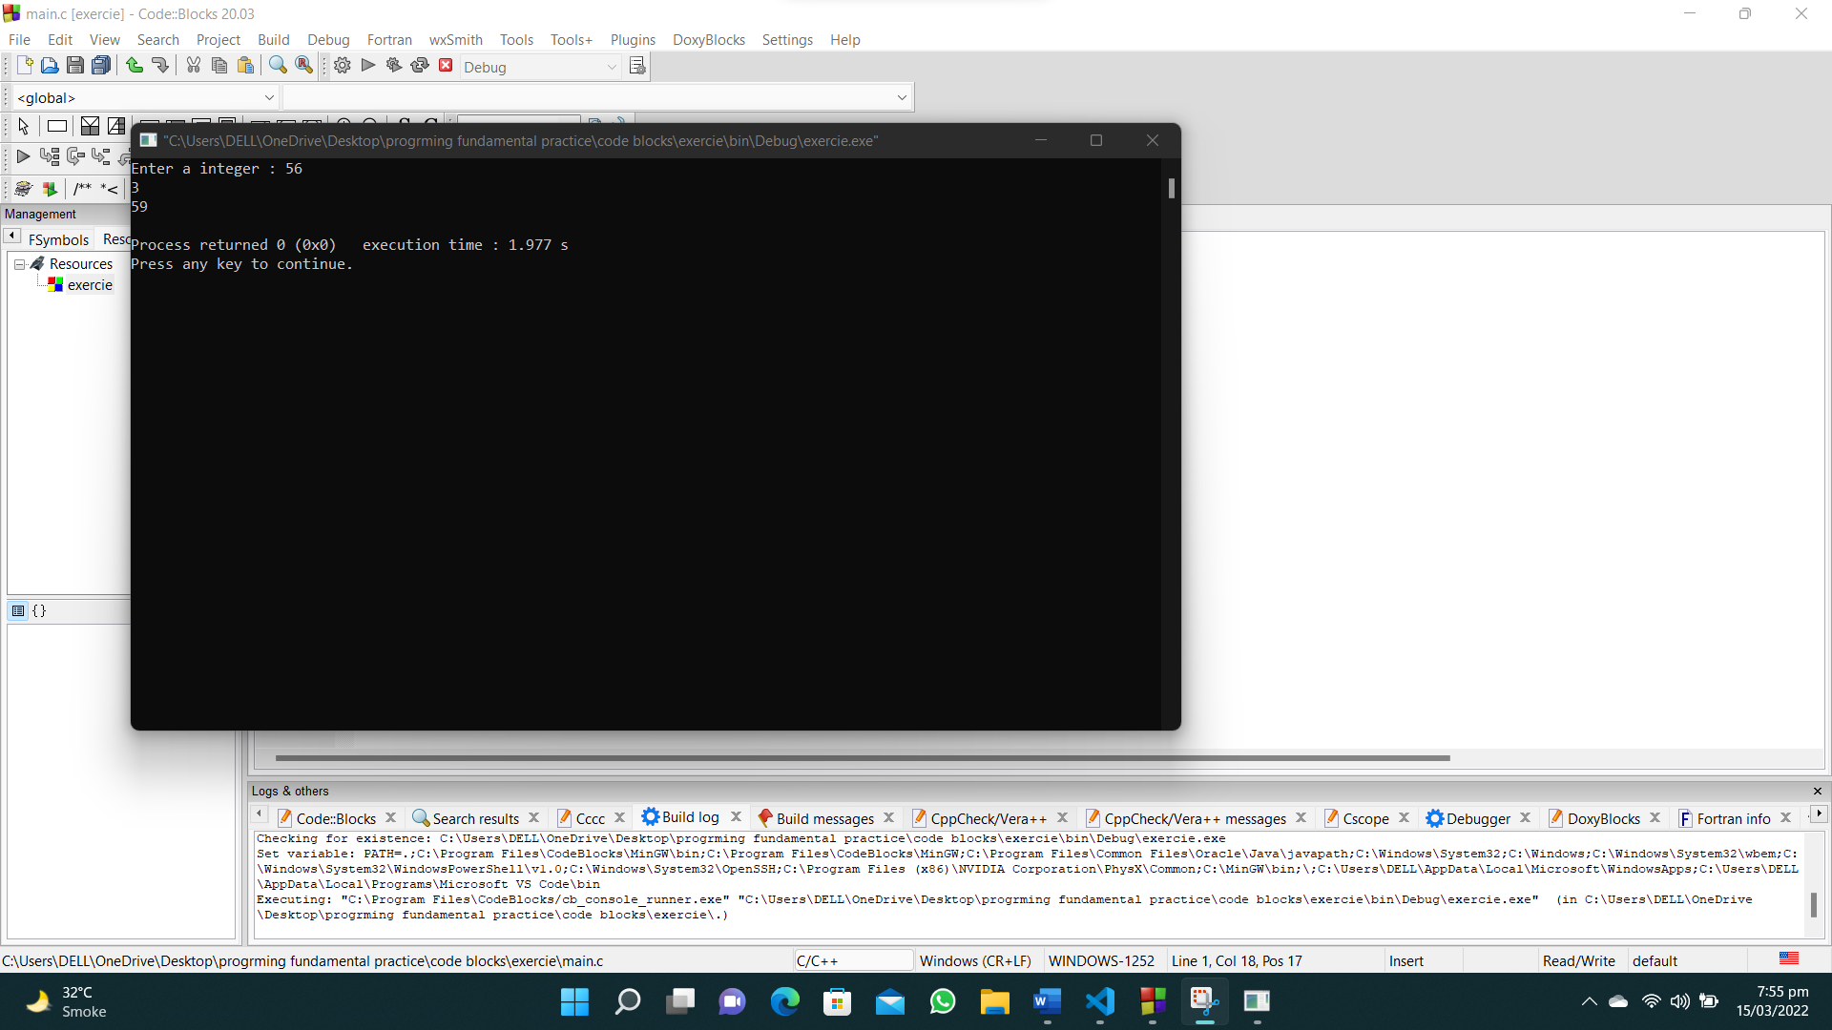

**33. Write a C program that accepts some integers from the user and find the highest value and the input position.**

**#include <stdio.h>**

**int main()**

**{**

**int position, num1, num2, num3, num4, num5, max;**

**printf("Enter number 1 : ");**

**scanf("%d", &num1);**

**max = num1;**

**printf("Enter number 2 : ");**

**scanf("%d", &num2);**

**if (num2 > max)**

**{**

**max = num2;**

**}**

**printf("Enter number 3 : ");**

**scanf("%d", &num3);**

**if (num3 > max)**

**{**

**max = num3;**

**}**

**printf("Enter number 4 : ");**

**scanf("%d", &num4);**

**if (num4 > max)**

**{**

**max = num4;**

**}**

**printf("Enter number 5 : ");**

**scanf("%d", &num5);**

**if (num5 > max)**

**{**

**max = num5;**

**}**

**printf("The highest value is : %d\n",max);**

**if(num1==max)**

**{**

**position=1;**

**}**

**if(num2==max)**

**{**

**position=2;**

**}**

**if(num3==max)**

**{**

**position=3;**

**}**

**if(num4==max)**

**{**

**position=4;**

**}**

**if(num5==max)**

**{**

**position=5;**

**}**

**printf("The position of highest value is : %d",position);**

**}**

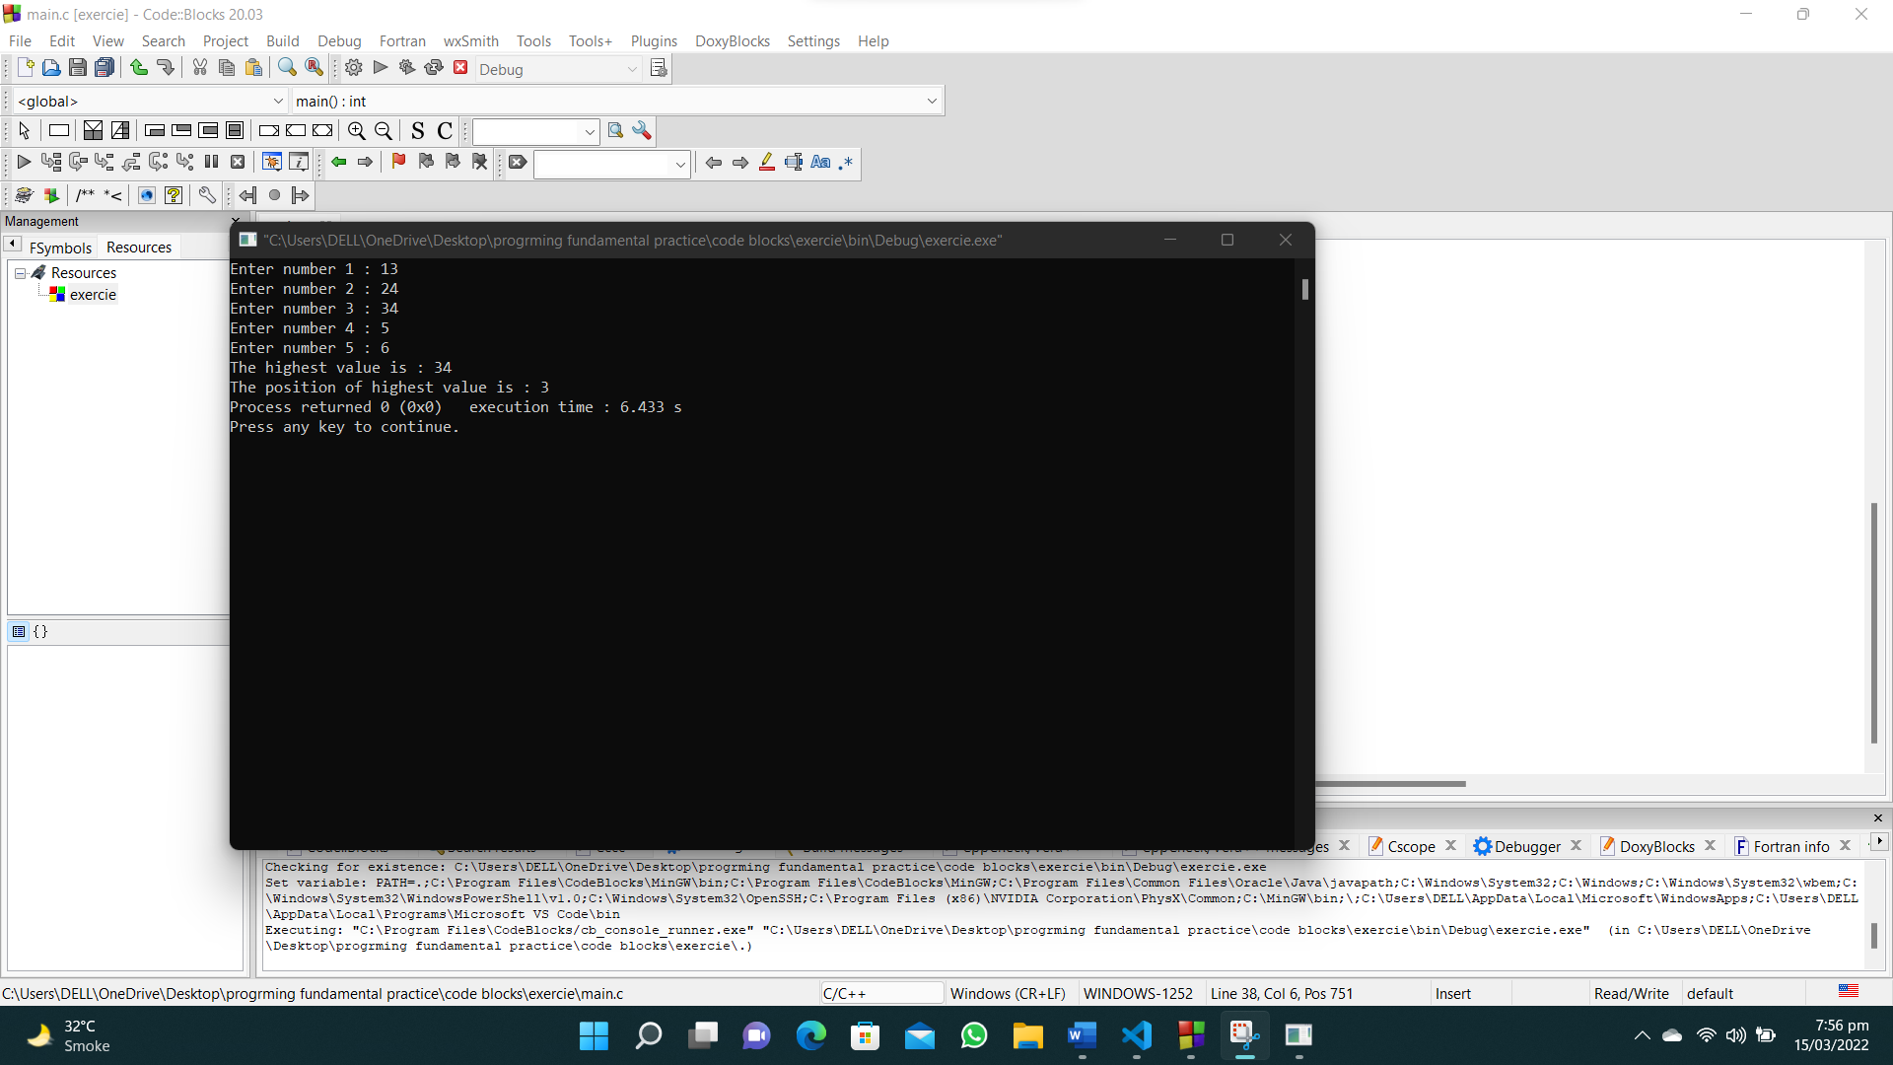

**34. Write a C program to compute the sum of consecutive odd numbers from a given pair of integers.**

**#include<stdio.h>**

**int main()**

**{**

**int num1,num2,total=0;**

**printf("Enter first pair of range : ");**

**scanf("%d",&num1);**

**printf("Enter second pair of range : ");**

**scanf("%d",&num2);**

**if(num2>num1)**

**{**

**int temp;**

**temp=num1;**

**num1=num2;**

**num2=temp;**

**}**

**for(int i=num1;i<=num2;i++)**

**{**

**if(i%2!=0)**

**{**

**printf("%d\n",i);**

**total=total+i;**

**}**

**}**

**printf("Sum = %d",total);**

**}**

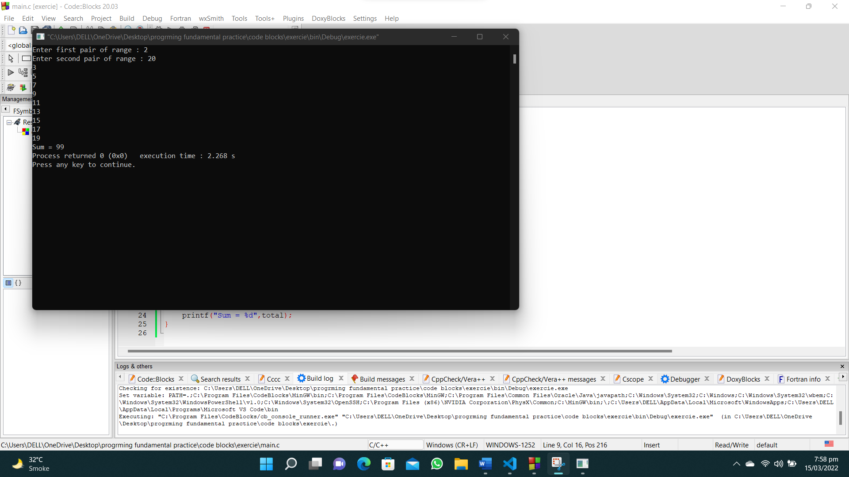

**35. Write a C program to check whether two numbers in a pair is in ascending order or descending order.**

**#include<stdio.h>**

**int main()**

**{**

**int num1,num2;**

**printf("Enter first number of the pair : ");**

**scanf("%d",&num1);**

**printf("Enter second number of the pair : ");**

**scanf("%d",&num2);**

**if(num1 > num2)**

**{**

**printf("%d : %d\n",num1,num2);**

**printf("The pair is in descending order");**

**}**

**if(num1 < num2)**

**{**

**printf("%d : %d\n",num1,num2);**

**printf("The pair is in ascending order");**

**}**

**}**

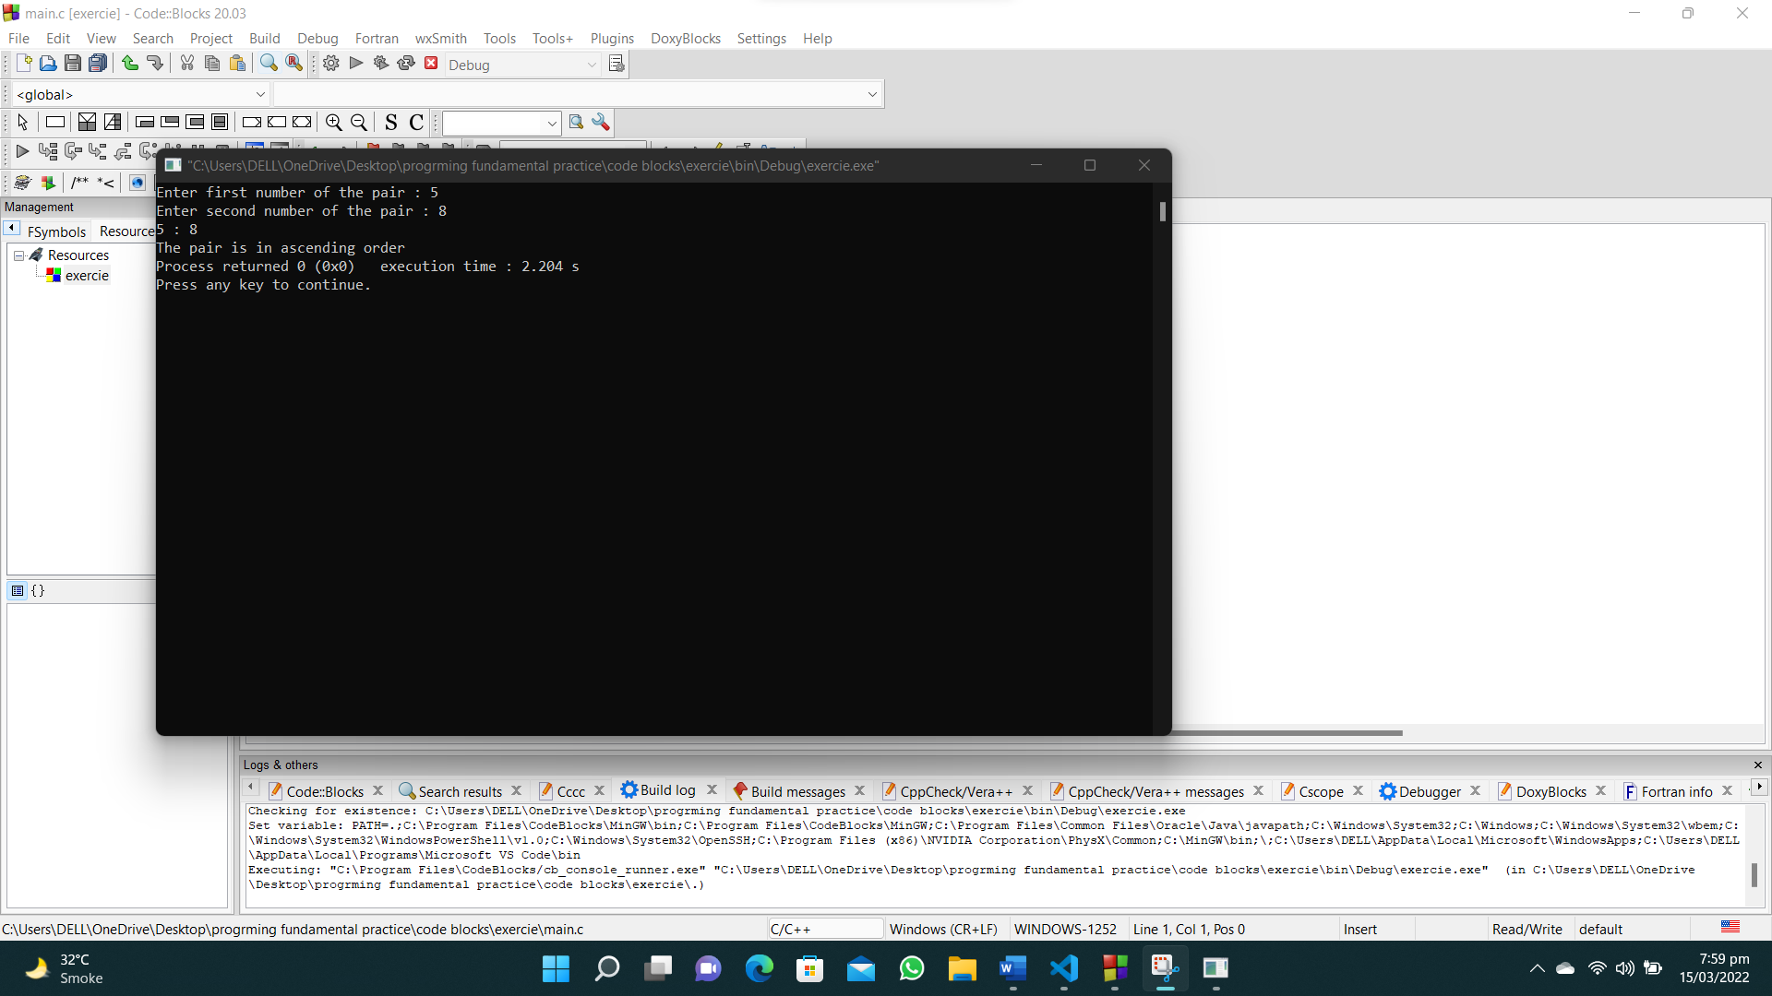

**36. Write a C program to read a password until it is correct. For wrong password print "Incorrect password" and for correct password print "Correct password" and quit the program. The correct password is 1234.**

**#include <stdio.h>**

**#include <stdlib.h>**

**int main()**

**{**

**int pass, w = 10;**

**while (w != 0)**

**{**

**printf("\nEnter your password : \n");**

**scanf("%d", &pass);**

**if (pass == 1234)**

**{**

**printf("Correct password");**

**w = 0;**

**}**

**else**

**{**

**printf("Incorrect password");**

**}**

**}**

**}**

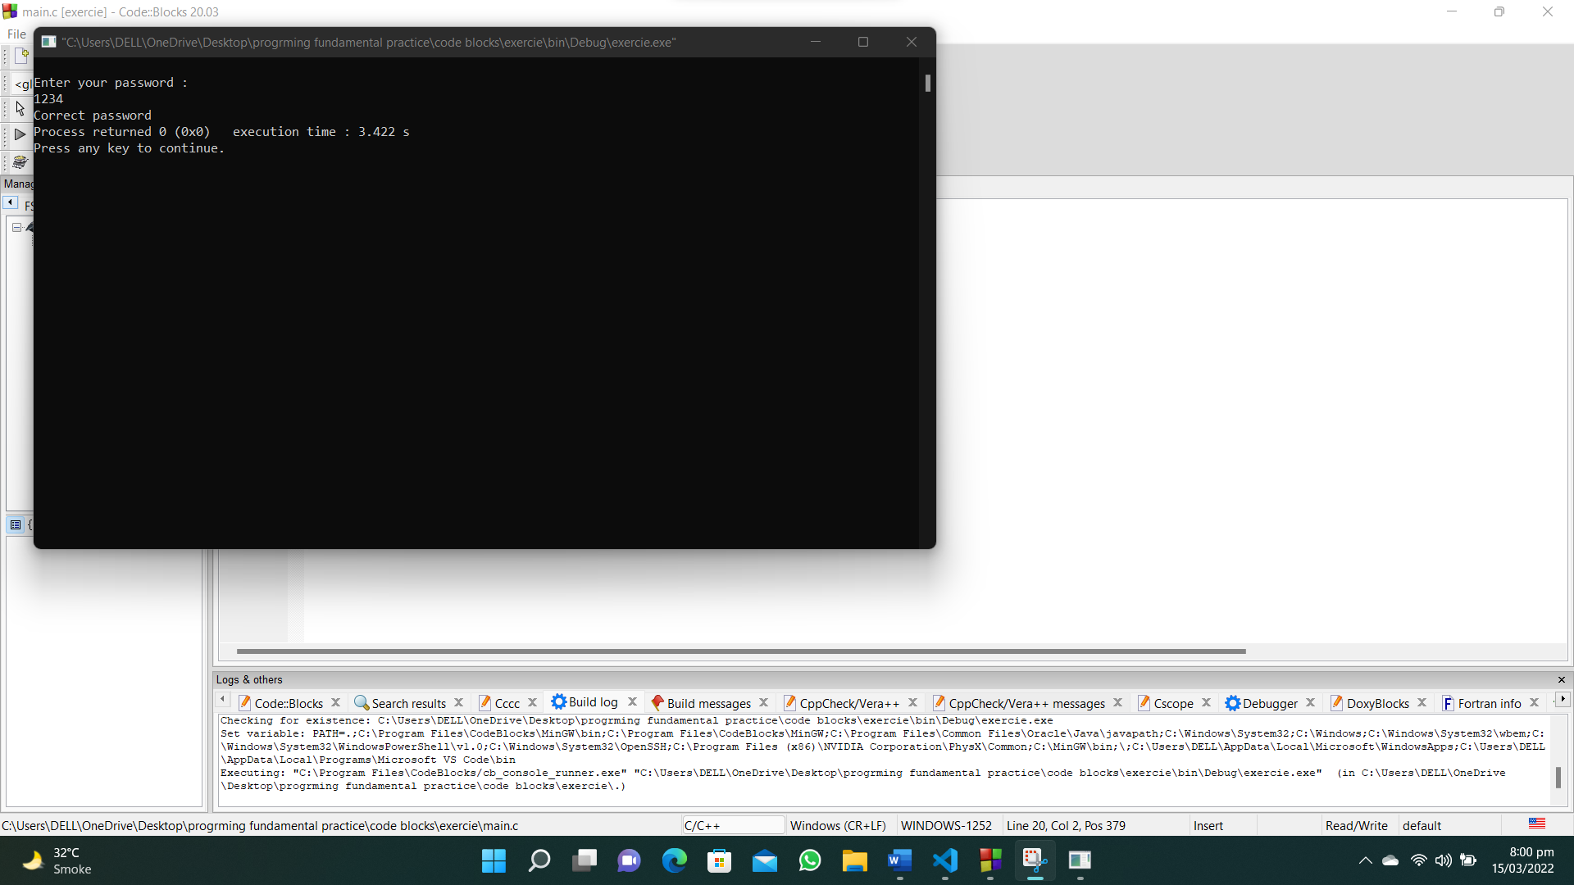

**37. Write a C program to read the coordinates(x, y) (in Cartesian system) and find the quadrant to which it belongs (Quadrant -I, Quadrant -II, Quadrant -III, Quadrant -IV).**

**#include<stdio.h>**

**int main()**

**{**

**int x,y;**

**printf("Input the coordinates (x,y)\n");**

**printf("Enter value of x : ");**

**scanf("%d",&x);**

**printf("Enter value of y : ");**

**scanf("%d",&y);**

**if (x>0 && y>0)**

**{**

**printf("The point lies in Quadrent 1");**

**}**

**else if (x<0 && y<0)**

**{**

**printf("The point lies in Quadrent 3");**

**}**

**else if (x<0 && y>0)**

**{**

**printf("The point lies in Quadrent 2");**

**}**

**else if (x>0 && y<0)**

**{**

**printf("The point lies in Quadrent 4");**

**}**

**}**

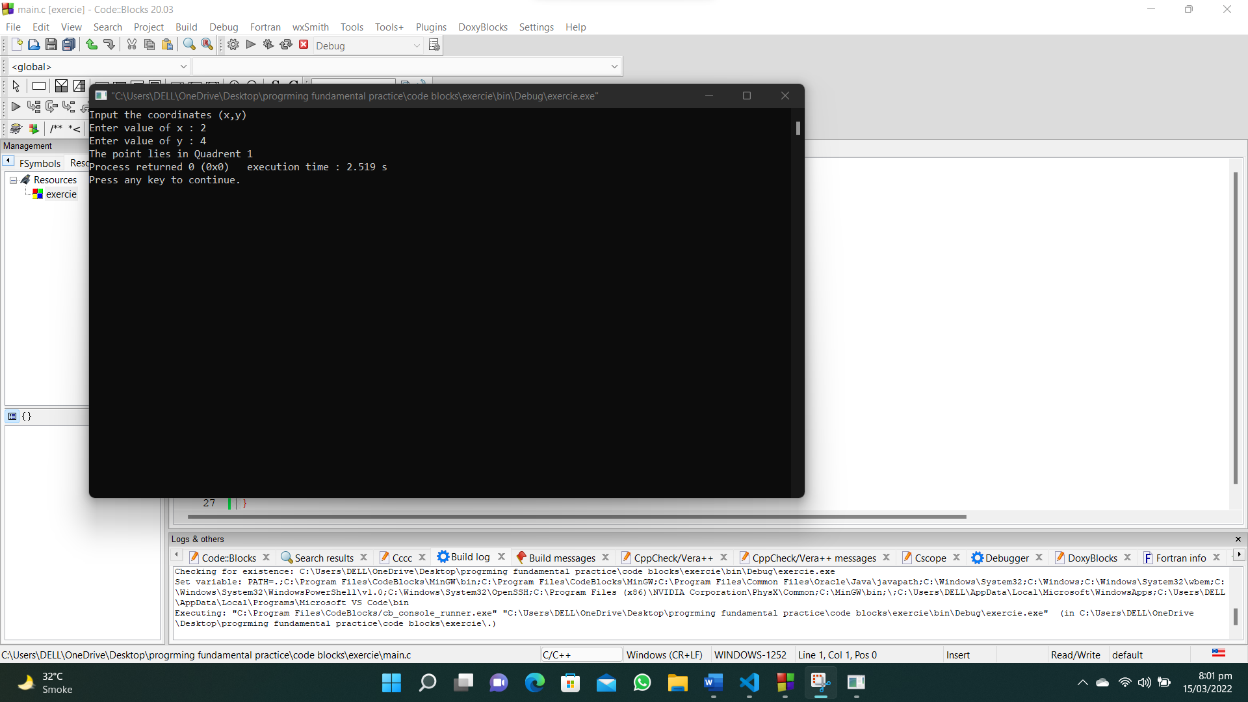

**38. Write a program that reads two numbers and divide the first number by second number. If the division not possible print "Division not possible".**

**#include<stdio.h>**

**int main()**

**{**

**int x,y;**

**printf("Enter first number : ");**

**scanf("%d",&x);**

**printf("Enter second number : ");**

**scanf("%d",&y);**

**if(y!=0)**

**{**

**printf("%d /%d =%.2f",x,y,(float)x/(float)y);**

**}**

**else**

**{**

**printf("Division not possible");**

**}**

**}**

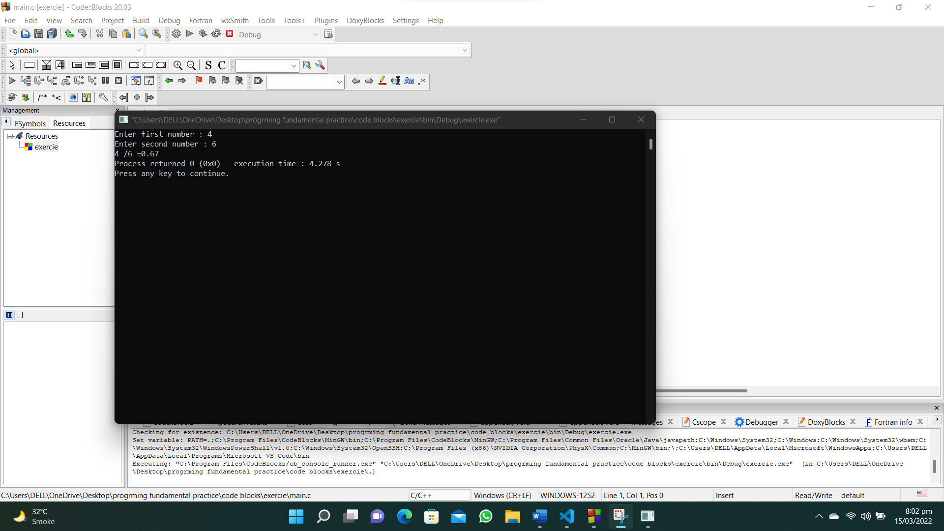

**39. Write a C program to calculate the sum of all number not divisible by 17 between two given integer numbers.**

**#include<stdio.h>**

**int main()**

**{**

**int num1,num2,total=0;**

**printf("Enter first number of the range : ");**

**scanf("%d",&num1);**

**printf("Enter second number of the range : ");**

**scanf("%d",&num2);**

**if(num1>num2)**

**{**

**int temp;**

**temp=num1;**

**num1=num2;**

**num2=temp;**

**}**

**for(int i=num1;i<=num2;i++)**

**{**

**if(i%17!=0)**

**{**

**total=total+i;**

**}**

**}**

**printf("The sum is : %d",total);**

**}**

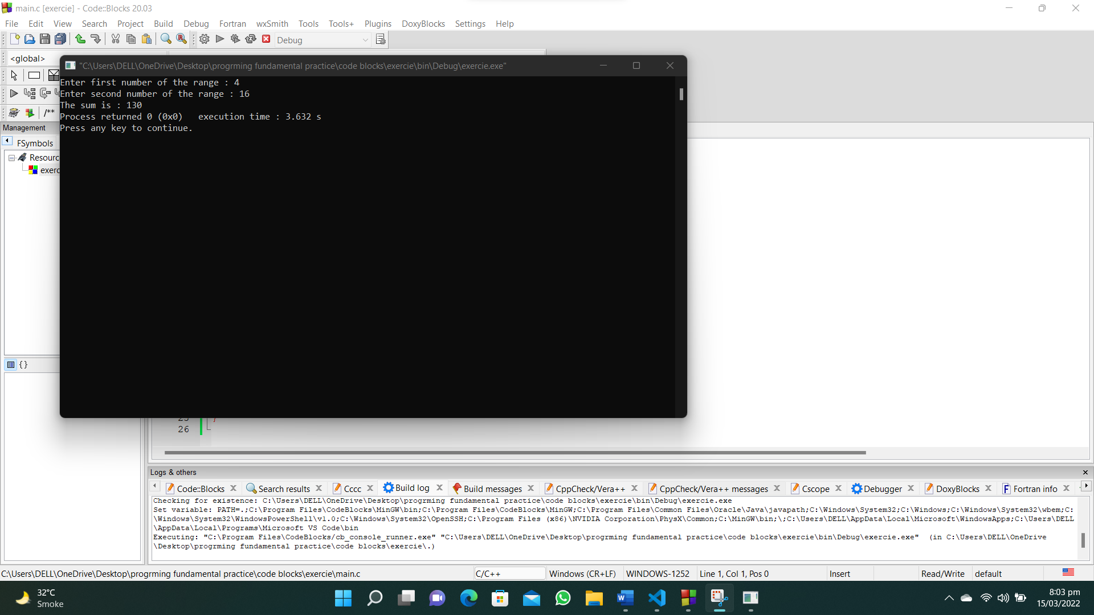

**40. Write a C program to find all numbers which are dividing by 7 and the remainder is equal to 2 or 3 between two given integer numbers.**

**#include<stdio.h>**

**int main()**

**{**

**int num1,num2,num;**

**printf("Enter first number of range : ");**

**scanf("%d",&num1);**

**printf("Enter second number of range : ");**

**scanf("%d",&num2);**

**if(num1>num2)**

**{**

**int temp;**

**temp=num1;**

**num1=num2;**

**num2=temp;**

**}**

**for(int i=num1;i<num2;i++)**

**{**

**if(i%7==2 || i%7==3)**

**{**

**printf("%d\n",i);**

**}**

**}**

**}**

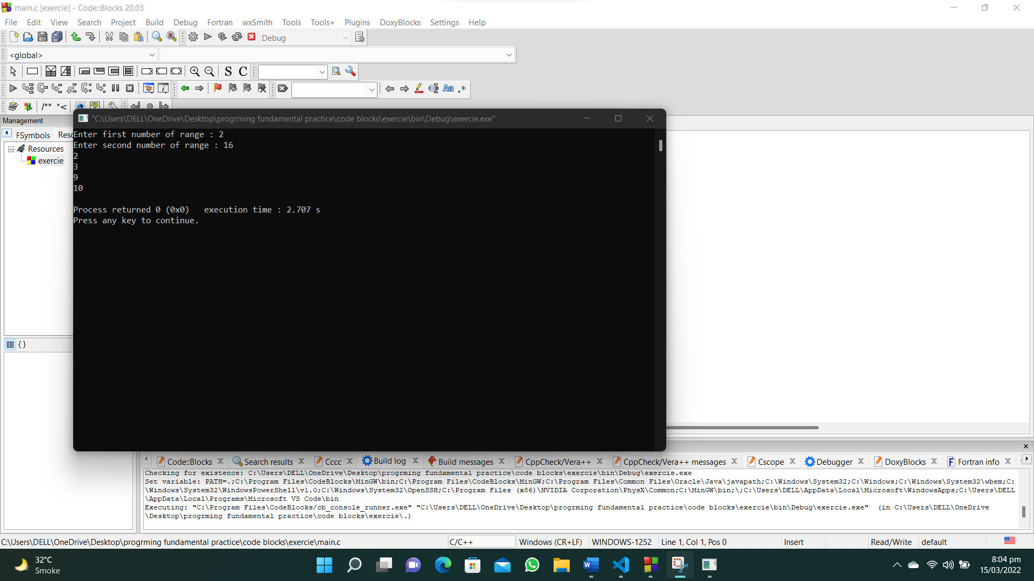

**41. Write a C program to print 3 numbers in a line, starting from 1 and print n lines. Accept number of lines (n, integer) from the user.**

**#include <stdio.h>**

**int main()**

**{**

**int n,a=1;**

**printf("Enter number of lines : ");**

**scanf("%d", &n);**

**for (int i = 1; i <= n; i++)**

**{**

**for (int j=1; j <= 3; j++)**

**{**

**printf("%d ",a);**

**a++;**

**}**

**printf("\n");**

**}**

**}**

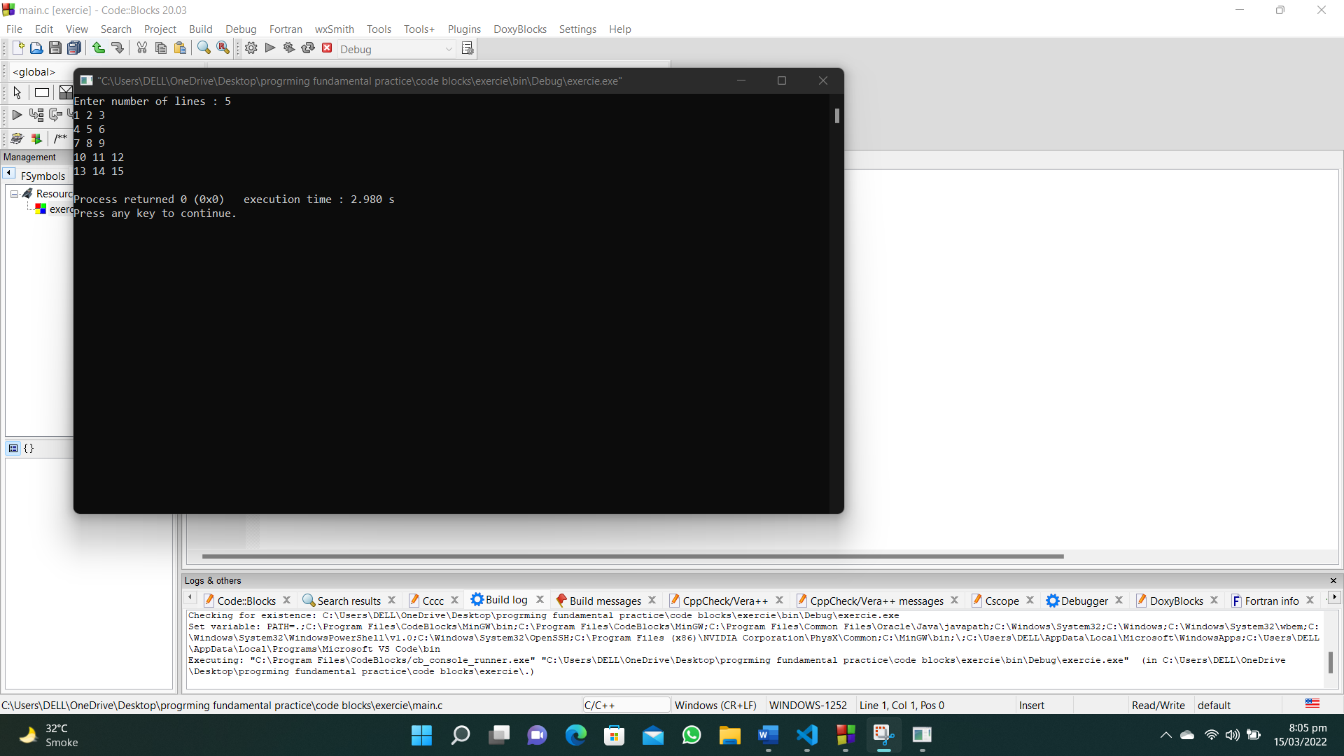

**42. Write a C program to print a number, it’s square and cube in a line, starting from 1 and print n lines. Accept number of lines (n, integer) from the user.**

**#include<stdio.h>**

**int main()**

**{**

**int n;**

**printf("Enter number of lines : ");**

**scanf("%d",&n);**

**for(int i=1;i<=n;i++)**

**{**

**printf("%d %d %d",i,i*i,i*i*i);**

**printf("\n");**

**}**

**}**

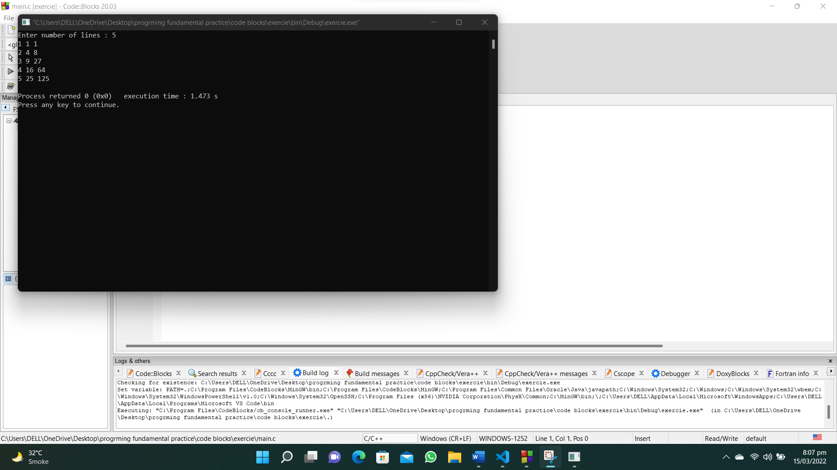

**43. Write a C program that reads two integers p and q, print p number of lines in a sequence of 1 to q in a line.**

**#include <stdio.h>**

**int main()**

**{**

**int n, c, a = 1;**

**printf("Enter number of lines : ");**

**scanf("%d", &n);**

**printf("Enter number of characters in a line : ");**

**scanf("%d", &c);**

**for (int i = 1; i <= n; i++)**

**{**

**for (int j = 1; j <= c; j++)**

**{**

**printf("%d ", a);**

**a++;**

**}**

**printf("\n");**

**}**

**}**

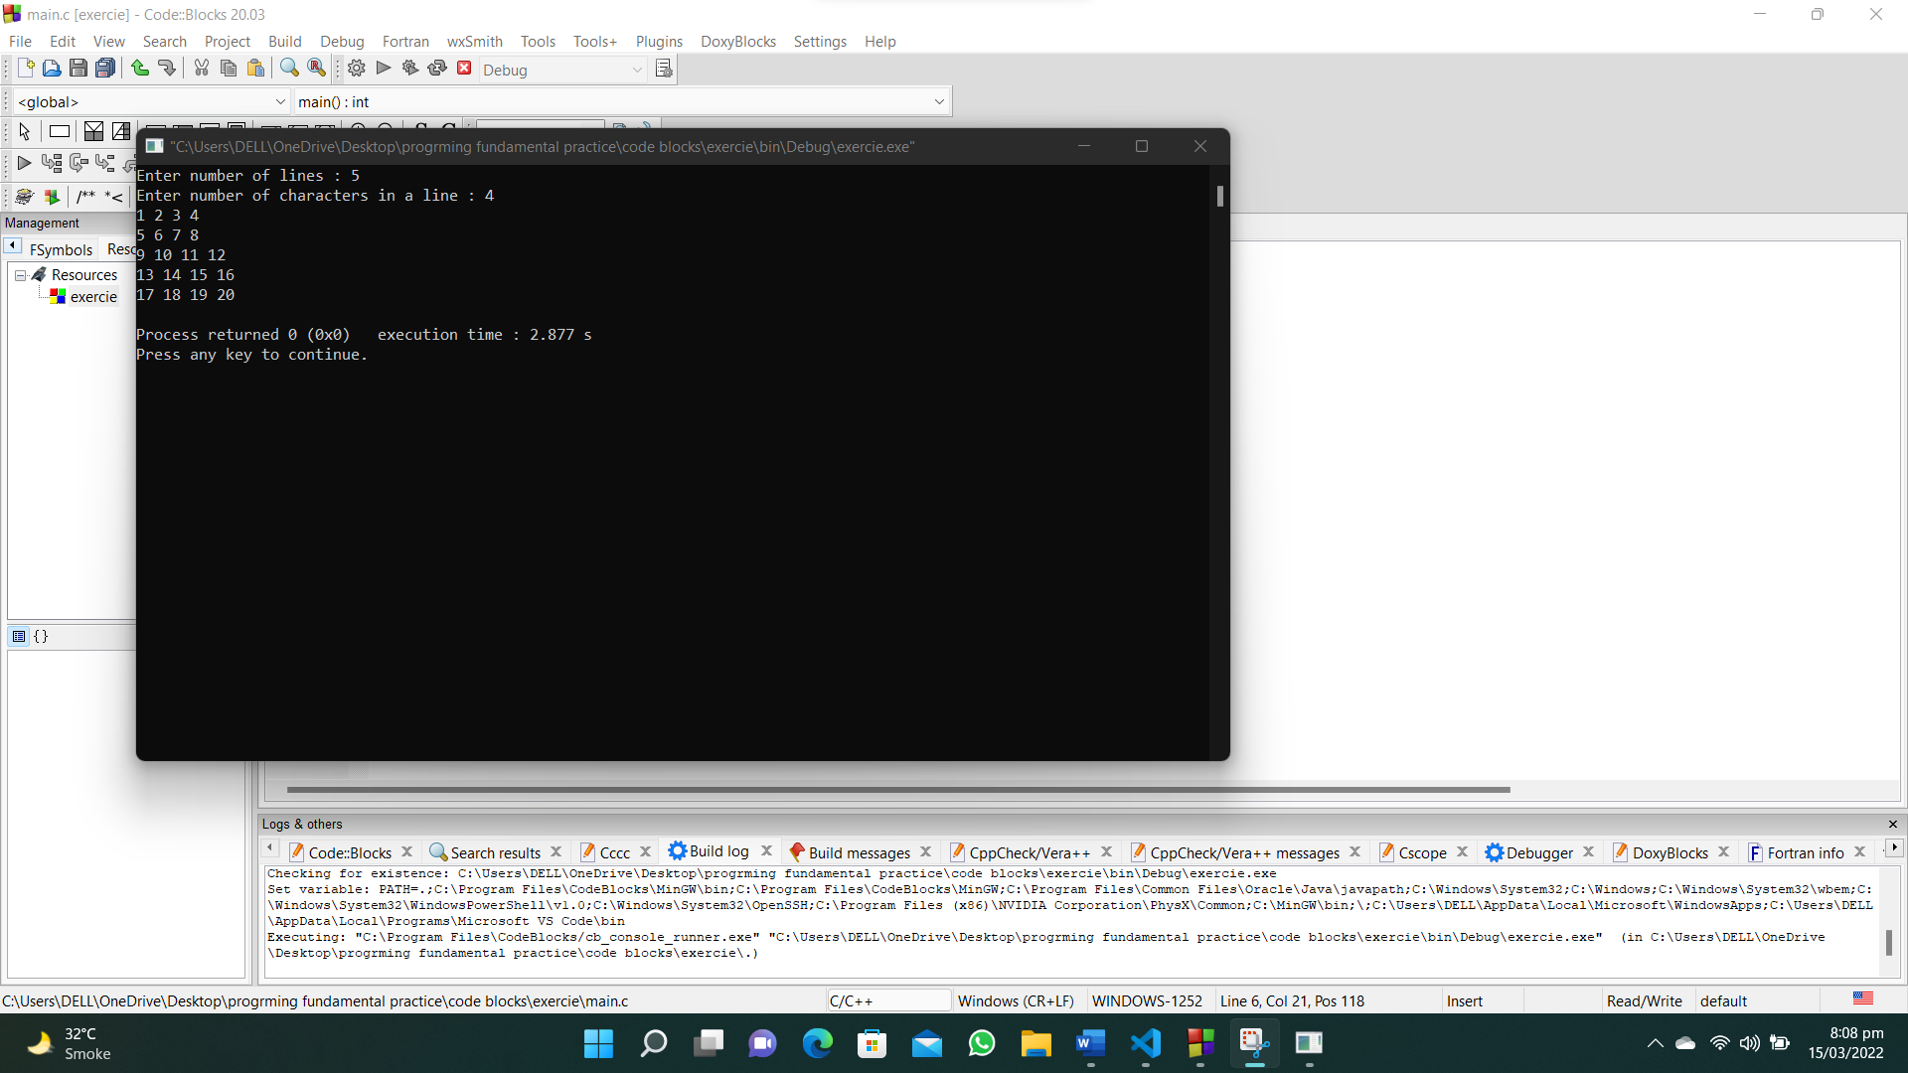

**44. Write a C program to calculate the average marks of mathematics of some students. Input 0 (excluding to calculate the average) or negative value to terminate the input process.**

**#include <stdio.h>**

**int main()**

**{**

**int marks, count = 0,total=0;**

**float average;**

**do**

**{**

**printf("Enter marks of student : ");**

**scanf("%d",&marks);**

**count++;**

**total=total+marks;**

**} while (marks > 0);**

**average = (float)total/ (count-1);**

**printf("The average marks are : %.2f",average);**

**}**

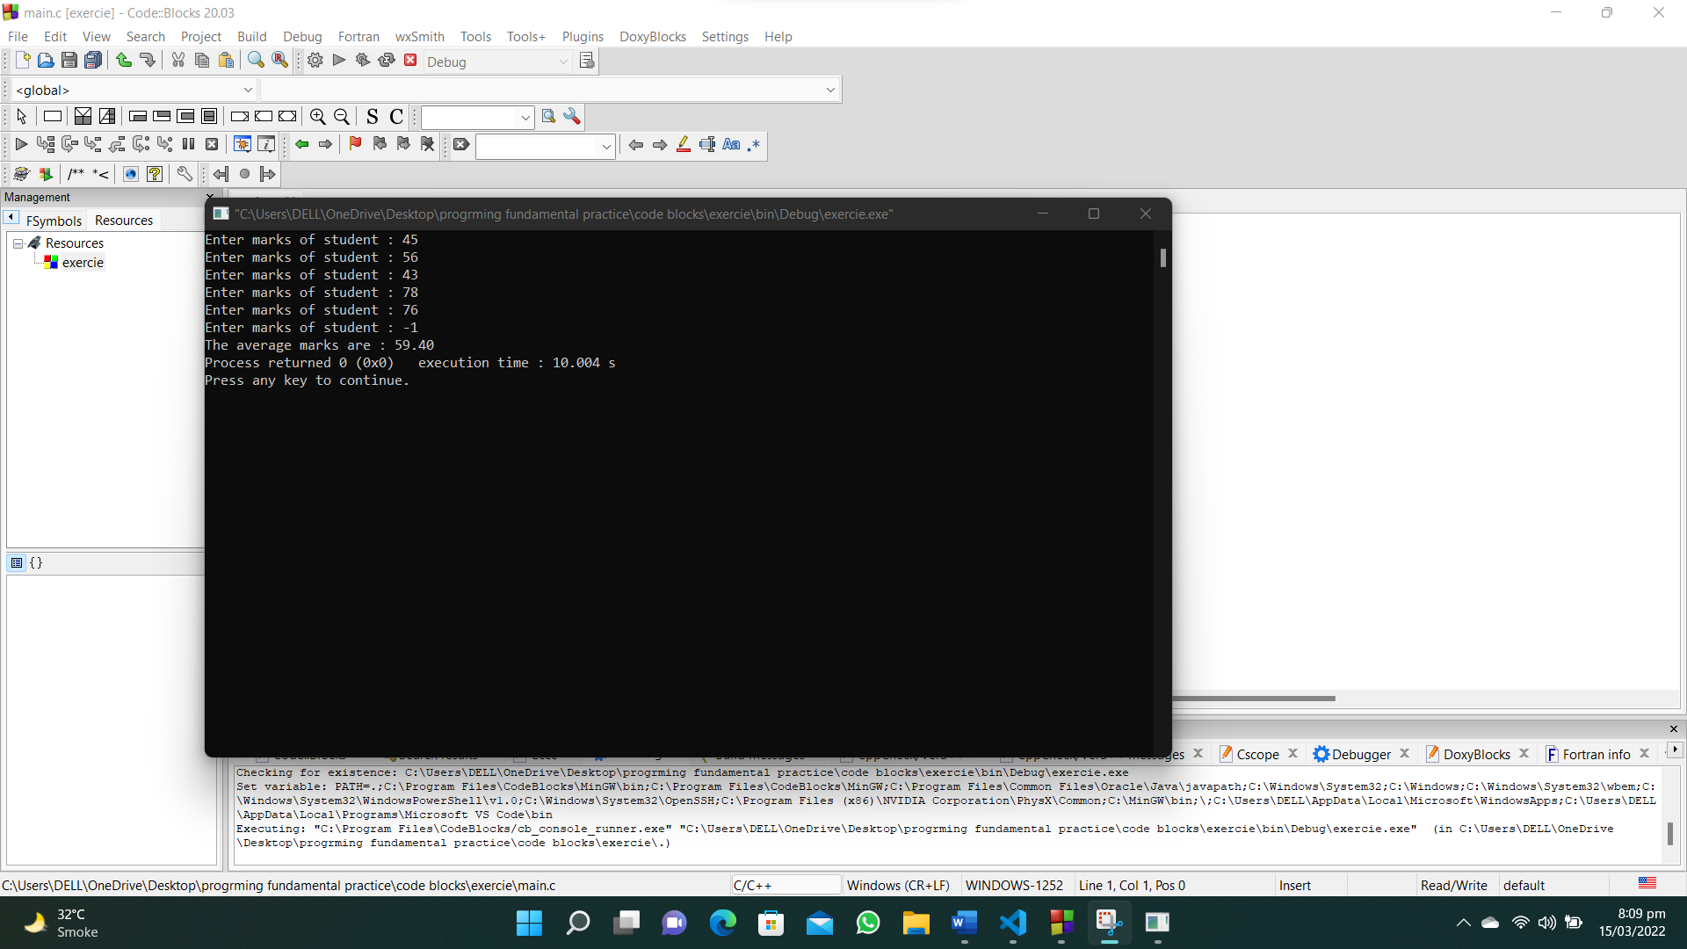

**45. Write a C program to calculate the value of S where S = 1 + 1/2 + 1/3 + … + 1/50.**

**#include <stdio.h>**

**int main()**

**{**

**float sum = 0;**

**for (int i = 1; i <= 50; i++)**

**{**

**sum = sum + (1 / (float)i);**

**}**

**printf("The sum of series is : %.2f", sum);**

**}**

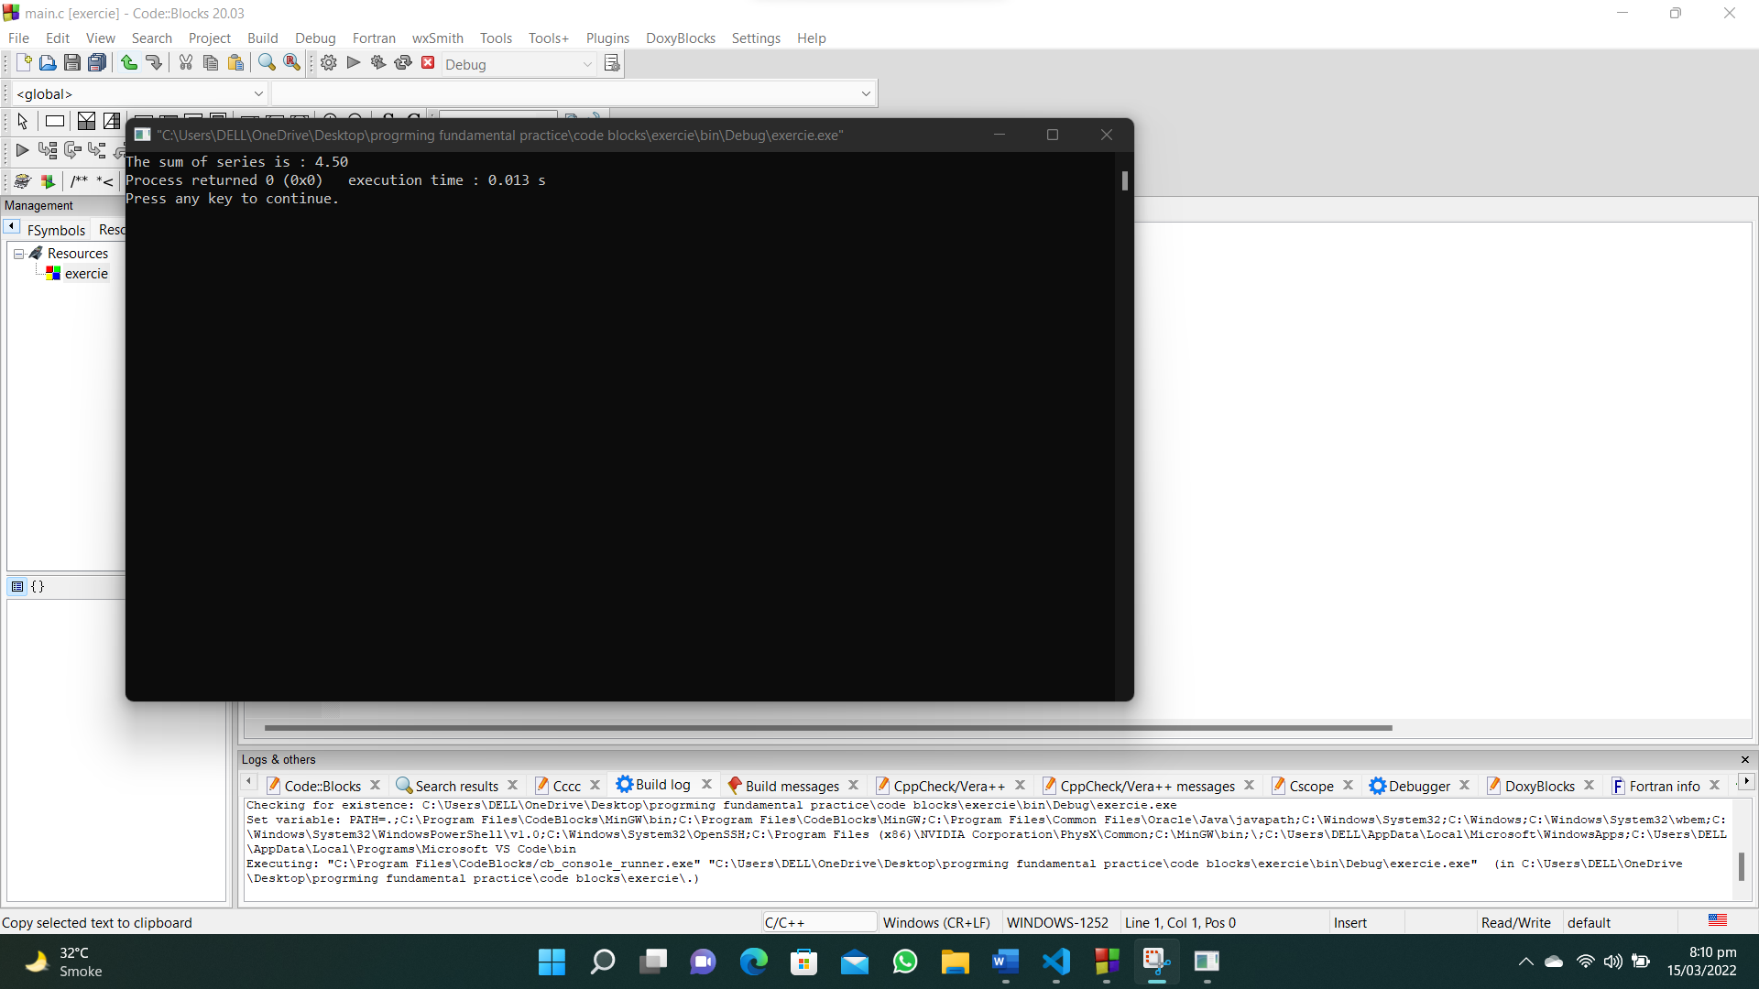

**46. Write a C program to calculate the value of S where S = 1 + 3/2 + 5/4 + 7/8.**

**#include <stdio.h>**

**#include<math.h>**

**int main()**

**{**

**int j,a = 1;**

**float sum = 1;**

**for (int i = 3; i <= 7; i = i + 2)**

**{**

**j=pow(2,a);**

**a++;**

**printf("%d/%d",i,j);**

**sum = sum + ((float)i / (float)j);**

**}**

**printf("The sum is : %.2f", sum);**

**}**

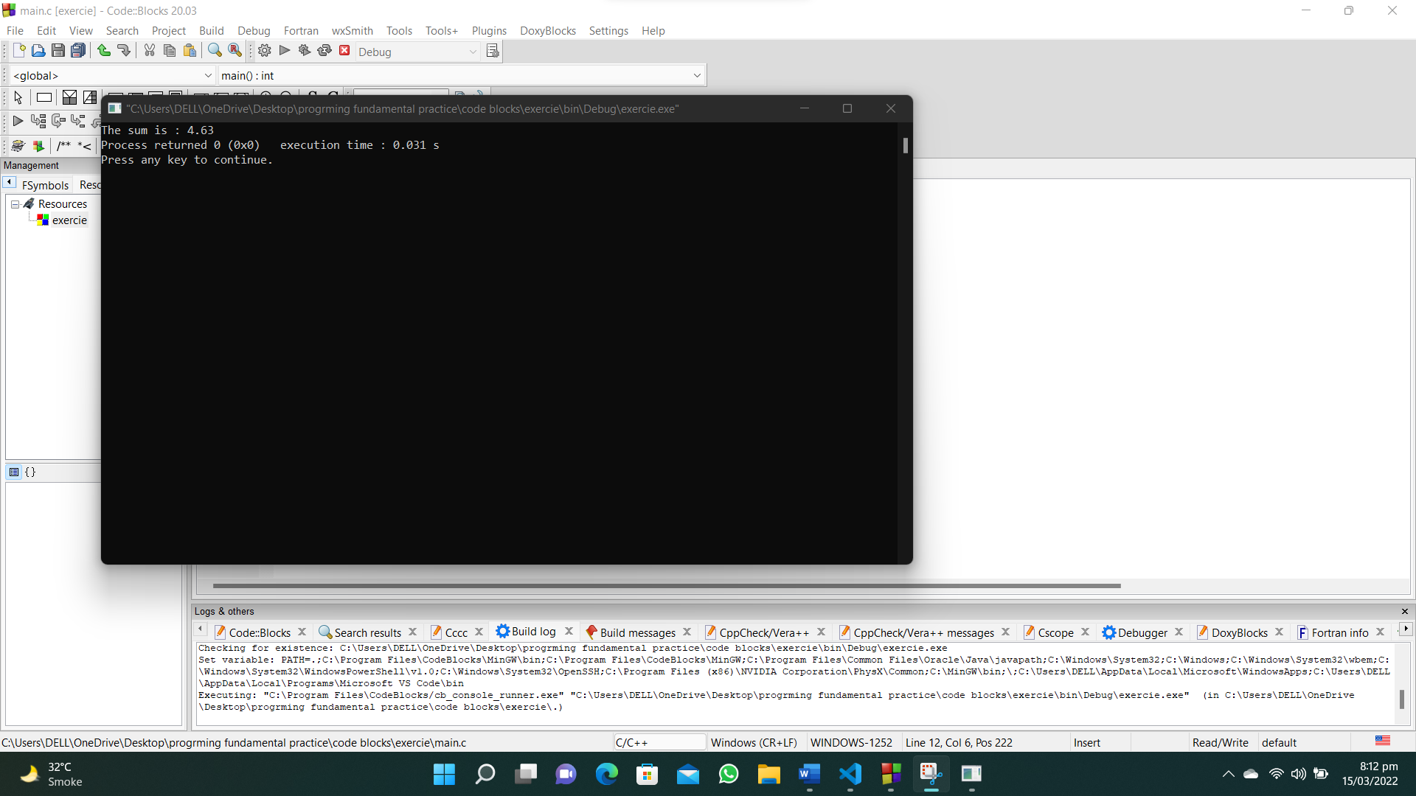

**47. Write a C program that reads an integer and find all its divisor.**

**#include<stdio.h>**

**int main()**

**{**

**int num;**

**printf("Enter a number : ");**

**scanf("%d",&num);**

**for(int i=1;i<=num;i++)**

**{**

**if(num%i==0)**

**{**

**printf("%d\n",i);**

**}**

**}**

**}**

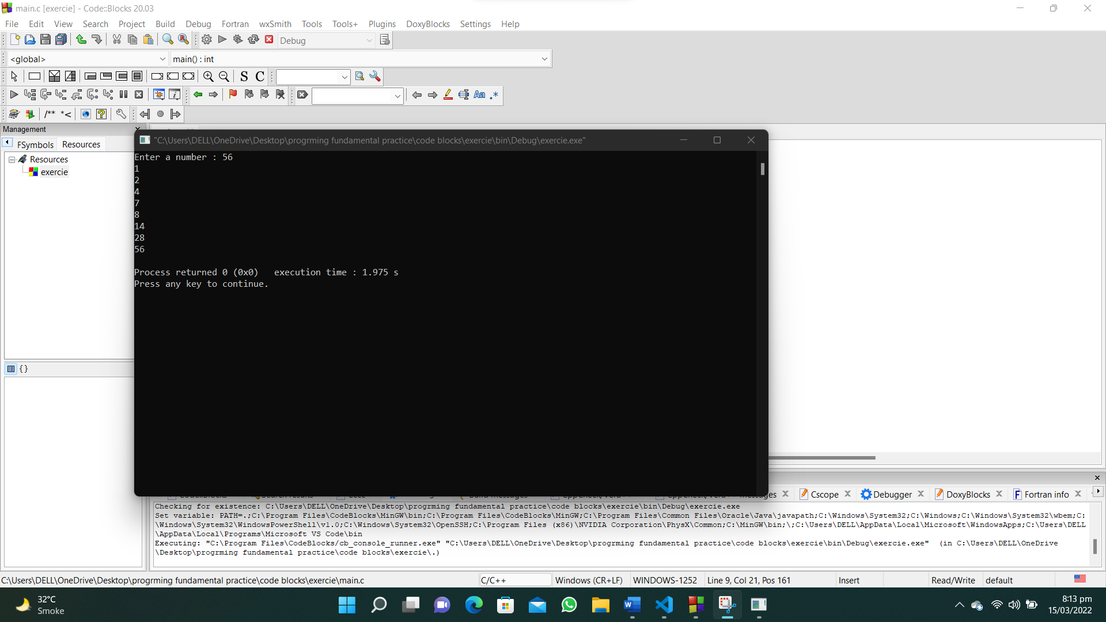

**53. Write a C program that accepts principle, rate of interest, time and compute the simple interest.**

**#include<stdio.h>**

**int main()**

**{**

**int principal,rate_intrest,time;**

**float intrest;**

**printf("Enter principal amount : ");**

**scanf("%d",&principal);**

**printf("Enter rate of intrest in %%: ");**

**scanf("%d",&rate_intrest);**

**printf("Enter time in years : ");**

**scanf("%d",&time);**

**intrest=(principal*((float)rate_intrest/100))*time;**

**printf("The simple intrest is : %.2f",intrest);**

**}**

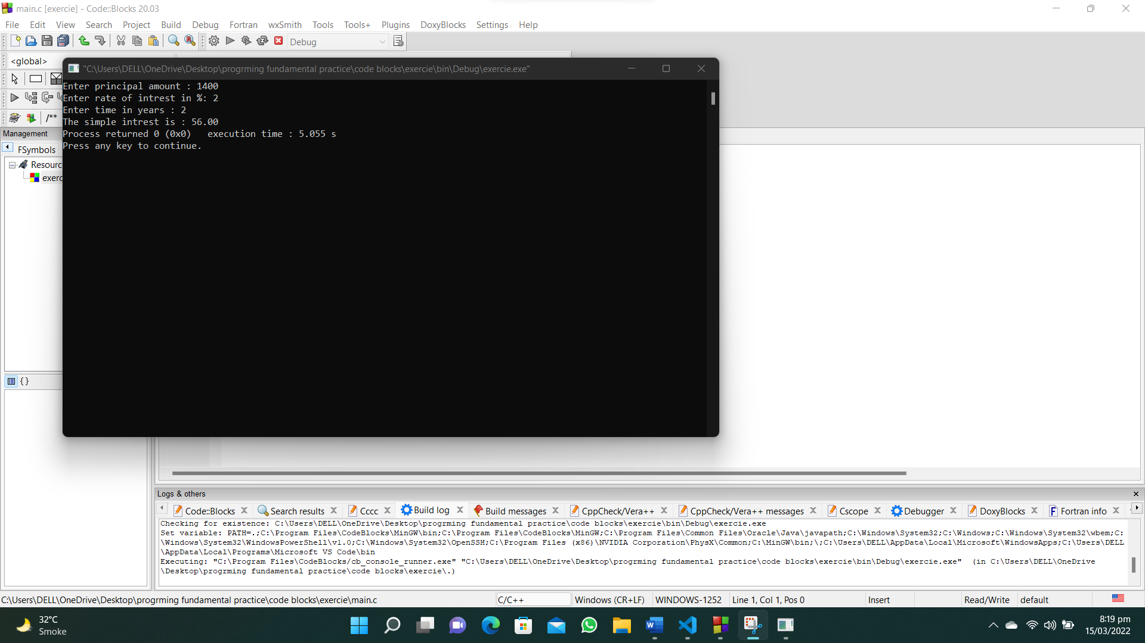

**54. Write a C program that accepts a distance in centimeters and prints the corresponding value in inches.**

**#include<stdio.h>**

**int main()**

**{**

**int cm;**

**float inch;**

**printf("Enter length in cm : ");**

**scanf("%d",&cm);**

**inch=cm*0.3937;**

**printf("The length in inches is : %.2f",inch);**

**}**

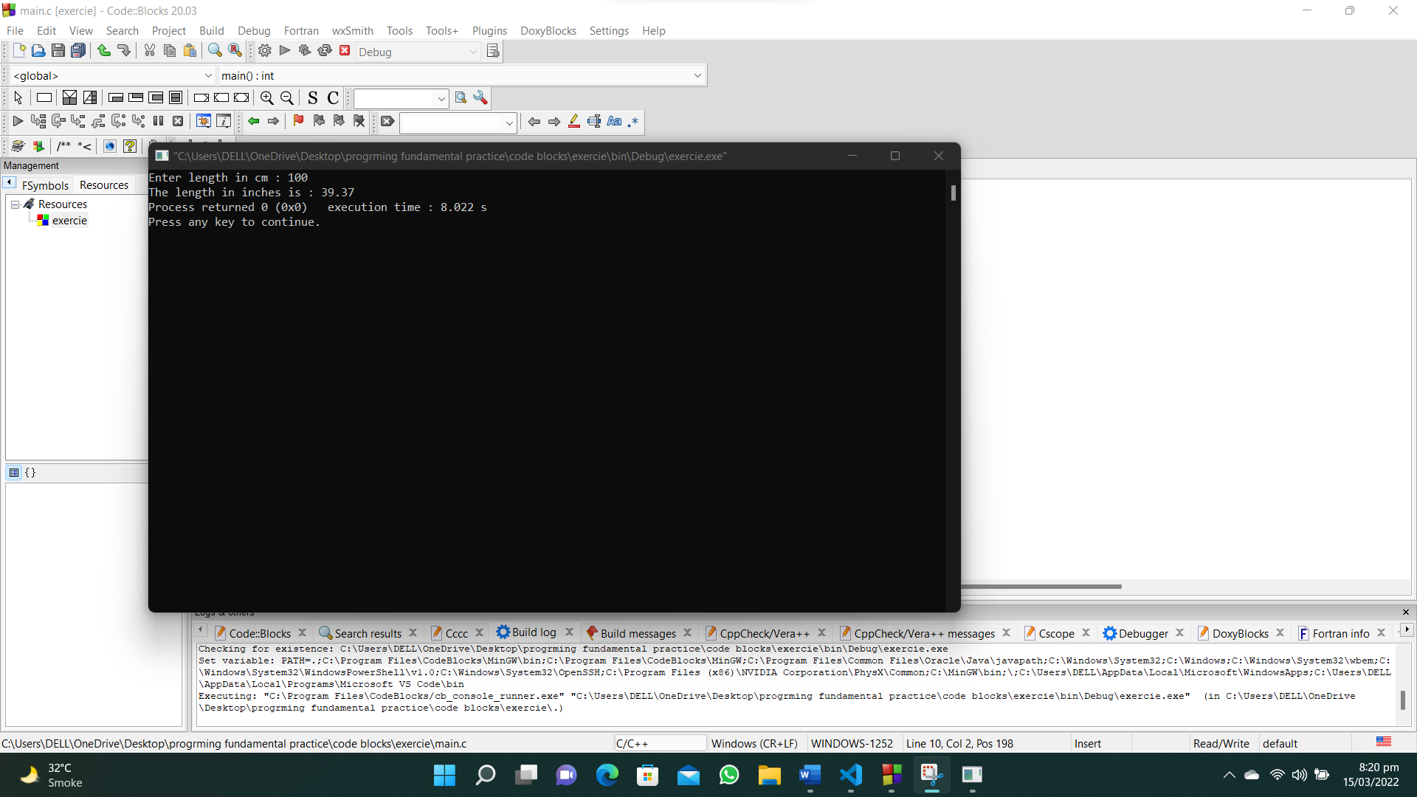

**55. Write a C program that swaps two numbers without using third variable.**

**#include<stdio.h>**

**int main()**

**{**

**int x,y;**

**printf("Enter value of x : ");**

**scanf("%d",&x);**

**printf("Enter value of y : ");**

**scanf("%d",&y);**

**printf("Values before swapping : %d :: %d\n",x,y);**

**x=x+y;**

**y=x-y;**

**x=x-y;**

**printf("Values after swapping : %d :: %d\n",x,y);**

**}**



**56. Write a C program to shift given data by two bits to the left.**

**#include<stdio.h>**

**int main()**

**{**

**int num,num1;**

**printf("Enter an integer : ");**

**scanf("%d",&num);**

**num1=num<<2;**

**printf("The number is : %d",num1);**

**}**

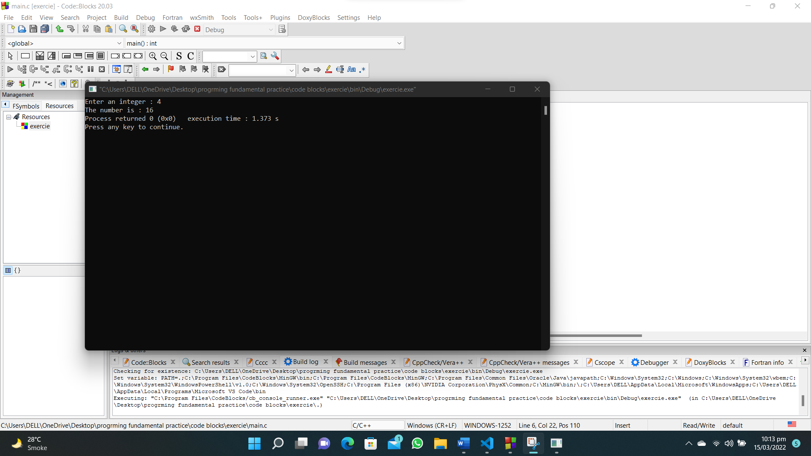

**57. Write a C program to reverse and print a given number.**

**#include <stdio.h>**

**int main()**

**{**

**int num, rev=0, rem;**

**printf("Enter a number : ");**

**scanf("%d", &num);**

**while (num != 0)**

**{**

**rem = num % 10;**

**rev = (rev * 10) + rem;**

**num=num/10;**

**}**

**printf("The reversed number is : %d",rev);**

**}**

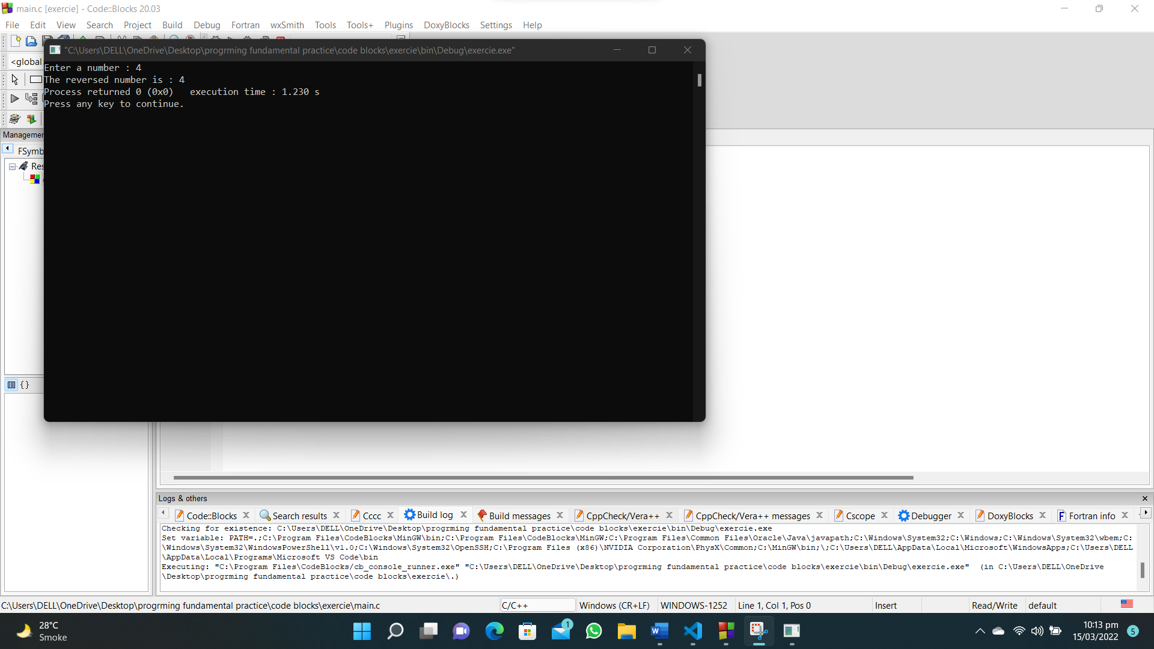

**58. Write a C program that accepts 4 real numbers from the keyboard and print out the difference of the maximum and minimum values of these four numbers.**

**#include<stdio.h>**

**int main()**

**{**

**float num1,num2,num3,num4,max,min;**

**printf("Enter first number : ");**

**scanf("%f",&num1);**

**max=num1;**

**min=num1;**

**printf("Enter second number : ");**

**scanf("%f",&num2);**

**if(num2>max)**

**{**

**max=num2;**

**}**

**else if(num2<min)**

**{**

**min=num2;**

**}**

**printf("Enter third number : ");**

**scanf("%f",&num3);**

**if(num3>max)**

**{**

**max=num3;**

**}**

**else if(num3<min)**

**{**

**min=num3;**

**}**

**printf("Enter fourth number : ");**

**scanf("%f",&num4);**

**if(num4>max)**

**{**

**max=num4;**

**}**

**else if(num4<min)**

**{**

**min=num4;**

**}**

**printf("%f\n",min);**

**printf("%f\n",max);**

**printf("The difference b/w max and min number is : %.3f",max-min);**

**}**

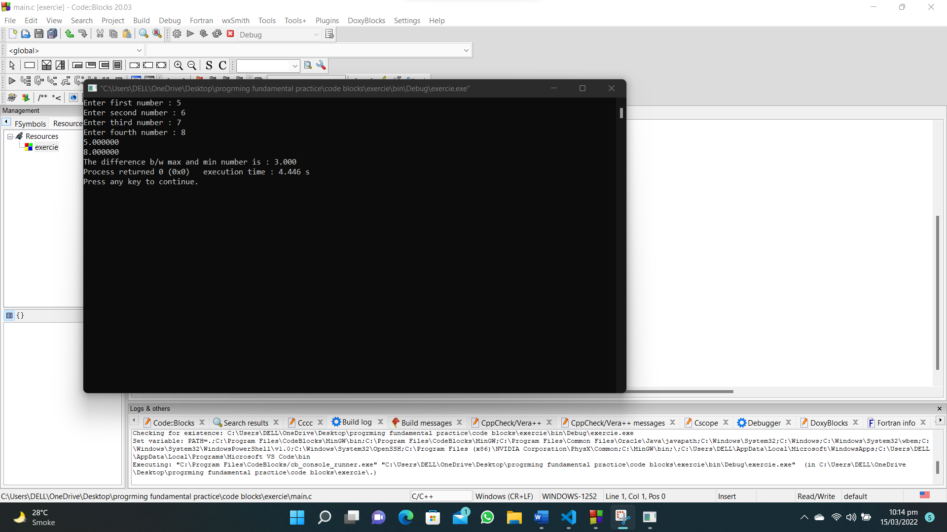

**59. Write a C program to display sum of series 1 + 1/2 + 1/3 + ………. + 1/n.**

**#include<stdio.h>**

**int main()**

**{**

**int num,i;**

**float sum=0;**

**printf("Enter any number : ");**

**scanf("%d",&num);**

**for(i=1;i<=num;i++)**

**{**

**sum=sum+(1/(float)i);**

**}**

**printf("The sum is : %.2f",sum);**

**}**

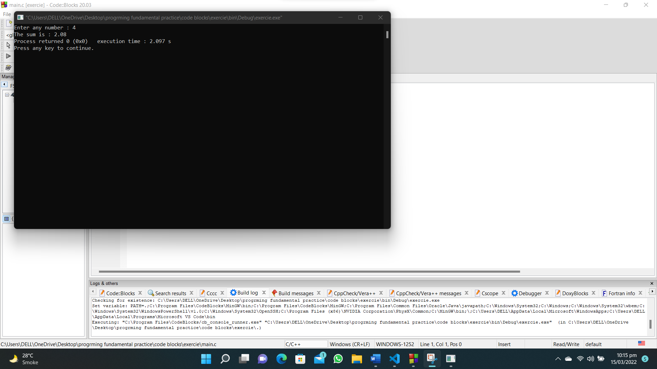

**61. Write a C program that accepts a real number x and prints out the corresponding value of sin(1/x) using 4-decimal places.**

**#include<stdio.h>**

**#include<math.h>**

**int main()**

**{**

**float num;**

**float ans;**

**printf("Enter value of x : ");**

**scanf("%f",&num);**

**ans=sin(1/num);**

**printf("The sin(1/x) is : %f",ans);**

**}**



**62. Write a C program that accepts a positive integer less than 500 and prints out the sum of the digits of this number.**

**#include <stdio.h>**

**int main()**

**{**

**int num, number, total = 0;**

**printf("Enter a number : ");**

**scanf("%d", &num);**

**if (num < 500)**

**{**

**while (num != 0)**

**{**

**number = num % 10;**

**total = total + number;**

**num = num / 10;**

**}**

**printf("The sum is %d ",total);**

**}**

**}**

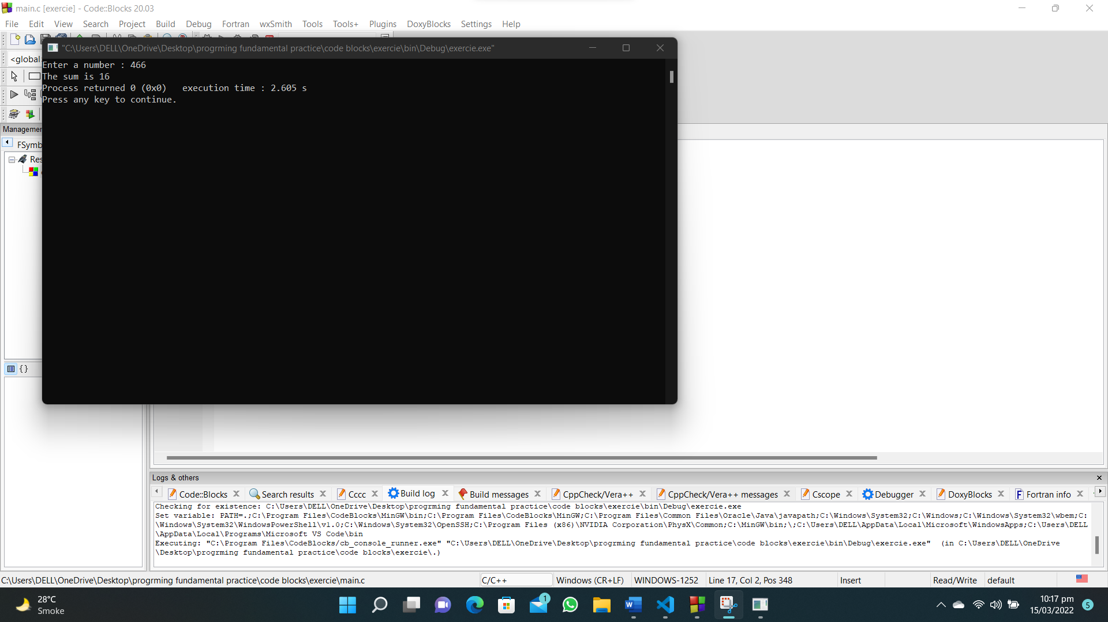

**63. Write a C program that accepts a positive integer n less than 100 from the user and prints out the sum 14 + 24 + 44 + 74 + 114 + • • • + m4 , where m is less than or equal to n. Print appropriate message.**

**#include <stdio.h>**

**#include <math.h>**

**int main()**

**{**

**int num, a, total = 0, b = 1;**

**printf("Enter a number : ");**

**scanf("%d", &num);**

**if (num < 1 || num > 100)**

**{**

**printf("Wrong input");**

**return 0;**

**}**

**for (int i = 1; i <= num; b++)**

**{**

**a = pow(i, 4);**

**total = total + a;**

**i = i + b;**

**}**

**printf("The sum of series is : %d", total);**

**}**

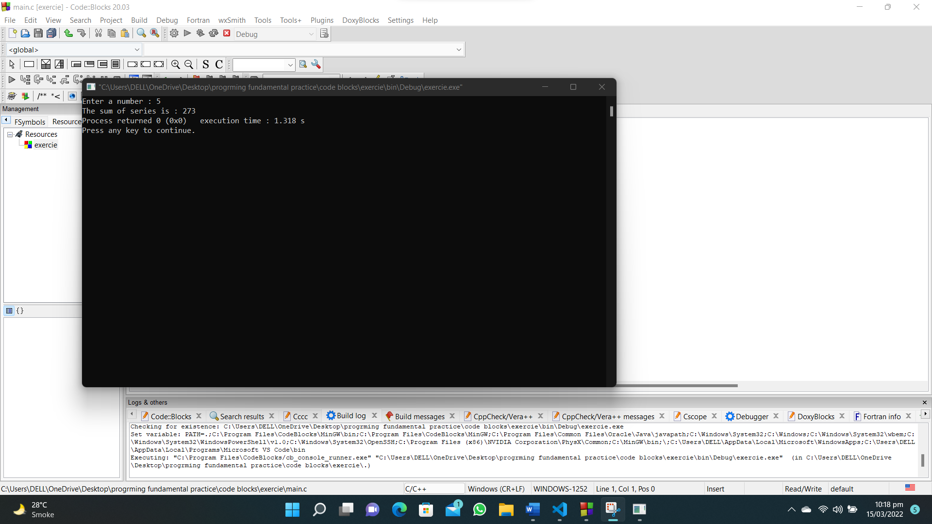

**64. Write a C program that accepts integers from the user until a zero or a negative number, display the number of positive values, the minimum value, the maximum value and the average of all numbers.**

**#include <stdio.h>**

**int main()**

**{**

**int num, count = 1, total = 0, num1 = 1, min, max;**

**printf("Enter a number : ");**

**scanf("%d", &num);**

**total = num;**

**min = num;**

**max = num;**

**while (num > 0 && num1 > 0)**

**{**

**if (num <= 0)**

**{**

**total = 0;**

**count = 0;**

**break;**

**}**

**printf("Enter next number : ");**

**scanf("%d", &num1);**

**total = total + num1;**

**if (num1 <= 0)**

**{**

**break;**

**}**

**count++;**

**if (num1 < min)**

**{**

**min = num1;**

**}**

**if (num1 > max)**

**{**

**max = num1;**

**}**

**}**

**printf("Positive numbers are : %d\n", count);**

**printf("maximum numbers are : %d\n", max);**

**printf("minimum number is : %d\n", min);**

**printf("The average of positive numbers is : %.2f\n", (float)total / (float)count);**

**}**

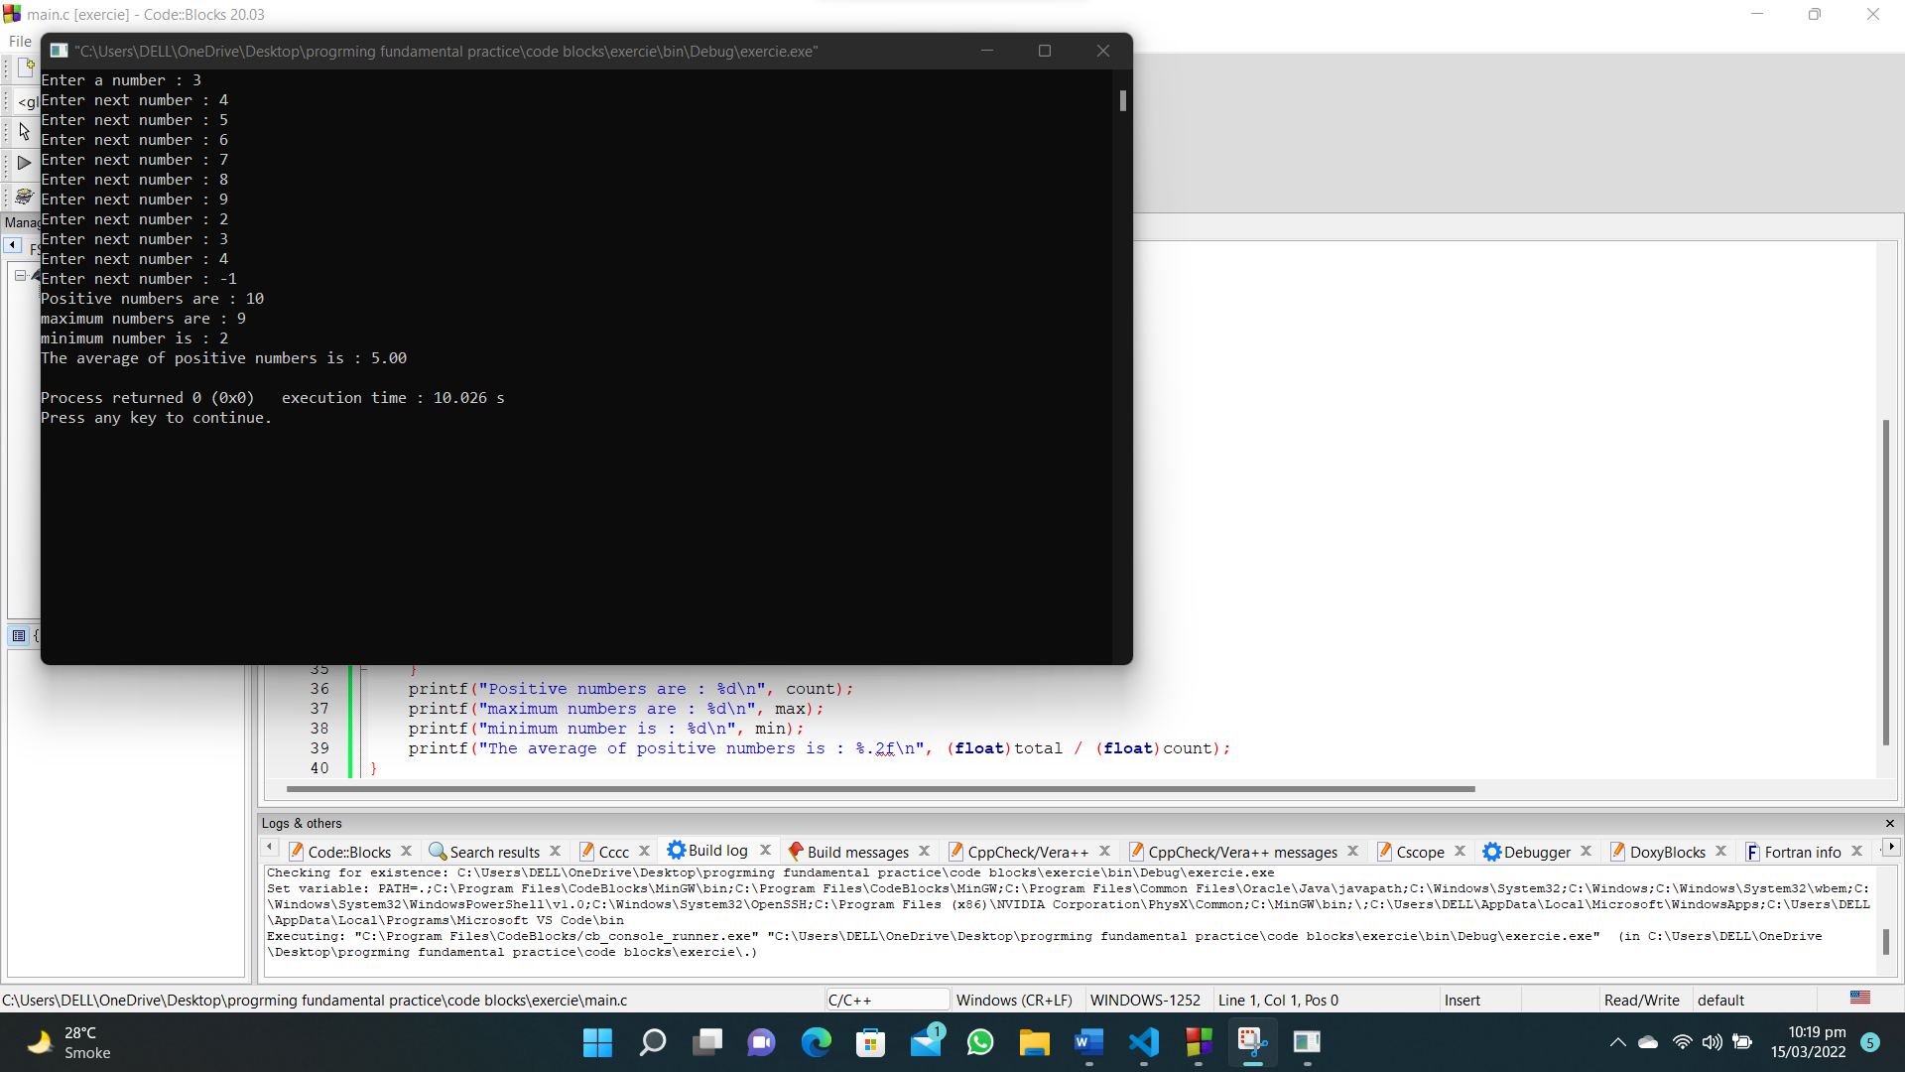

**68. Write a C program to print the powers of 2 table for the power 0 to 10, both positive and negative.**

**#include<stdio.h>**

**#include<math.h>**

**int main()**

**{**

**int n,a;**

**float b;**

**printf("Enter value of n : ");**

**scanf("%d",&n);**

**for (int i = 0; i <=n; i++)**

**{**

**a=pow(2,i);**

**b=pow(2,-i);**

**printf("%d\t%d\t%f\n",n,a,b);**

**}**

**}**

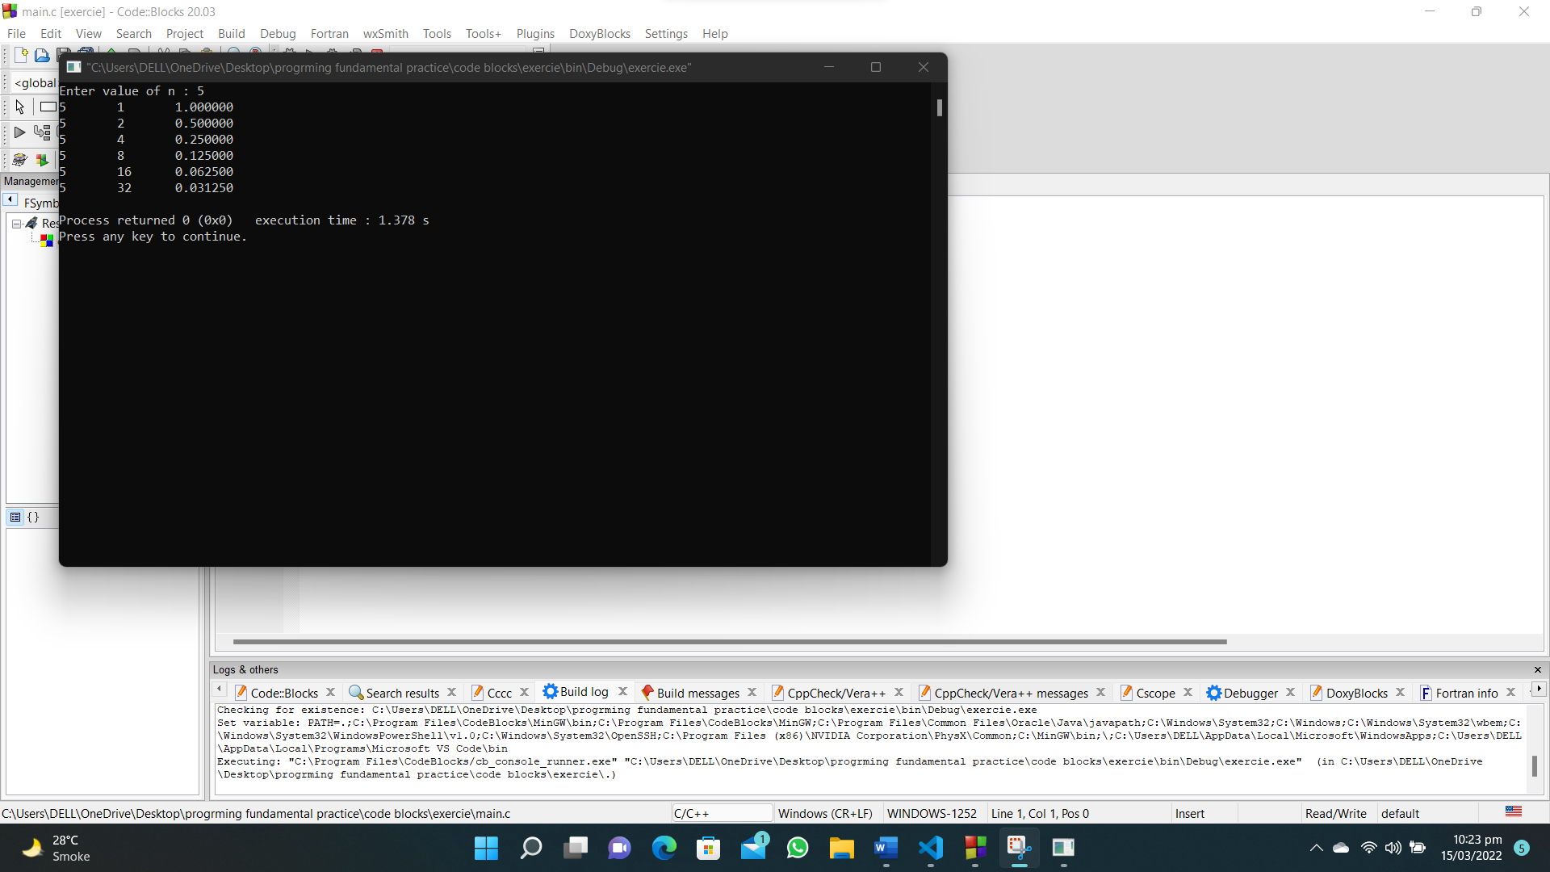

**69. Write a C program to print a binomial coefficient table.**

**#include<stdio.h>**

**int main()**

**{**

**int n,a,b,i;**

**n=10;**

**i=n-1;**

**a=n*i;**

**for(;i>=1;)**

**{**

**if(i==1)**

**{**

**break;**

**}**

**i--;**

**a=a*i;**

**}**

**printf("%d",a);**

**}**

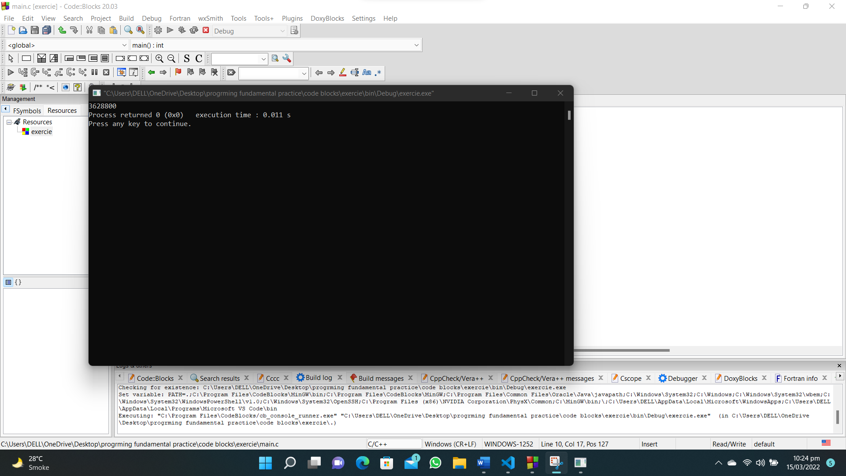

**72. Write a C program to remove any negative sign in front of a number.**

**#include <stdio.h>**

**int main()**

**{**

**int num;**

**printf("Enter a number : ");**

**scanf("%d", &num);**

**if (num < 0)**

**{**

**printf("%d", num * -1);**

**}**

**else**

**{**

**printf("%d", num);**

**}**

**}**

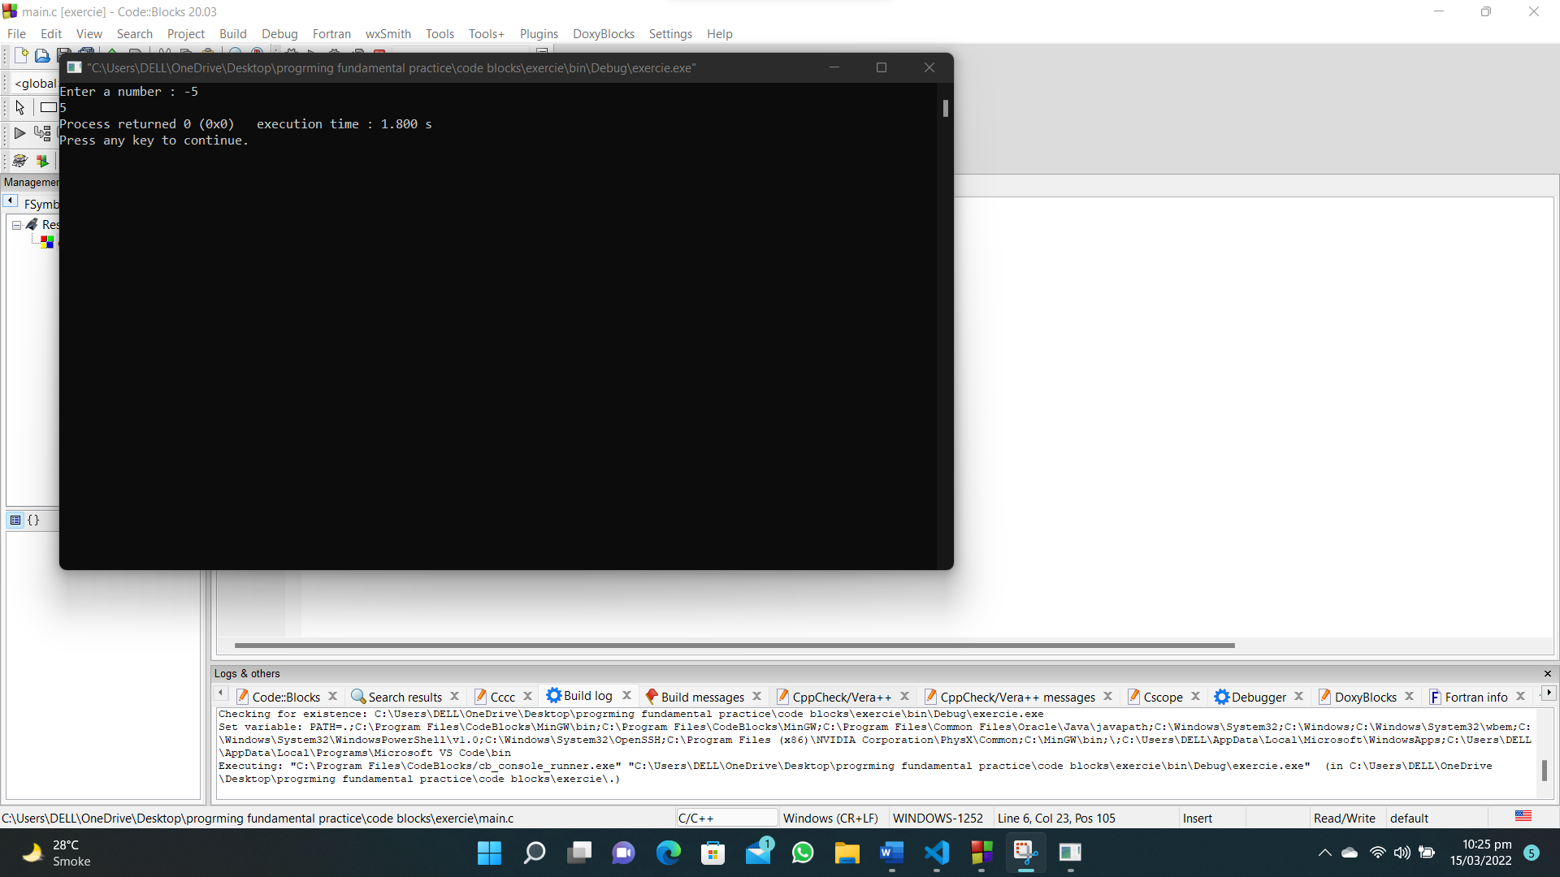

**76. Write a C program to calculate and prints the squares and cubes of the numbers from 0 to 20 and uses tabs to display them in a table of values.**

**#include<stdio.h>**

**int main()**

**{**

**for (int i = 1; i <= 20; i++)**

**{**

**printf("%d\t%d\t%d\n",i,i*i,i*i*i);**

**}**

**}**

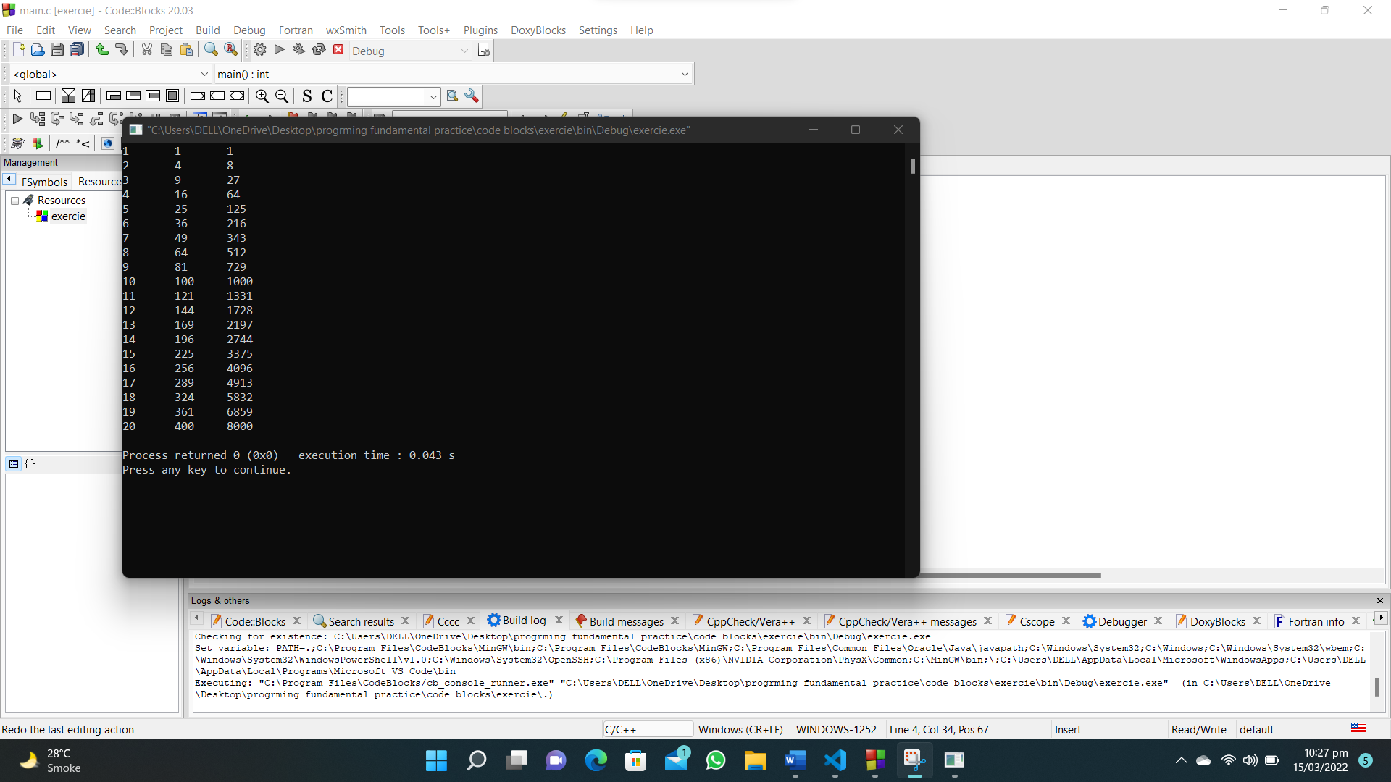

**78. Write a C program to demonstrates the difference between predecrementing and postdecrementing using the decrement operator --.**

**#include <stdio.h>**

**int main()**

**{**

**int x = 10;**

**printf("Predecrementing:\n");**

**printf("x = %d\n", x);**

**printf("x-- = %d\n", x--);**

**printf("x = %d\n\n", x);**

**x = 10;**

**printf("Postdecrementing:\n");**

**printf(" x = %d\n", x);**

**printf("--x = %d\n", --x);**

**printf(" x = %d\n", x);**

**return 0;**

**}**

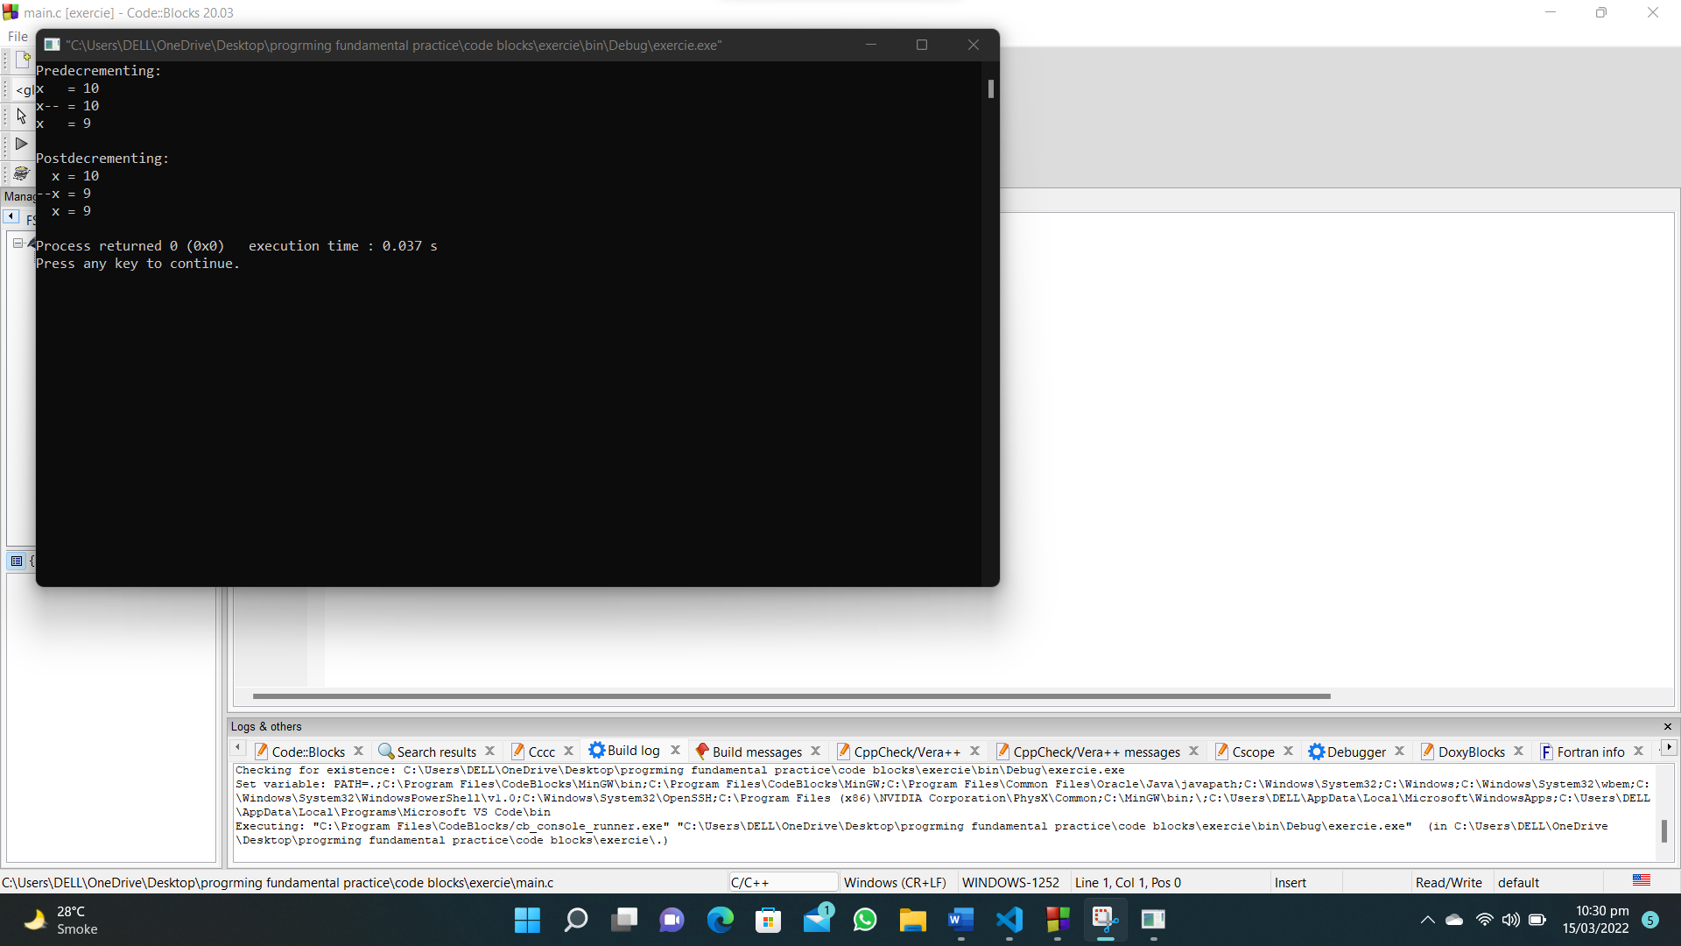

**79. Write a C program using looping to produce the following table of values.**

**#include<stdio.h>**

**int main()**

**{**

**printf("x\tx+2\tx+4\tx+6\n___________________________\n");**

**for (int i = 1; i < 15; i=i+3)**

**{**

**printf("%d\t%d\t%d\t%d\n",i,i+2,i+4,i+6);**

**}**

**}**

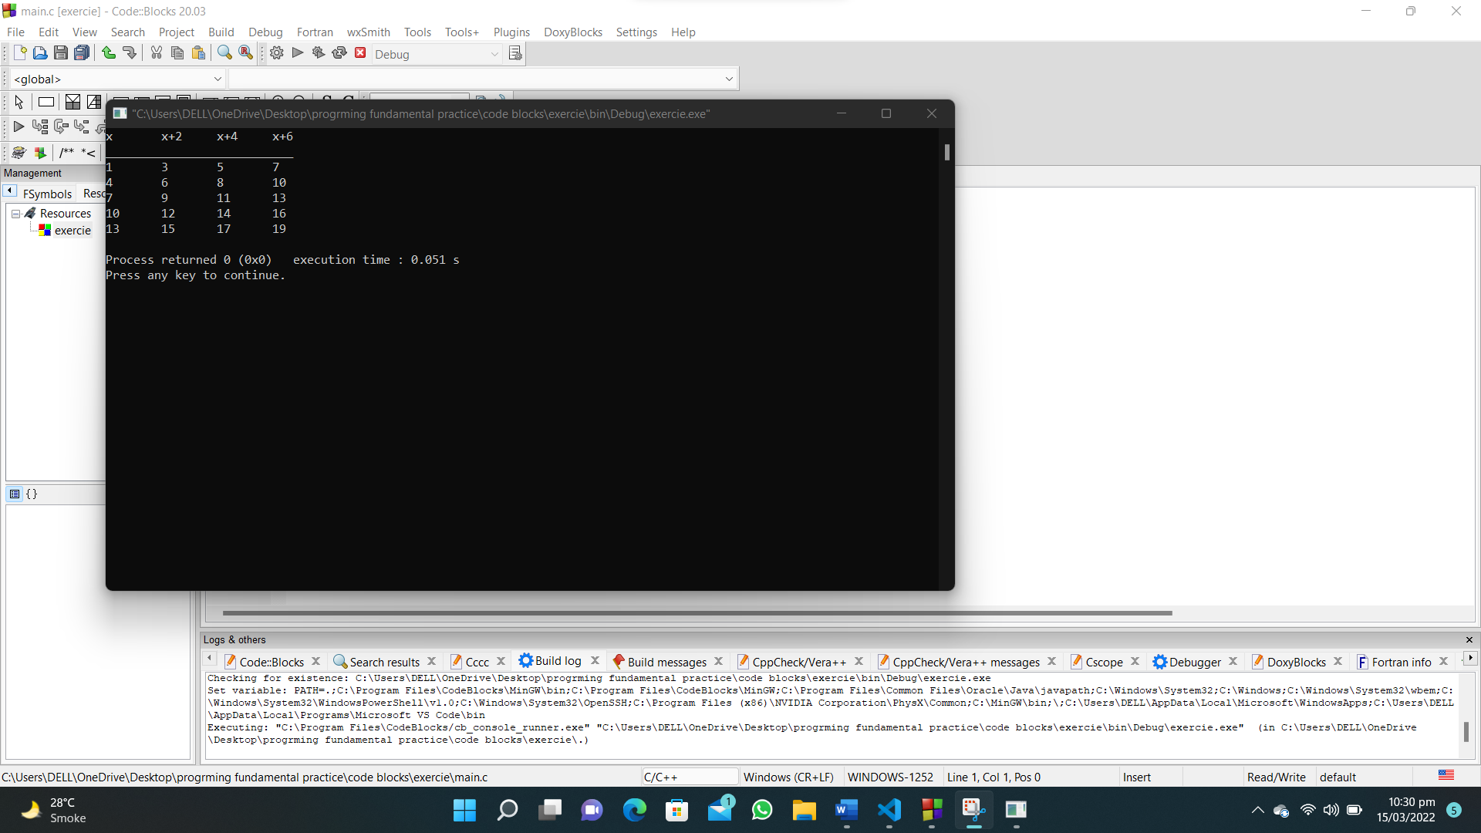

**80. Write a C program that reads the side (side sizes between 1 and 10 of a square and prints square using hash (#) character.**

**#include<stdio.h>**

**int main()**

**{**

**int num;**

**printf("Enter a number : ");**

**scanf("%d",&num);**

**for (int i = 0; i < 10; i++)**

**{**

**for (int j = 0; j < 10; j++)**

**{**

**printf("# ");**

**}**

**printf("\n");**

**}**

**}**

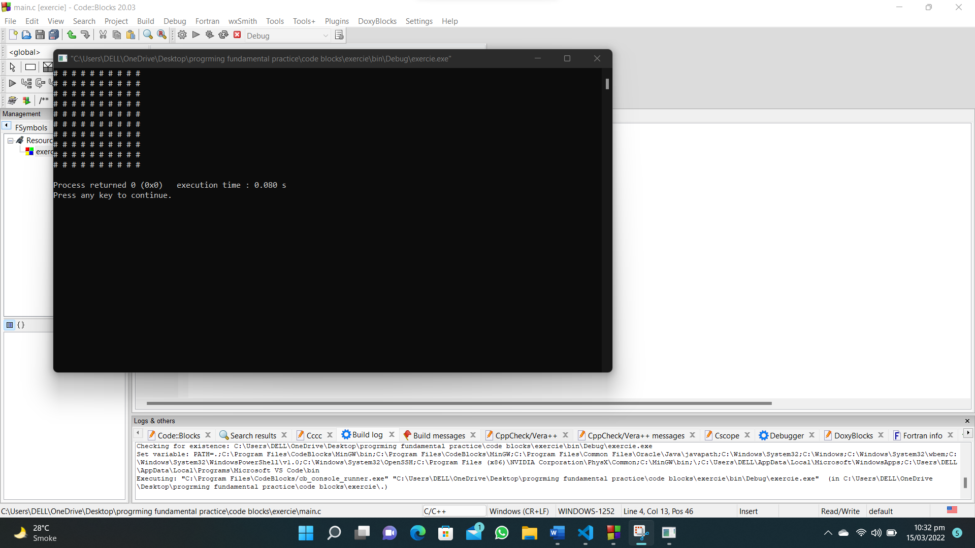

**81. Write a C program that reads the side (side sizes between 1 and 10 ) of a square and prints a hollow square using hash (#) character.**

**#include <stdio.h>**

**int main()**

**{**

**int num;**

**printf("Enter a number : ");**

**scanf("%d", &num);**

**for (int i = 0; i < num; i++)**

**{**

**for (int j = 0; j < num; j++)**

**{**

**if (i == 0 || i == num - 1)**

**{**

**printf("#");**

**}**

**else if(i != 0 || i != num - 1)**

**{**

**if (j == 0 || j == num - 1)**

**{**

**printf("#");**

**}**

**else**

**{**

**printf(" ");**

**}**

**}**

**}**

**printf("\n");**

**}**

**}**

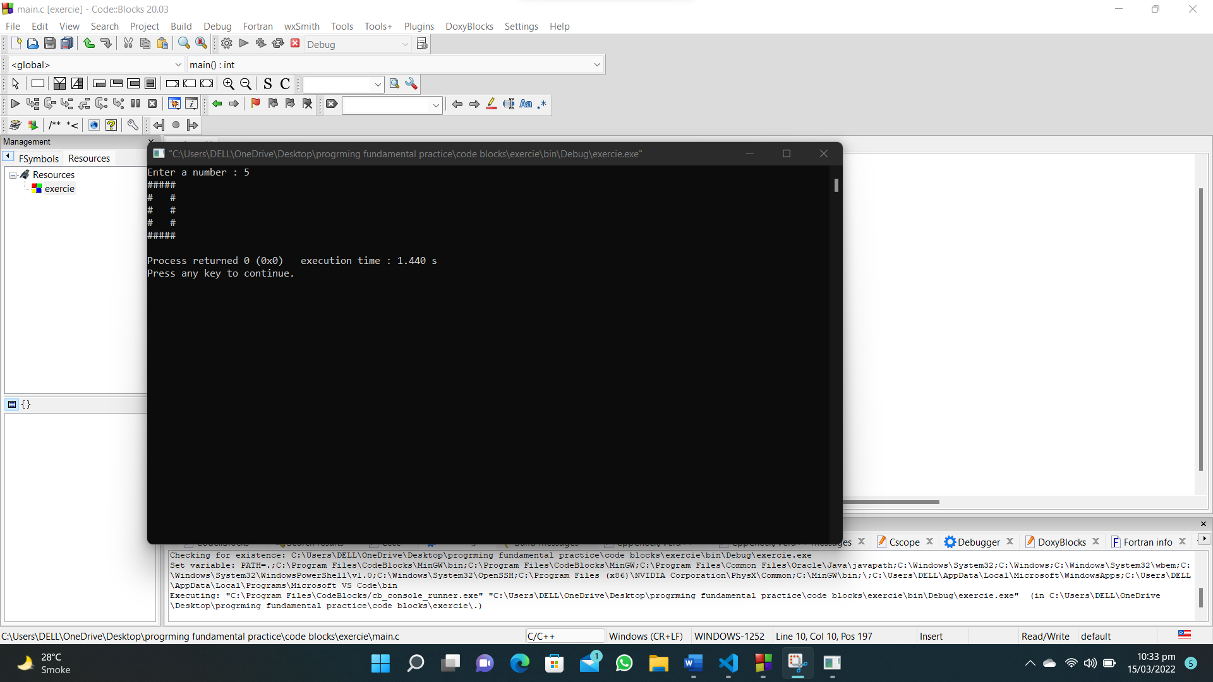

**82. Write a C program that reads in a five-digit integer and determines whether or not it’s a palindrome.**

**#include <stdio.h>**

**int main()**

**{**

**int num, rev=0, rem,num1=1;**

**printf("Enter a number : ");**

**scanf("%d", &num);**

**rem = num % 10;**

**num1=num;**

**while (num1 != 0)**

**{**

**rev = (rev * 10) + rem;**

**num1=num1/10;**

**rem = num1 % 10;**

**}**

**printf("The reversed number is : %d\n",rev);**

**if(rev==num)**

**{**

**printf("The number is a palindrome");**

**}**

**}**

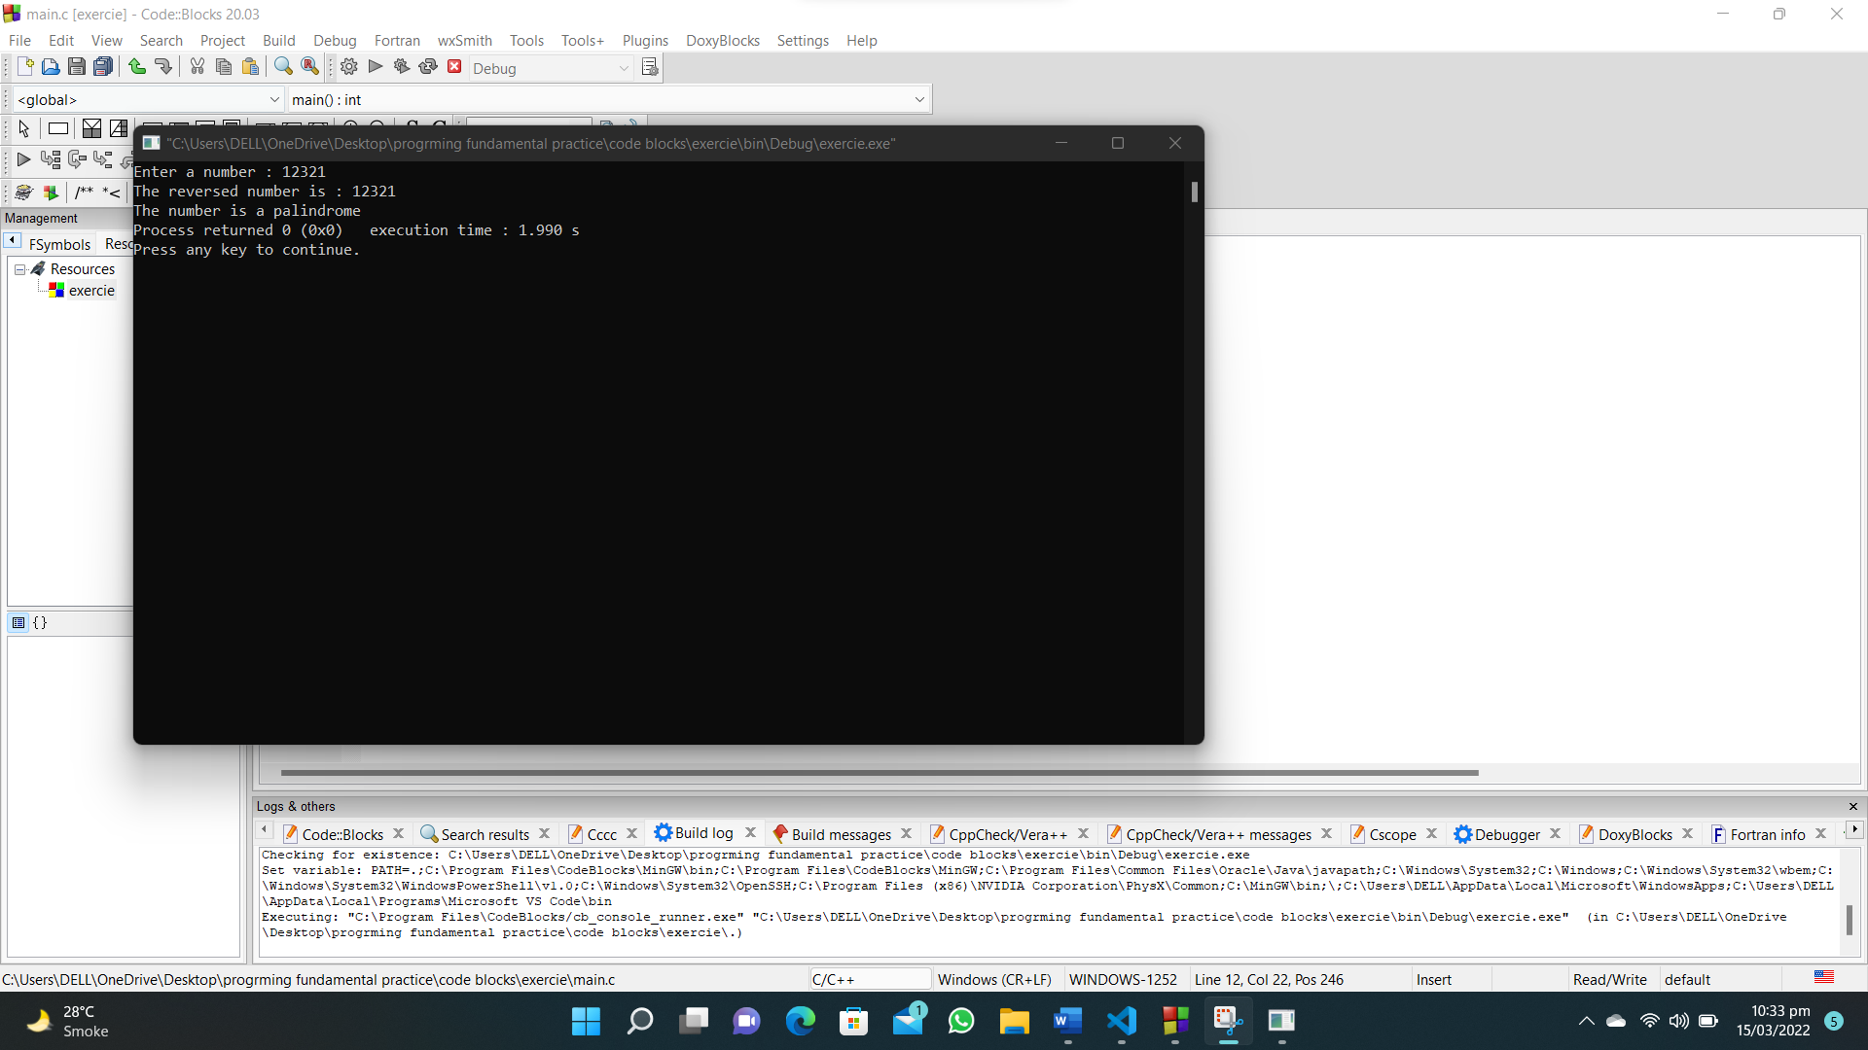

**83. Write a C program which reads an integer (7 digits or fewer) and count number of 3s in the given number.**

**#include<stdio.h>**

**int main()**

**{**

**int num,rem,count=0;**

**printf("Enter a number : ");**

**scanf("%d",&num);**

**while(num!=0)**

**{**

**rem=num%10;**

**num=num/10;**

**if(rem==3)**

**{**

**count++;**

**}**

**}**

**printf("Number of threes in number %d",count);**

**}**

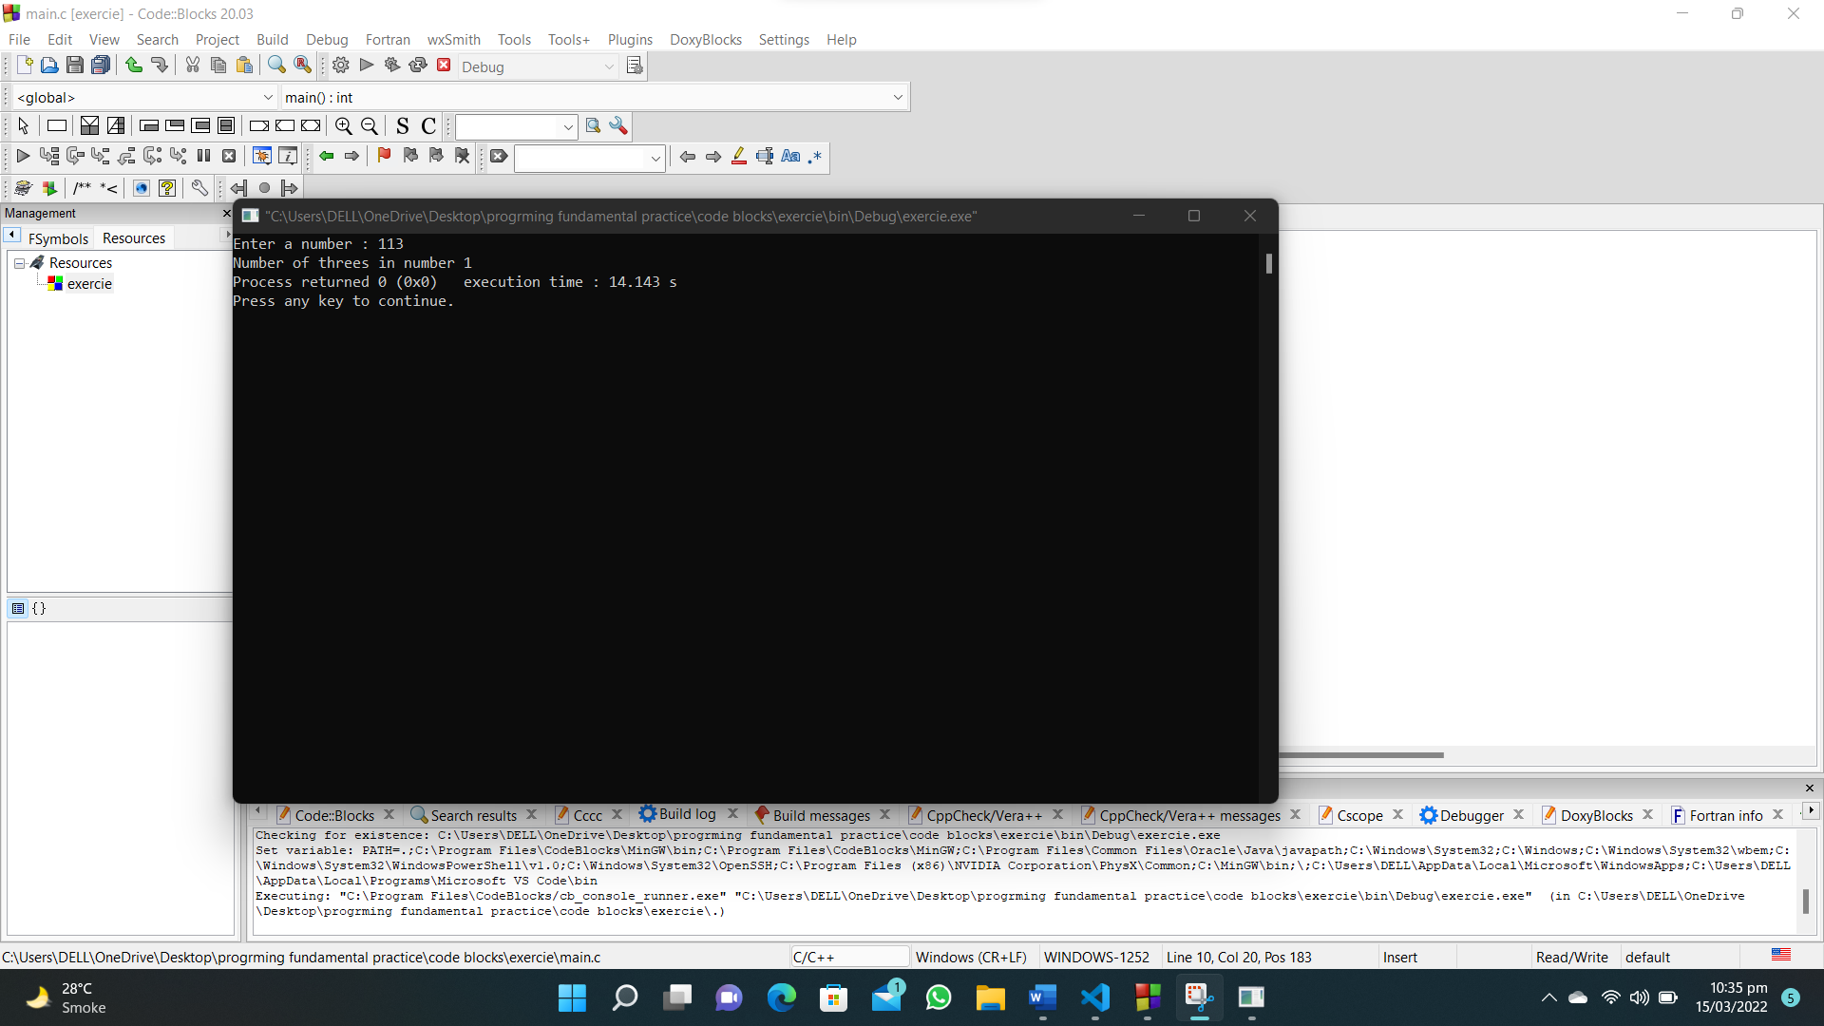

**84. Write a C program to calculate and print the average of some integers. Accept all the values preceding 888.**

**#include<stdio.h>**

**int main()**

**{**

**int num,total=0,count=0;**

**do**

**{**

**printf("Enter a number(888 to exit) : ");**

**scanf("%d",&num);**

**if (num==888)**

**{**

**break;**

**}**

**total=total+num;**

**count++;**

**} while (num!=888);**

**printf("The average of entered numbers is : %.2f",(float)total/(float)count);**

**}**

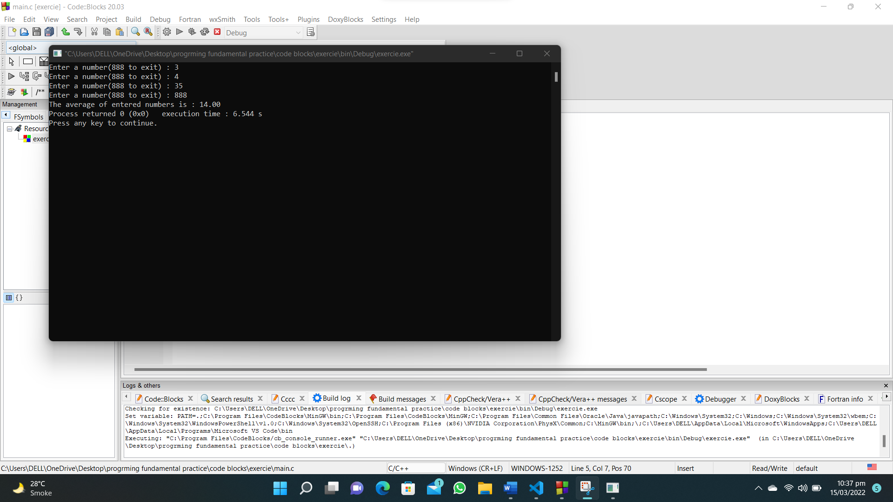

**94. Write a C program to calculate body mass index and display the grade.**

**#include<stdio.h>**

**int main()**

**{**

**float w,h,bmi;**

**printf("Enter your weight : ");**

**scanf("%f",&w);**

**printf("Enter your height : ");**

**scanf("%f",&h);**

**bmi=w/(h*h);**

**if (bmi < 18.5)**

**{**

**printf("Underweight");**

**}**

**else if(18.5 <=bmi < 25.0)**

**{**

**printf("Normal weight");**

**}**

**else if(25.0 <=bmi < 30.0)**

**{**

**printf("Overweight");**

**}**

**else if(30.0 <= bmi)**

**{**

**printf("Obesity");**

**}**

**}**

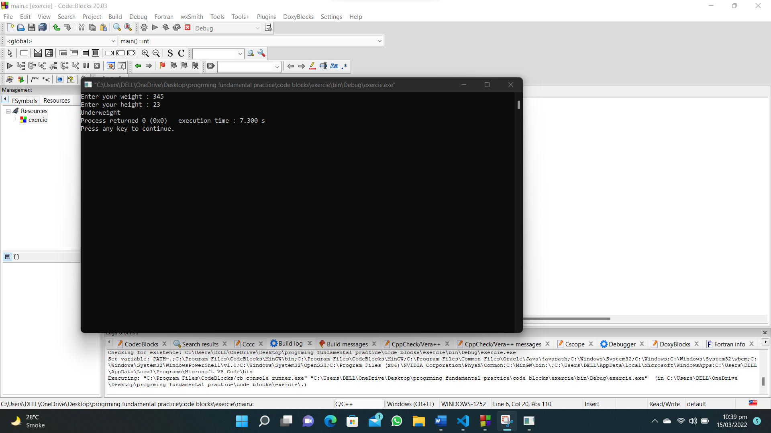

**95. Write a C program to print the corresponding Fahrenheit to Celsius and Celsius to Fahrenheit.**

**#include<stdio.h>**

**int main()**

**{**

**float c,f;**

**printf("Celcius to Farenheit\n-----------------------\nFarenheit\tCelcius\n");**

**for (float i = 0; i <= 150.0; i=i+10)**

**{**

**c=0.556*(i-32);**

**printf("%.1f\t\t%.1f\n",i,c);**

**}**

**printf("Farenheit to Celcius\n-----------------------\nCelcius\t\tFarenheit\n");**

**for ( float i = 0; i <= 150.0; i=i+10)**

**{**

**f=(1.8*i)+32;**

**printf("%.1f\t\t%.1f\n",i,f);**

**}**

**}**

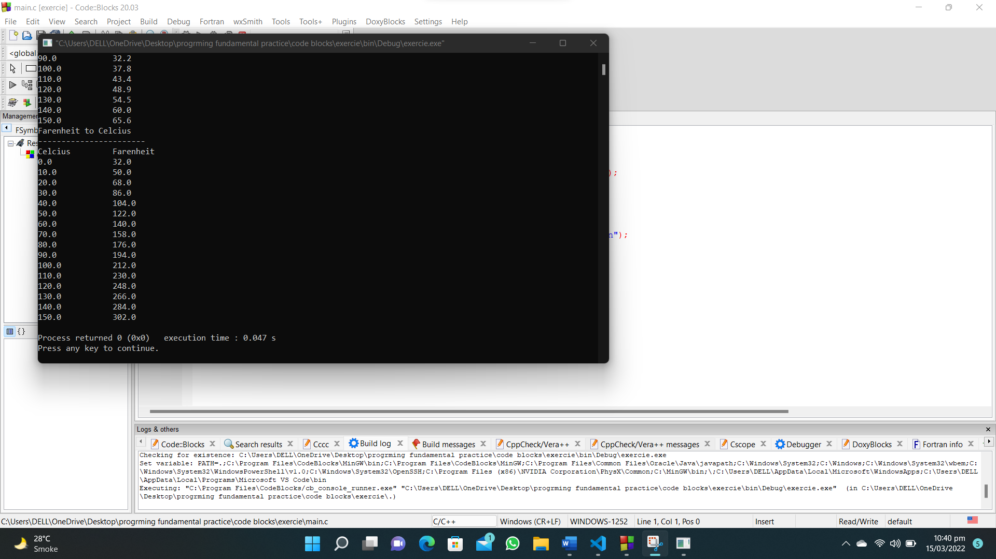

**100. Write a C program to convert a currency value (floating point with two decimal places) to possible number of notes and coins.**

**#include <stdio.h>**

**int main()**

**{**

**float amount;**

**int one_hundredRs, fifty_Rs, five_Rs, two_Rs,half_Rs,quater_Rs;**

**int rem;**

**printf("Enter the amount : ");**

**scanf("%f", &amount);**

**one_hundredRs = amount / 100;**

**rem=amount;**

**rem = rem % 100;**

**printf("\n%d notes of 100\n", one_hundredRs);**

**fifty_Rs = rem / 50;**

**rem = rem % 50;**

**printf("\n%d notes of 50\n", fifty_Rs);**

**five_Rs = rem / 5;**

**rem = rem % 5;**

**printf("\n%d notes of 5\n", five_Rs);**

**two_Rs = rem / 2;**

**rem = rem % 2;**

**printf("\n%d notes of 2\n", two_Rs);**

**half_Rs = 2*rem;**

**rem = rem % (1/2);**

**printf("\n%d notes of 0.5\n", half_Rs);**

**quater_Rs = 4*rem;**

**rem = rem % (1/4);**

**printf("\n%d notes of 0.25\n", quater_Rs);**

**}**

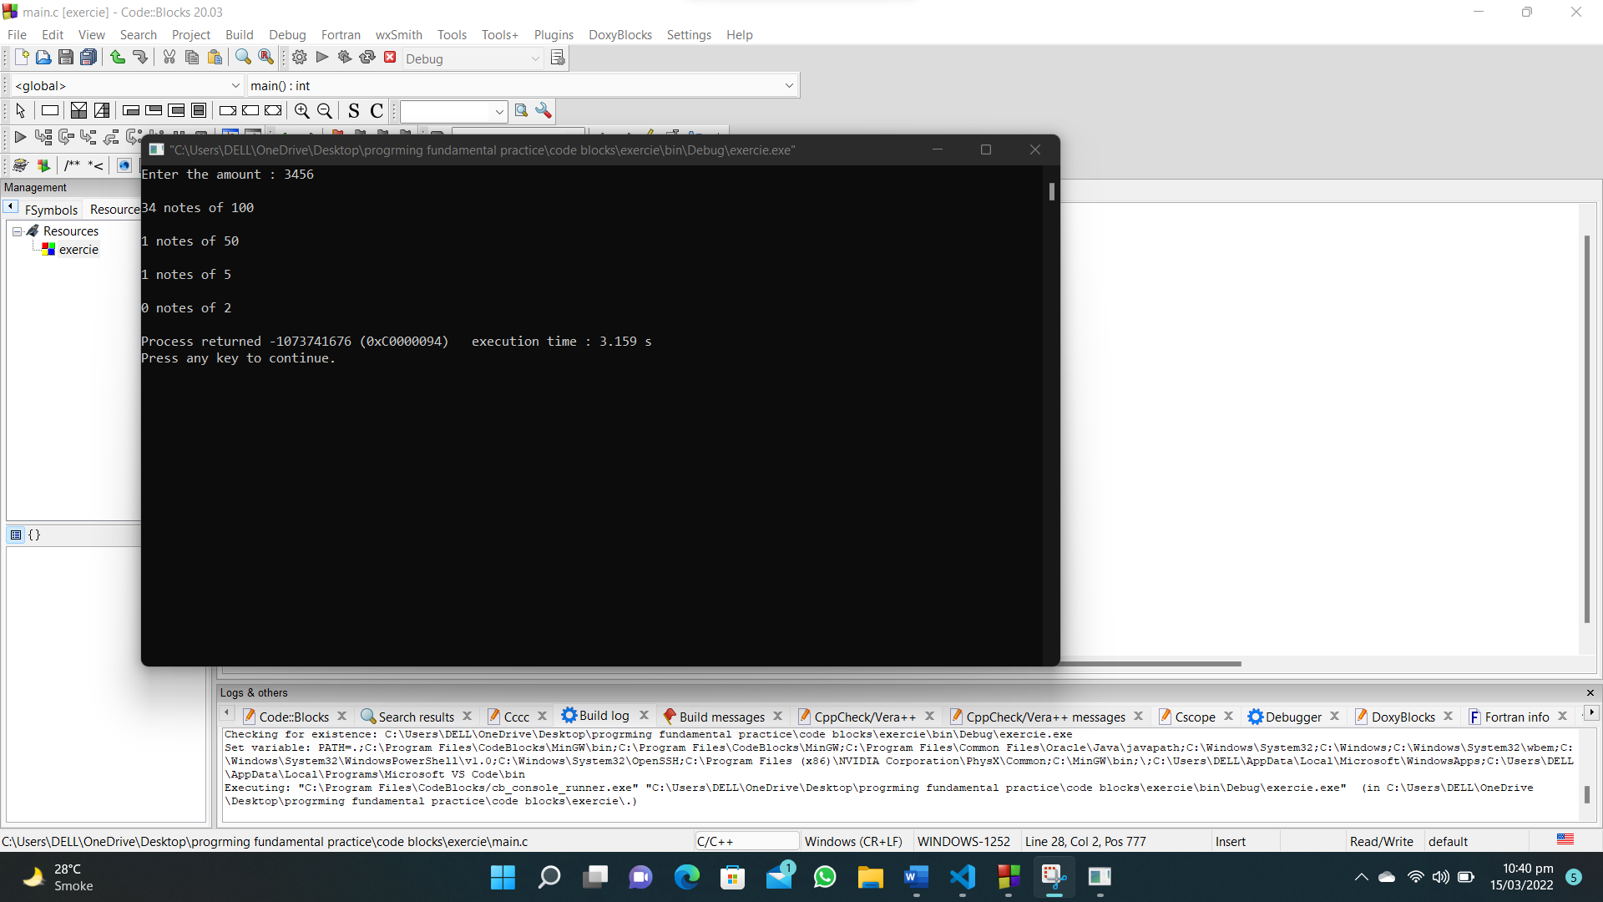

**101. There are three given ranges, write a C program that reads a floating-point number and find the range where it belongs from four given ranges.**

**#include <stdio.h>**

**int main()**

**{**

**float num = 0;**

**printf("Input a number: ");**

**scanf("%f", &num);**

**if (num >= 0 && num <= 30)**

**printf("Range [0,30]\n");**

**else if (num > 30 && num <= 50)**

**printf("Range (30,50]\n");**

**else if (num > 50 && num <= 80)**

**printf("Range (50,80]\n");**

**else if (num > 80 && num <= 100)**

**printf("Range (80,100]\n");**

**else**

**printf("\nNot within range..!\n");**

**}**

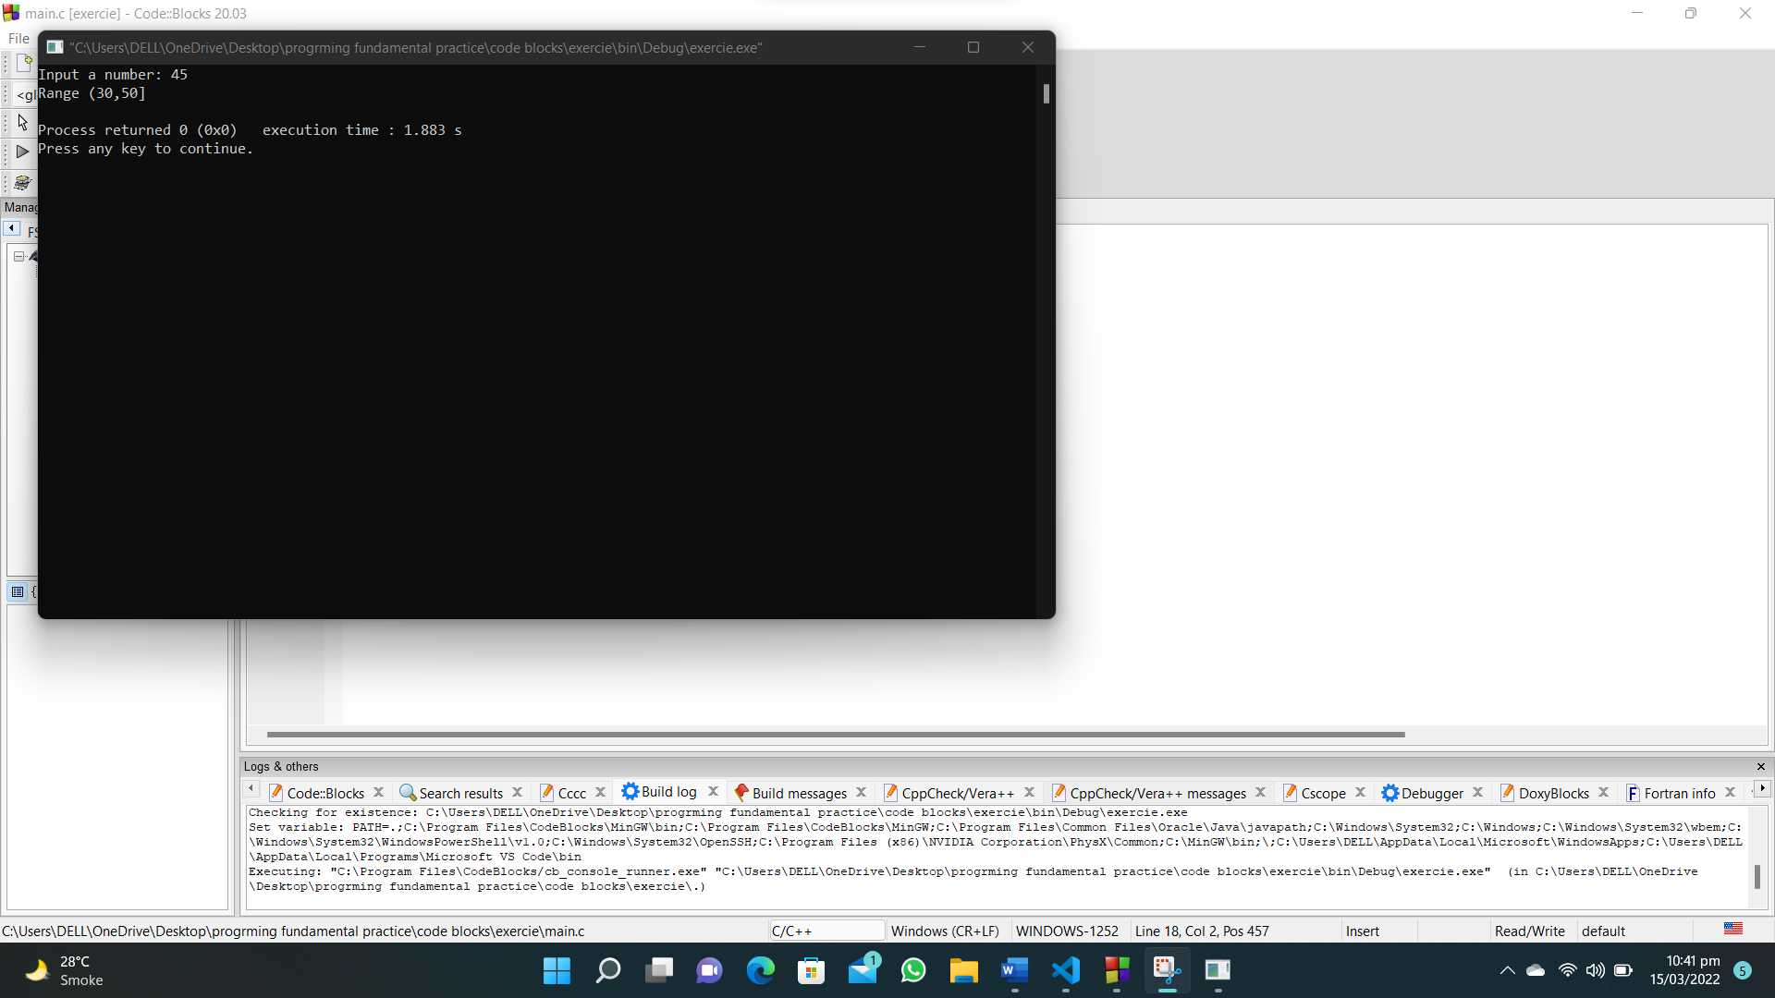

**102. Write a C program that reads three integers and sort the numbers in ascending order. Print the original numbers and sorted numbers.**

**#include <stdio.h>**

**int main()**

**{**

**int a, b, c, min, max, mid;**

**printf("Enter first number : ");**

**scanf("%d", &a);**

**min = a;**

**max = a;**

**mid = a;**

**printf("Enter second number : ");**

**scanf("%d", &b);**

**if (b > max)**

**{**

**max = b;**

**}**

**else if (b < min)**

**{**

**min = b;**

**}**

**else**

**{**

**mid = b;**

**}**

**printf("Enter third number : ");**

**scanf("%d", &c);**

**if (c > max)**

**{**

**max = c;**

**}**

**else if (c < min)**

**{**

**min = c;**

**}**

**else**

**{**

**mid=c;**

**}**

**printf("Unsorted numbers : %d %d %d\n",a,b,c);**

**printf("Sorted numbers : %d %d %d",min,mid,max);**

**}**

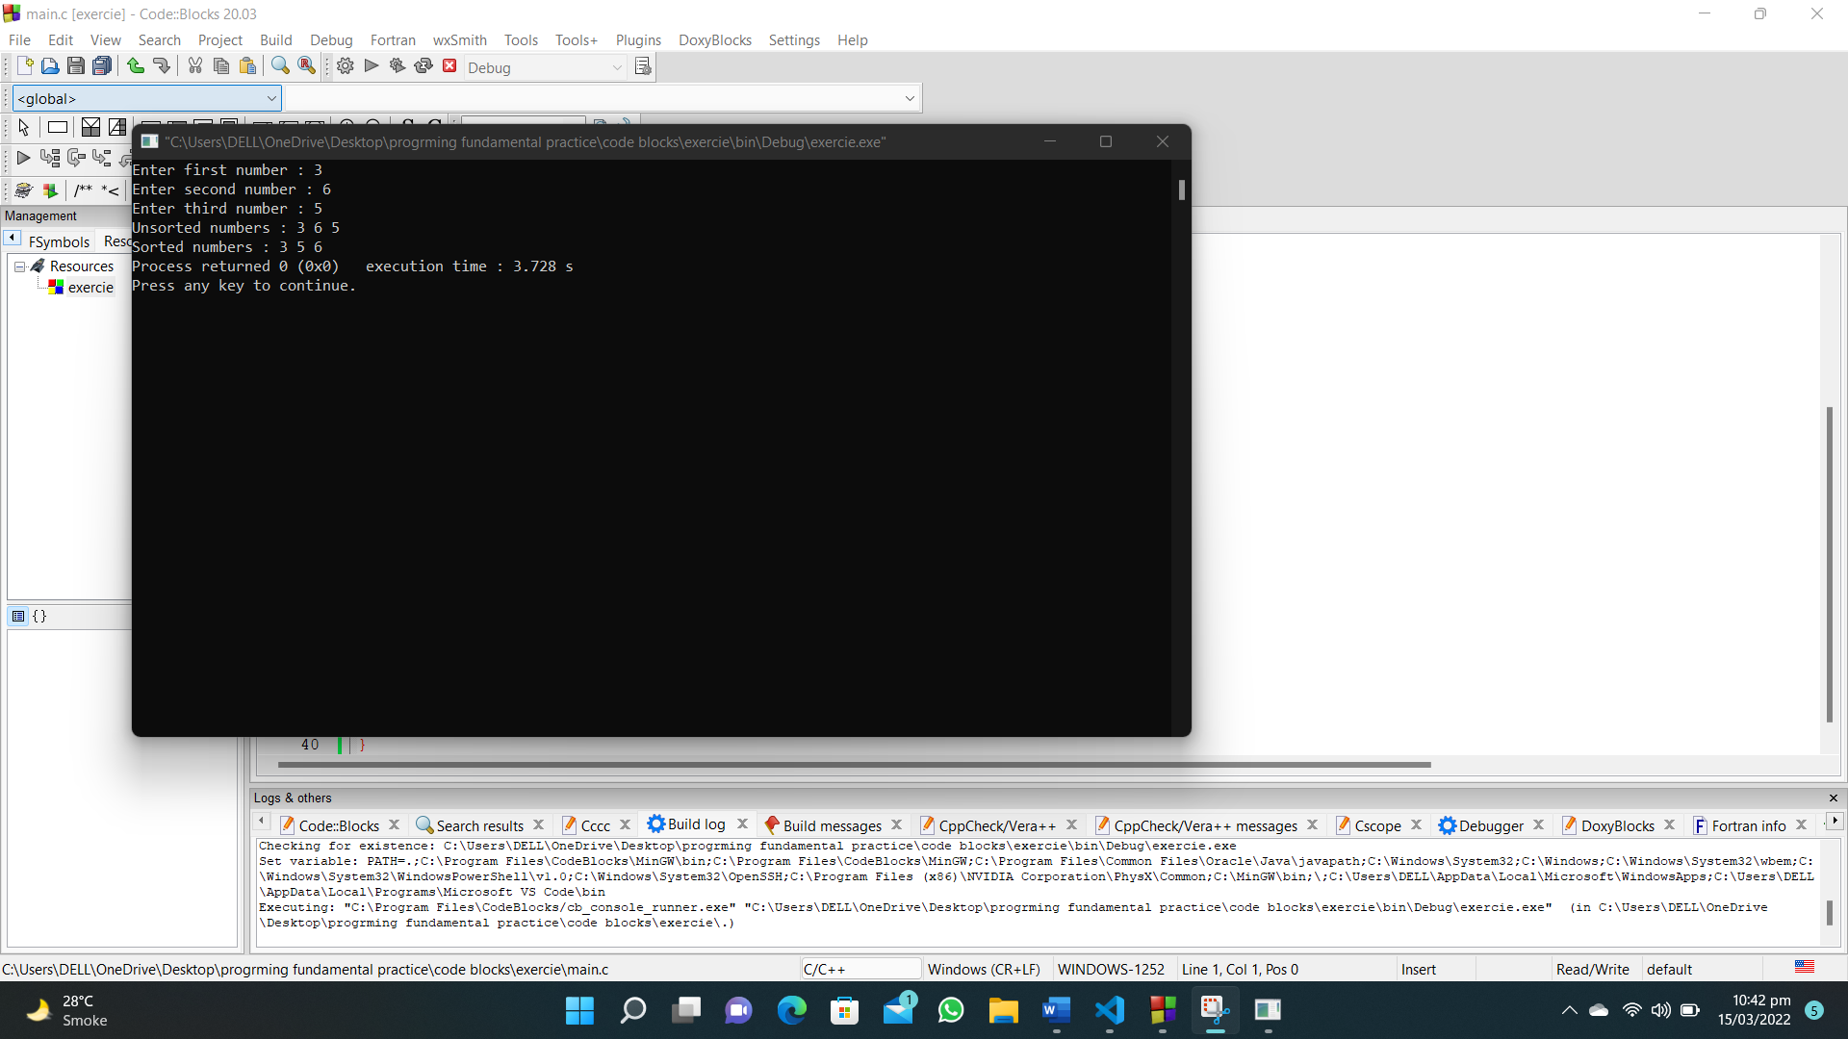

**103. Write a C program that takes two integers and test whether they are multiplies are not.**

**#include <stdio.h>**

**int main()**

**{**

**int a, b, c;**

**printf("Enter first number : ");**

**scanf("%d", &a);**

**printf("Enter second number : ");**

**scanf("%d", &b);**

**if (a > b)**

**{**

**c = a % b;**

**}**

**else if (a < b)**

**{**

**c = b % a;**

**}**

**if (c == 0)**

**{**

**printf("The numbers are multiples of each other");**

**}**

**else**

**{**

**printf("The numbers are not multiples of each other");**

**}**

**}**

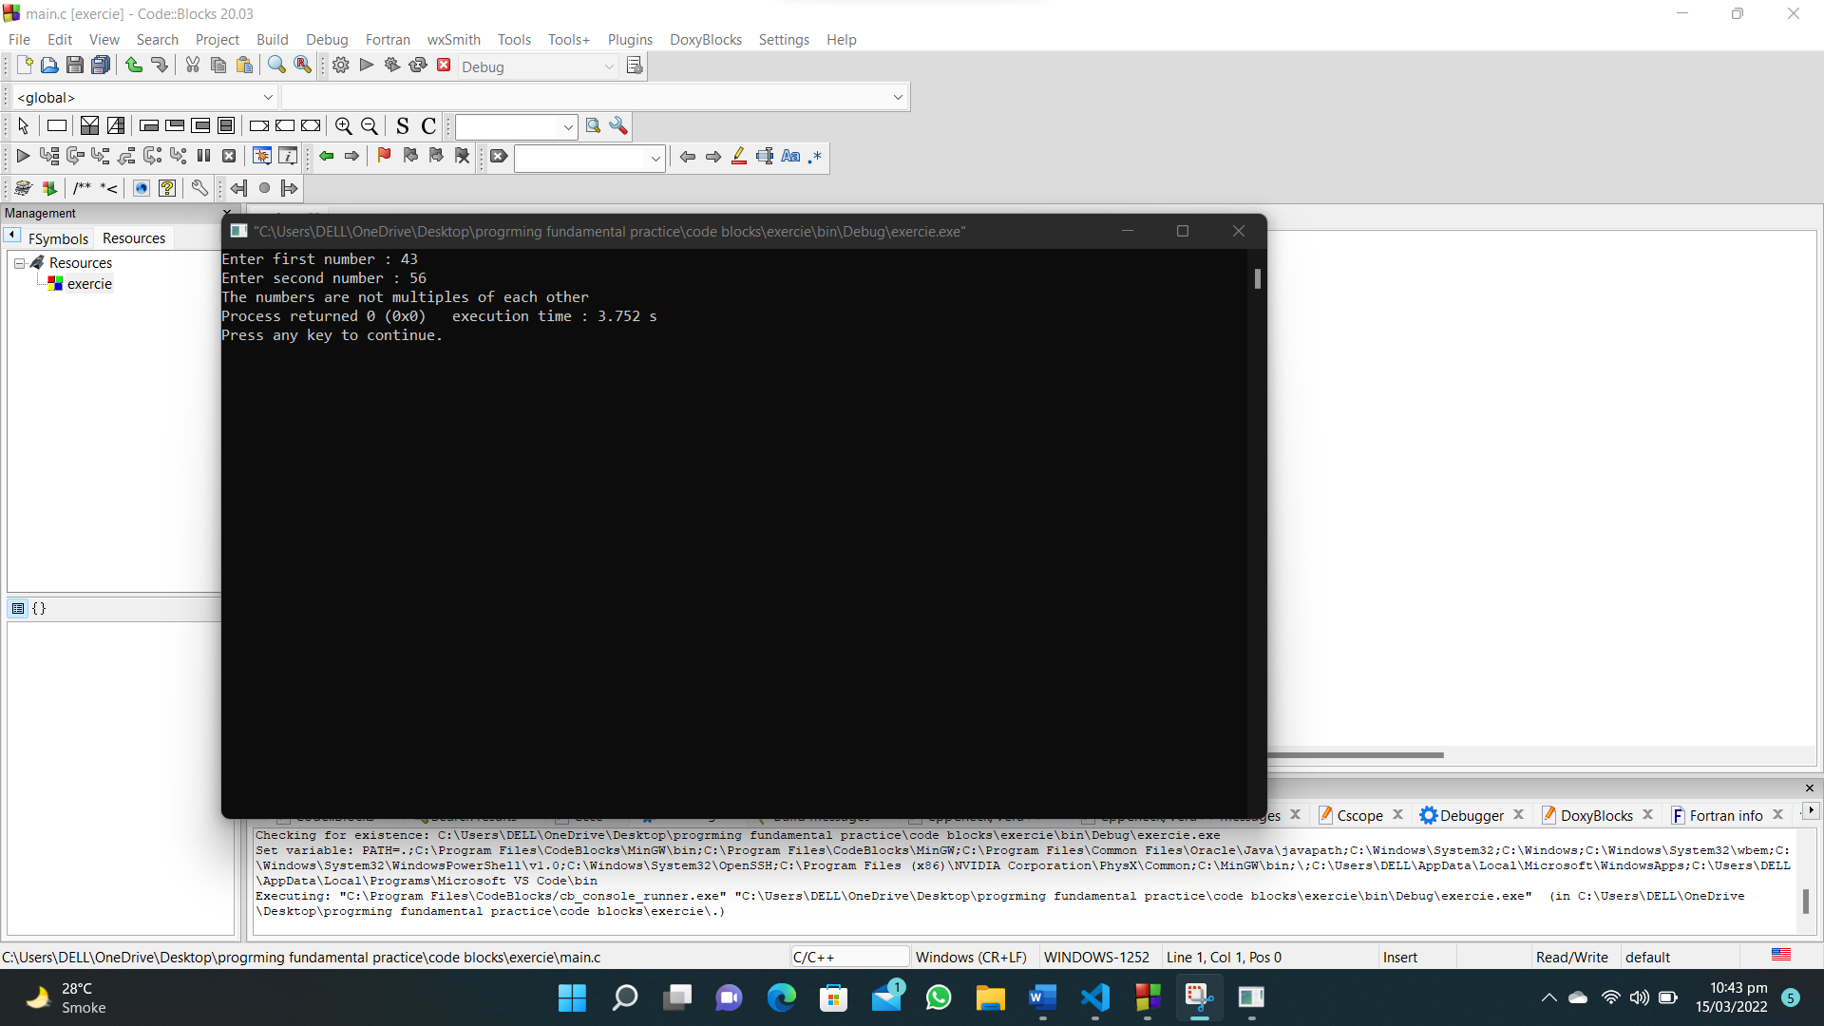

**104. Write a C program that read the item’s price and create new item price and increased price of that item according to the item price table.**

**#include <stdio.h>**

**int main()**

**{**

**float price,increase,i_price;**

**printf("Enter item price : ");**

**scanf("%f", &price);**

**if (price >= 100 && price <= 400)**

**{**

**increase=0.14;**

**i_price=price*increase;**

**// 14%**

**}**

**if (price > 400 && price <= 800)**

**{**

**increase=0.11;**

**i_price=price*increase;**

**/* 400.01 - 800.00 11% */**

**}**

**if (price > 800 && price <= 1200)**

**{**

**increase=0.09;**

**i_price=price*increase;**

**/* 800.01 - 1200.00 9% */**

**}**

**if (price > 1200 && price <= 2000)**

**{**

**increase=0.06;**

**i_price=price*increase;**

**/* 1200.01 - 2000.00 6% */**

**}**

**if (price > 2000)**

**{**

**increase=0.03;**

**i_price=price*increase;**

**/* Above 2000.00 3% */**

**}**

**printf("Increased price : %.1f\n",i_price);**

**printf("New price : %.1f\n",price+i_price);**

**printf("Increase rate %.1f%%\n",increase*100);**

**}**

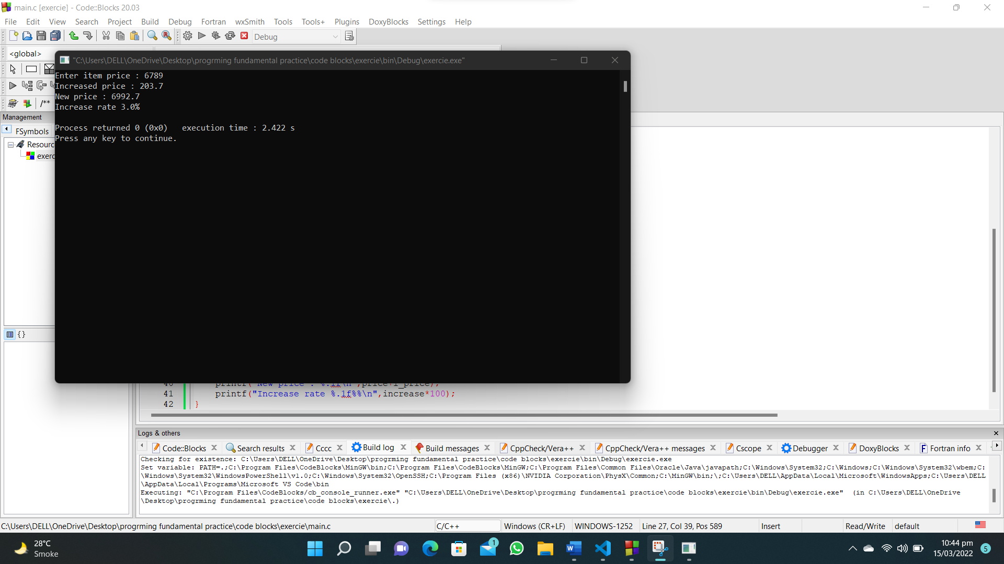

**105. Write a C program that accepts seven floating point numbers and count the number of positive and negative numbers. Also print the average of all positive and negative values with two digit after the decimal number.**

**#include <stdio.h>**

**int main()**

**{**

**float num1, num2, num3, num4, num5, num6, num7, pos_total = 0, neg_total = 0;**

**int pos = 0, neg = 0;**

**printf("Enter first number : ");**

**scanf("%f", &num1);**

**printf("Enter second number : ");**

**scanf("%f", &num2);**

**printf("Enter third number : ");**

**scanf("%f", &num3);**

**printf("Enter fourth number : ");**

**scanf("%f", &num4);**

**printf("Enter fifth number : ");**

**scanf("%f", &num5);**

**printf("Enter sixth number : ");**

**scanf("%f", &num6);**

**printf("Enter seventh number : ");**

**scanf("%f", &num7);**

**if (num1 > 0)**

**{**

**pos = pos + 1;**

**pos_total = pos_total + num1;**

**}**

**else**

**{**

**neg_total = neg_total + num1;**

**}**

**if (num2 > 0)**

**{**

**pos_total = pos_total + num2;**

**pos = pos + 1;**

**}**

**else**

**{**

**neg_total = neg_total + num2;**

**}**

**if (num3 > 0)**

**{**

**pos_total = pos_total + num3;**

**pos = pos + 1;**

**}**

**else**

**{**

**neg_total = neg_total + num3;**

**}**

**if (num4 > 0)**

**{**

**pos_total = pos_total + num4;**

**pos = pos + 1;**

**}**

**else**

**{**

**neg_total = neg_total + num4;**

**}**

**if (num5 > 0)**

**{**

**pos_total = pos_total + num5;**

**pos = pos + 1;**

**}**

**else**

**{**

**neg_total = neg_total + num5;**

**}**

**if (num6 > 0)**

**{**

**pos_total = pos_total + num6;**

**pos = pos + 1;**

**}**

**else**

**{**

**neg_total = neg_total + num6;**

**}**

**if (num7 > 0)**

**{**

**pos_total = pos_total + num7;**

**pos = pos + 1;**

**}**

**else**

**{**

**neg_total = neg_total + num7;**

**}**

**neg = 7 - pos;**

**printf("The number of positive integars are : %d\n", pos);**

**printf("The number of negative integars are : %d\n", neg);**

**printf("The average of negative integars are : %.2f\n", neg_total/neg);**

**printf("The average of positive integars are : %.2f\n", pos_total/pos);**

**}**

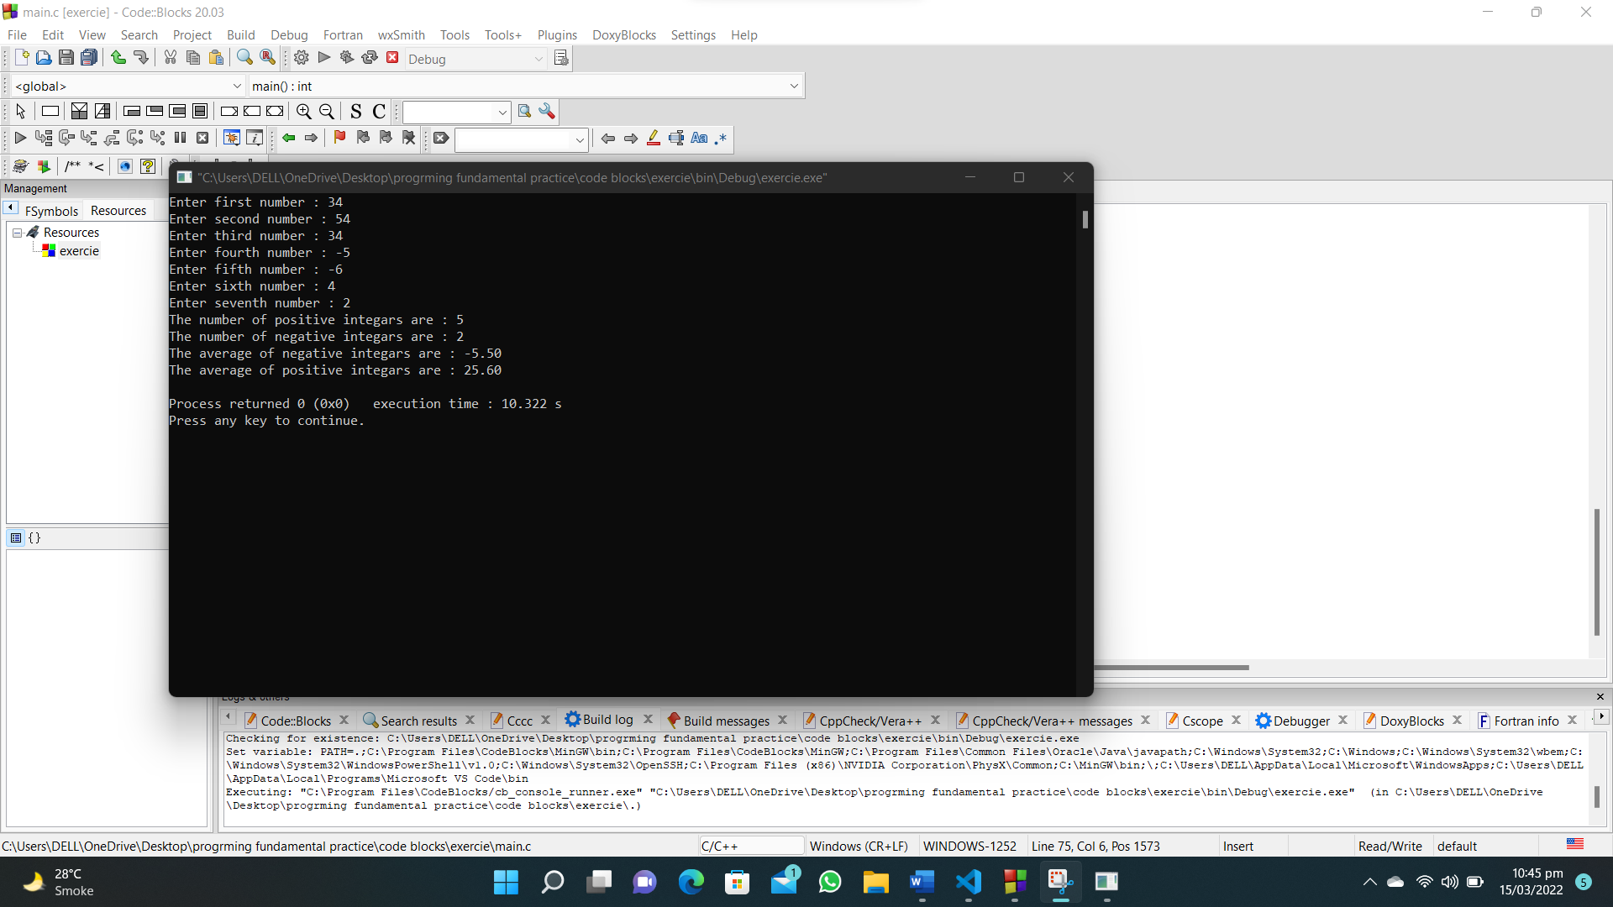

**106. Write a C program that accepts 7 integer values and count the even, odd, positive and negative values.**

**#include <stdio.h>**

**int main()**

**{**

**int num, odd = 0, even = 0, pos = 0, neg = 0;**

**for (int i = 0; i < 7; i++)**

**{**

**printf("Enter a integer : ");**

**scanf("%d", &num);**

**if (num % 2 == 0)**

**{**

**even++;**

**}**

**if (num < 0)**

**{**

**neg++;**

**}**

**if (num % 2 != 0)**

**{**

**odd++;**

**}**

**if (num > 0)**

**{**

**pos++;**

**}**

**}**

**printf("Number of even values: %d\nNumber of odd values: %d\nNumber of positive values: %d\nNumber of negative values: %d\n",even,odd,pos,neg);**

**}**

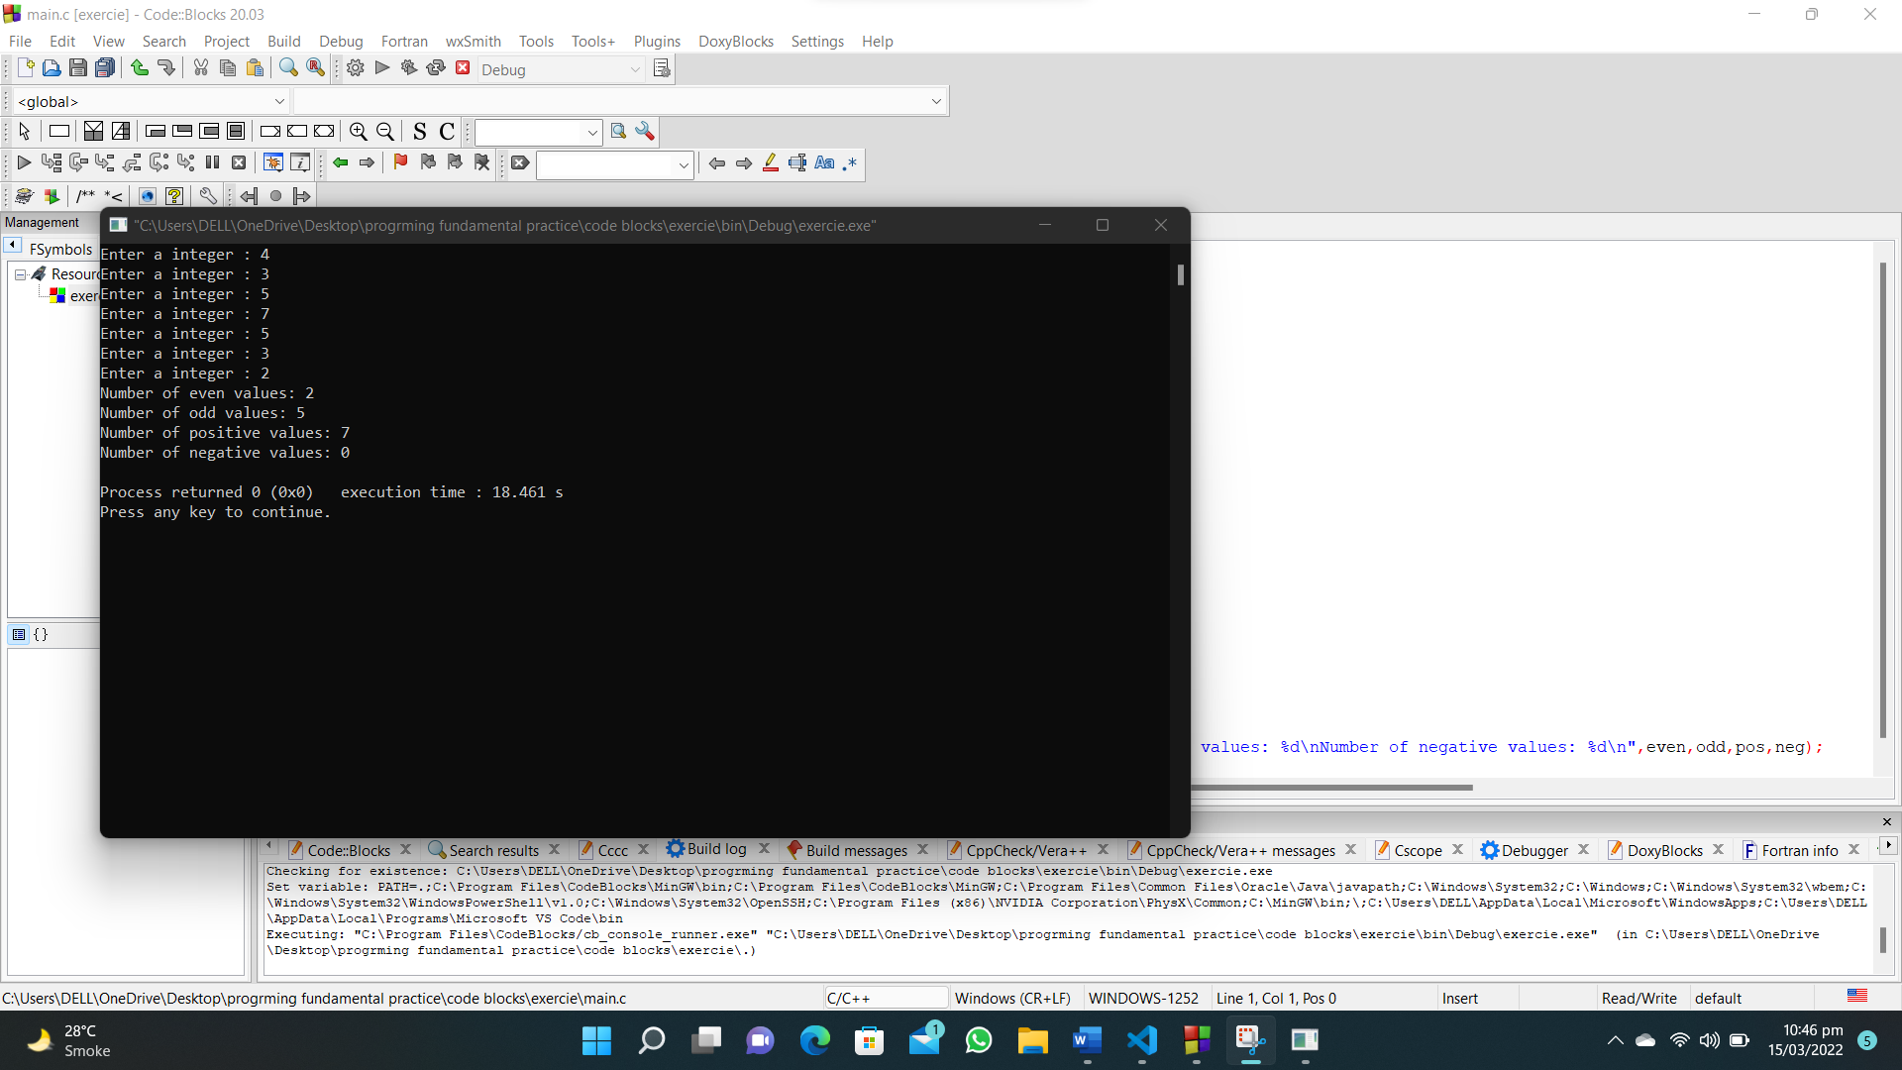

**107. Write a C program that accepts an integer and print next ten consecutive odd and even numbers.**

**#include<stdio.h>**

**int main()**

**{**

**int num;**

**printf("Enter a number : ");**

**scanf("%d",&num);**

**printf("Even: ");**

**for (int i = num+1; i <= num+20; i++)**

**{**

**if (i%2==0)**

**{**

**printf("%d ",i);**

**}**

**}**

**printf("\nOdd: ");**

**for (int i = num+1; i <= num+20; i++)**

**{**

**if (i%2!=0)**

**{**

**printf("%d ",i);**

**}**

**}**

**}**

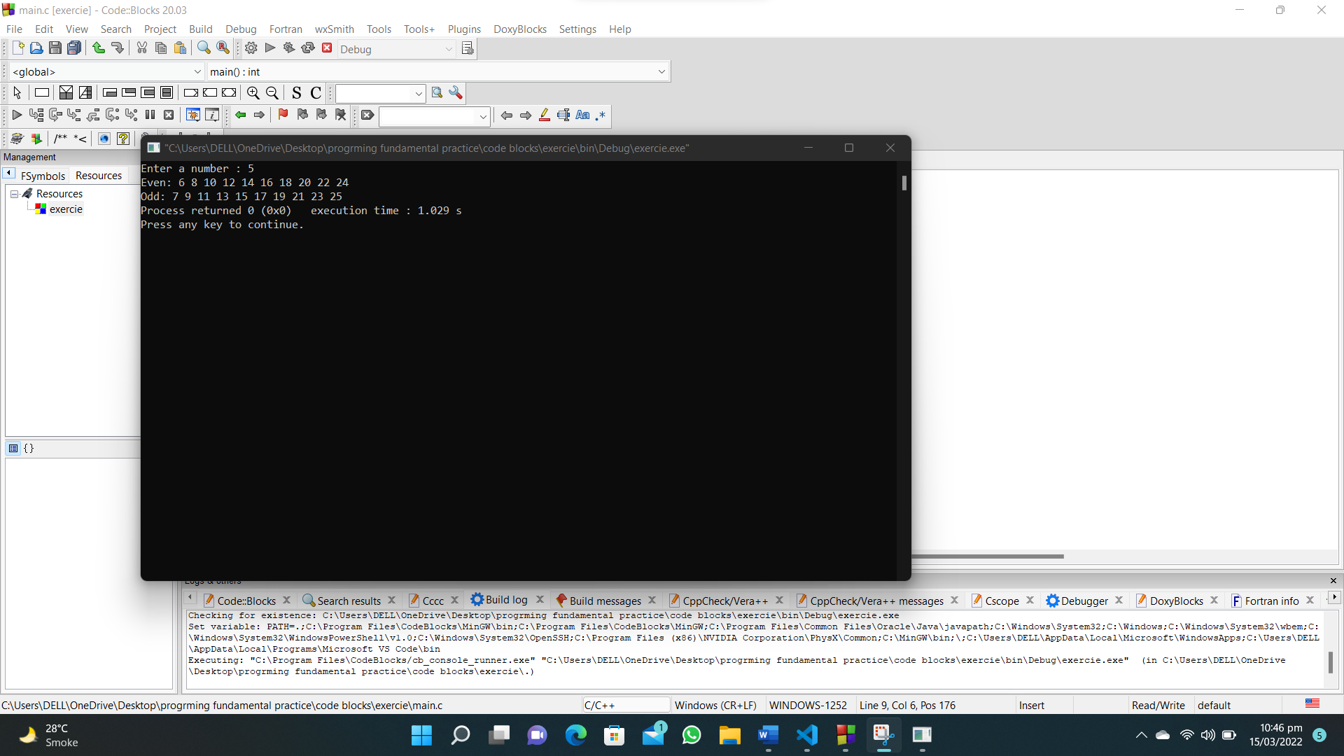

**108. Write a C program that reads two integer values and calculate the sum of all odd and values between them.**

**#include <stdio.h>**

**int main()**

**{**

**int num1, num2, total_even = 0, total_odd = 0;**

**printf("Enter first integer of range : ");**

**scanf("%d", &num1);**

**printf("Enter second integer of range : ");**

**scanf("%d", &num2);**

**for (int i = num1+1 ; i < num2; i++)**

**{**

**if (i % 2 == 0)**

**{**

**total_even = total_even + i;**

**}**

**if (i % 2 != 0)**

**{**

**total_odd = total_odd + i;**

**}**

**}**

**printf("Sum of even numbers is : %d\n", total_even);**

**printf("Sum of odd numbers is : %d", total_odd);**

**}**

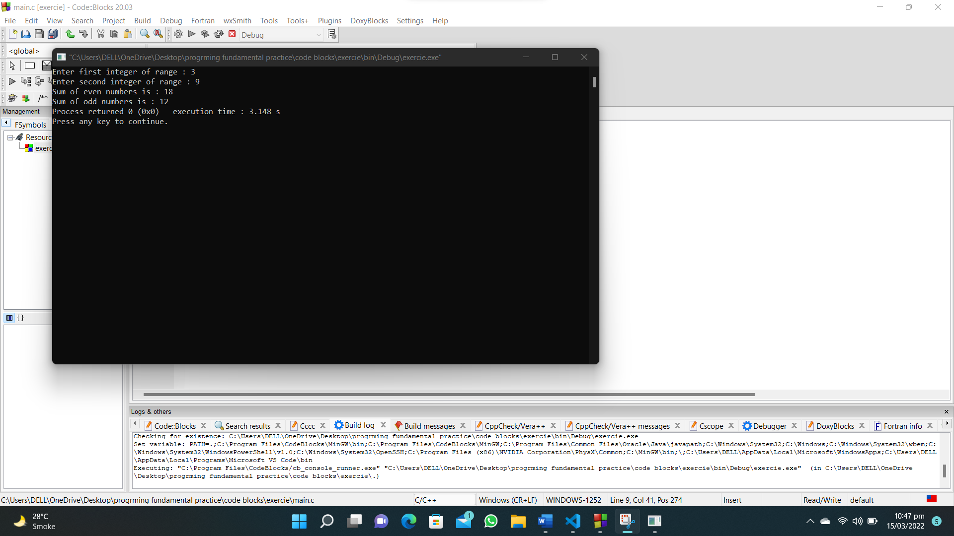

**109. Write a C program to find and print the square of each even and odd values between 1 and a given number.**

**#include<stdio.h>**

**#include<math.h>**

**int main()**

**{**

**int num,a;**

**printf("Enter a number of range : ");**

**scanf("%d",&num);**

**printf("Square of Even number between 1 and %d",num);**

**for (int i = 1; i <= num; i++)**

**{**

**if(i%2==0)**

**{**

**a=pow(i,2);**

**printf("%d ^ 2 = %d\n",i,a);**

**}**

**}**

**printf("Square of odd number between 1 and %d",num);**

**for (int i = 1; i <= num; i++)**

**{**

**if(i%2!=0)**

**{**

**a=pow(i,2);**

**printf("%d ^ 2 = %d\n",i,a);**

**}**

**}**

**}**

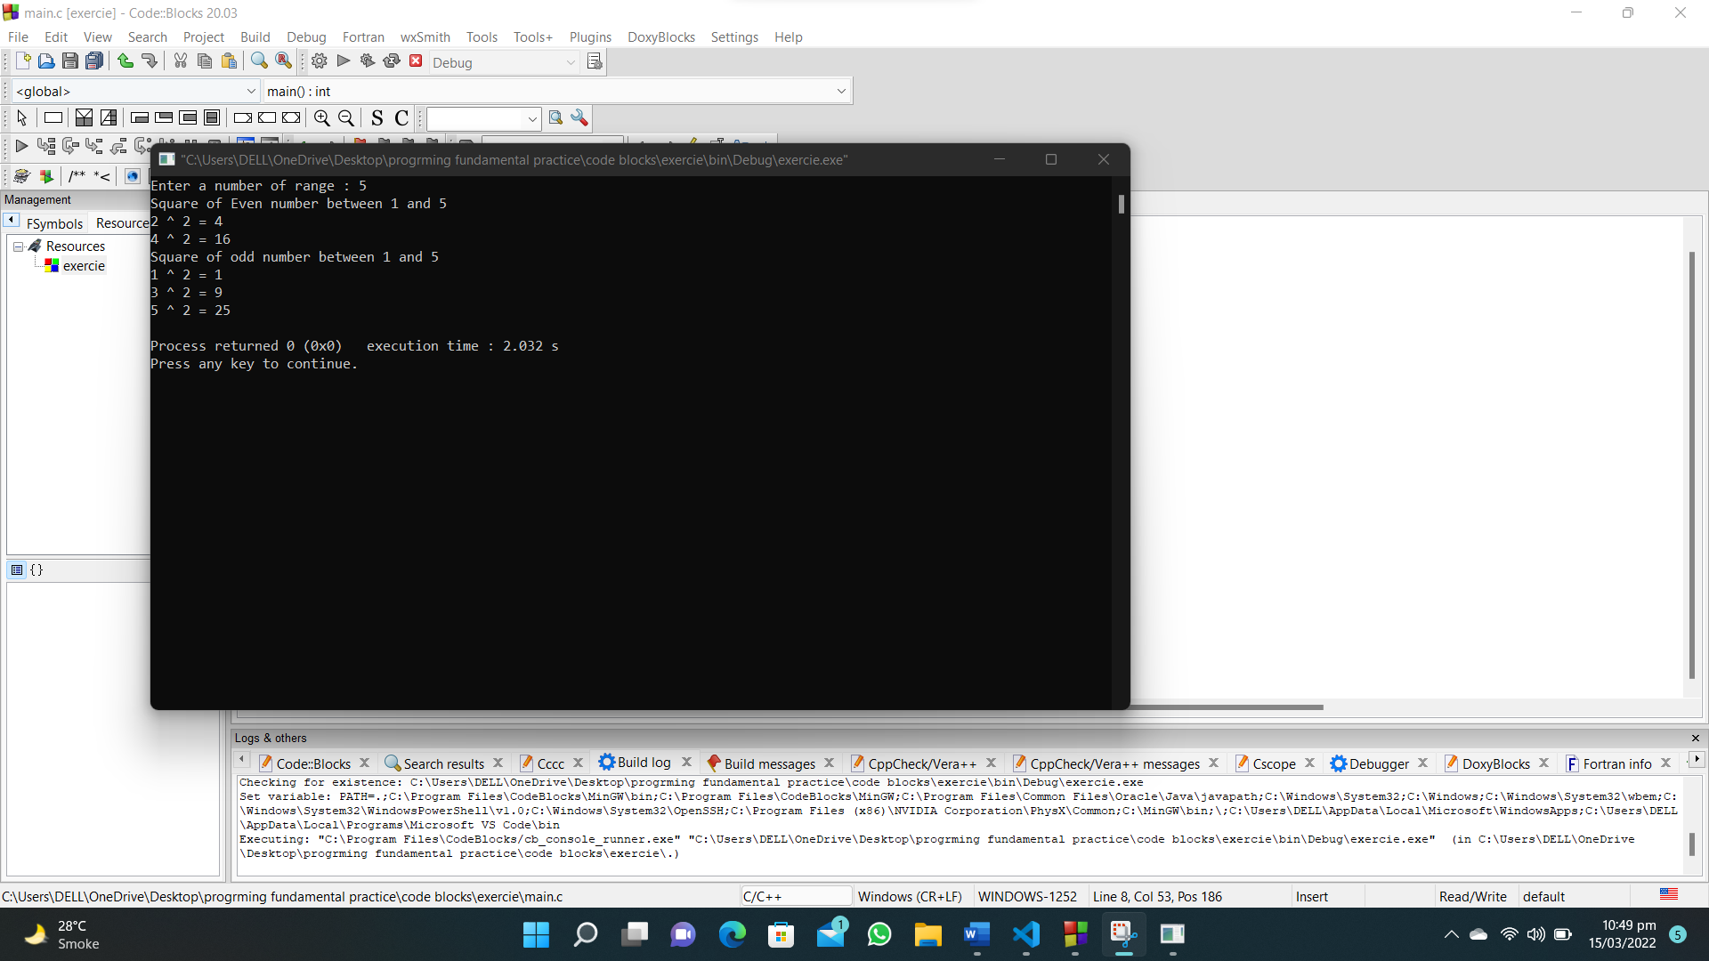

**110. Write a C program to find the odd, even, positive and negative number form a given number(integer) and print a message 'Number is positive odd' or 'Number is negative odd' or 'Number is positive even' or 'Number is negative even'. If the number is 0 print “Zero”.**

**#include <stdio.h>**

**int main()**

**{**

**int i, b;**

**printf("Input a number (integer):\n");**

**scanf("%d", &b);**

**if (b % 2 == 0 && b > 0)**

**{**

**printf("Number is positive even\n");**

**}**

**else if (b % 2 == 0 && b < 0)**

**{**

**printf("Number is negative even'\n");**

**}**

**else if (b % 2 != 0 && b > 0)**

**{**

**printf("Number is positive odd\n");**

**}**

**else if (b % 2 != 0 && b < 0)**

**{**

**printf("Number is negative odd\n");**

**}**

**}**

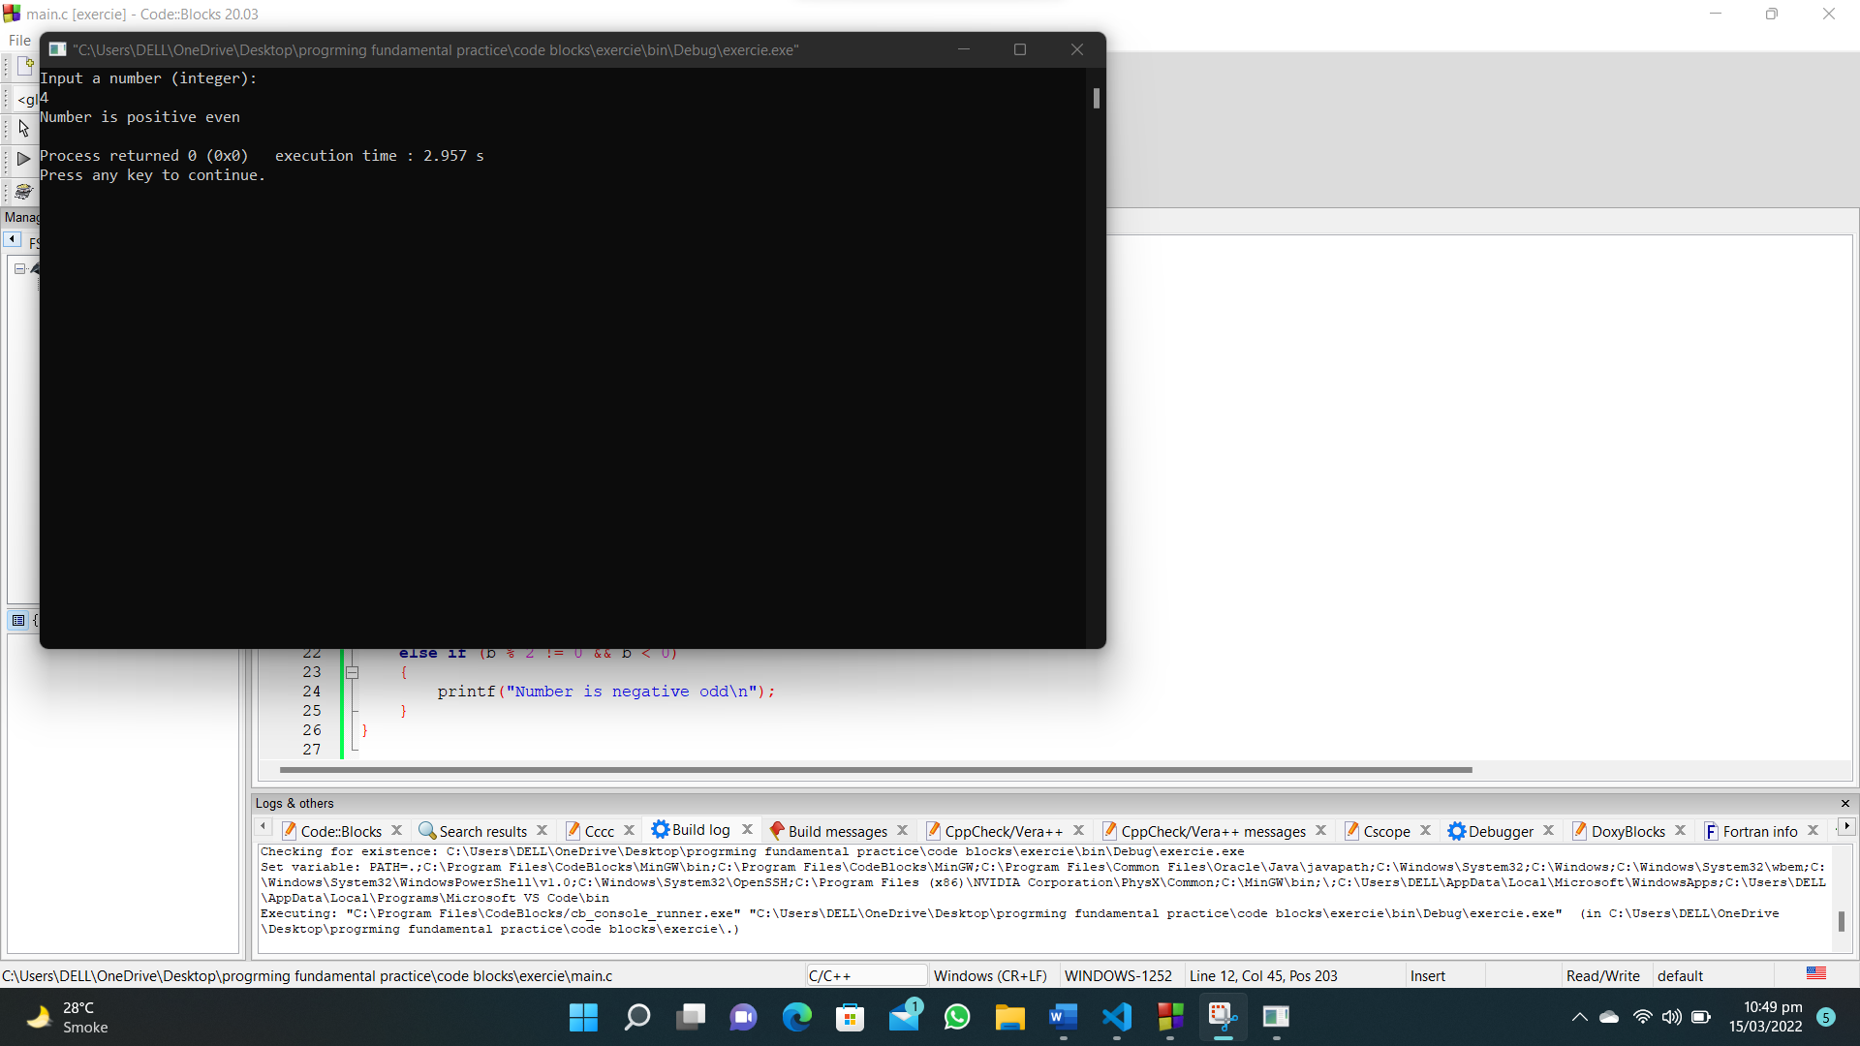

**111. Write a C program that accepts an integer from the user and divide all numbers between 1 and 100. Print those numbers where remainder value is 3.**

**#include<stdio.h>**

**int main()**

**{**

**int num;**

**printf("Enter a integer(1-100) : ");**

**scanf("%d",&num);**

**for ( int i = 0; i < 100; i++)**

**{**

**if(i%num ==3)**

**{**

**printf("%d\n",i);**

**}**

**}**

**}**

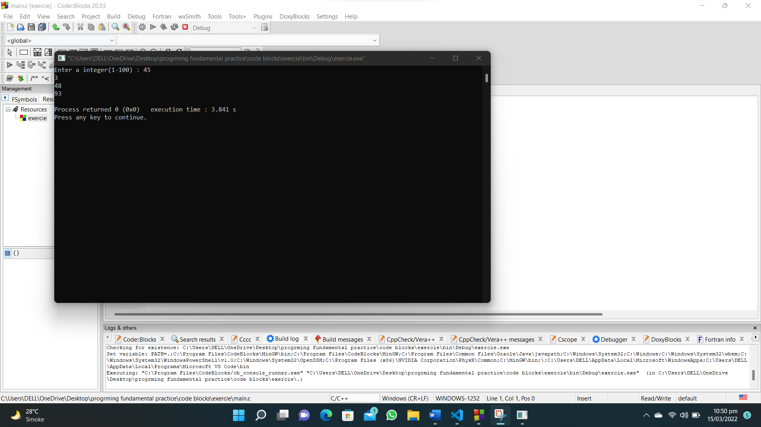

**112. Write a C program that reads seven integer values from the user and find the highest value and it’s position.**

**#include <stdio.h>**

**int main()**

**{**

**int position, num1, num2, num3, num4, num5,num6,num7,max;**

**printf("Enter number 1 : ");**

**scanf("%d", &num1);**

**max = num1;**

**printf("Enter number 2 : ");**

**scanf("%d", &num2);**

**if (num2 > max)**

**{**

**max = num2;**

**}**

**printf("Enter number 3 : ");**

**scanf("%d", &num3);**

**if (num3 > max)**

**{**

**max = num3;**

**}**

**printf("Enter number 4 : ");**

**scanf("%d", &num4);**

**if (num4 > max)**

**{**

**max = num4;**

**}**

**printf("Enter number 5 : ");**

**scanf("%d", &num5);**

**if (num5 > max)**

**{**

**max = num5;**

**}**

**printf("Enter number 6 : ");**

**scanf("%d", &num6);**

**if (num6 > max)**

**{**

**max = num6;**

**}**

**printf("Enter number 7 : ");**

**scanf("%d", &num7);**

**if (num7 > max)**

**{**

**max = num7;**

**}**

**printf("The highest value is : %d\n",max);**

**if(num1==max)**

**{**

**position=1;**

**}**

**if(num2==max)**

**{**

**position=2;**

**}**

**if(num3==max)**

**{**

**position=3;**

**}**

**if(num4==max)**

**{**

**position=4;**

**}**

**if(num5==max)**

**{**

**position=5;**

**}**

**if(num6==max)**

**{**

**position=6;**

**}**

**if(num7==max)**

**{**

**position=7;**

**}**

**printf("The position of highest value is : %d",position);**

**}**

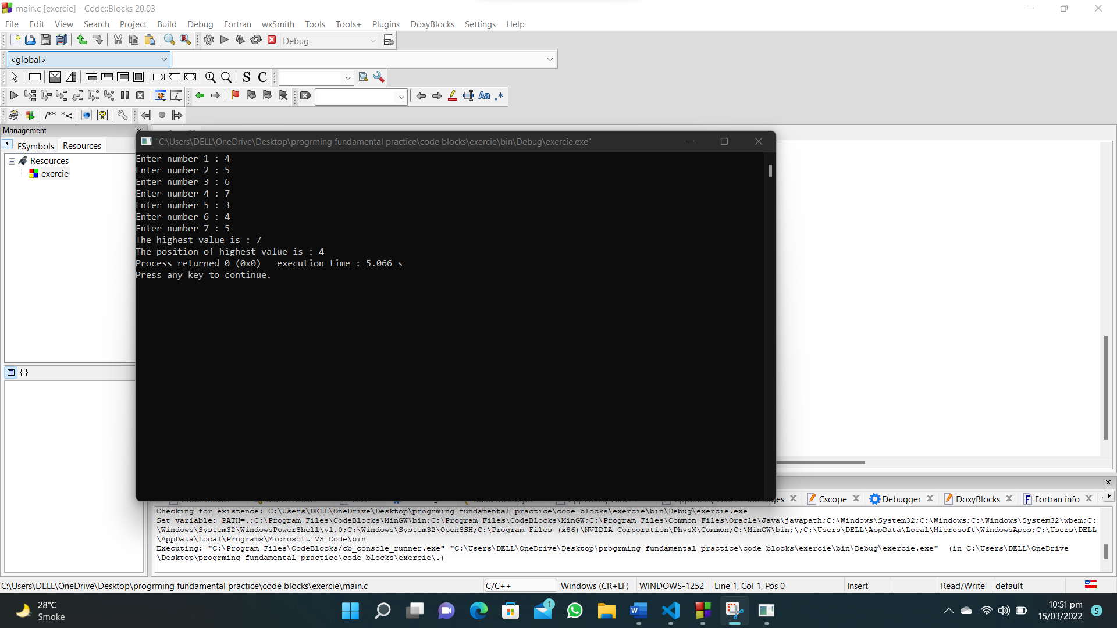

**113. Write a C program to create and print the sequence of the following example.**

**#include<stdio.h>**

**int main()**

**{**

**int a,b=100;**

**for (int i = 1; i < 52; i=i+5,b=b-10)**

**{**

**printf("a=%d\tb=%d\n",i,b);**

**}**

**}**

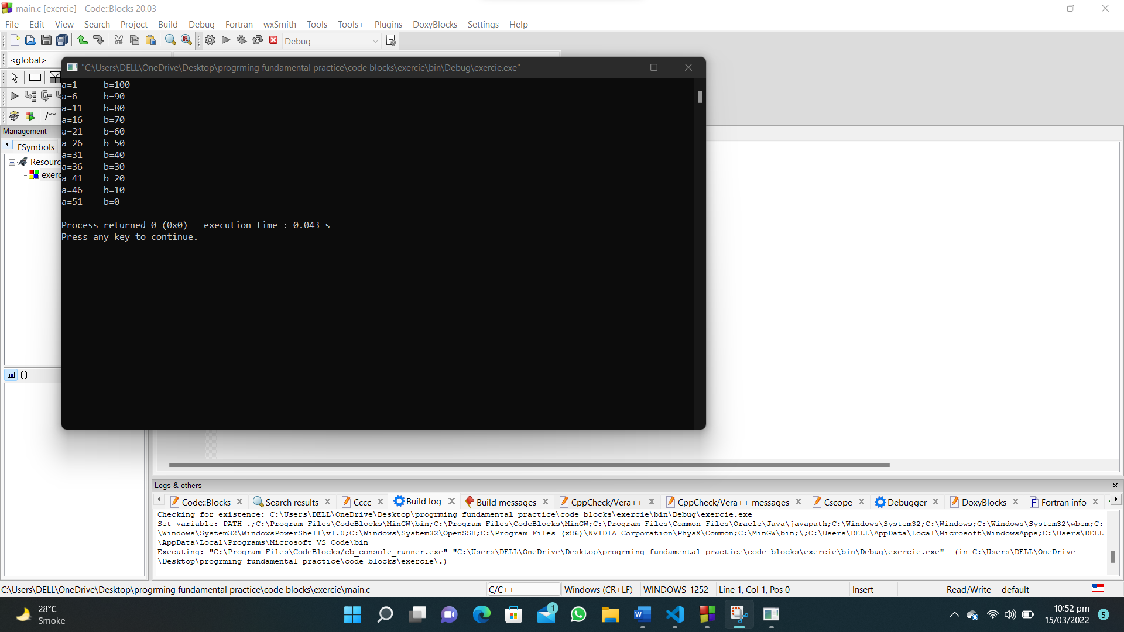

**114. Write a C program that accepts two integers values and calculate the sum of all even values between them, exclusive input values.**

**#include <stdio.h>**

**int main()**

**{**

**int num1, num2, total_even = 0,temp;**

**printf("Enter first integer of range : ");**

**scanf("%d", &num1);**

**printf("Enter second integer of range : ");**

**scanf("%d", &num2);**

**if (num2<num1)**

**{**

**temp=num2;**

**num2=num1;**

**num1=temp;**

**}**

**for (int i = num1+1 ; i < num2; i++)**

**{**

**if (i % 2 == 0)**

**{**

**total_even = total_even + i;**

**}**

**}**

**printf("Sum of even numbers is : %d\n", total_even);**

**}**

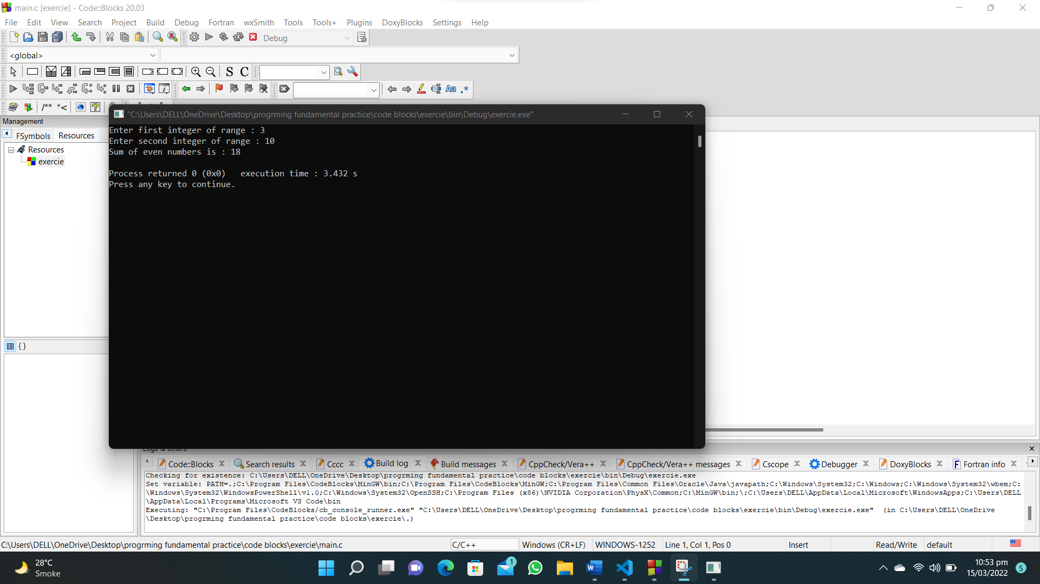

**115. Write a C program that accepts a pair of numbers from the user and print the sequence from the lowest to highest number. Also, print the average value of the sequence.**

**#include<stdio.h>**

**int main()**

**{**

**int num1,num2,total=0,count=0;**

**printf("Enter first number of pair : ");**

**scanf("%d",&num1);**

**printf("Enter second number of pair : ");**

**scanf("%d",&num2);**

**printf("equence from lower to higher number \n");**

**for (int i = num1; i <= num2; i++)**

**{**

**printf("%d ",i);**

**total=total+i;**

**count++;**

**}**

**printf("\nAverage of the sequence of numbers : %.2f",(float)total/(float)count);**

**}**

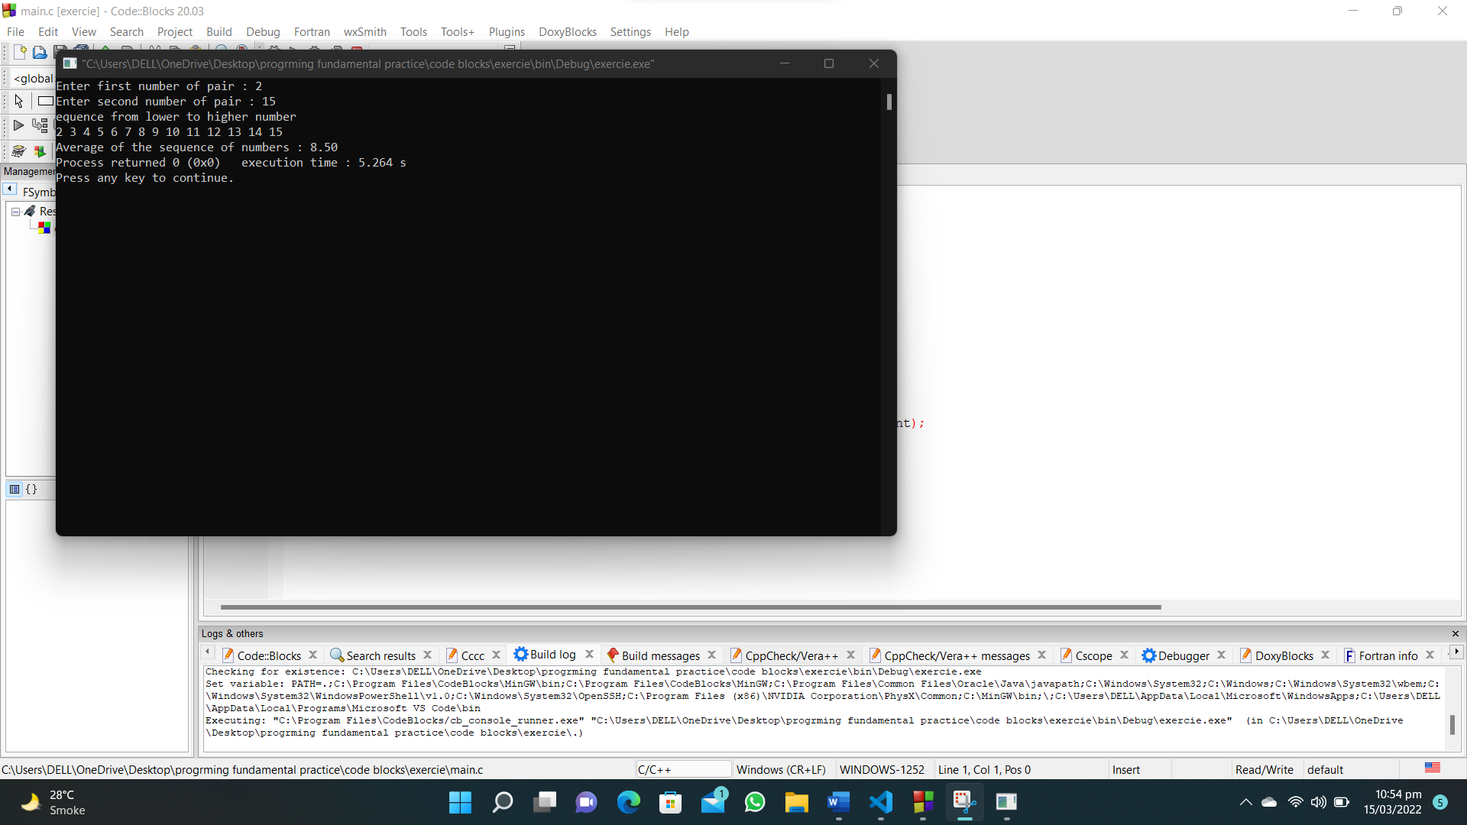

**116. Write a C program that accepts a pair of numbers from the user and prints "Ascending order" if the two numbers are in ascending order, otherwise prints, "Descending order".**

**#include<stdio.h>**

**int main()**

**{**

**int num1,num2;**

**printf("Enter first number of the pair : ");**

**scanf("%d",&num1);**

**printf("Enter second number of the pair : ");**

**scanf("%d",&num2);**

**if(num1 > num2)**

**{**

**printf("%d : %d\n",num1,num2);**

**printf("The pair is in descending order");**

**}**

**if(num1 < num2)**

**{**

**printf("%d : %d\n",num1,num2);**

**printf("The pair is in ascending order");**

**}**

**}**

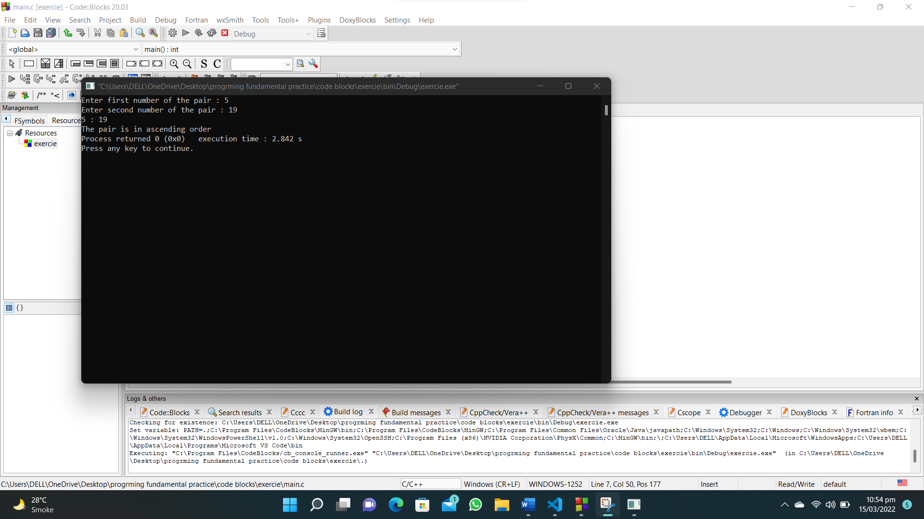

**117. Write a C program that read two integers and dividing the first number by second, print the result of this division with two digits after the decimal point and print "Division not possible..!" if the division is not possible.**

**#include<stdio.h>**

**int main()**

**{**

**float num1,num2;**

**printf("Enter first number : ");**

**scanf("%f",&num1);**

**printf("Enter second number : ");**

**scanf("%f",&num2);**

**if(num2==0)**

**{**

**printf("Division not possible");**

**}**

**else**

**{**

**printf("Result\n%.2f",num1/num2);**

**}**

**}**

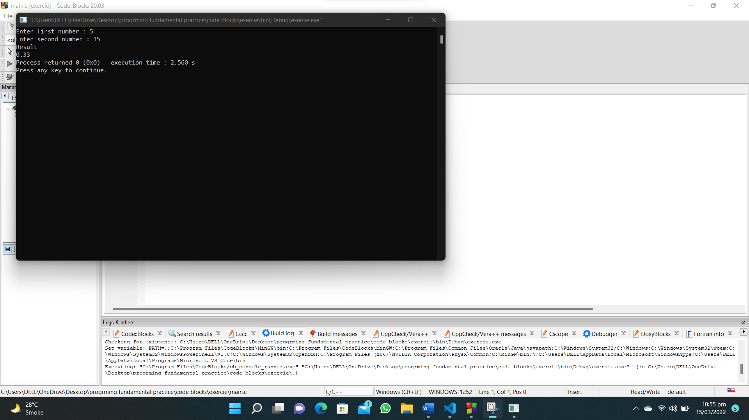

**118. Write a C program that reads five subject marks (0-100) of a student and calculate the average of these marks.**

**#include <stdio.h>**

**int main () {**

**float marks, total_marks = 0;**

**int i = 0, subject = 0;**

**printf("Input five subject marks(0-100):\n");**

**while (subject != 5)**

**{**

**scanf("%f", &marks);**

**if (marks < 0 || marks > 100)**

**{**

**printf("Not a valid marks\n");**

**}**

**else**

**{**

**total_marks =total_marks+ marks;**

**subject++;**

**}**

**}**

**printf("Average marks = %.2f\n", total_marks/5);**

**}**

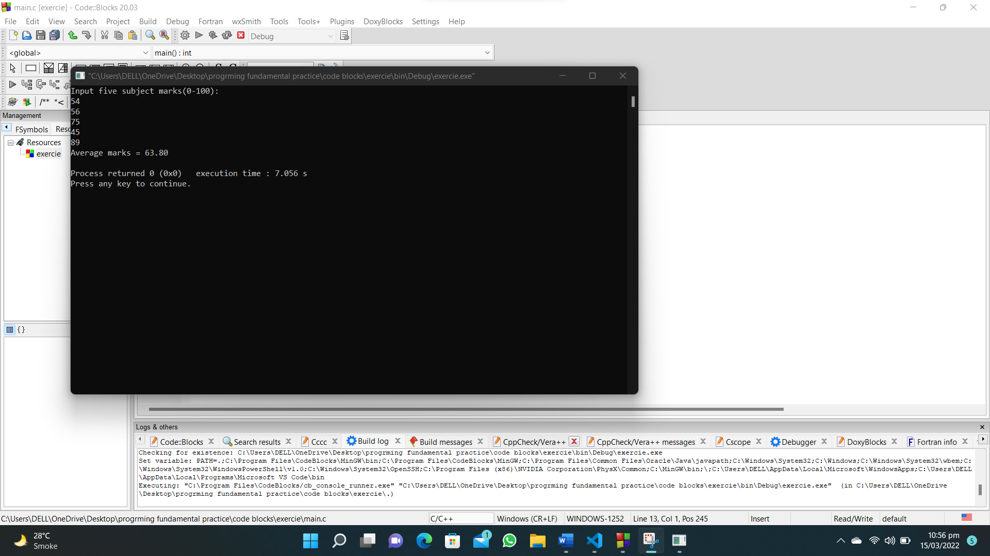

**119. Write a C program to calculate the sum all numbers between two given numbers (inclusive) not divisible by 7.**

**#include<stdio.h>**

**int main()**

**{**

**int num1,num2,total=0,temp;**

**printf("Enter first number of range : ");**

**scanf("%d",&num1);**

**printf("Enter second number of range : ");**

**scanf("%d",&num2);**

**if (num2<num1)**

**{**

**temp=num2;**

**num2=num1;**

**num1=temp;**

**}**

**for (int i = num1; i <= num2; i++)**

**{**

**if (i%7!=0)**

**{**

**total=total+i;**

**}**

**}**

**printf("Sum of all numbers between said numbers not divisible by 7: %d",total);**

**}**

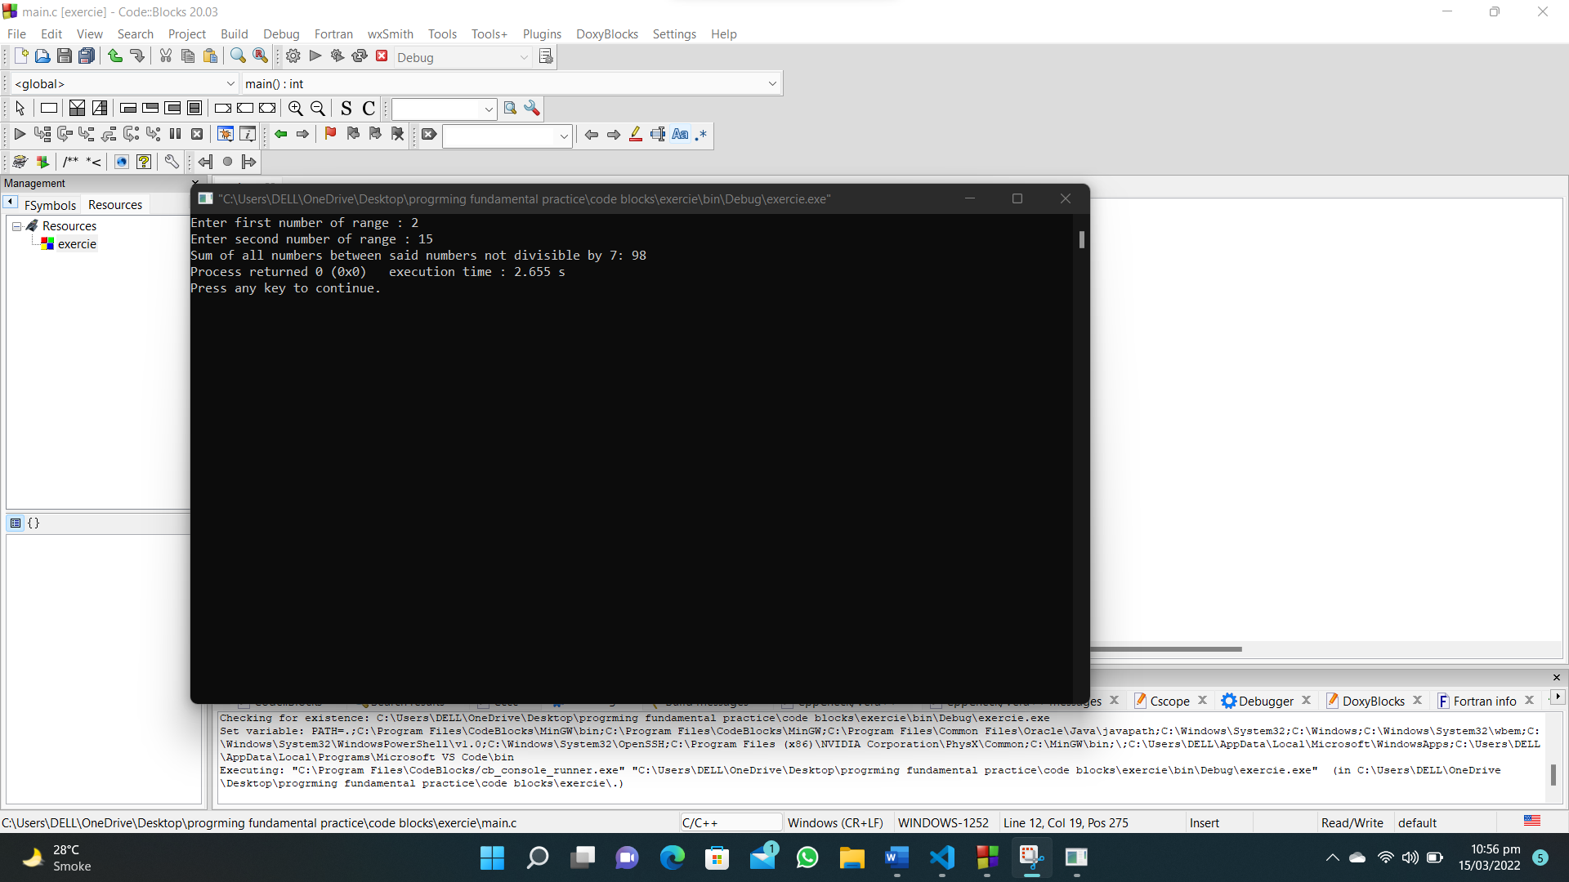

**120. Write a C program to print a sequence from 1 to a given (integer) number, insert a comma between these numbers, there will be no comma after the last character.**

**#include<stdio.h>**

**int main()**

**{**

**int num;**

**printf("Input a number : ");**

**scanf("%d",&num);**

**for (int i = 1; i <= num; i++)**

**{**

**if (i!=num)**

**{**

**printf("%d,",i);**

**}**

**else**

**{**

**printf("%d",i);**

**}**

**}**

**}**

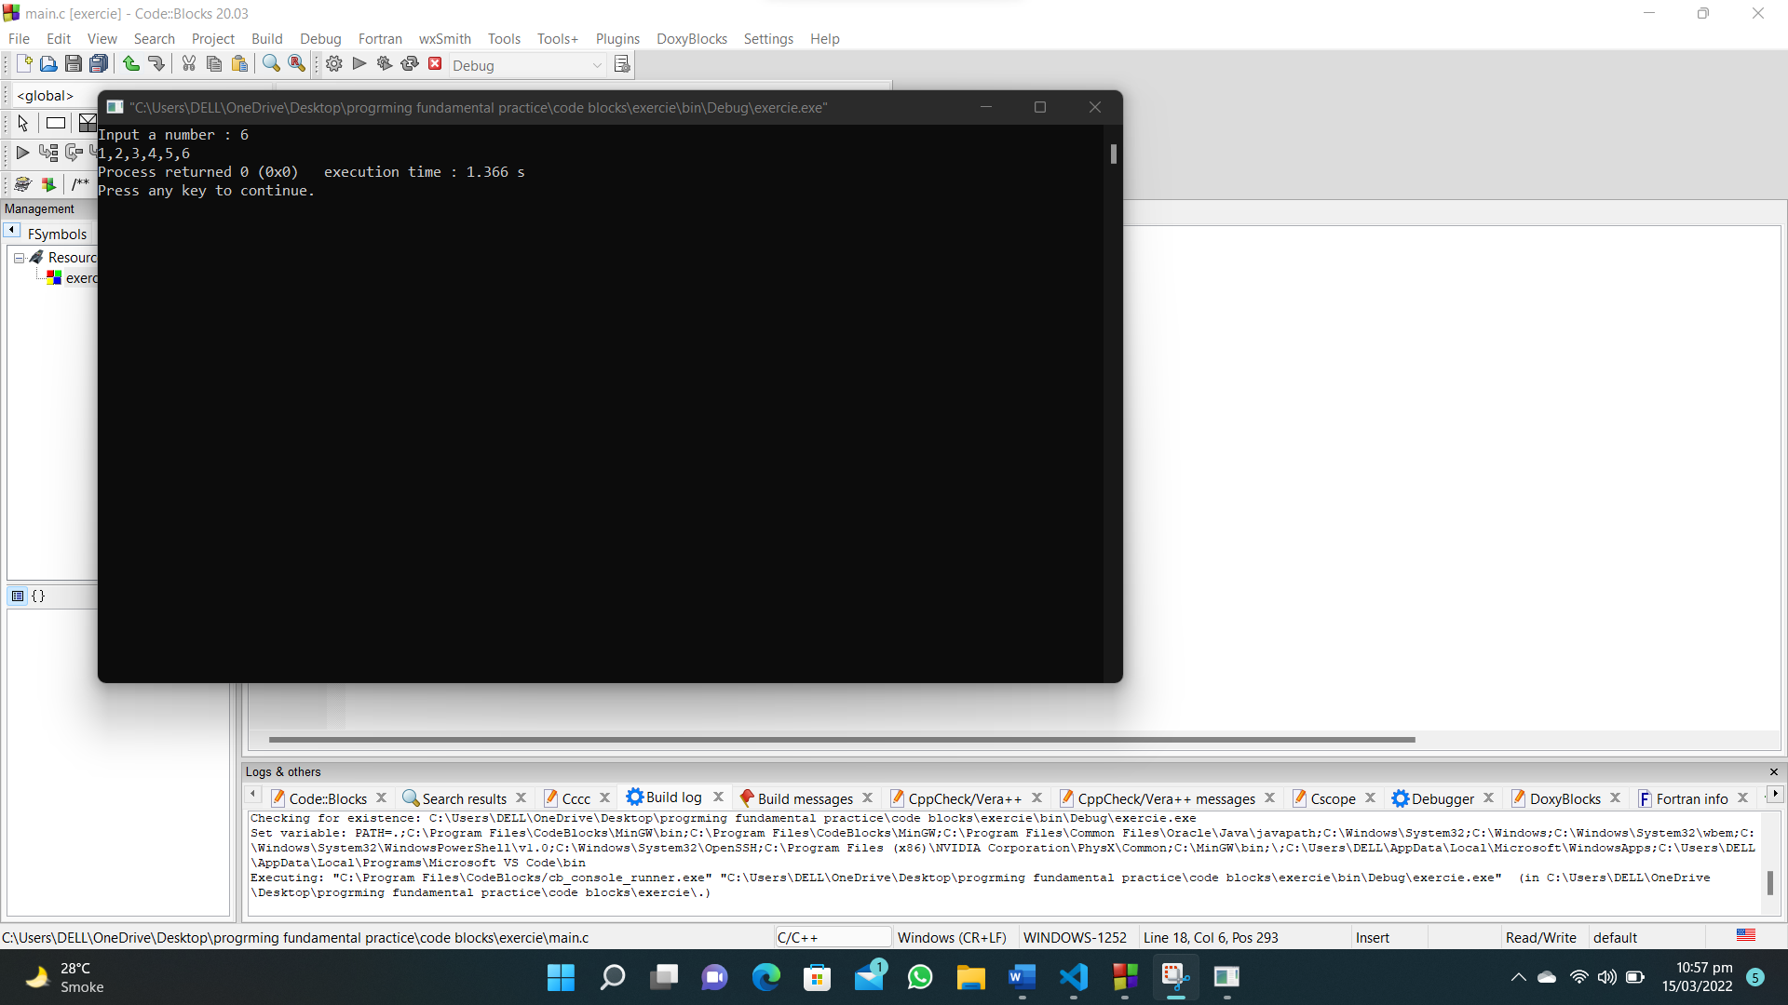

**121. Write a C program that reads an integer and find all the divisors of the said integer.**

**#include<stdio.h>**

**int main()**

**{**

**int num;**

**printf("Enter a number : ");**

**scanf("%d",&num);**

**for (int i = 1; i <= num; i++)**

**{**

**if(num%i==0)**

**{**

**printf("%d\n",i);**

**}**

**}**

**}**

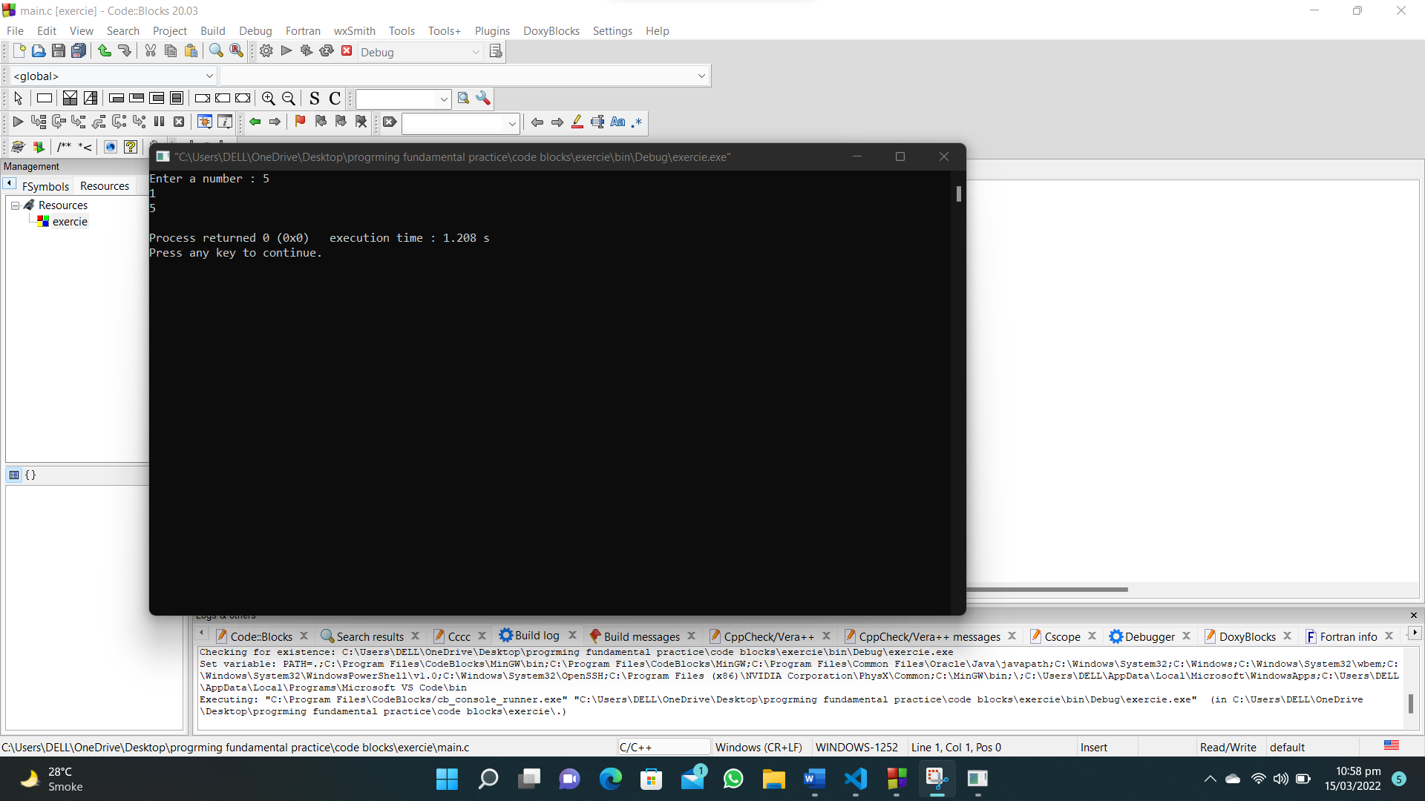

**122. Write a C program that reads two integers m, n and compute the sum of n even numbers starting from m.**

**#include<stdio.h>**

**int main()**

**{**

**int m,n,count=0,total=0;**

**printf("Enter a number from which you want to start : ");**

**scanf("%d",&m);**

**printf("Enter how many numbers you want sum of even numbers : ");**

**scanf("%d",&n);**

**for (int i = m; count<n; i++)**

**{**

**if (i%2==0)**

**{**

**count++;**

**total=total+i;**

**}**

**}**

**printf("Sum of %d even numbers starting from %d : %d",n,m,total);**

**}**

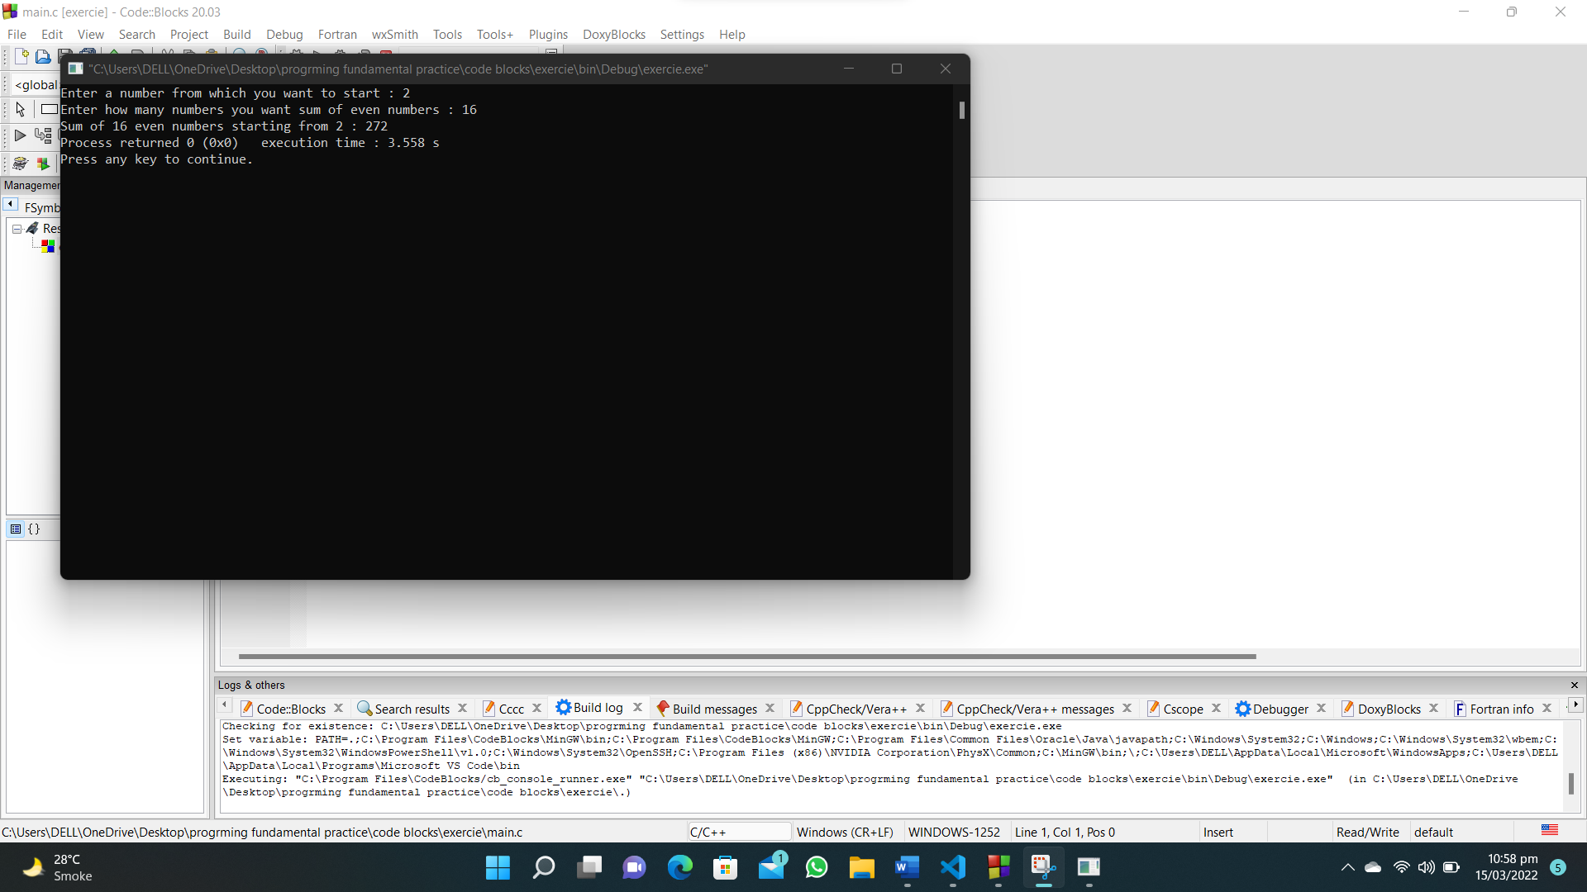

**123. Write a C program that reads two integers m, n and compute the sum of n odd numbers starting from m.**

**#include<stdio.h>**

**int main()**

**{**

**int m,n,count=0,total=0;**

**printf("Enter a number from which you want to start : ");**

**scanf("%d",&m);**

**printf("Enter how many numbers you want sum of odd numbers : ");**

**scanf("%d",&n);**

**for (int i = m; count<n; i++)**

**{**

**if (i%2!=0)**

**{**

**count++;**

**total=total+i;**

**}**

**}**

**printf("Sum of %d odd numbers starting from %d : %d",n,m,total);**

**}**

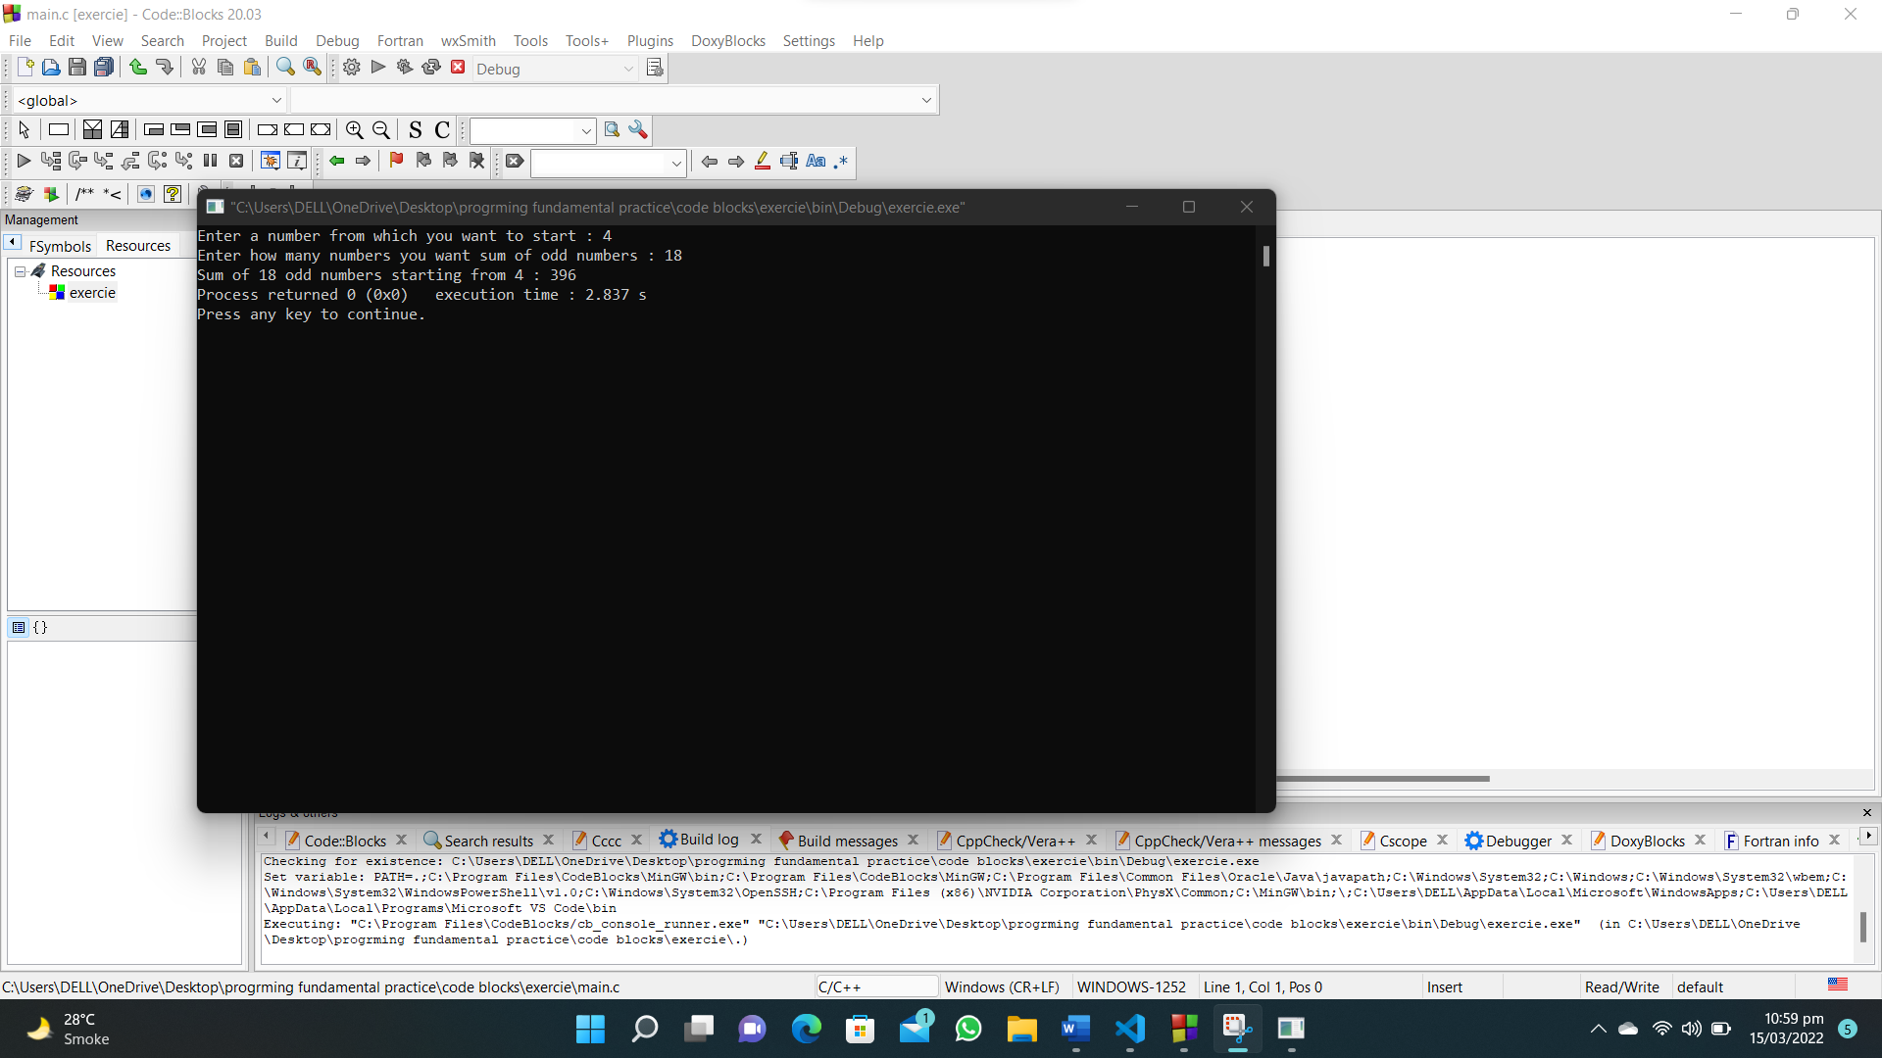

**133. Write a C program to calculate the sum of two given integers and count the number of digits of the sum value.**

**#include<stdio.h>**

**int main()**

**{**

**int num1,num2,sum,count=0;**

**printf("Enter first number : ");**

**scanf("%d",&num1);**

**printf("Enter second number : ");**

**scanf("%d",&num2);**

**sum=num1+num2;**

**while (sum!=0)**

**{**

**sum=sum/10;**

**count++;**

**}**

**printf("Number of digits of the sum value of the said numbers:%d",count);**

**}**

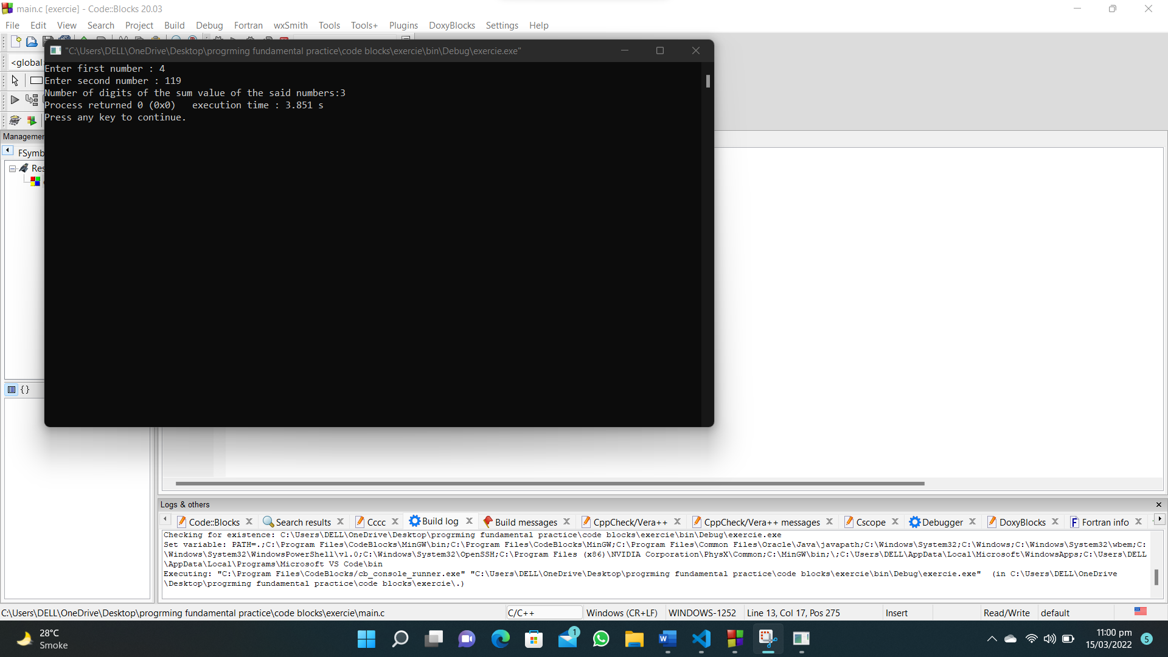

**134. Write a C program to check whether three given lengths (integers) of three sides of a triangle form a right triangle or not. Print "Yes" if the given sides form a right triangle otherwise print "No".**

**#include <stdio.h>**

**int main()**

**{**

**int base, hyp, perp;**

**printf("Input the first sides of a trainagel:\n");**

**scanf("%d", &base);**

**printf("Input the second sides of a trainagel:\n");**

**scanf("%d", &hyp);**

**printf("Input the third sides of a trainagel:\n");**

**scanf("%d", &perp);**

**if ((base * base) + (hyp * hyp) == (perp * perp) || (base * base) + (perp * perp) == (hyp * hyp) || (hyp * hyp) + (perp * perp) == (base * base))**

**{**

**printf("It is a right angle triangle!\n");**

**}**

**else**

**{**

**printf("It is not a right angle triangle!\n");**

**}**

**return 0;**

**}**

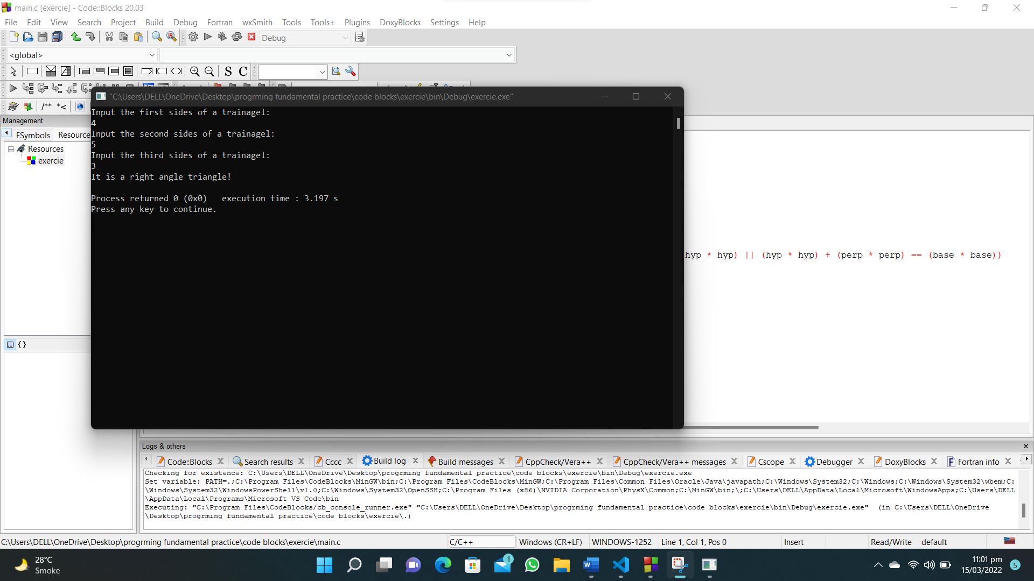

**135. Write a C program which reads an integer n and find the number of combinations of a, b, c and d (0 <= a, b, c, d <= 9) where (a + b + c + d) will be equal to n.**

**#include <stdio.h>**

**int main()**

**{**

**int n, count = 0;**

**printf("Enter a number : ");**

**scanf("%d", &n);**

**for (int a = 0; a <= 9; a++)**

**{**

**for (int b = 0; b <= 9; b++)**

**{**

**for (int c = 0; c <= 9; c++)**

**{**

**for (int d = 0; d <= 9; d++)**

**{**

**if (a + b + c + d == n)**

**{**

**printf("%d, %d, %d, %d\n", a, b, c, d);**

**count++;**

**}**

**}**

**}**

**}**

**}**

**printf("Total number of combinations:%d", count);**

**}**

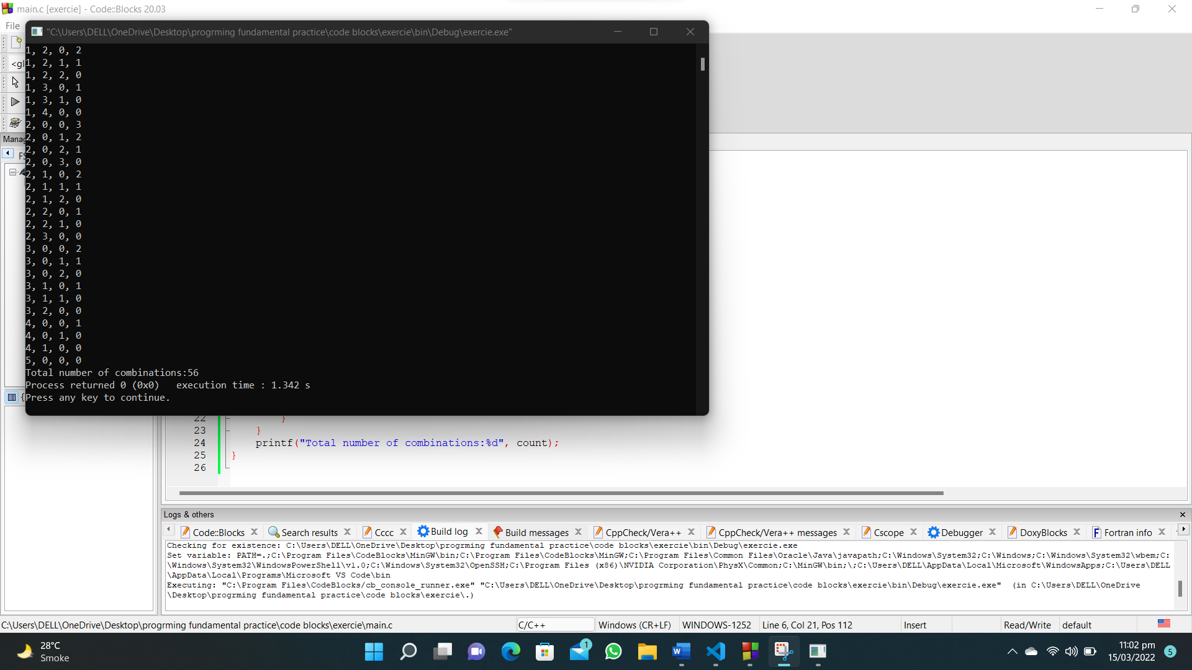

**138. Write a C program to test whether two lines are parallel or not. The four points are P(x1, y1), Q(x2, y2), R(x3, y3) and S(x4, y4), check PQ and RS are parallel are not.**

**#include<stdio.h>**

**int main()**

**{**

**int x1,x2,y1,y2,x3,x4,y3,y4;**

**printf("Enter value of P(x1,y1)");**

**scanf("%d %d",&x1,&y1);**

**printf("Enter value of Q(x2,y2)");**

**scanf("%d %d",&x1,&y2);**

**printf("Enter value of R(x3,y3)");**

**scanf("%d %d",&x3,&y3);**

**printf("Enter value of S(x4,y4)");**

**scanf("%d %d",&x4,&x4);**

**if ((y2-y1)/(x2-x1) ==(y4-y3)/(x4-x3))**

**{**

**printf("The lines are parallel");**

**}**

**else**

**{**

**printf("The lines are not parallel");**

**}**

**}**

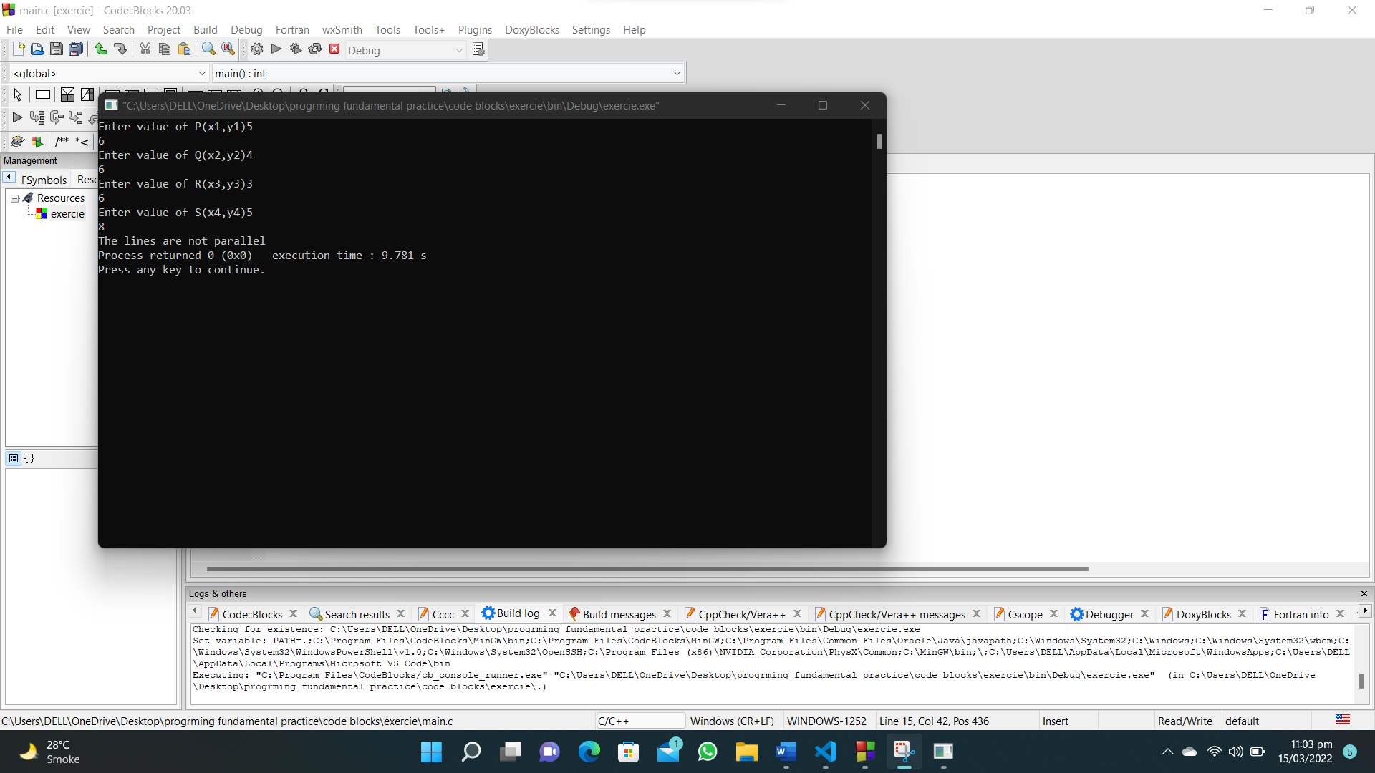

**139. Write a C program to find the maximum sum of a contiguous subsequence from a given sequence of numbers a1, a2, a3, ... an ( n = number of terms in the sequence).**

**#include<stdio.h>**

**int main()**

**{**

**int num,total=0,num1;**

**printf("Enter how many number you want to sum : ");**

**scanf("%d",&num);**

**for (int i = 1; i <=num; i++)**

**{**

**printf("Enter the number : ");**

**scanf("%d",&num1);**

**total=total+num1;**

**}**

**printf("Maximum sum is : %d",total);**

**}**

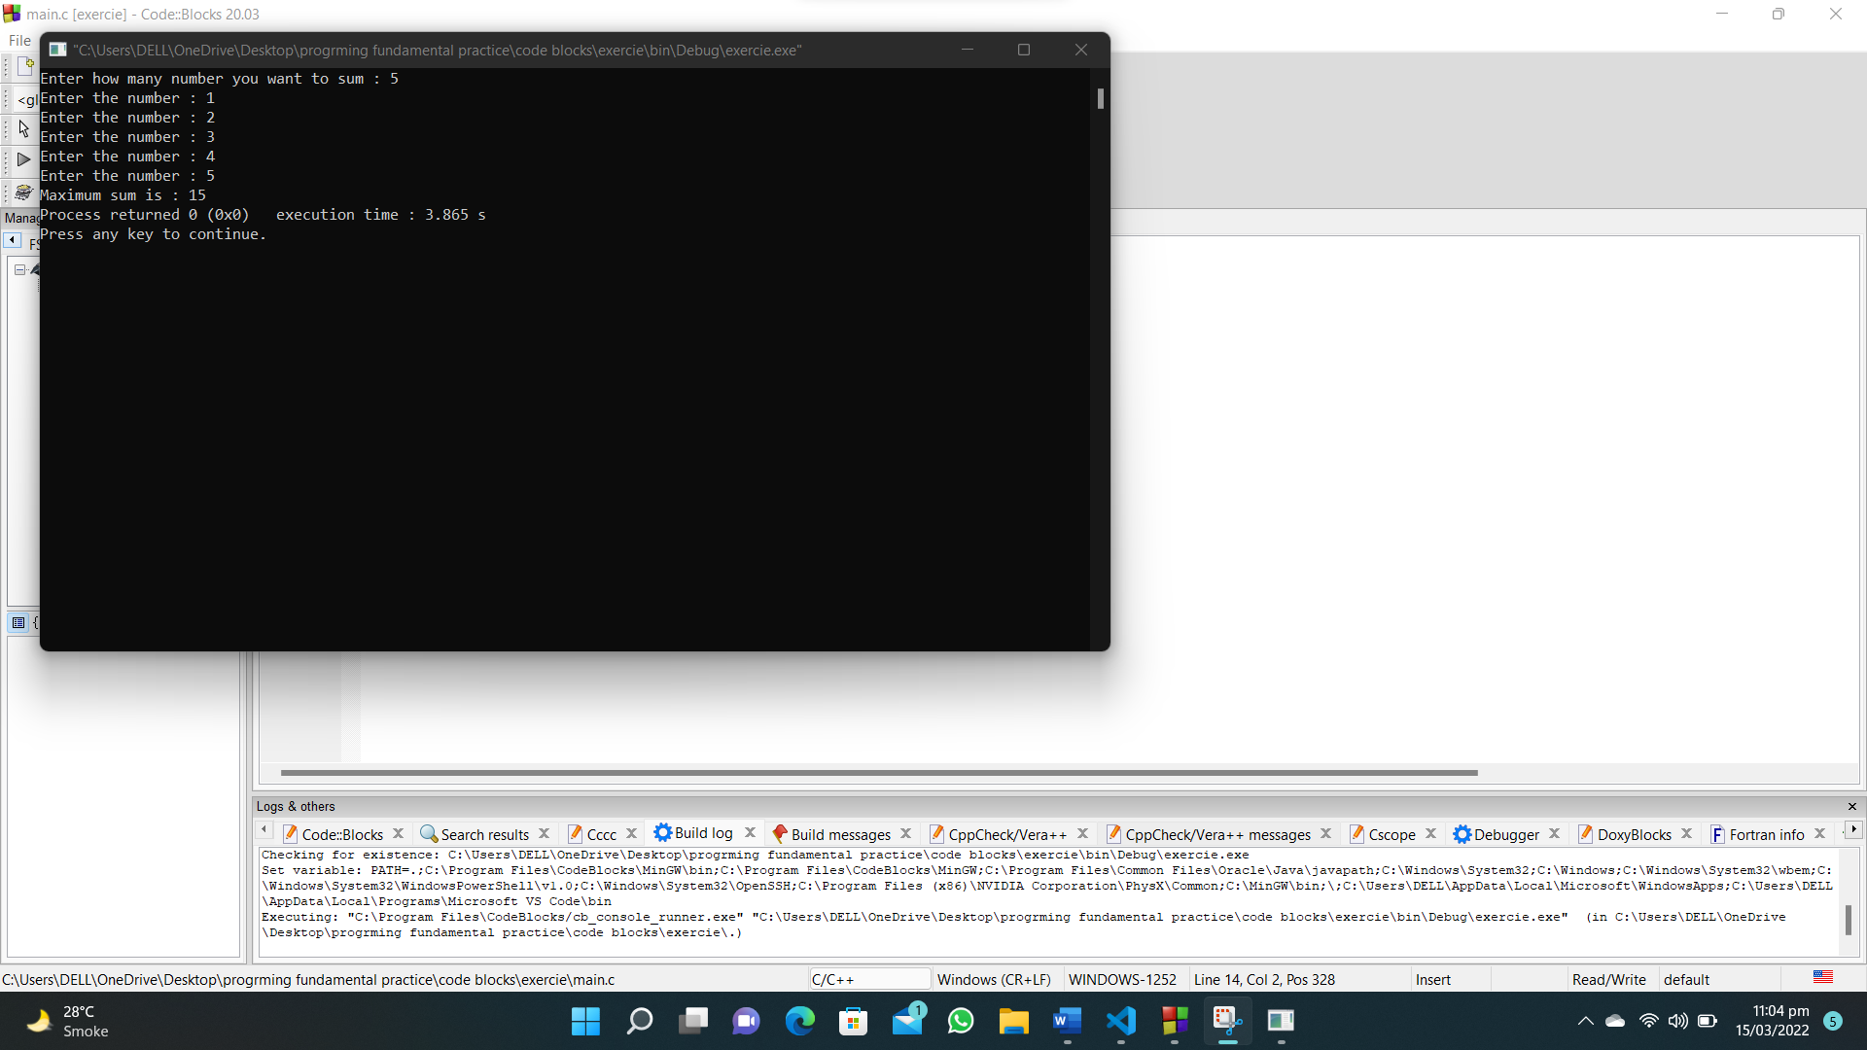

**142. Write a C program which reads the two adjoined sides and the diagonal of a parallelogram and check whether the parallelogram is a rectangle or a rhombus.**

**#include <stdio.h>**

**int main()**

**{**

**int side1, side2, diagonal;**

**printf("Input two adjoined sides of the parallelogram:\n");**

**scanf("%d %d", &side1, &side2);**

**printf("\nInput the diagonal of the parallelogram:\n");**

**scanf("%d", &diagonal);**

**if (diagonal*diagonal==(side1*side1) + (side2*side2))**

**{**

**printf("This is a rectangle");**

**}**

**else**

**{**

**printf("This is a rhombus");**

**}**

**}**

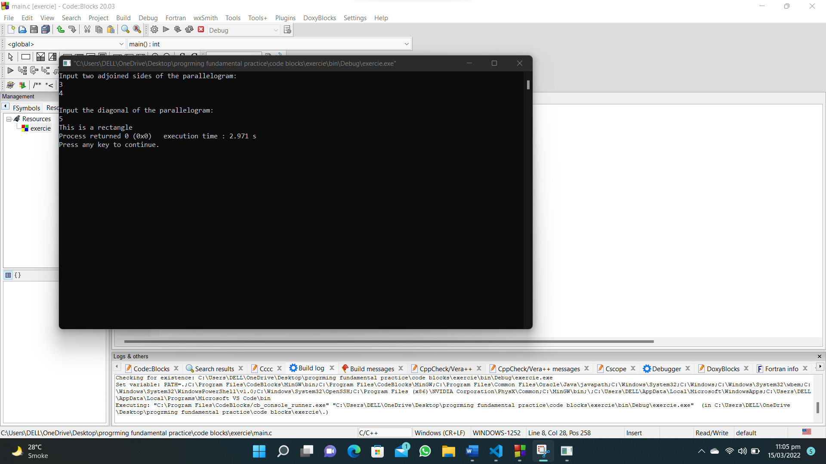

**5. Write a C program to generate a random number.**

**#include <stdio.h>**

**#include<stdlib.h>**

**#include<time.h>**

**int main()**

**{**

**int num, guessed_number,tries;**

**srand(time(0));**

**num = rand() % 10 + 1;**

**printf("\n\n\tNumber guessing game (5-tries)\n");**

**printf("\nGuess a number between 1-10: ");**

**scanf("%d", &guessed_number);**

**tries=1;**

**while (guessed_number != num)**

**{**

**if(guessed_number < num)**

**{**

**printf("Enter a higher number : ");**

**scanf("%d",&guessed_number);**

**}**

**else if(guessed_number > num)**

**{**

**printf("Enter a lower number : ");**

**scanf("%d",&guessed_number);**

**}**

**tries++;**

**if(guessed_number == num)**

**{**

**printf("You WON(In %d tries)",tries);**

**break;**

**}**

**if(tries ==5)**

**{**

**printf("You Lose");**

**break;**

**}**

**}**

**}**

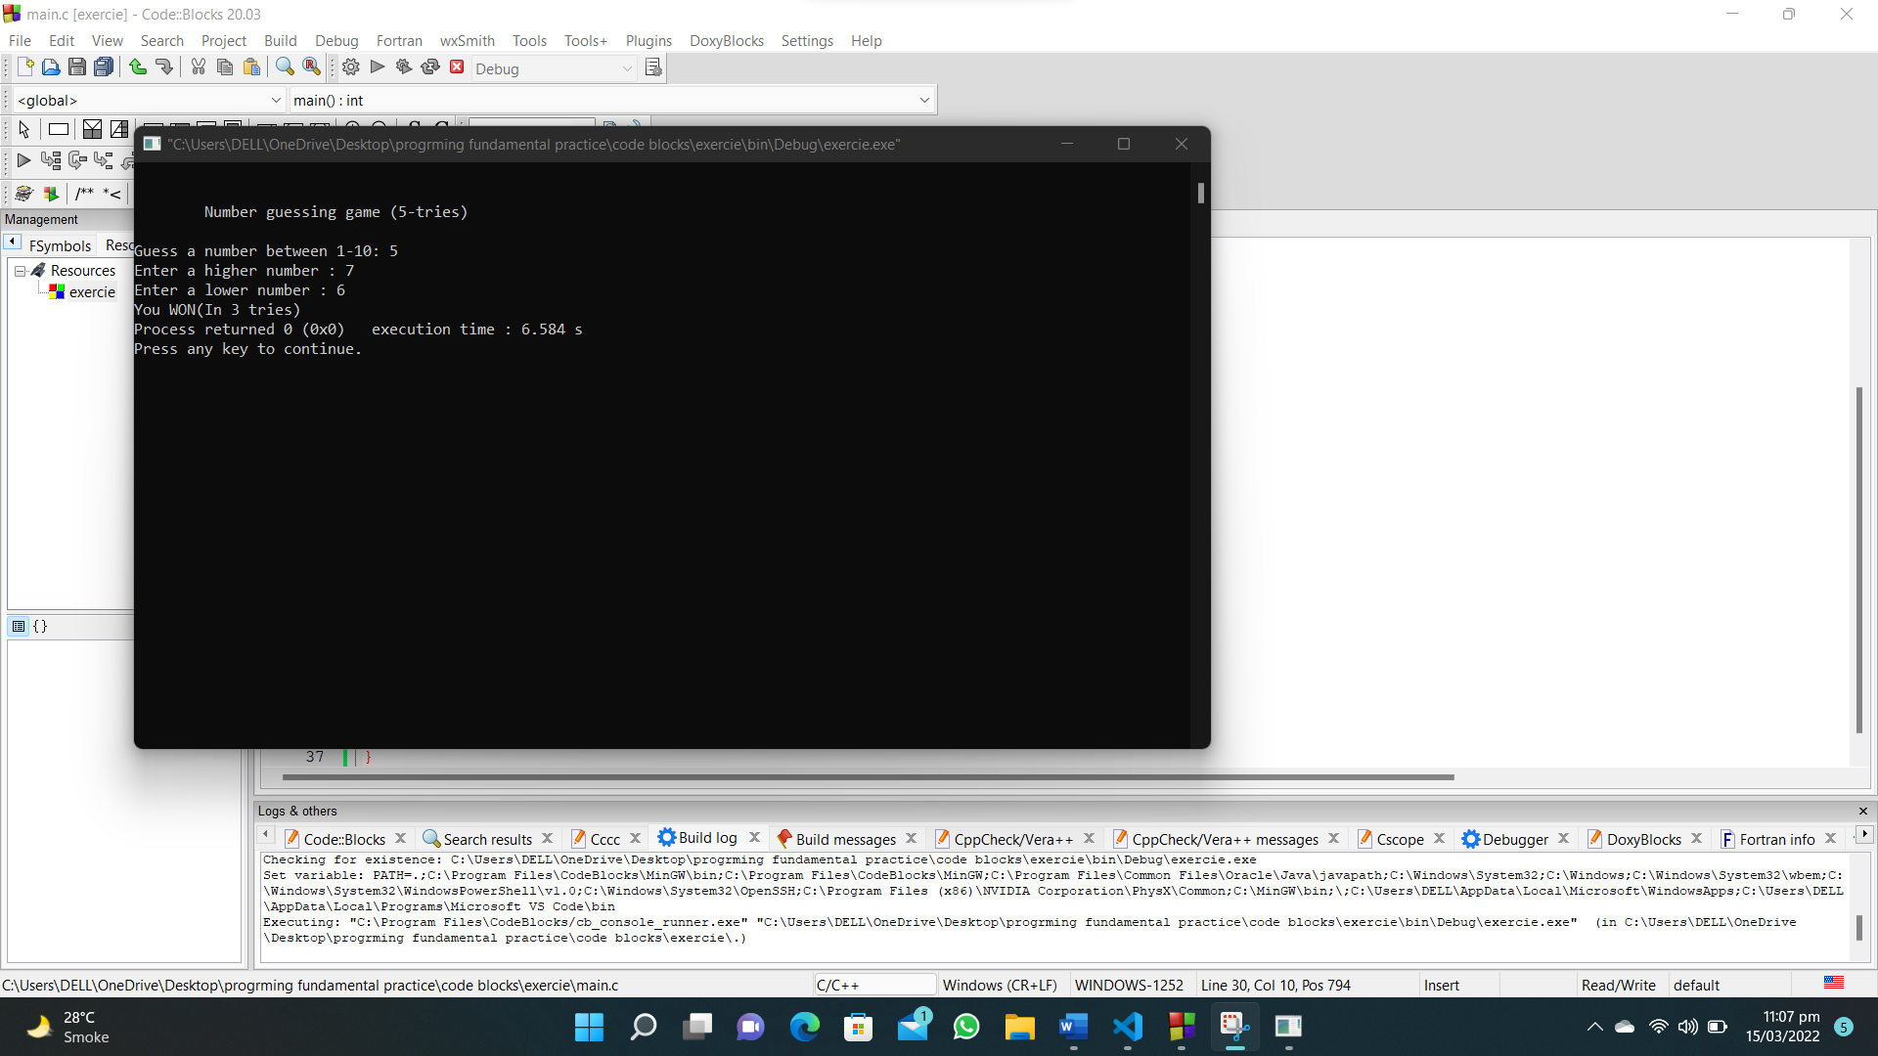

**7. Write a C program to integral quotient and remainder of a division.**

**#include<stdio.h>**

**int main()**

**{**

**int n,d;**

**printf("Enter numinator : ");**

**scanf("%d",&n);**

**printf("Enter denominator : ");**

**scanf("%d",&d);**

**printf("quotient = %d, remainder = %d",n/d,n%d);**

**}**

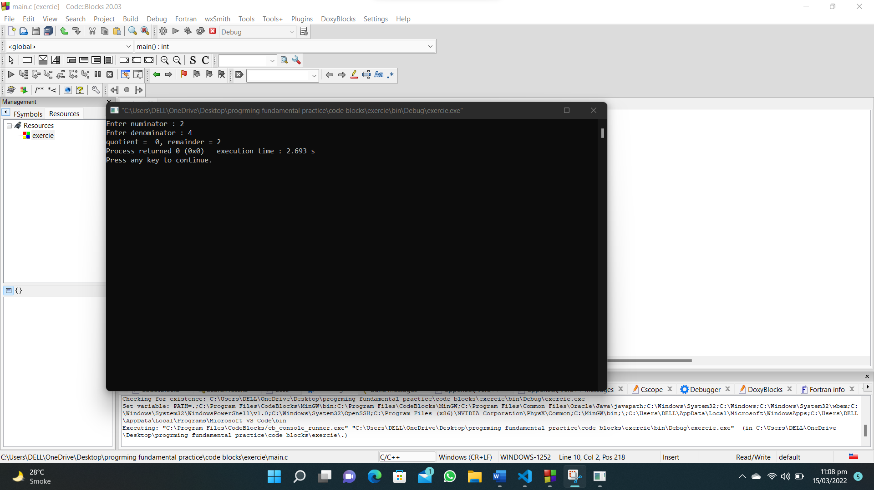

**8. Write a C program to return the absolute value of a long integer.**

**#include <stdio.h>**

**int main()**

**{**

**int a, b;**

**printf("Input 1st number (positive or negative) : ");**

**scanf("%d", &a);**

**printf("Input 2nd number (positive or negative) : ");**

**scanf("%d", &b);**

**if (a < 0)**

**{**

**printf("%d\n",a*(-1));**

**}**

**else**

**{**

**printf("%d\n",a);**

**}**

**if (b < 0)**

**{**

**printf("%d\n",b*(-1));**

**}**

**else**

**{**

**printf("%d\n",b);**

**}**

**}**

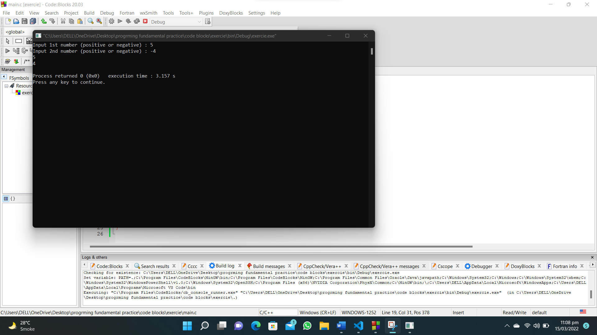

**10. Write a C program to return the quotient and remainder of a division.**

**#include<stdio.h>**

**int main()**

**{**

**int n,d;**

**printf("Enter numinator : ");**

**scanf("%d",&n);**

**printf("Enter denominator : ");**

**scanf("%d",&d);**

**printf("quotient = %d, remainder = %d",n/d,n%d);**

**}**

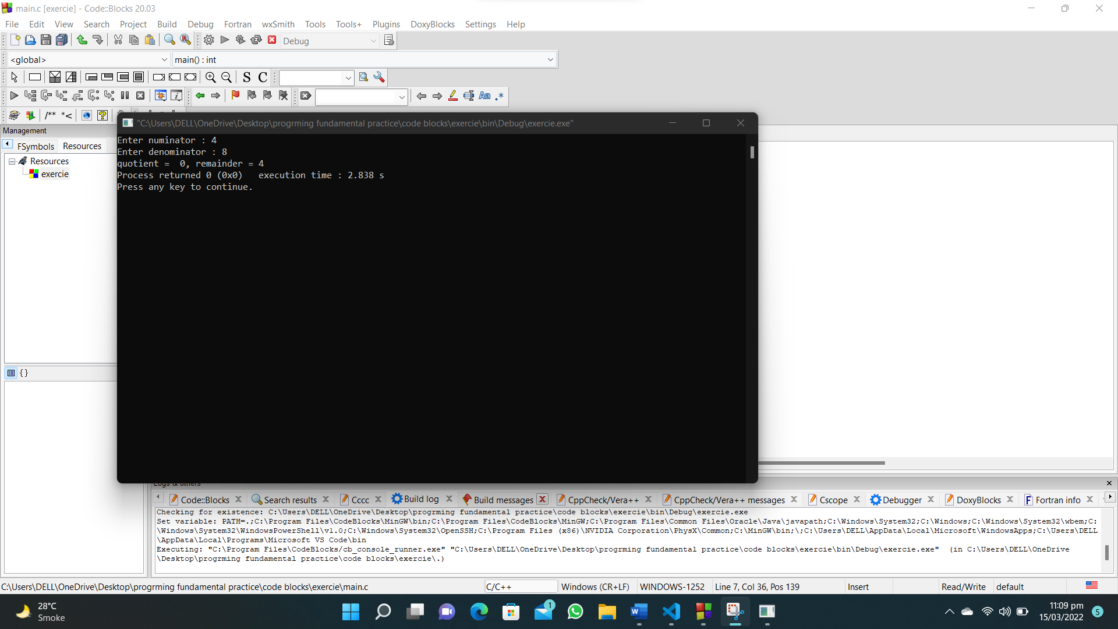

**16. Write a C program to return the absolute value of an integer.**

**#include <stdio.h>**

**int main()**

**{**

**int a;**

**printf("Input 1st number (positive or negative) : ");**

**scanf("%d", &a);**

**if (a < 0)**

**{**

**printf("%d\n",a*(-1));**

**}**

**else**

**{**

**printf("%d\n",a);**

**}**

**}**

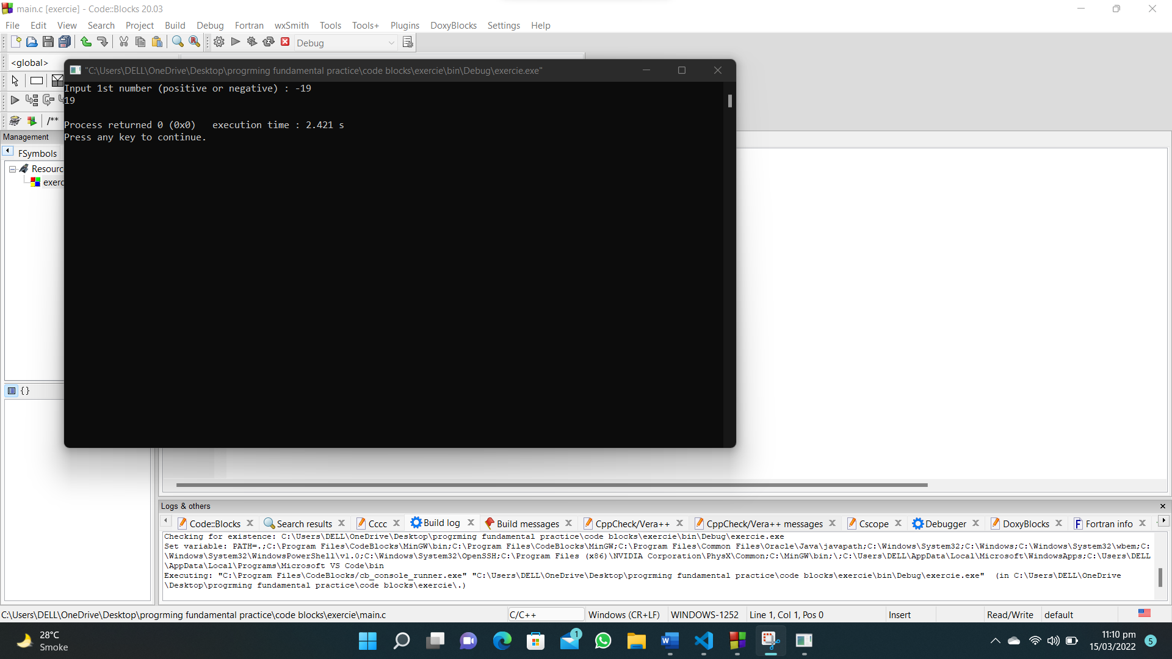

**18. Write a C program to demonstrate the working of keyword long.**

**#include <stdio.h>**

**int main()**

**{**

**int a;**

**long b;**

**long long c;**

**double e;**

**long double f;**

**printf(" The size of int = %ld bytes \n", sizeof(a));**

**printf(" The size of long = %ld bytes\n", sizeof(b));**

**printf(" The size of long long = %ld bytes\n", sizeof(c));**

**printf(" The size of double = %ld bytes\n", sizeof(e));**

**printf(" The size of long double = %ld bytes\n\n", sizeof(f));**

**return 0;**

**}**

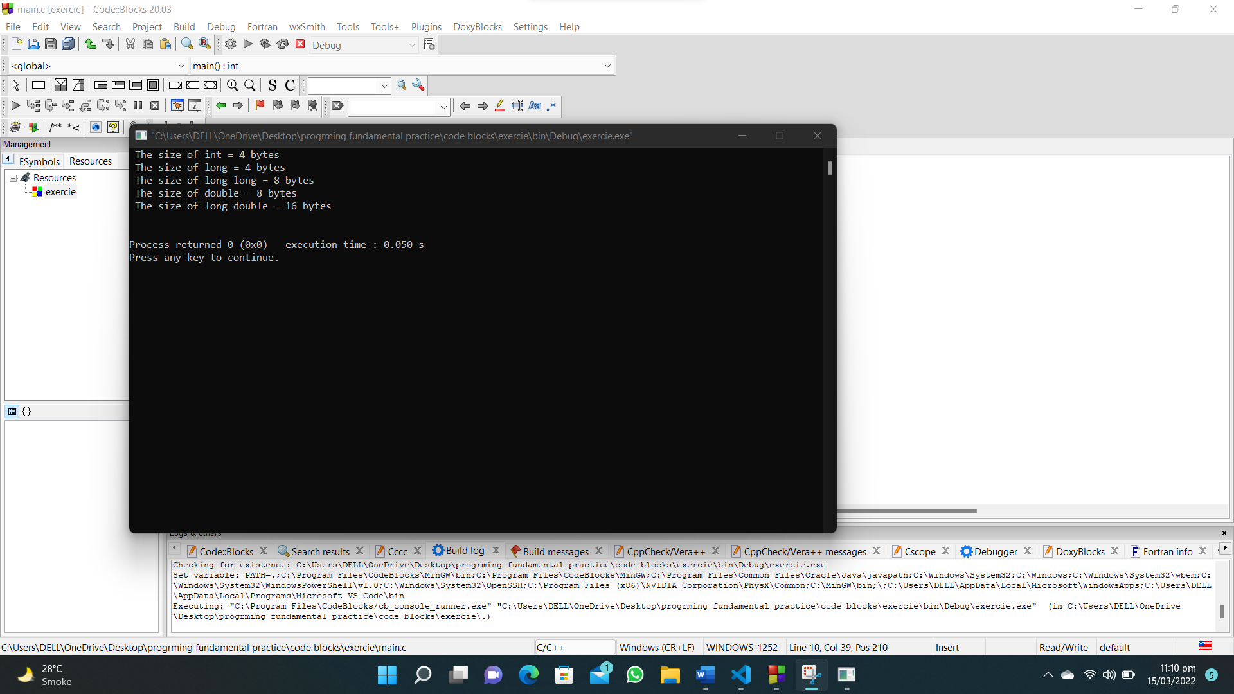

1. **Write a program that converts Centigrade to Fahrenheit.**

**#include <stdio.h>**

**int main()**

**{**

**float c, f;**

**printf("Enter temprature in celcius : ");**

**scanf("%f", &c);**

**f = (1.8 * c) + 32;**

**printf("%.1f\n", f);**

**}**

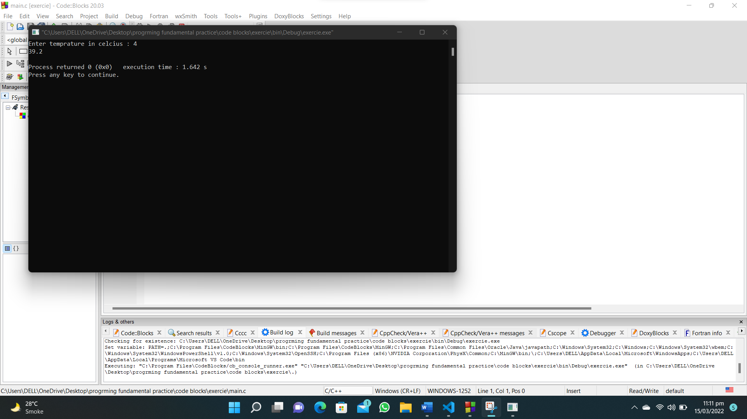

1. **Write a C program that calculates the volume of a sphere.**

**#include<stdio.h>**

**int main()**

**{**

**float r,v;**

**printf("Input radius of sphere : ");**

**scanf("%f",&r);**

**v=1.333333*3.14*r*r*r;**

**printf("The volume of sphere is %.2f",v);**

**}**

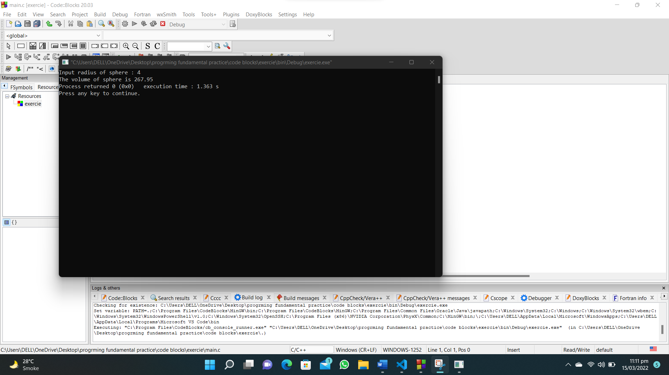

1. **Write a C program that prints the perimeter of a rectangle to take its height and width as input.**

**#include<stdio.h>**

**int main()**

**{**

**int h,w,p;**

**printf("Enter value of height : ");**

**scanf("%d",&h);**

**printf("Enter value of width : ");**

**scanf("%d",&w);**

**p=2*(w+h);**

**printf("Perimeter of the Rectangle is : %d",p);**

**}**

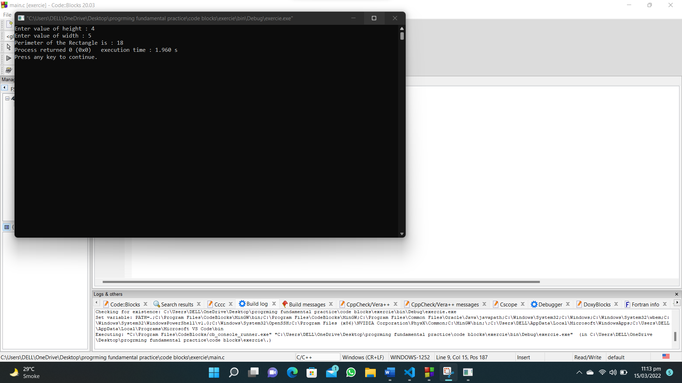

1. **Write a C program that converts kilometers per hour to miles per hour.**

**#include <stdio.h>**

**int main()**

**{**

**float d;**

**printf("Enter distance in KM : ");**

**scanf("%f", &d);**

**printf("Miles per hour : %f",d*0.621371);**

**}**

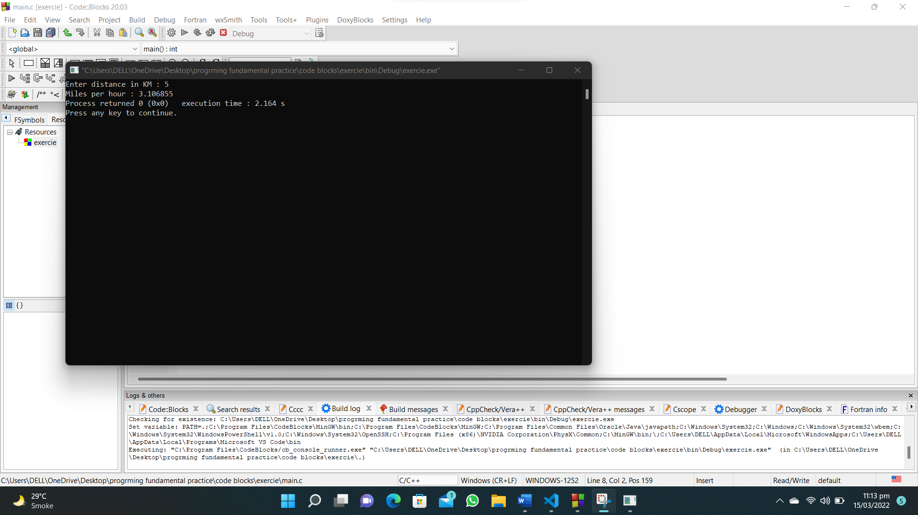

1. **Write a C program that takes hours and minutes as input, and calculates the total number of minutes.**

**#include<stdio.h>**

**int main()**

**{**

**int h,m;**

**printf("Input hours : ");**

**scanf("%d",&h);**

**printf("Input minutes : ");**

**scanf("%d",&m);**

**printf("Total minutes : %d",(h*60)+m);**

**}**

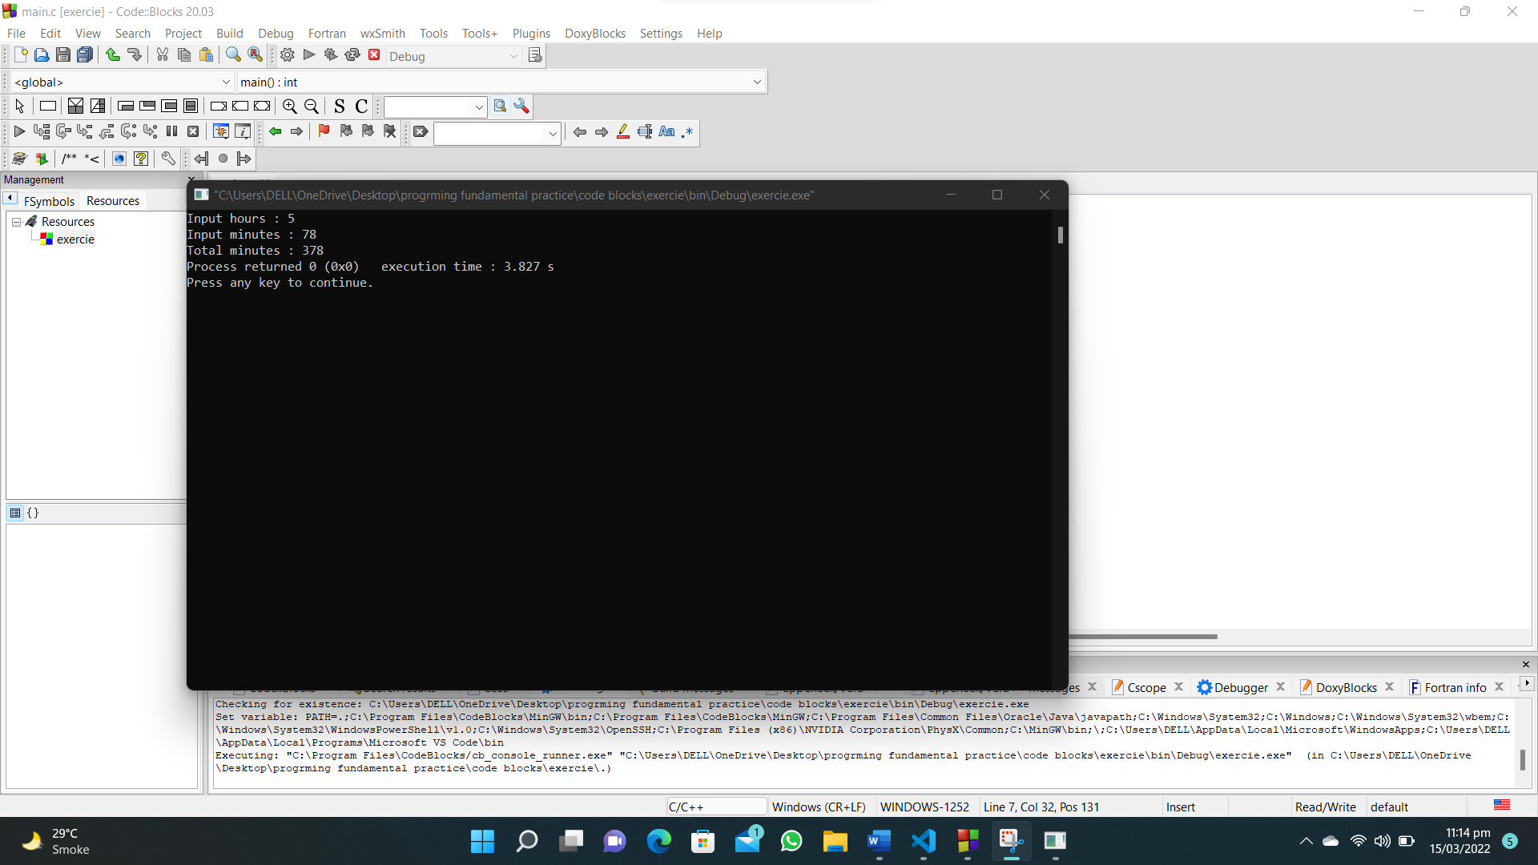

1. **Write a program in C that takes minutes as input, and display the total number of hours and minutes.**

**#include<stdio.h>**

**int main()**

**{**

**int h,min,m;**

**printf("Input number of minutes : ");**

**scanf("%d",&m);**

**printf("Hours : %d\tminutes : %d ",m/60,m%60);**

**}**

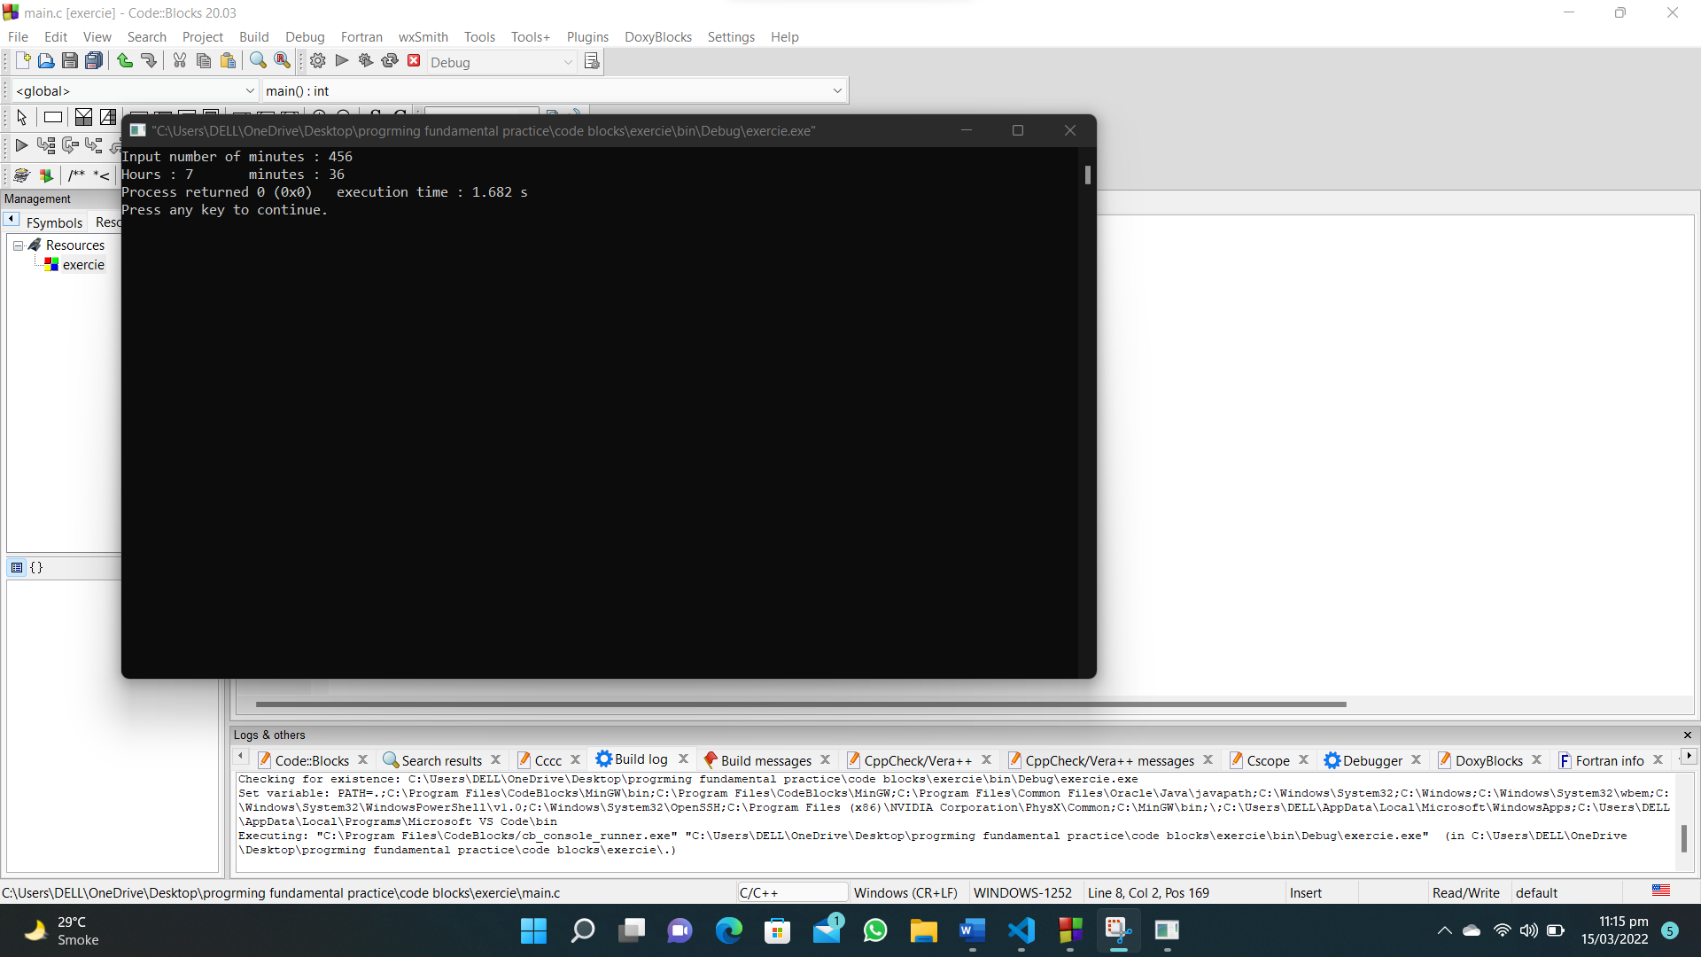

**9. Write a C program to perform addition, subtraction, multiplication and  division of two numbers.**

**#include<stdio.h>**

**#include<math.h>**

**#include<stdlib.h>**

**int main()**

**{**

**int operator_choice,num1,num2,answer;**

**printf("Enter first number : ");**

**scanf("%d",&num1);**

**printf("Enter second number : ");**

**scanf("%d",&num2);**

**printf("Press 1 for addition\n");**

**printf("Press 2 for subtraction\n");**

**printf("Press 3 for multiplication\n");**

**printf("Press 4 for division\n");**

**printf("Press 5 for exponent\nEnter your choice : ");**

**scanf("%d",&operator_choice);**

**if(operator_choice==1)**

**{**

**answer=num1+num2;**

**printf("%d + %d =%d",num1,num2,answer);**

**}**

**else if(operator_choice==2)**

**{**

**answer=num1-num2;**

**printf("%d - %d =%d",num1,num2,answer);**

**}**

**else if(operator_choice==3)**

**{**

**answer=num1*num2;**

**printf("%d * %d =%d",num1,num2,answer);**

**}**

**else if(operator_choice==4)**

**{**

**answer=num1/num2;**

**printf("%d / %d =%d",num1,num2,answer);**

**}**

**else if(operator_choice==5)**

**{**

**answer=pow(num1,num2);**

**printf("%d ^ %d =%d",num1,num2,answer);**

**}**

**return 0;**

**}**

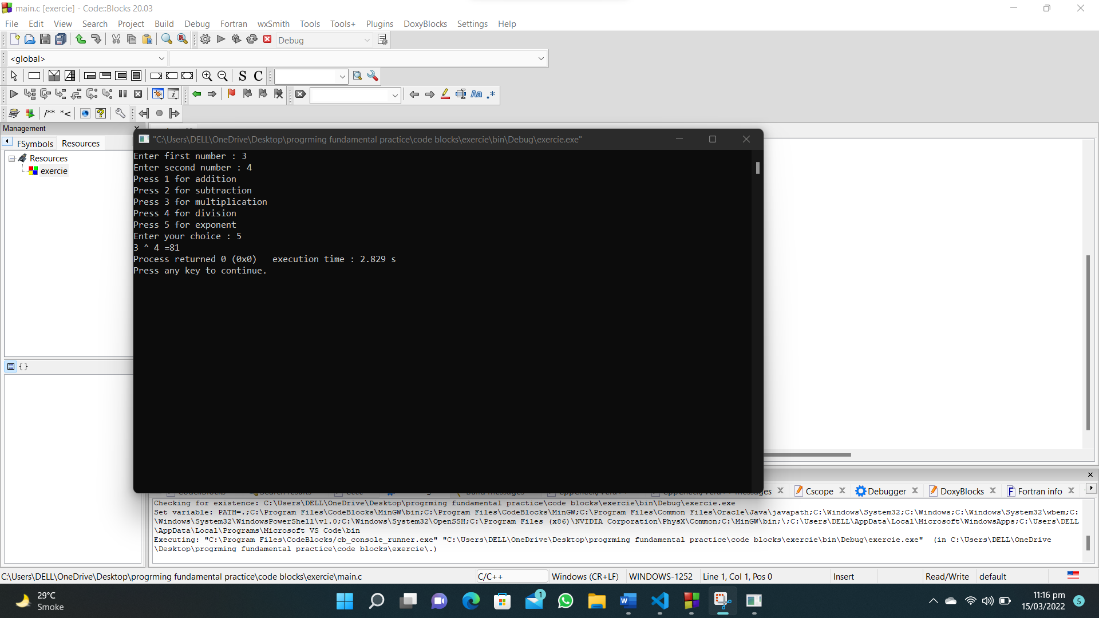

**10. Write a C program to find the third angle of a triangle if two angles are given.**

**#include<stdio.h>**

**int main()**

**{**

**int a,b;**

**printf("Enter first angle : ");**

**scanf("%d",&a);**

**printf("Enter second angle : ");**

**scanf("%d",&b);**

**printf("Third angle is : %d",180-(a+b));**

**}**

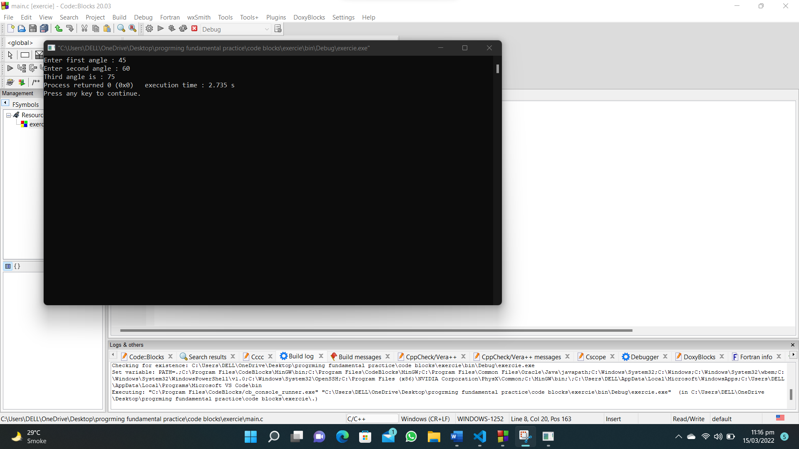

1. Write a C program to compute the sum of the two given integer values. If the two values are the same, then return triple their sum.

#include <stdio.h>

int main(void)

{

int num1, num2,sum;

sum = 0;

printf("enter number 1 ");

scanf("%d", &num1);

printf("enter number 2 ");

scanf("%d", &num2);

if (num1 == num2)

{

sum = (num1+num2)*3;

}

else

{

sum = num1 + num2 ;

}

printf("the sum is %d",sum);

}

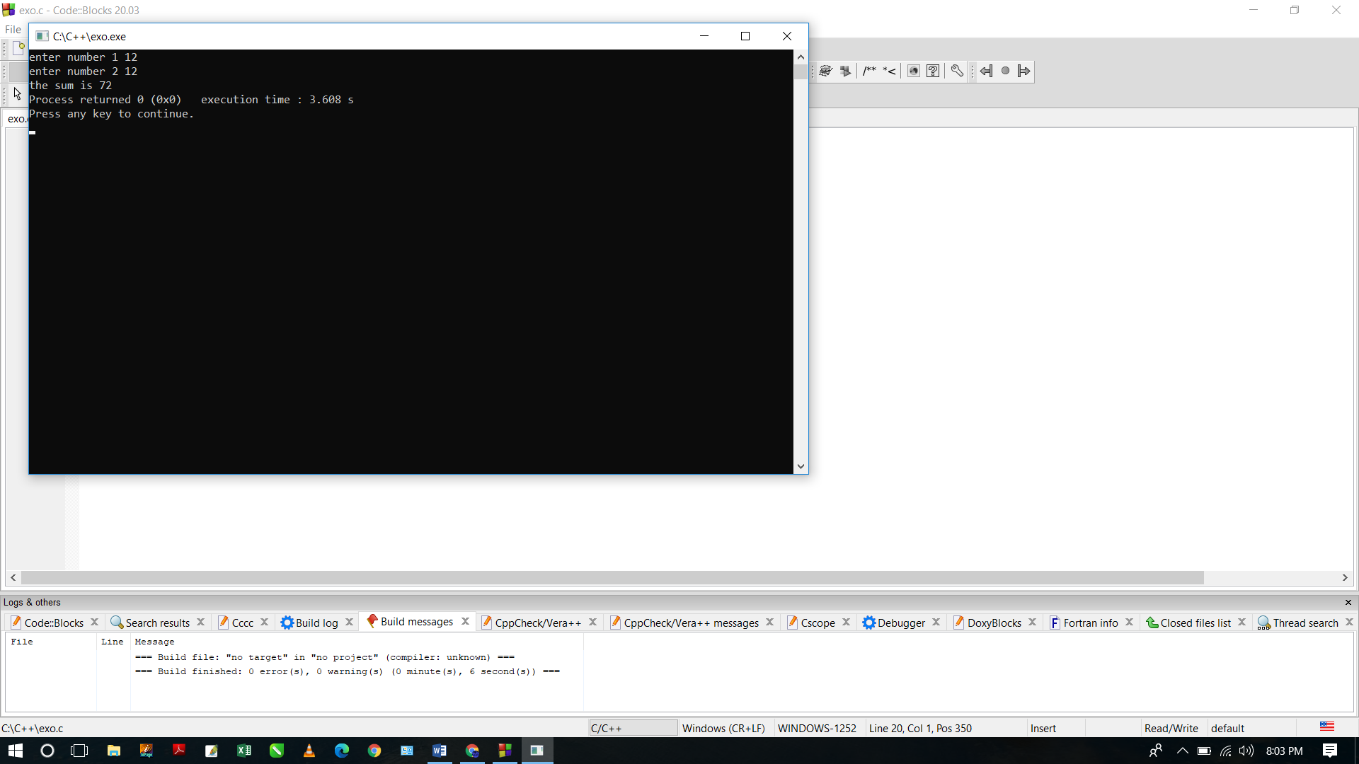

1. Write a C program to get the absolute difference between n and 51. If n is greater than 51 return triple the absolute difference.

#include <stdio.h>

int main(void)

{

int n,diff;

diff = 0;

printf("enter the number \t");

scanf("%d",&n);

if(n>51)

{

diff = (n-51)*3;

}

else

if(n<51)

{

diff = n-51;

}

else

{

diff = 0;

}

printf("%d",diff);

}

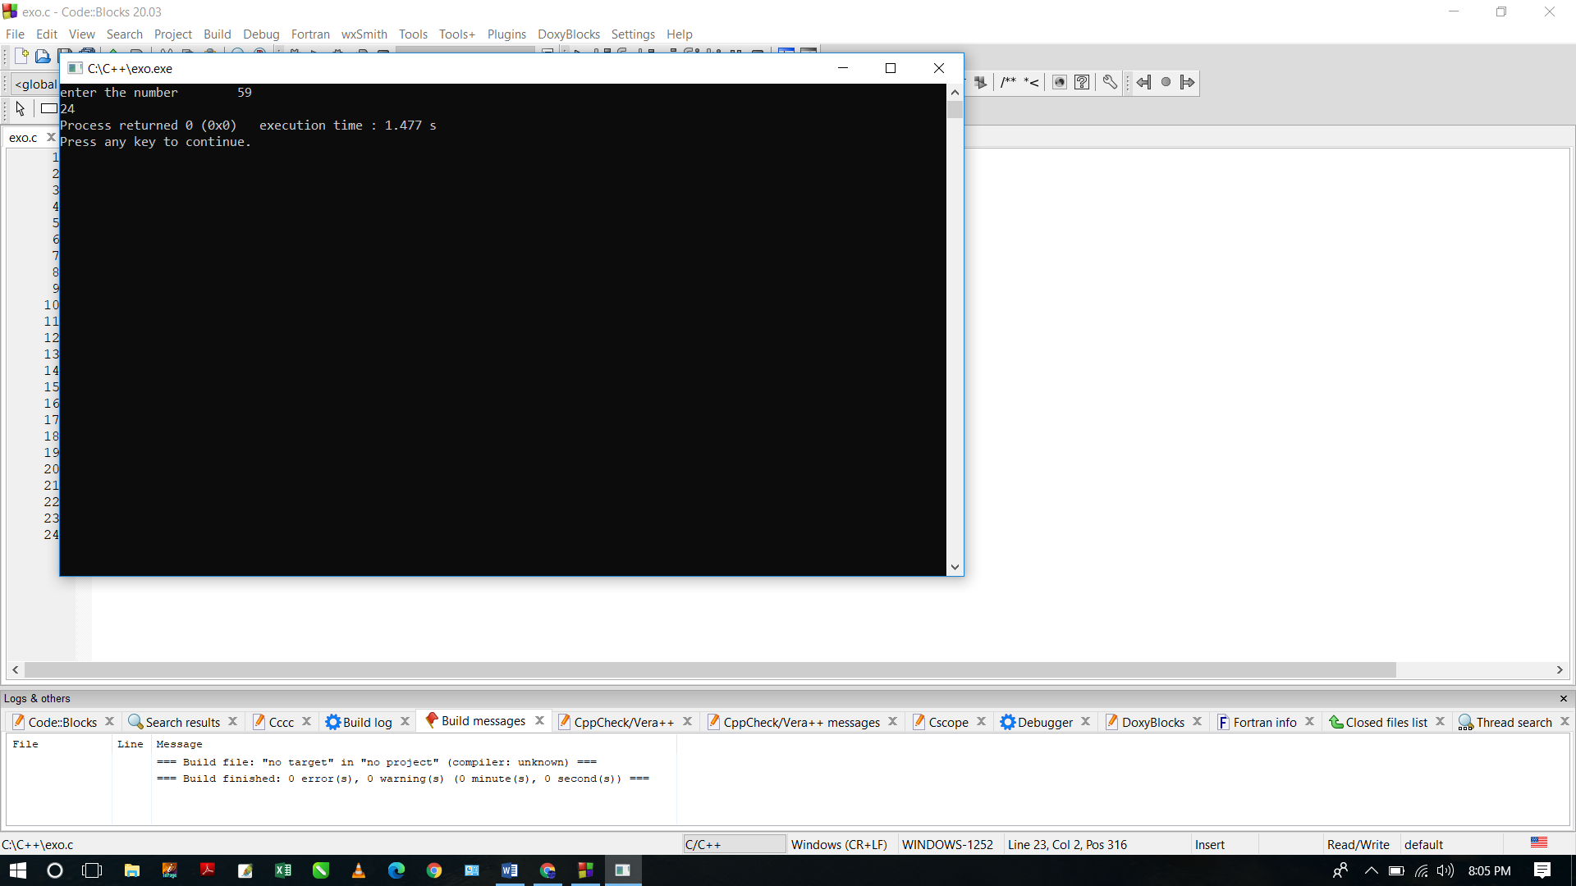

1. Write a C program to check two given integers, and return true if one of them is 30 or if their sum is 30.

#include <stdio.h>

int main(void){

int num1, num2;

printf("enter first number \t");

scanf("%d",&num1);

printf("enter second number \t");

scanf("%d",&num2);

if(num1 == 30 || num2 == 30 || (num1+num2) == 30)

{

printf("TRUE");

}

else

{

printf("FALSE");

}

}

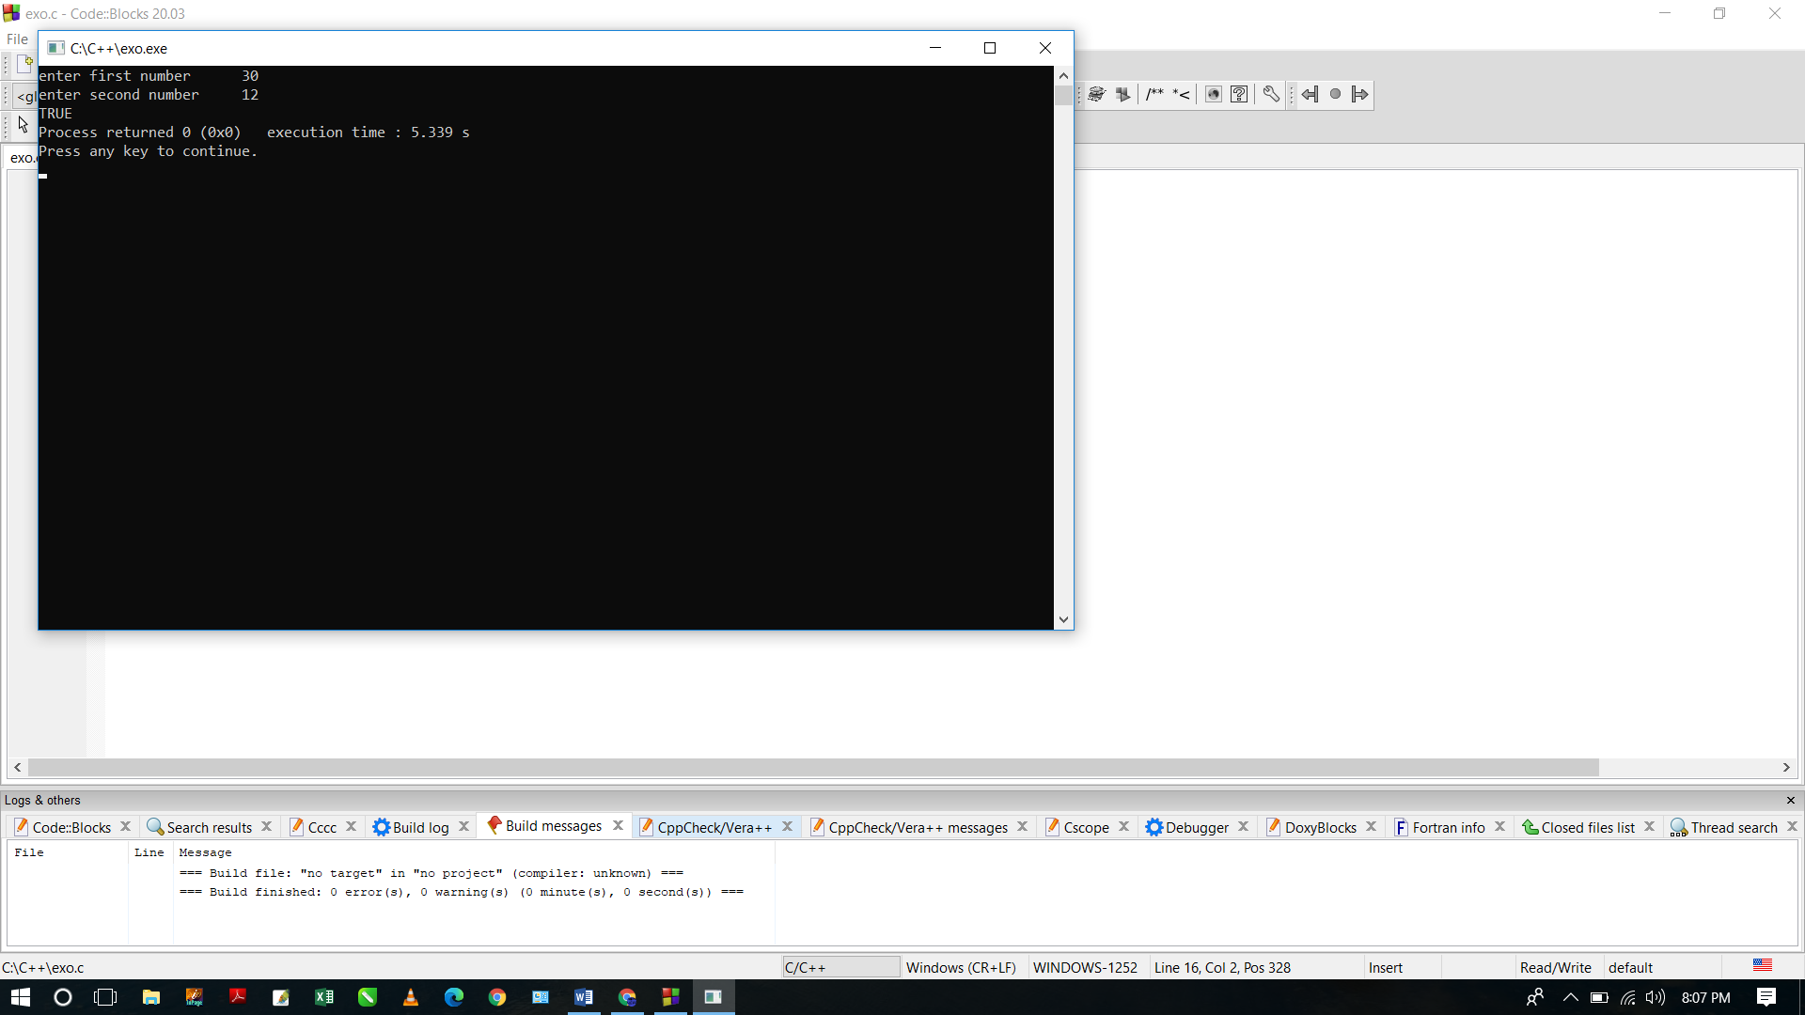

1. Write a C program to check a given integer and return true if it is within 10 of 100 or 200.

#include <stdio.h>

int main(void){

int num1;

printf("enter the number \t");

scanf("%d",&num1);

if((num1 - 100)<=10 || (num1 - 200)<=20)

{

printf("True");

}

else

printf("False");

}

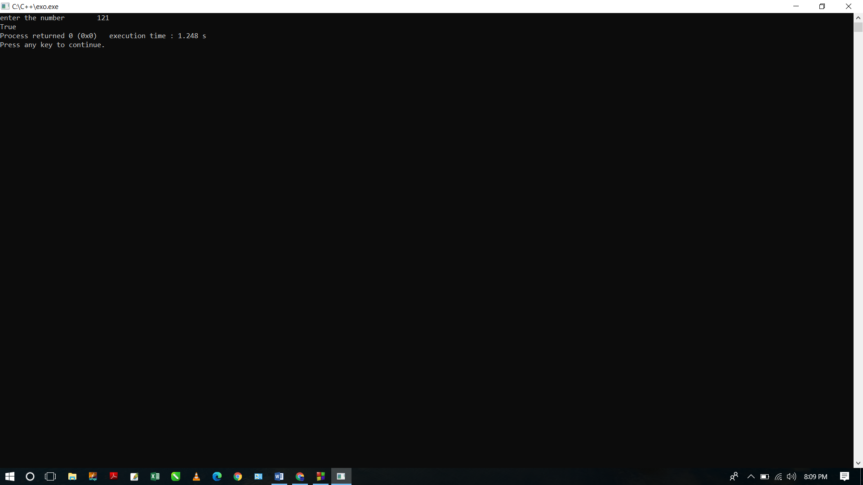

1. Write a C program to check whether a given positive number is a multiple of 3 or a multiple of 7

#include <stdio.h>

int main(void){

int num1;

printf("enter the number \t");

scanf("%d",&num1);

if( num1 % 3 == 0 || num1 % 7 ==0)

{

printf("True");

}

else

{

printf("False");

}

}

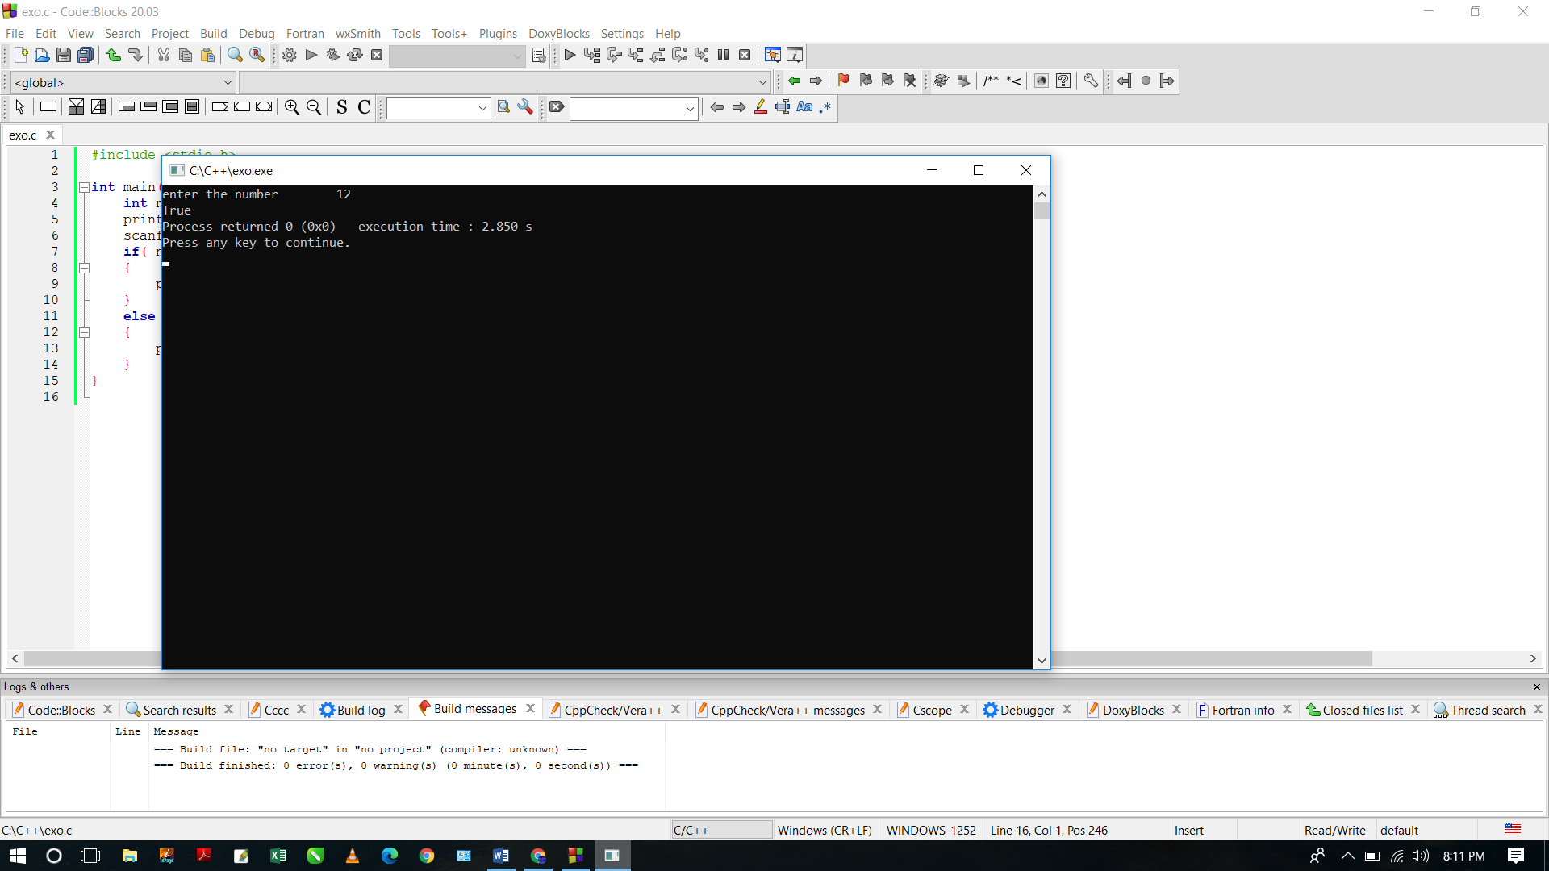

1. Write a C program to check whether a given temperatures is less than 0 and the other is greater than 100.

#include <stdio.h>

#include <stdlib.h>

int main(void){

int temp1, temp2;

int num1, num2;

printf("enter first temperature \t");

scanf("%d",&temp1);

printf("enter second temperature \t");

scanf("%d",&temp2);

if (temp1 < 10 && temp2 >100)

{

printf("one temperature is less than 10 and other is greater than 100");

}

else

{

printf("False");

}

}

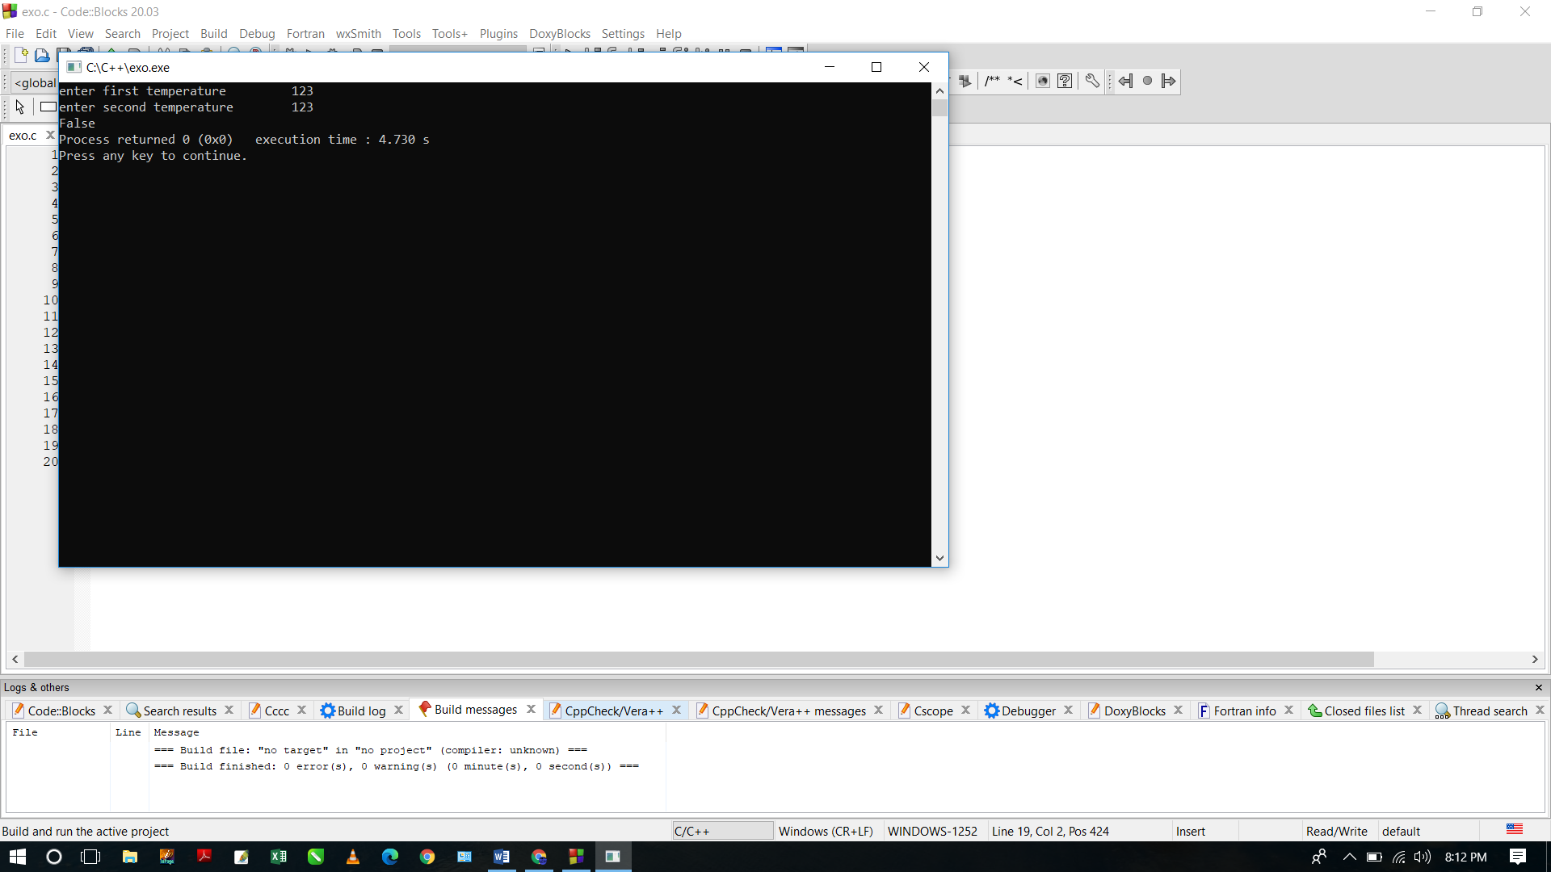

1. Write a C program to check two given integers whether either of them is in the range 100..200 inclusive.

#include<stdio.h>

int main(void)

{

int num1, num2;

printf("enter first number \t");

scanf("%d",&num1);

printf("enter second number \t");

scanf("%d",&num2);

if ( (num1 >= 100 && num1 <= 200) || (num2 >= 100 && num2 <= 200) )

{

printf("True");

}

else

{

printf("False");

}

}

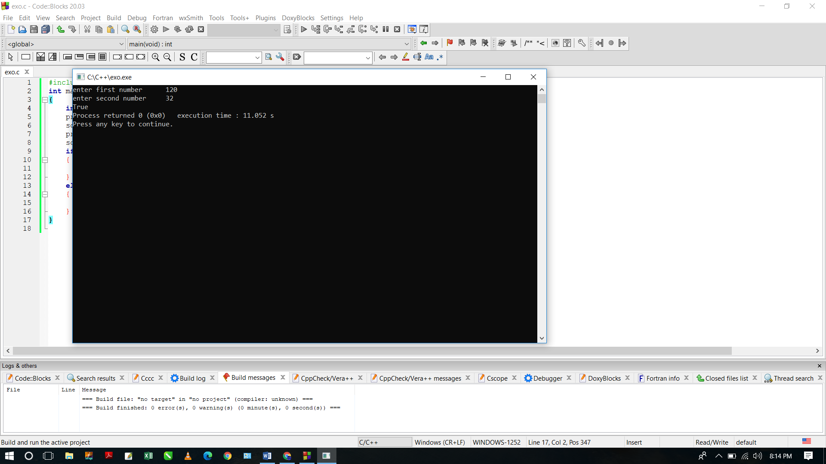

1. Write a C program to check whether three given integer values are in the range 20..50 inclusive. Return true if 1 or more of them are in the said range otherwise return false.

#include<stdio.h>

int main(void)

{

int num1, num2, num3;

printf("enter first number \t");

scanf("%d",&num1);

printf("enter second number \t");

scanf("%d",&num2);

printf("enter third number \t");

scanf("%d",&num3);

if ((num1 >= 20 && num1 <= 50) || (num2 >= 20 && num2 <= 50) || (num3 >= 20 && num3 <= 50))

{

printf("True");

}

else

{

printf("False");

}

}

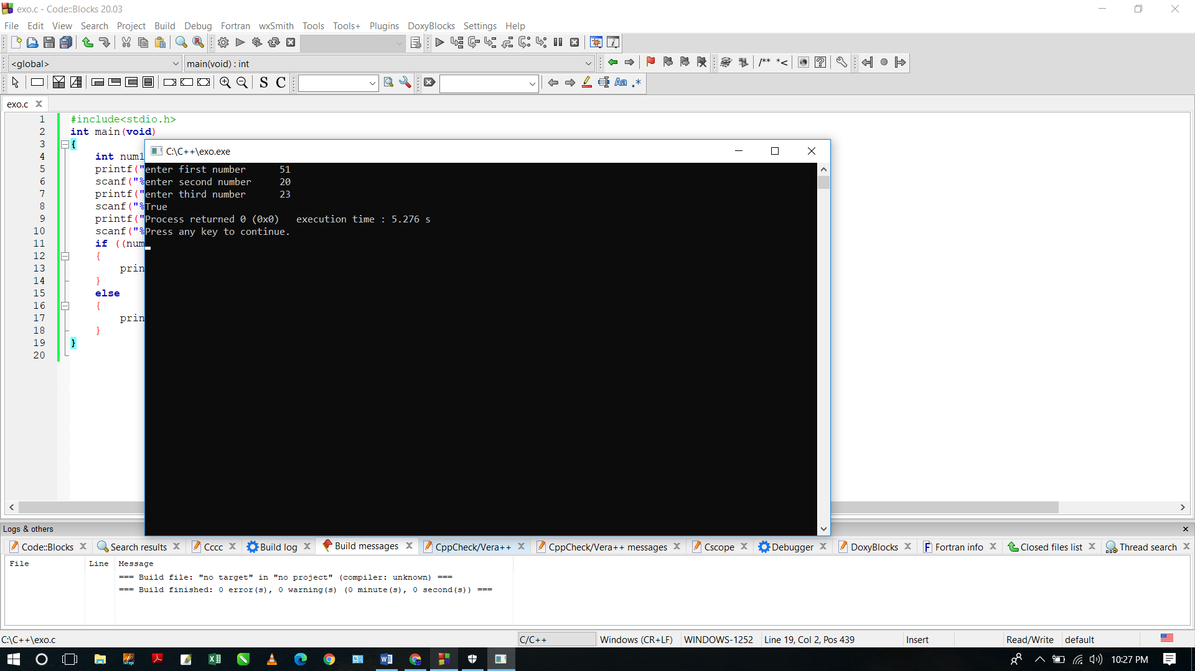

1. Write a C program to check whether two given integer values are in the range 20..50 inclusive. Return true if 1 or other is in the said range otherwise false.

#include<stdio.h>

int main(void)

{

int num1, num2;

printf("enter first number \t");

scanf("%d",&num1);

printf("enter second number \t");

scanf("%d",&num2);

if ((num1 >= 20 && num1 <= 50) && (num2 >= 20 && num2 <= 50) )

{

printf("False");

}

else

if ((num1 >= 20 && num1 <= 50) || (num2 >= 20 && num2 <= 50) )

{

printf("True");

}

else

{

printf("False");

}

}

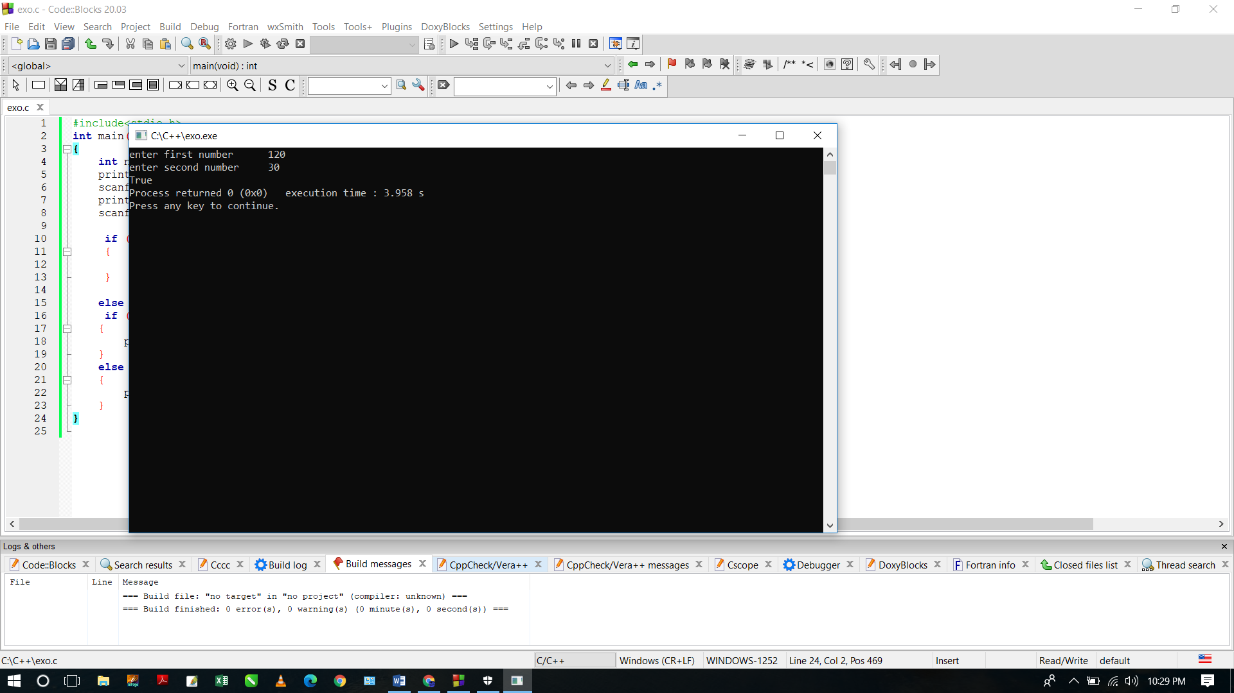

1. Write a C program to check which number nearest to the value 100 among two given integers. Return 0 if the two numbers are equal.

#include<stdio.h>

int main(void)

{

int num1, num2, diff1, diff2;

printf("enter number 1 \t");

scanf("%d",&num1);

printf("enter number 2 \t");

scanf("%d",&num2);

if(num1 <= 100 && num2 <= 100)

{

diff1 = 100 - num1;

diff2 = 100 - num2 ;

if(diff1<diff2)

printf("number 1 is nearest to 100");

else if(diff2 < diff1)

{

printf("number 2 is nearest to 100");

}

else

printf("0");

}

else

printf("Please enter numbers less than or equal 100");

}

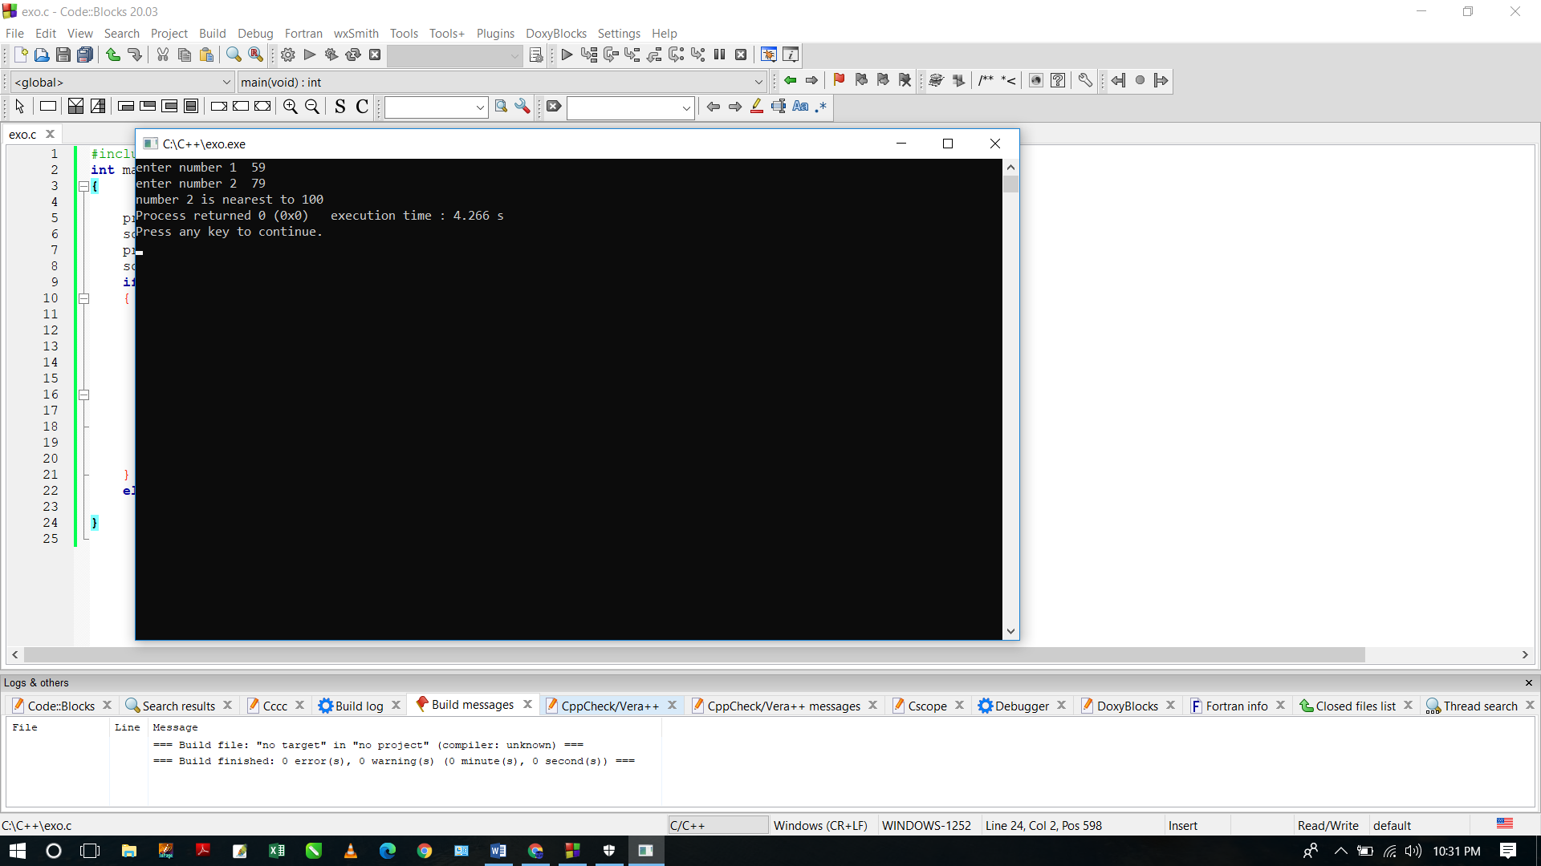

1. Write a C program to check whether two given integers are in the range 40..50 inclusive, or they are both in the range 50..60 inclusive.

#include<stdio.h>

int main(void)

{

int num1, num2, diff1, diff2;

printf("enter number 1 \t");

scanf("%d",&num1);

printf("enter number 2 \t");

scanf("%d",&num2);

if(num1 >= 40 && num1 <= 50 && num2 >= 40 && num2 <= 50)

{

printf("True");

}

else if(num1 >= 50 && num1 <= 60 && num2 >= 50 && num2 <= 60)

{

printf("True");

}

else

{

printf("False");

}

}

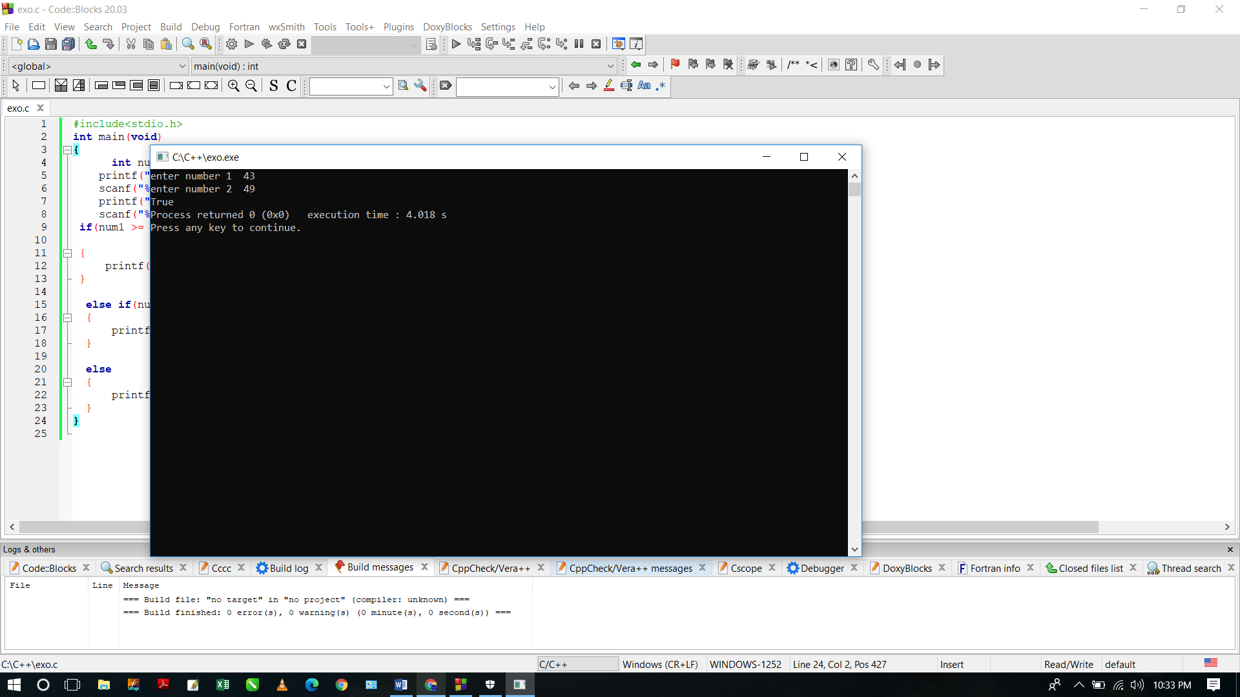

1. Write a C program to find the larger value from two positive integer values that is in the range 20..30 inclusive, or return 0 if neither is in that range.

#include<stdio.h>

int main(void)

{

int num1, num2;

printf("enter number 1 \t");

scanf("%d",&num1);

printf("enter number 2 \t");

scanf("%d",&num2);

if (num1 >= 20 && num1 <= 30 && num2 >= 20 && num2 <= 30)

{

if (num1 > num2)

{

printf("the greater number is %d",num1);

}

else

if (num2 > num1)

{

printf("the greater number is %d",num2);

}

else{

printf("Both Numbers are equal");

}

}

else

printf("0");

}

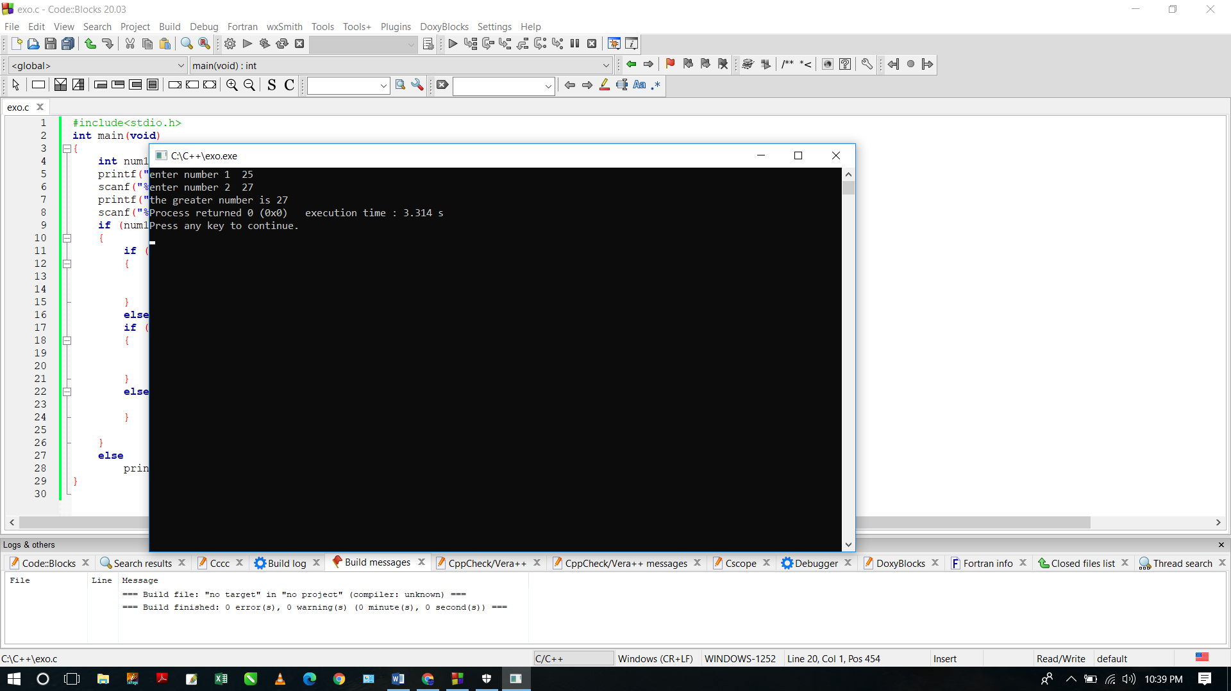

1. Write a C program to check if two given non-negative integers have the same last digit.

#include<stdio.h>

int main(void)

{

int num1, num2;

printf("enter number 1 \t");

scanf("%d",&num1);

if (num1 < 0)

{

num1 = num1 * -1;

}

printf("enter number 2 \t \n");

scanf("%d",&num2);

if (num2 < 0)

{

num2 = num2 * -1;

}

if( num1 % 10 == num2 % 10)

{

printf("numbers have same last digit");

}

else

printf("number's doesn't have last digit");

}

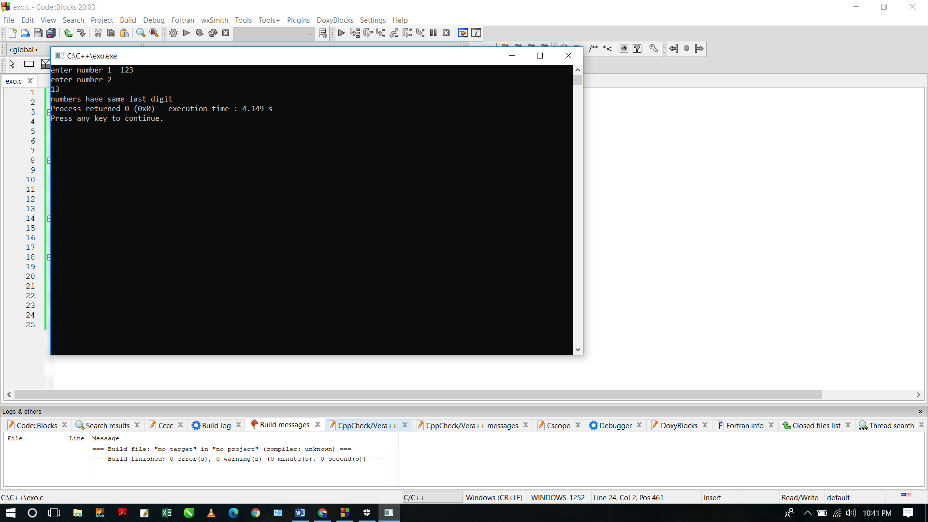

**17.** Write a C program to compute the sum of the two given integers. If the sum is in the range 10..20 inclusive return 30

#include<stdio.h>

int main(void)

{

int num1, num2,sums;

printf("enter number 1 \t");

scanf("%d",&num1);

printf("enter number 2 \t");

scanf("%d",&num2);

sums = num1 + num2 ;

if(sums >= 10 && sums <= 20)

{

sums = 30;

}

printf("the sum is %d",sums);

}

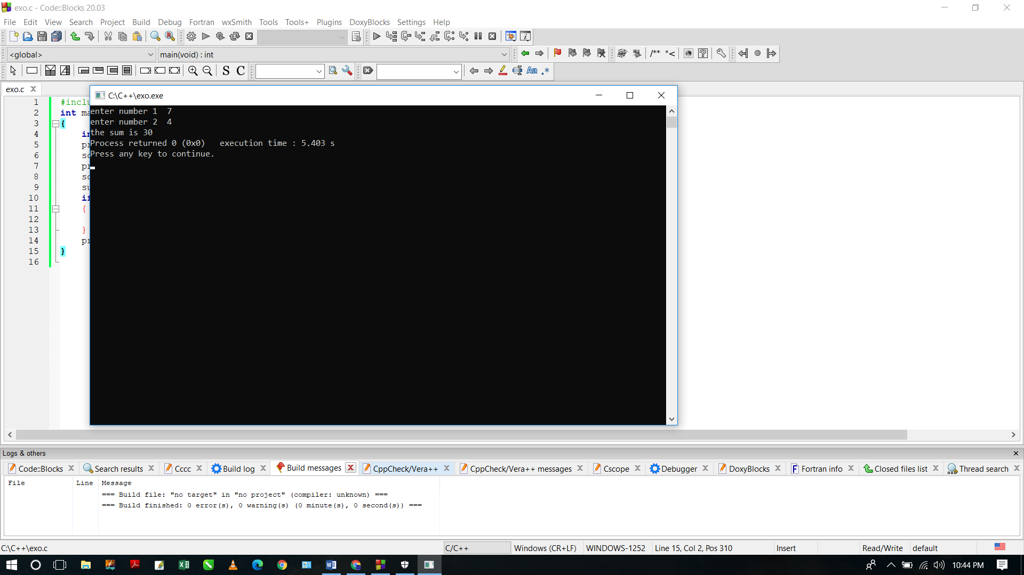

**18.** Write a C program that accept two integers and return true if either one is 5 or their sum or difference is 5.

#include<stdio.h>

int main(void)

{

int num1, num2,sums;

printf("enter number 1 \t");

scanf("%d",&num1);

printf("enter number 2 \t");

scanf("%d",&num2);

sums = num1 + num2 ;

if(num1 == 5 || num2 == 5 || sums == 5 || num1 - num2 == 5 || num2 - num1)

{

printf("True");

}

else

{

printf("False");

}

}

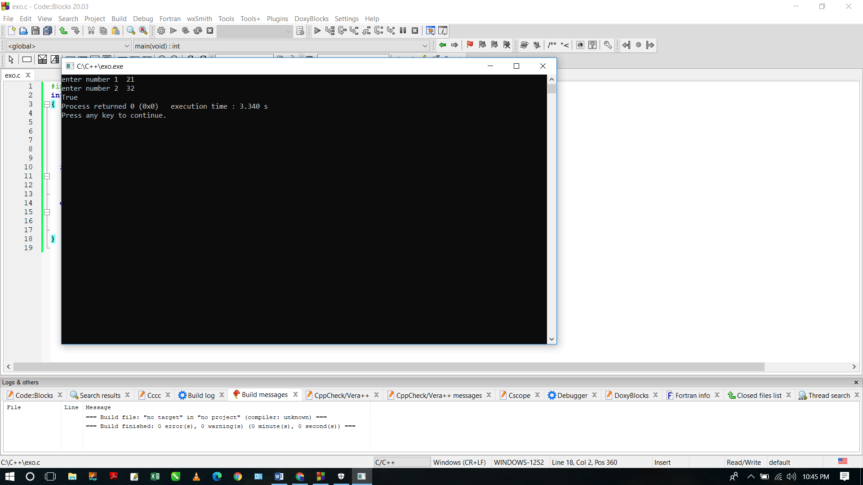

**19.** Write a C program to to test whether a given non-negative number is a multiple of 13 or it is one more than a multiple of 13

#include<stdio.h>

int main(void)

{

int num1;

printf("enter number 1 \t");

scanf("%d",&num1);

if(num1 % 13 == 0 || num1 % 13 == 1)

{

printf("True");

}

else

{

printf("False");

}

}

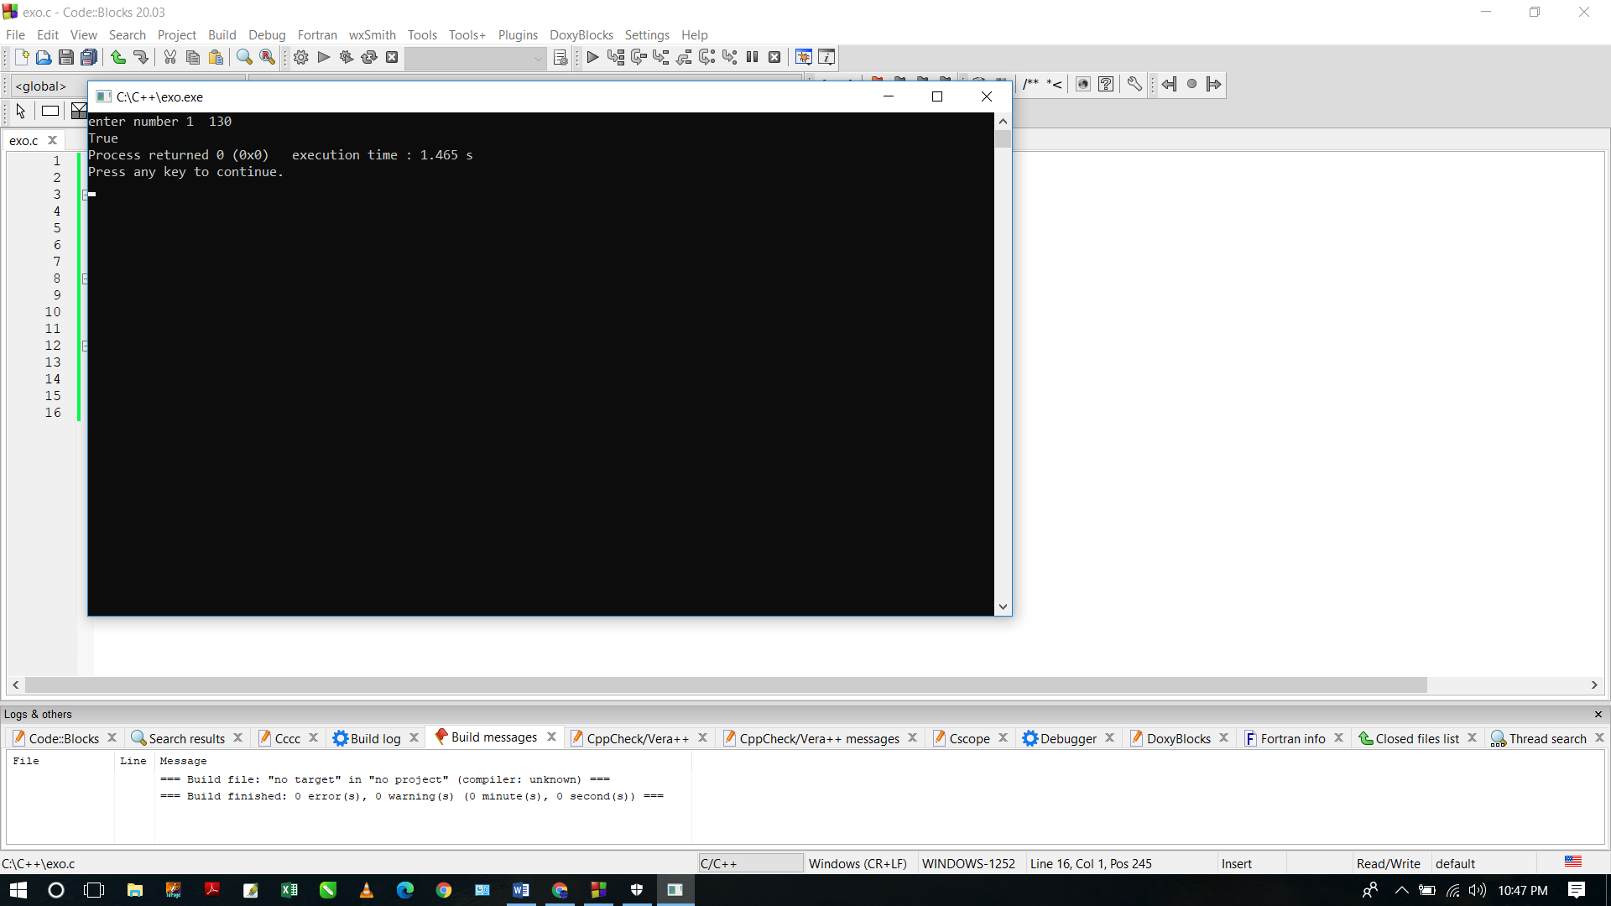

**20.** Write a C program to check whether a given non-negative number is a multiple of 3 or 7, but not both.

#include<stdio.h>

int main(void)

{

int num1, num2;

printf("enter number 1 \t");

scanf("%d",&num1);

if (num1 < 0)

{

num1 = num1 * -1;

}

if(num1 % 3 == 0)

{

printf("%d is a multiple of 3",num1);

}

else if ( num1 % 7 ==0)

{

printf("%d is a multiple of 7",num1);

}

else

{

printf("%d is not a multiple of 3 or 7",num1);

}

}

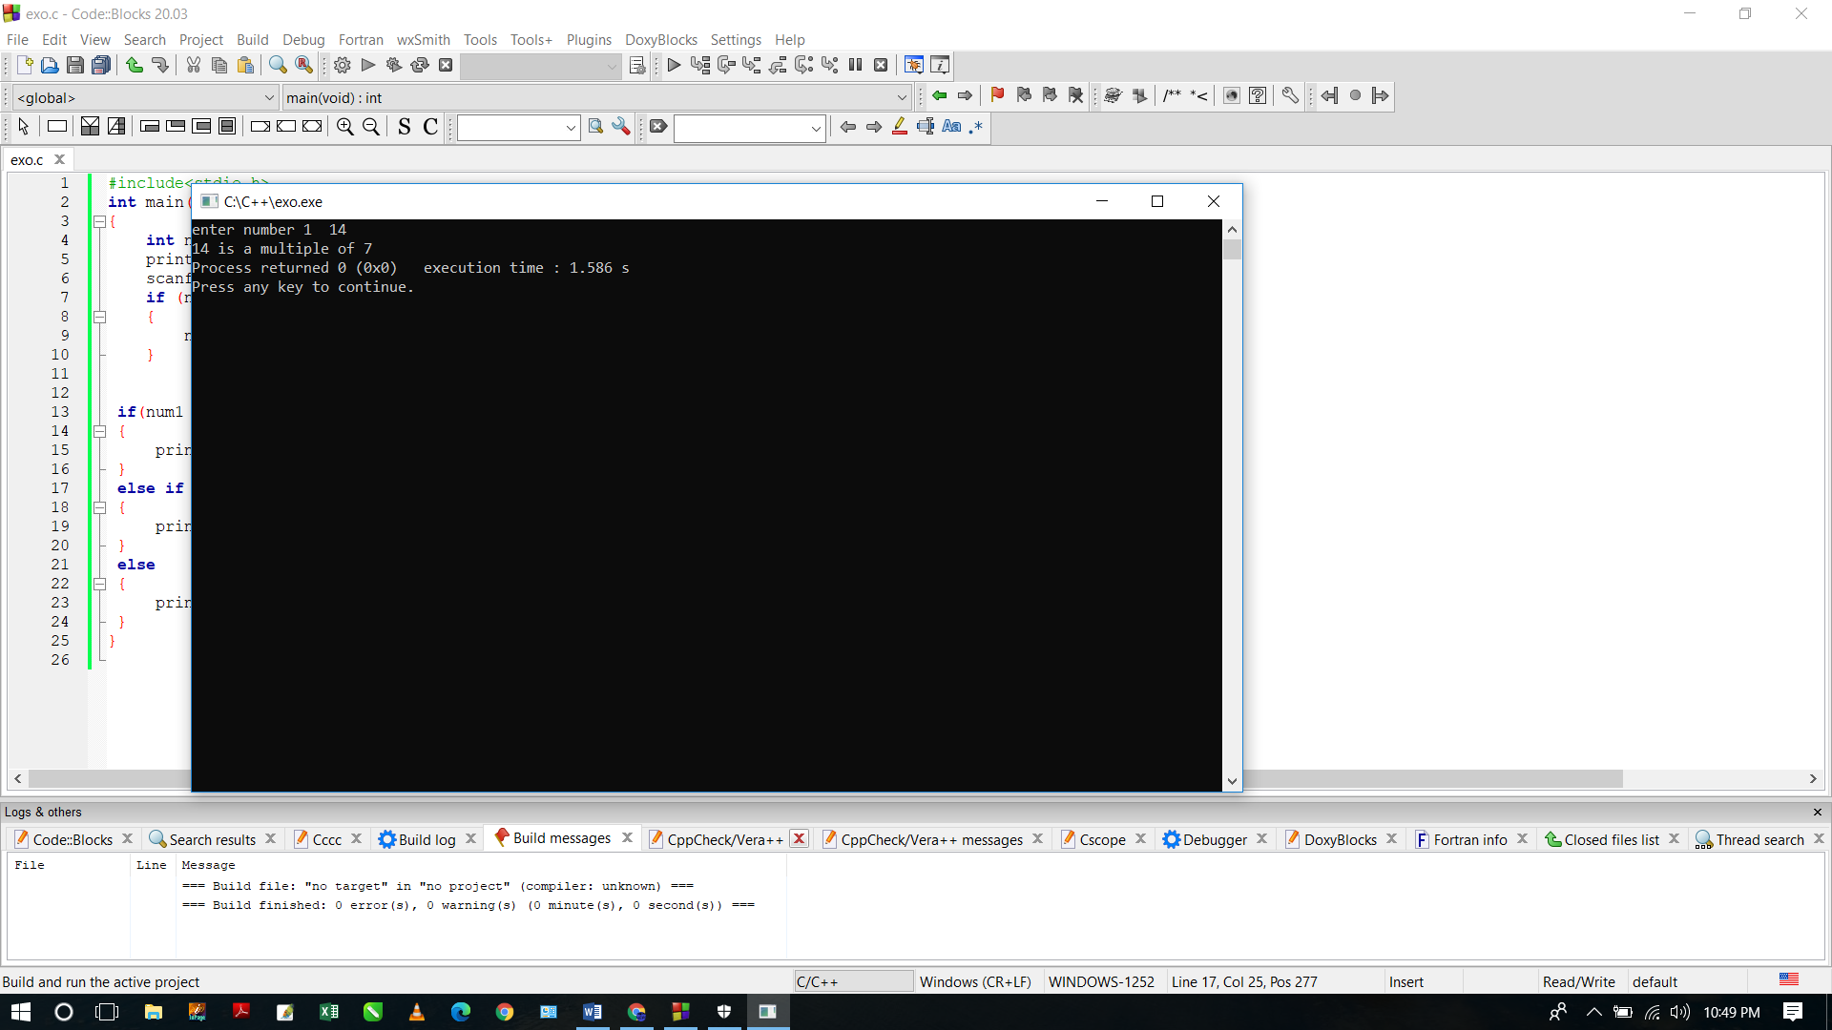

1. Write a C program to compute the sum of the two given integer values. If the two values are the same, then return triple their sum.

#include <stdio.h>

int main(void)

{

int num1, num2,sum;

sum = 0;

printf("enter number 1 ");

scanf("%d", &num1);

printf("enter number 2 ");

scanf("%d", &num2);

if (num1 == num2)

{

sum = (num1+num2)*3;

}

else

{

sum = num1 + num2 ;

}

printf("the sum is %d",sum);

}



1. Write a C program to get the absolute difference between n and 51. If n is greater than 51 return triple the absolute difference.

#include <stdio.h>

int main(void)

{

int n,diff;

diff = 0;

printf("enter the number \t");

scanf("%d",&n);

if(n>51)

{

diff = (n-51)*3;

}

else

if(n<51)

{

diff = n-51;

}

else

{

diff = 0;

}

printf("%d",diff);

}



1. Write a C program to check two given integers, and return true if one of them is 30 or if their sum is 30.

#include <stdio.h>

int main(void){

int num1, num2;

printf("enter first number \t");

scanf("%d",&num1);

printf("enter second number \t");

scanf("%d",&num2);

if(num1 == 30 || num2 == 30 || (num1+num2) == 30)

{

printf("TRUE");

}

else

{

printf("FALSE");

}

}



1. Write a C program to check a given integer and return true if it is within 10 of 100 or 200.

#include <stdio.h>

int main(void){

int num1;

printf("enter the number \t");

scanf("%d",&num1);

if((num1 - 100)<=10 || (num1 - 200)<=20)

{

printf("True");

}

else

printf("False");

}



1. Write a C program to check whether a given positive number is a multiple of 3 or a multiple of 7

#include <stdio.h>

int main(void){

int num1;

printf("enter the number \t");

scanf("%d",&num1);

if( num1 % 3 == 0 || num1 % 7 ==0)

{

printf("True");

}

else

{

printf("False");

}

}



1. Write a C program to check whether a given temperatures is less than 0 and the other is greater than 100.

#include <stdio.h>

#include <stdlib.h>

int main(void){

int temp1, temp2;

int num1, num2;

printf("enter first temperature \t");

scanf("%d",&temp1);

printf("enter second temperature \t");

scanf("%d",&temp2);

if (temp1 < 10 && temp2 >100)

{

printf("one temperature is less than 10 and other is greater than 100");

}

else

{

printf("False");

}

}



1. Write a C program to check two given integers whether either of them is in the range 100..200 inclusive.

#include<stdio.h>

int main(void)

{

int num1, num2;

printf("enter first number \t");

scanf("%d",&num1);

printf("enter second number \t");

scanf("%d",&num2);

if ( (num1 >= 100 && num1 <= 200) || (num2 >= 100 && num2 <= 200) )

{

printf("True");

}

else

{

printf("False");

}

}



1. Write a C program to check whether three given integer values are in the range 20..50 inclusive. Return true if 1 or more of them are in the said range otherwise return false.

#include<stdio.h>

int main(void)

{

int num1, num2, num3;

printf("enter first number \t");

scanf("%d",&num1);

printf("enter second number \t");

scanf("%d",&num2);

printf("enter third number \t");

scanf("%d",&num3);

if ((num1 >= 20 && num1 <= 50) || (num2 >= 20 && num2 <= 50) || (num3 >= 20 && num3 <= 50))

{

printf("True");

}

else

{

printf("False");

}

}



1. Write a C program to check whether two given integer values are in the range 20..50 inclusive. Return true if 1 or other is in the said range otherwise false.

#include<stdio.h>

int main(void)

{

int num1, num2;

printf("enter first number \t");

scanf("%d",&num1);

printf("enter second number \t");

scanf("%d",&num2);

if ((num1 >= 20 && num1 <= 50) && (num2 >= 20 && num2 <= 50) )

{

printf("False");

}

else

if ((num1 >= 20 && num1 <= 50) || (num2 >= 20 && num2 <= 50) )

{

printf("True");

}

else

{

printf("False");

}

}



1. Write a C program to check which number nearest to the value 100 among two given integers. Return 0 if the two numbers are equal.

#include<stdio.h>

int main(void)

{

int num1, num2, diff1, diff2;

printf("enter number 1 \t");

scanf("%d",&num1);

printf("enter number 2 \t");

scanf("%d",&num2);

if(num1 <= 100 && num2 <= 100)

{

diff1 = 100 - num1;

diff2 = 100 - num2 ;

if(diff1<diff2)

printf("number 1 is nearest to 100");

else if(diff2 < diff1)

{

printf("number 2 is nearest to 100");

}

else

printf("0");

}

else

printf("Please enter numbers less than or equal 100");

}



1. Write a C program to check whether two given integers are in the range 40..50 inclusive, or they are both in the range 50..60 inclusive.

#include<stdio.h>

int main(void)

{

int num1, num2, diff1, diff2;

printf("enter number 1 \t");

scanf("%d",&num1);

printf("enter number 2 \t");

scanf("%d",&num2);

if(num1 >= 40 && num1 <= 50 && num2 >= 40 && num2 <= 50)

{

printf("True");

}

else if(num1 >= 50 && num1 <= 60 && num2 >= 50 && num2 <= 60)

{

printf("True");

}

else

{

printf("False");

}

}



1. Write a C program to find the larger value from two positive integer values that is in the range 20..30 inclusive, or return 0 if neither is in that range.

#include<stdio.h>

int main(void)

{

int num1, num2;

printf("enter number 1 \t");

scanf("%d",&num1);

printf("enter number 2 \t");

scanf("%d",&num2);

if (num1 >= 20 && num1 <= 30 && num2 >= 20 && num2 <= 30)

{

if (num1 > num2)

{

printf("the greater number is %d",num1);

}

else

if (num2 > num1)

{

printf("the greater number is %d",num2);

}

else{

printf("Both Numbers are equal");

}

}

else

printf("0");

}



1. Write a C program to check if two given non-negative integers have the same last digit.

#include<stdio.h>

int main(void)

{

int num1, num2;

printf("enter number 1 \t");

scanf("%d",&num1);

if (num1 < 0)

{

num1 = num1 * -1;

}

printf("enter number 2 \t \n");

scanf("%d",&num2);

if (num2 < 0)

{

num2 = num2 * -1;

}

if( num1 % 10 == num2 % 10)

{

printf("numbers have same last digit");

}

else

printf("number's doesn't have last digit");

}



**17.** Write a C program to compute the sum of the two given integers. If the sum is in the range 10..20 inclusive return 30

#include<stdio.h>

int main(void)

{

int num1, num2,sums;

printf("enter number 1 \t");

scanf("%d",&num1);

printf("enter number 2 \t");

scanf("%d",&num2);

sums = num1 + num2 ;

if(sums >= 10 && sums <= 20)

{

sums = 30;

}

printf("the sum is %d",sums);

}



**18.** Write a C program that accept two integers and return true if either one is 5 or their sum or difference is 5.

#include<stdio.h>

int main(void)

{

int num1, num2,sums;

printf("enter number 1 \t");

scanf("%d",&num1);

printf("enter number 2 \t");

scanf("%d",&num2);

sums = num1 + num2 ;

if(num1 == 5 || num2 == 5 || sums == 5 || num1 - num2 == 5 || num2 - num1)

{

printf("True");

}

else

{

printf("False");

}

}



**19.** Write a C program to to test whether a given non-negative number is a multiple of 13 or it is one more than a multiple of 13

#include<stdio.h>

int main(void)

{

int num1;

printf("enter number 1 \t");

scanf("%d",&num1);

if(num1 % 13 == 0 || num1 % 13 == 1)

{

printf("True");

}

else

{

printf("False");

}

}



**20.** Write a C program to check whether a given non-negative number is a multiple of 3 or 7, but not both.

#include<stdio.h>

int main(void)

{

int num1, num2;

printf("enter number 1 \t");

scanf("%d",&num1);

if (num1 < 0)

{

num1 = num1 * -1;

}

if(num1 % 3 == 0)

{

printf("%d is a multiple of 3",num1);

}

else if ( num1 % 7 ==0)

{

printf("%d is a multiple of 7",num1);

}

else

{

printf("%d is not a multiple of 3 or 7",num1);

}

}

